**Dolphin Therapy Study**

Swimming with dolphins can certainly be fun, but is it also therapeutic for patients suffering from clinical depression? To investigate this possibility, researchers recruited 30 subjects aged 18-65 with a clinical diagnosis of mild to moderate depression. Subjects were required to discontinue use of any antidepressant drugs or psychotherapy four weeks prior to the experiment, and throughout the experiment. These 30 subjects went to an island off the coast of Honduras, where they were randomly assigned to one of two treatment groups. Both groups engaged in the same amount of swimming and snorkeling each day, but one group (the animal care program) did so in the presence of bottlenose dolphins and the other group (outdoor nature program) did not. At the end of two weeks, each subjects’ level of depression was evaluated, as it had been at the beginning of the study, and it was determined whether they showed substantial improvement (reducing their level of depression) by the end of the study[1].

**Discuss the Following Questions**

1. What are the 5 W’s?
2. What is the explanatory variable in this study?
3. What is the response variable in this study?

The researchers found that 10 of 15 subjects in the dolphin therapy group showed substantial improvement, compared to 3 of 15 subjects in the control group.

1. Organize these data/results into a 2×2 frequency table.

|  |  |  |  |
| --- | --- | --- | --- |
|  | **No Improvement** | **Improvement** | **Total** |
| **Control Group** |  |  |  |
| **Dolphin Therapy** |  |  |  |
| **Total** |  |  |  |

1. Compute the percent of the overall sample (all 30 subjects) that improved.
2. For subjects in the control group, what proportion improved?
3. Compute the marginal distribution for the improvement variable.
4. Compute the marginal distribution for the treatment variable.
5. Compute the conditional distribution for the improvement variable conditioned on treatment group.

|  |  |  |  |
| --- | --- | --- | --- |
|  | **No Improvement** | **Improvement** | **Total** |
| **Control Group** |  |  |  |
| **Dolphin Therapy** |  |  |  |
| **Total** |  |  |  |

1. Interpret the proportion you computed for question 8 in the first cell in the table.

A mosaic plot is provided below. Use it to answer questions 11 and 12.

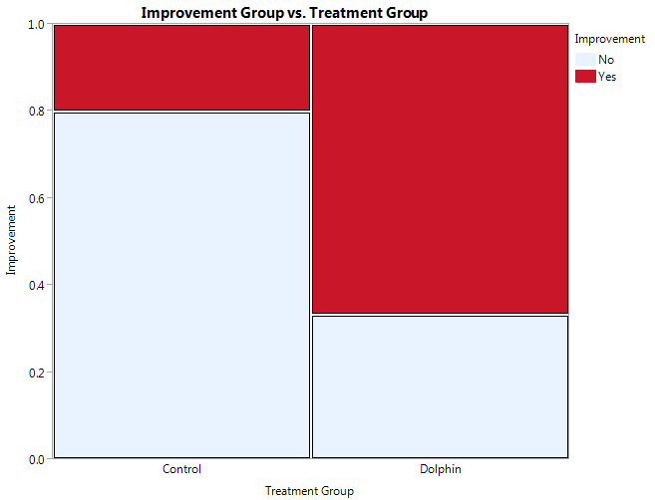

1. Are the conditional distributions of improvement group given treatment group (control or dolphin) different? Explain.
2. Is there an association between improvement group and treatment group? Explain.

1. Antonioli, C., & Reveley, M. A. (2005). Randomised controlled trial of animal facilitated therapy with dolphins in the treatment of depression. *British Medical Journal, 331*, 1-4.