**Dolphin Therapy Study**

Swimming with dolphins can certainly be fun, but is it also therapeutic for patients suffering from clinical depression? To investigate this possibility, researchers recruited 30 subjects aged 18-65 with a clinical diagnosis of mild to moderate depression. Subjects were required to discontinue use of any antidepressant drugs or psychotherapy four weeks prior to the experiment, and throughout the experiment. These 30 subjects went to an island off the coast of Honduras, where they were randomly assigned to one of two treatment groups. Both groups engaged in the same amount of swimming and snorkeling each day, but one group (the animal care program) did so in the presence of bottlenose dolphins and the other group (outdoor nature program) did not. At the end of two weeks, each subjects’ level of depression was evaluated, as it had been at the beginning of the study, and it was determined whether they showed substantial improvement (reducing their level of depression) by the end of the study[1].

**Discuss the Following Questions**

1. What are the 5 W’s?

*Who: 30 people aged 18-65 with clinical diagnosis of mild to moderate depression*

*What: Treatment group (control or dolphin group) and whether or not there was improvement in level of depression*

*Where: Island off the coast of Honduras*

*When: Does not say but it must have been before 2005 because that is when the article was published.*

*Why: To determine if swimming with dolphins rather than swimming without dolphins improved levels of depression.*

*How: People were randomly assigned to swim with dolphins or swim without dolphins and all participated for 2 weeks.*

1. What is the explanatory variable in this study?

*Treatment variable = swimming or not swimming with dolphins*

1. What is the response variable in this study?

*Improvement or no improvement in depression levels*

The researchers found that 10 of 15 subjects in the dolphin therapy group showed substantial improvement, compared to 3 of 15 subjects in the control group.

1. Organize these data/results into a 2×2 frequency table.

|  |  |  |  |
| --- | --- | --- | --- |
|  | **No Improvement** | **Improvement** | **Total** |
| **Control Group** | *12* | *3* | *15* |
| **Dolphin Therapy** | *5* | *10* | *15* |
| **Total** | *17* | *13* | *30* |

1. Compute the percent of the overall sample (all 30 subjects) that improved.

*13/30*100 = .43*100 = 43% (note that this question asked to report the percent, not proportion)*

1. For subjects in the control group, what proportion improved?

*3/15 = .2 (note that this question asked to report the proportion)*

1. Compute the marginal distribution for the improvement variable.

*No improvement: 17/30 = .57*

*Improvement: 13/30 = .43*

1. Compute the marginal distribution for the treatment variable.

*Control group: 15/30 = .5*

*Dolphin group: 15/30 = .5*

1. Compute the conditional distribution for the improvement variable conditioned on treatment group.

|  |  |  |  |
| --- | --- | --- | --- |
|  | **No Improvement** | **Improvement** | **Total** |
| **Control Group** | *12/15 = .8* | *3/15 = .2* | *1* |
| **Dolphin Therapy** | *5/15 = .33* | *10/15 = .67* | *1* |
| **Total** | *17/30 = .57* | *13/30 = .43* | *1* |

1. Interpret the proportion you computed for question 8 in the first cell in the table.

*The proportion of people in the control group that did not show any improvement was .8.*

A mosaic plot is provided below. Use it to answer questions 11 and 12.

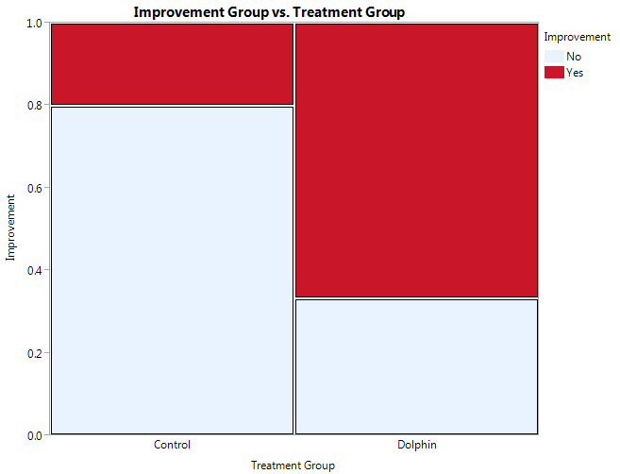

1. Are the conditional distributions of improvement group given treatment group (control or dolphin) different? Explain.

*Yes. Looking across the graph in a horizontal fashion, the lines separating the improvement groups do not match up.*

1. Is there an association between improvement group and treatment group? Explain.

*Yes, because the conditions distributions are different as stated in question 11.*

1. Antonioli, C., & Reveley, M. A. (2005). Randomised controlled trial of animal facilitated therapy with dolphins in the treatment of depression. *British Medical Journal, 331*, 1-4.