Session 1 - Introduction.Rmd

Table of Contents

# The purpose of this course

* An introduction to basic techniques in R 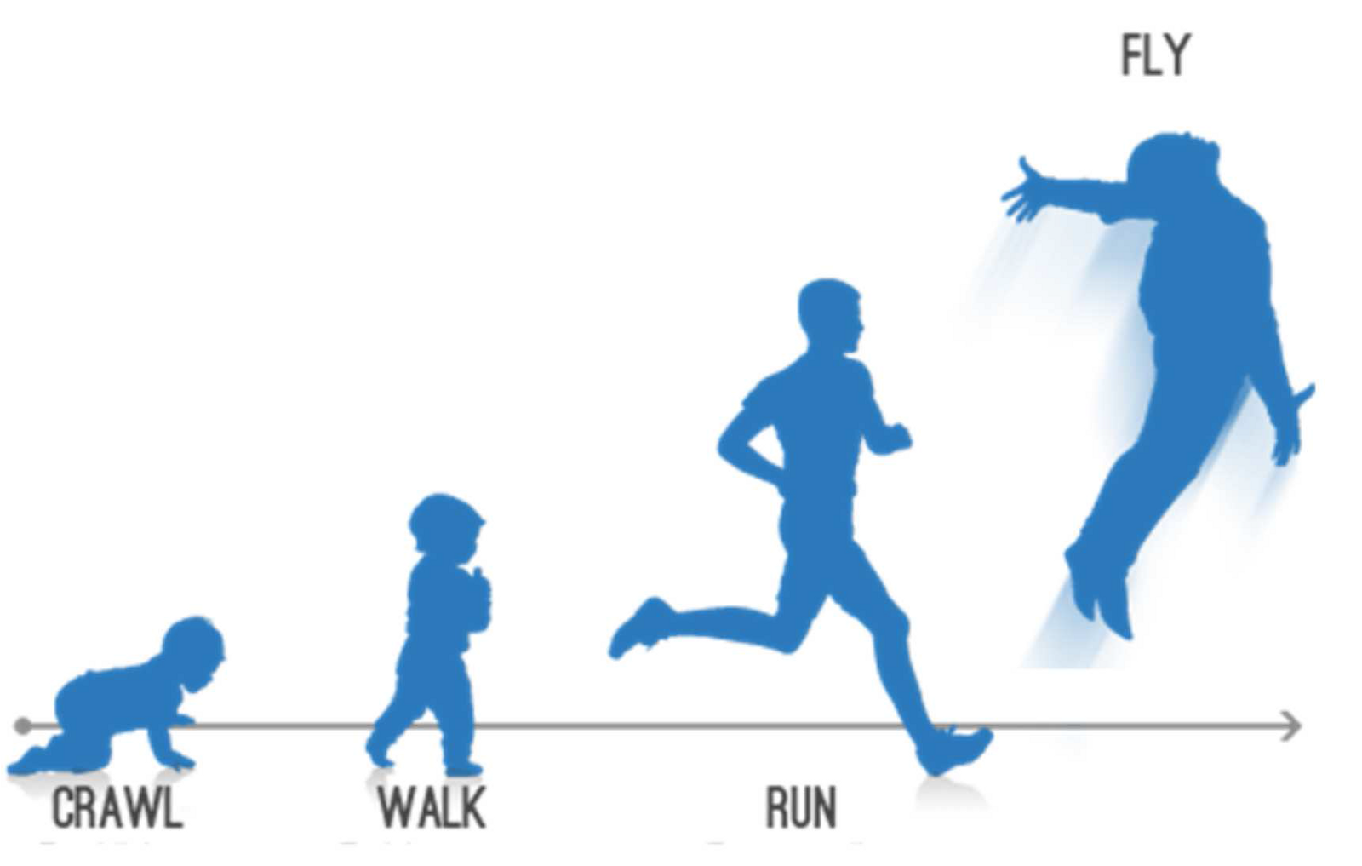
* An interdisciplinary approach to R, e.g. regression modelling for psychologists, and text analysis for digital humanities

# Why R?

* *Open Source*
  + means that analyses are (a) cutting edge and (b) accurate
* *Strong emphasis on reproducible research*
  + data are (a) accurately reported (b) shareable

# How to use an R Markdown file

This is an [R Markdown](http://rmarkdown.rstudio.com) Notebook. When you execute code within the notebook, the results appear beneath the code.

Try executing this chunk by clicking the *Run* button within the chunk or by placing your cursor inside it and pressing *Ctrl+Shift+Enter*.

plot(cars)

Add a new chunk by clicking the *Insert* button on the toolbar or by pressing *Ctrl+Alt+I*.

When you save the notebook, an HTML file containing the code and output will be saved alongside it (click the *Preview* button or press *Ctrl+Shift+K* to preview the HTML file).

one <- 1  
one

## [1] 1

# RStudio breakdown

## Panes

RStudio shows you four panes:

1. The ‘Source’ pane: the file where you write your code
2. The ‘Console’ where actual code is run
3. The ‘Environment’ pane, which shows you variables / datasets
4. The ‘Viewer’ pane, which shows you plots and help files

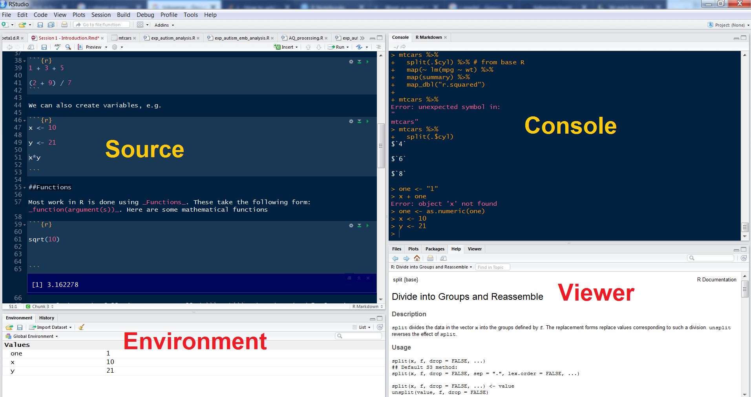

You can arrange these in any order using Tools > Global Options.

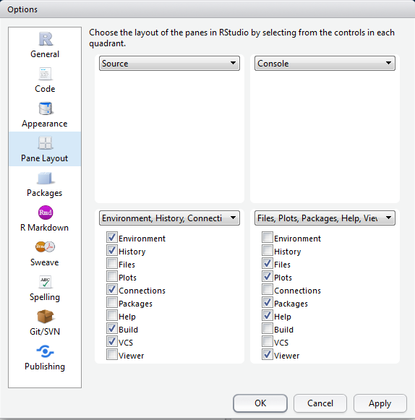

## Autocomplete

RStudio has fantastic autocomplete capabilites. To autocomplete just press TAB. This is especially useful when loading files as using autocomplete will help you to identify relevant ones. However it also does lots of other things…

# R basics

## Setting the working directory

At the very beginning of an R session you MUST set a ‘working directory’. This tells R where to look for and save files. An easy way to do this is from RStudio. We’re going to look at three ways to dos this.

### The easy way

Within RStudio go to Session >> Set Working Directory > Choose Directory...

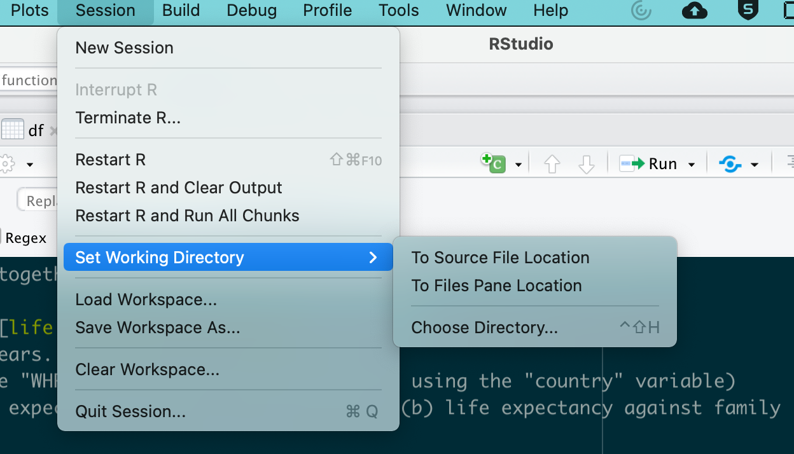

You also have an option to set the working directory to the most recently-loaded .R or .Rmd file.

### The difficult way (1)

To do this type

setwd("path/to/directory")

Unfortunately, if you are on a windows machine you will need to change all backslashes \ to forward slashes /. This is because R follows UNIX conventions which are native to Linux and Mac computers.

If you are not sure what your working directory is type

getwd()

Getting the right path is a vital first step in R, and you really need to know how to do this. Here are some instructional videos if you get stuck…

For Windows computers refer to [this YouTube video](https://www.youtube.com/watch?v=QzSV8wvA1Do). For Macs refer to [this YouTube video](https://www.youtube.com/watch?v=43W9TuPwqac). If you’re on Linux then refer to [this YouTube video](https://www.youtube.com/watch?v=dQw4w9WgXcQ)

However this is a big problem with this approach. If you send your file to someone else who is working on a different machine, it is most likely that your path will be pointing to the wrong location

### The difficult way (2) (but by far the best way!)

By far the best way to set the working directory is create and “R Project” in RStudio. When you do this, the RProject stores all files and data objects which were opened in the last session, and also keeps track of where the files are stored, so there is no need to set the directory.

## Using R as a calculator

We can use the console for general arithmetic

1 + 3 + 5

## [1] 9

(2 + 9) / 7

## [1] 1.571429

1 + 2+ 3

## [1] 6

We can also create variables, e.g.

x <- 10 # This is a comment  
x = 10 # Does the same thing!!  
y <- 21  
x\*y

## [1] 210

## Comments

If you’d like to comment on any code you write (i.e. you do not wish R to try to ‘run’ this code) just add a hash (#) or series of hashes in front of it, e.g.

x <- 100 # create a variable called x with the valuee 100  
  
# Now double it  
  
x\*2

## [1] 200

## Functions

Most work in R is done using *Functions*. These take the following form: *function(argument(s))*. Here are some functions

sqrt(10)

## [1] 3.162278

seq(1, 10, 2)

## [1] 1 3 5 7 9

rep(5, 10)

## [1] 5 5 5 5 5 5 5 5 5 5

## EX 1 & 2: Working with Functions

EX1: What do the arguments of seq and rep do? To find out more search for the relevant help file in the console by typing ?seq or by using Google.

EX2: Have a look at the following arguments called gsub and grepl. What do they do? Clue: if you’re stuck, search the help file using ?

gsub("R-studio", "Rstudio", "R-studio is a great piece of software")

## [1] "Rstudio is a great piece of software"

grepl("chocolate", "Mary likes chocolate cookies")

## [1] TRUE

## DIY functions

It’s possible to **create your own functions**. This makes R extremely powerful and extendable. We’re not going to cover making your own functions in this course, but it’s important to be aware of this capability. There are plenty of good resources online for learning how to do this, including [this one](https://www.statmethods.net/management/userfunctions.html)

## Getting help

As we have seen above, to find out about a particular function just type ? and the name of the function into the console, e.g. ?grepl. This accesses the help files on your computer. If you’d like to search more broadly type ??grepl and your computer will look online for relevant materials on CRAN (the main R website)

Help files in R are quite densely written and not particularly aimed at beginners. Fortunately there are loads of excellent resources on the internet. Here are some really good sites:

1. <https://www.tidyverse.org/> - A brilliant set of of resources on all things related to the tidyverse, Hadley Wickham’s brilliant suite of packages
2. <https://www.statmethods.net/index.html> - a quick way of looking up basic R techniques
3. <https://stats.idre.ucla.edu/r/modules/>
4. <https://rseek.org/> - a search engine for all things related to R (because the word ‘R’ brings up a whole load of irrelevant stuff in Google)
5. <http://www.cookbook-r.com/> - this has lots of tips on how to do graphics.

And there are plenty more! If you find a good one share it with your colleagues via email, Twitter, or whatever social media you prefer!

# Packages

## Installation

To enhance the basic capabilities of R, we need to load packages/libraries. Most of the time, we download these from ‘CRAN’ Tools > Install packages or install.packages(). Once the package/library is installed (i.e. it is sitting somewhere on your computer), we then need to *load* it to the current R session using the library() function.

Remember using a package/library is a two-stage process. We

1. *Install* the package/library onto your computer (from the internet)
2. *Load* the package/library into your current session using the library command.

One of the most useful packages is called ‘tidyverse’.

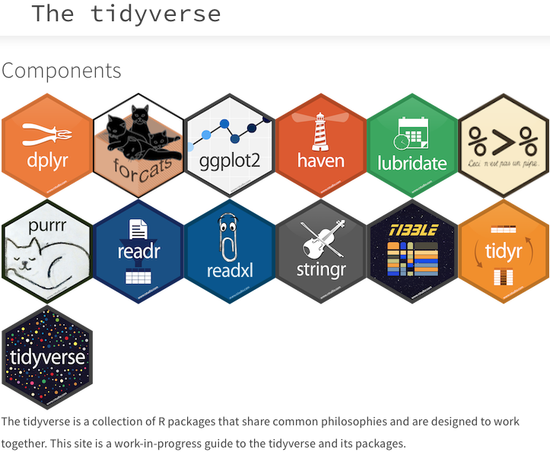

It contains a number of useful commands for plots, and data manipulation.

Install the ‘tidyverse’ package, and then load it with the following function:

library(tidyverse)

## ── Attaching packages ─────────────────────────────────────── tidyverse 1.3.1 ──

## ✔ ggplot2 3.3.4 ✔ purrr 0.3.4  
## ✔ tibble 3.1.7 ✔ dplyr 1.0.9  
## ✔ tidyr 1.1.3 ✔ stringr 1.4.0  
## ✔ readr 1.4.0 ✔ forcats 0.5.1

## Warning: package 'dplyr' was built under R version 4.1.2

## ── Conflicts ────────────────────────────────────────── tidyverse\_conflicts() ──  
## ✖ dplyr::filter() masks stats::filter()  
## ✖ dplyr::lag() masks stats::lag()

I find that a particularly easy way to load packages is via the p\_load function from the pacman library. We are not going to practise using it, but just to let you know that it exists!

## Obtaining help

To find out more about a package type ?package\_name in the console. Alternatively you can look for the package documentation on [CRAN](https://cran.r-project.org/).

## Using functions from packages

Most of the functions loaded in a package should work ‘out of the box’. However occasionally you need to refer to the package first, and then the function using the format package\_name::function\_from\_that\_package. This is useful for a variety of reasons:

1. It allows you to use a function from a package without having to load that package (using the “library” commmand)
2. It helps in cases where you load two packages which contain two different functions which happen to have the same name.
3. Sometimes, even when a package is loaded, you need to precede a function by the package name. However, most of the time this is not necessary. (NB I am not sure why R sometimes requires the name of the package to be specified like this)

## EX 3 - Using packages

1. Install and load the package ggplot2
2. Look up the function geom\_point from this package. What does it do?

# Objects, data frames and indices

## Objects

A variable is a type of ‘object’ which R stores in memory. R is capable of creating and storing a wide range of objects. To see what type of object we have created, we use the function class(), e.g.

x <- 1  
  
class(x)

## [1] "numeric"

z <- "hello"  
  
class(z)

## [1] "character"

*class* is one of the most useful functions in R as errors are often due to misassignment of class, e.g.

x + z

## Error in x + z: non-numeric argument to binary operator

Here we have tried to add a number to a string which is clearly impossible. It’s possible to change the class of an object using commands such as as.character, as.integer, as.numeric, as.factor, e.g.

one <- "1"  
x + one

## Error in x + one: non-numeric argument to binary operator

one <- as.numeric(one)  
x + one

## [1] 2

Here is a visual summary of *some* of the main data types / object classes in R:

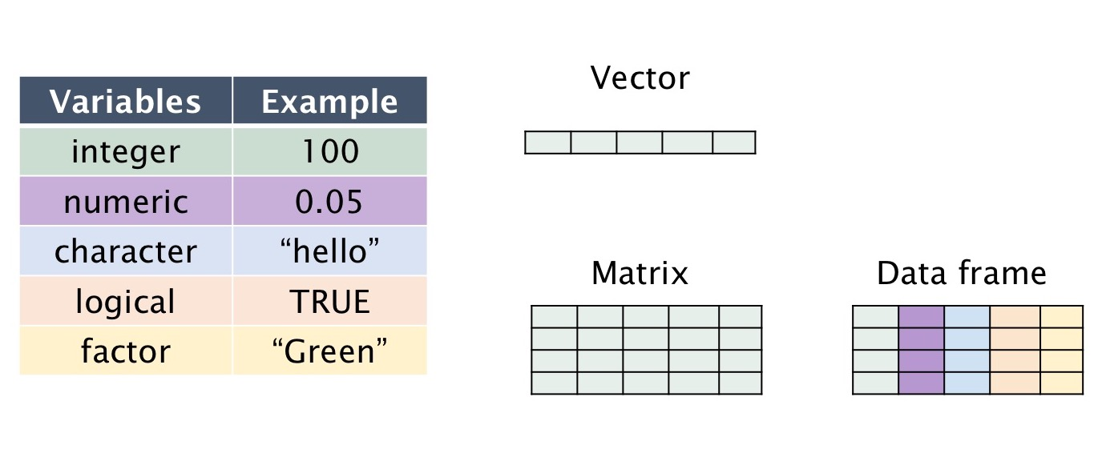

Here are some definitions

1. *integer* = rounded number
2. *numeric* = number with decimal points
3. *character* = a string of characters
4. *logical* = has a TRUE / FALSE value
5. *factor* = a label which looks like a character variable, but which is mapped to a nominal variable, e.g. “nationality”
6. *vector* = a one-dimensional array where each position contains a different value from the same data type, e.g. a series of numbers, or a series of words.
7. *list* = a one-dimensional array where ach position contains a different value. Data types may *vary*
8. *matrix* = a two-dimensional array where all values are from the same data type
9. *data frame* = a typical “spreadsheet” format. Columns are labelled. Columns may be of different types, e.g. a column containing strings (characters), or a column containing numbers.

In order to create a vector we need to use the c function. (c = ‘combine’), e.g.

vector.of.numbers <- c(1,4,54,22,43,9,0,0,21)  
  
mean(vector.of.numbers)

## [1] 17.11111

sd(vector.of.numbers)

## [1] 19.85223

a.character.vector <- c("Mary", "Jane", "Ali", "Chen")  
  
a.list <- as.list(c(1, 2, "Mary", "Jane"))

## Creating a data frame from scratch

A data frame is a two-dimensional object containing variables and row numbers. It’s basically a spreadsheet.

The following code creates a data frame programmatically. It creates two variables, and combines them together to make a data frame. Note that to do this we need to use the functions as.data.frame and cbind.

list.of.movies <- c("Independence Day", "Pretty Woman", "The Godfather Part  
Two", "Planet of the Apes (original)")  
  
rotten.tomatoes.variable <- c(62, 61, 97, 89)  
  
df <- as.data.frame(cbind(list.of.movies, rotten.tomatoes.variable)) # 'cbind' binds columns together

## Viewing the contents of a data frame

To glimpse the top few rows type head(name\_of\_data\_frame) in the console, e.g.

head(df)

## list.of.movies rotten.tomatoes.variable  
## 1 Independence Day 62  
## 2 Pretty Woman 61  
## 3 The Godfather Part\nTwo 97  
## 4 Planet of the Apes (original) 89

To view the data frame in the ‘source’ window, type View(name\_of\_data\_frame) in the console, .e.g.

View(df) #NB first letter is a capital letter.

## Referring to variables

To refer to variables, use the following syntax data\_frame\_name$variable\_name, e.g.

df$list.of.movies

## [1] "Independence Day" "Pretty Woman"   
## [3] "The Godfather Part\nTwo" "Planet of the Apes (original)"

When naming variables we can use dots and underscores, e.g. df$list.of.movies and df$list\_of\_movies. We can use numbers as long as they don’t come at the beginning, e.g. df$list\_of\_movies.v3.

If you use this convention, then the names for variables can get very long. However, it’s generally useful, as in R you often have multiple data frames loaded into memory. By specifiying both the name of the data frame and the variable, this avoids confusion.

Try to be consistent with your naming conventions. I tend to use underscores to name variables, e.g. data.frame.x$variable\_y. This is also what Hadley Wickham recommends (Have a look at the [Tidyverse Style Guide](https://style.tidyverse.org/))

If you’d like to see all the variable names in a data frame type names(data\_frame), e.g.

names(df)

## [1] "list.of.movies" "rotten.tomatoes.variable"

## Indices

Whenever you wish to access the contents of an object with multiple values (e.g. a data frame) you use indexes. These are placed inside square brackets, e.g. [1]. Have a look at the following example:

df[1,2]

## [1] "62"

df[1,] # here the second number is blank

## list.of.movies rotten.tomatoes.variable  
## 1 Independence Day 62

df[,2] # here the first number is blank

## [1] "62" "61" "97" "89"

Below is a diagram demonstrating how indices work.

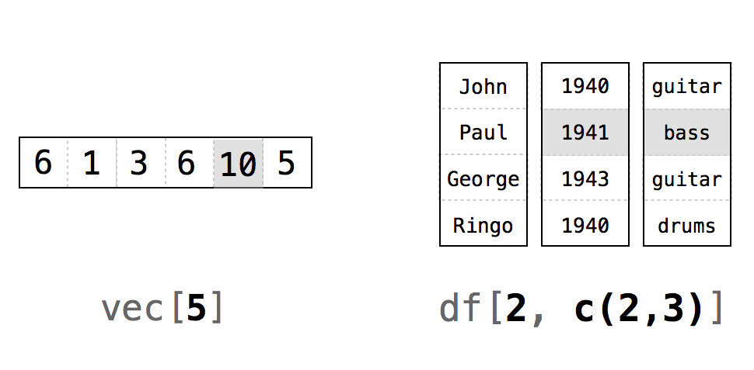

## EX 3 - understanding indices

What does each number refer to? What happens when we leave a blank cell?

## Reading data frames from files using menus

We can use the menu in Rstudio: File > Import dataset. You can do this to import Excel, SPSS, SAS and STATA files.

## Reading data frames from files using code

However, rather than use the menu, it’s much better to use actual code, as this will automate the process. Let’s import a dataset on World Happiness Report (2017), by country. The files are <WHR_2019.xlsx>, and <WHR_2019.csv>. Alternatively you can actually download the data set straight from the URL (below)

library(tidyverse)  
  
df <- readxl::read\_excel("WHR\_2019.xlsx") # Read an excel file  
  
df <- read\_csv("WHR\_2019.csv") # Read from a .csv file  
  
# Or to download straight from the URL!!  
  
# df <- read\_csv("https://verbingnouns.github.io/AdventuresInR/docs/WHR\_2017.csv")  
  
# This code adds a region variable for each country. Don't worry about how the code works. We will come back go it later!!  
  
df.regions <- readxl::read\_excel("countries\_and\_regions.xlsx")  
  
df %>% merge(df.regions) -> df

Possibly the best data format to work in is the .csv data format (Comma-Separated Value). This is good because it is readable in Excel, small, simple, and not easily-corrupted.

To read .csv files we use the read.csv() function from base R, or read\_csv() from the tidyverse (I would go with the latter as it also shows you a list of the variable types)

# Subsetting a data set using (a) base R and (d) dplyr

## Subsetting with base R

We’re going to *subset* the WHR dataset (i.e. choose only those cases/observations which fulfil a specific criterion). To do this we’re going to use the which() function. When you apply which to a variable in a dataset, it will produce indices (indexes) of the rows which fulfil a certain criterio, e.g. which(df$var\_name == 2) will give you the indices of all rows where the value of the variable is 2.

## EX4: Subsetting the hard way!

Armed with this knowledge, your task is to subset the data frame so that it only contains information from African countries.

If you’re stuck have a look at the answer below.

df.Africa <- df[which(df$region == "Africa"), ]

## Piping

Okay, the above code is pretty horrible to look at, so we’re going to explore an alternative using the package dplyr which is from the tidyverse. But before we can use dplyr we have to learn how to ‘pipe’.



Pipes are written in R as %>% (note you must use a percentage sign before and after the pipe). To demonstrate what pipes do, I have a look at the following pseudocode.

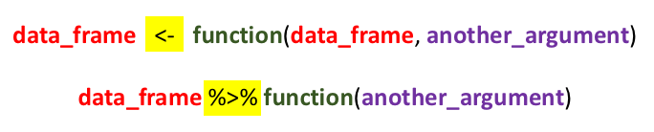

All pipes do is enable us to ‘pass’ a data frame (or another object) to a new function without having to keep on specifying the data frame. In addition, we can *chain* pipes together indefinitely.

Here’s how we would subset the data frame using piping:

df.Africa <- filter(df, region == "Africa") # This is the version without piping  
  
df %>% filter(region == "Africa") -> df.Africa # This is the version with piping. It looks longer, but we can chain multiple functions together!

Note that to create a new data frame, we need a solid arrow at the end. If we don’t include that solid arrow, the results are shown in the console, but no new data frame is created. This is an incredibly useful feature of pipes. You can try before you buy!

And here is an example where we *chain* a series of pipes together:

df.new <- read\_csv("WHR\_2019.csv")

##   
## ── Column specification ────────────────────────────────────────────────────────  
## cols(  
## rank = col\_double(),  
## country = col\_character(),  
## happiness\_score = col\_double(),  
## gdp\_per\_capita = col\_double(),  
## social\_support = col\_double(),  
## healthy\_life\_expectancy = col\_double(),  
## freedom = col\_double(),  
## generosity = col\_double(),  
## perceptions\_of\_corruption = col\_double()  
## )

df.new %>%   
 merge(df.regions) %>%   
 group\_by(region) %>%  
 summarise(mean.happiness = mean(happiness\_score)) ->  
 df.mean.happiness.by.region

NB When piping the code becomes more readable when the line ends with the pipe.

There are a couple of important points to note.

1. We can refer to variables without specifying the data frame
2. If we wish to store the results we must output them using and arrow ->. If we don’t store the results they will merely be displayed in the console.

Piping is a key technique in R and once you’ve learnt it you will write much more powerful and readable code.

As well as using pipes to create data frame, you can also insert pipes into both analyses and figures! Here are some examples

# An ANOVA without a pipe. NB we are using the base function "aov". If you would like to conduct SPSS-style ANOVAs, the best package is called "afex".  
  
  
  
mod <- aov(rank ~ region, data = df)  
  
pacman::p\_load(broom) # To load the "tidy" function.  
  
tidy(mod)

## # A tibble: 2 × 6  
## term df sumsq meansq statistic p.value  
## <chr> <dbl> <dbl> <dbl> <dbl> <dbl>  
## 1 region 9 173153. 19239. 20.5 1.73e-21  
## 2 Residuals 137 128837. 940. NA NA

# Here we use a pipe inside the analysis  
mod <- aov(rank ~ region, # NB note we can break the line after a comma  
 data = df %>% filter(region == "Africa" | region == "South America"))  
  
tidy(mod)

## # A tibble: 2 × 6  
## term df sumsq meansq statistic p.value  
## <chr> <dbl> <dbl> <dbl> <dbl> <dbl>  
## 1 region 1 52918. 52918. 119. 2.25e-14  
## 2 Residuals 46 20388 443. NA NA

g <- ggplot(aes(x = gdp\_per\_capita, y = happiness\_score, colour = region), # NB note we can break the line after a comma  
 data = df %>% filter(region == "Africa" | region == "South America"))  
g <- g + geom\_point()  
g <- g + geom\_smooth(method = "lm")  
g

## `geom\_smooth()` using formula 'y ~ x'

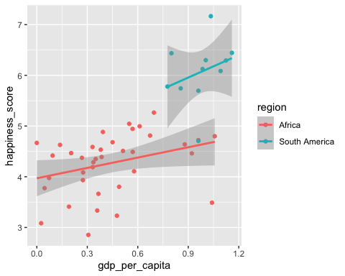

Note how I have broken some of the lines after a comma. This makes the code more readable. Generally we can break a line when it ends in some kind of symbol, e.g. a pipe, an arrow, or a comma.

# Loops and if-then statements

Loops and if-then statements are useful programming tools which have the same structure: FUNCTION (STATEMENT) {.....}.

## Loops



for(i in 1:10){  
 print(as.character(i))  
}

## [1] "1"  
## [1] "2"  
## [1] "3"  
## [1] "4"  
## [1] "5"  
## [1] "6"  
## [1] "7"  
## [1] "8"  
## [1] "9"  
## [1] "10"

To demonstrate a loop we’re going to look at the WHR data set. We’re going to ask the question ’for different regions of the world, what is the relationship between GDP per capita nd happiness?

Here’s how we would do it

# This code drops regions where number of observations are less than 3 (we can't do correlations if there are less than 3 observations)  
  
df %>%  
 group\_by(region) %>%  
 summarise(num = n()) %>%  
 filter(num > 3) ->  
 df.region  
  
# Here is the code with the loop  
  
for (i in 1:length(df.region$region)){ # We loop through the list  
 df %>% filter(region == df.region$region[i]) -> temp.df # we subset the data according to the region. This contains a temporary dataset "temp.df"  
 model <- cor.test(temp.df$gdp\_per\_capita, temp.df$happiness\_score) # We do the analysis  
 print(paste("Region: ", df.region$region[i])) # We print the results  
 print(model)  
}

## [1] "Region: Africa"  
##   
## Pearson's product-moment correlation  
##   
## data: temp.df$gdp\_per\_capita and temp.df$happiness\_score  
## t = 2.0109, df = 35, p-value = 0.05208  
## alternative hypothesis: true correlation is not equal to 0  
## 95 percent confidence interval:  
## -0.002446336 0.584858677  
## sample estimates:  
## cor   
## 0.3218278   
##   
## [1] "Region: Central America"  
##   
## Pearson's product-moment correlation  
##   
## data: temp.df$gdp\_per\_capita and temp.df$happiness\_score  
## t = 3.0683, df = 8, p-value = 0.01539  
## alternative hypothesis: true correlation is not equal to 0  
## 95 percent confidence interval:  
## 0.1967029 0.9329775  
## sample estimates:  
## cor   
## 0.7352669   
##   
## [1] "Region: Central Asia"  
##   
## Pearson's product-moment correlation  
##   
## data: temp.df$gdp\_per\_capita and temp.df$happiness\_score  
## t = 2.5002, df = 12, p-value = 0.02791  
## alternative hypothesis: true correlation is not equal to 0  
## 95 percent confidence interval:  
## 0.07926072 0.85143038  
## sample estimates:  
## cor   
## 0.5852289   
##   
## [1] "Region: Europe"  
##   
## Pearson's product-moment correlation  
##   
## data: temp.df$gdp\_per\_capita and temp.df$happiness\_score  
## t = 8.5991, df = 38, p-value = 1.9e-10  
## alternative hypothesis: true correlation is not equal to 0  
## 95 percent confidence interval:  
## 0.6711488 0.8971197  
## sample estimates:  
## cor   
## 0.8127395   
##   
## [1] "Region: Middle East"  
##   
## Pearson's product-moment correlation  
##   
## data: temp.df$gdp\_per\_capita and temp.df$happiness\_score  
## t = 6.7362, df = 15, p-value = 6.68e-06  
## alternative hypothesis: true correlation is not equal to 0  
## 95 percent confidence interval:  
## 0.6622123 0.9512146  
## sample estimates:  
## cor   
## 0.8669246   
##   
## [1] "Region: South America"  
##   
## Pearson's product-moment correlation  
##   
## data: temp.df$gdp\_per\_capita and temp.df$happiness\_score  
## t = 0.95472, df = 9, p-value = 0.3647  
## alternative hypothesis: true correlation is not equal to 0  
## 95 percent confidence interval:  
## -0.3625785 0.7641243  
## sample estimates:  
## cor   
## 0.303255   
##   
## [1] "Region: South Asia"  
##   
## Pearson's product-moment correlation  
##   
## data: temp.df$gdp\_per\_capita and temp.df$happiness\_score  
## t = 0.45547, df = 4, p-value = 0.6724  
## alternative hypothesis: true correlation is not equal to 0  
## 95 percent confidence interval:  
## -0.7190973 0.8757883  
## sample estimates:  
## cor   
## 0.2220511   
##   
## [1] "Region: South East Asia"  
##   
## Pearson's product-moment correlation  
##   
## data: temp.df$gdp\_per\_capita and temp.df$happiness\_score  
## t = 3.7913, df = 7, p-value = 0.006791  
## alternative hypothesis: true correlation is not equal to 0  
## 95 percent confidence interval:  
## 0.3424415 0.9608725  
## sample estimates:  
## cor   
## 0.8200623

## EX5: Loops

The code below creates a sequence ranging from 0 to 30 going up in steps of 0.25. Try to achieve the same result using a loop

seq(0,30,2.5)

## [1] 0.0 2.5 5.0 7.5 10.0 12.5 15.0 17.5 20.0 22.5 25.0 27.5 30.0

## If-then statements

To demonstrate if-then statements, we are going to create a new variable which shows if the happiness index is above the mean

df$happiness\_above\_mean <- 0 # Set variable to 0  
mean\_happiness <- mean(df$happiness\_score) # Calculate mean mpg  
for (i in 1:nrow(df)){  
 if(df$happiness\_score[i] > mean\_happiness){df$happiness\_above\_mean[i] <- 1}  
}

Note loops and if-then statements are quite verbose, and there is almost always a neater and much shorter alternatives. However, I think they are useful procedures for the relative beginner.

Here is some code using dplyr, which does the same thing, but avoids the loop and the if-then statement.

df %>%  
 mutate(happiness\_above\_mean = as.numeric(happiness\_score > mean(happiness\_score)))

## country rank happiness\_score gdp\_per\_capita social\_support  
## 1 Afghanistan 154 3.203 0.350 0.517  
## 2 Albania 107 4.719 0.947 0.848  
## 3 Algeria 88 5.211 1.002 1.160  
## 4 Argentina 47 6.086 1.092 1.432  
## 5 Armenia 116 4.559 0.850 1.055  
## 6 Australia 11 7.228 1.372 1.548  
## 7 Austria 10 7.246 1.376 1.475  
## 8 Azerbaijan 90 5.208 1.043 1.147  
## 9 Bahrain 37 6.199 1.362 1.368  
## 10 Bangladesh 125 4.456 0.562 0.928  
## 11 Belarus 81 5.323 1.067 1.465  
## 12 Belgium 18 6.923 1.356 1.504  
## 13 Benin 102 4.883 0.393 0.437  
## 14 Bhutan 95 5.082 0.813 1.321  
## 15 Bolivia 61 5.779 0.776 1.209  
## 16 Bosnia and Herzegovina 78 5.386 0.945 1.212  
## 17 Botswana 148 3.488 1.041 1.145  
## 18 Brazil 32 6.300 1.004 1.439  
## 19 Bulgaria 97 5.011 1.092 1.513  
## 20 Burkina Faso 115 4.587 0.331 1.056  
## 21 Burundi 145 3.775 0.046 0.447  
## 22 Cambodia 109 4.700 0.574 1.122  
## 23 Cameroon 96 5.044 0.549 0.910  
## 24 Canada 9 7.278 1.365 1.505  
## 25 Central African Republic 155 3.083 0.026 0.000  
## 26 Chad 132 4.350 0.350 0.766  
## 27 Chile 26 6.444 1.159 1.369  
## 28 China 93 5.191 1.029 1.125  
## 29 Colombia 43 6.125 0.985 1.410  
## 30 Congo (Brazzaville) 103 4.812 0.673 0.799  
## 31 Congo (Kinshasa) 127 4.418 0.094 1.125  
## 32 Costa Rica 12 7.167 1.034 1.441  
## 33 Croatia 75 5.432 1.155 1.266  
## 34 Cyprus 49 6.046 1.263 1.223  
## 35 Czech Republic 20 6.852 1.269 1.487  
## 36 Denmark 2 7.600 1.383 1.573  
## 37 Dominican Republic 77 5.425 1.015 1.401  
## 38 Ecuador 50 6.028 0.912 1.312  
## 39 Egypt 137 4.166 0.913 1.039  
## 40 El Salvador 35 6.253 0.794 1.242  
## 41 Estonia 55 5.893 1.237 1.528  
## 42 Ethiopia 134 4.286 0.336 1.033  
## 43 Finland 1 7.769 1.340 1.587  
## 44 France 24 6.592 1.324 1.472  
## 45 Gabon 104 4.799 1.057 1.183  
## 46 Georgia 119 4.519 0.886 0.666  
## 47 Germany 17 6.985 1.373 1.454  
## 48 Ghana 98 4.996 0.611 0.868  
## 49 Greece 82 5.287 1.181 1.156  
## 50 Guatemala 27 6.436 0.800 1.269  
## 51 Guinea 118 4.534 0.380 0.829  
## 52 Haiti 147 3.597 0.323 0.688  
## 53 Honduras 59 5.860 0.642 1.236  
## 54 Hungary 62 5.758 1.201 1.410  
## 55 Iceland 4 7.494 1.380 1.624  
## 56 India 140 4.015 0.755 0.765  
## 57 Indonesia 92 5.192 0.931 1.203  
## 58 Iran 117 4.548 1.100 0.842  
## 59 Iraq 126 4.437 1.043 0.980  
## 60 Ireland 16 7.021 1.499 1.553  
## 61 Israel 13 7.139 1.276 1.455  
## 62 Italy 36 6.223 1.294 1.488  
## 63 Ivory Coast 99 4.944 0.569 0.808  
## 64 Jamaica 56 5.890 0.831 1.478  
## 65 Japan 58 5.886 1.327 1.419  
## 66 Jordan 101 4.906 0.837 1.225  
## 67 Kazakhstan 60 5.809 1.173 1.508  
## 68 Kenya 121 4.509 0.512 0.983  
## 69 Kosovo 46 6.100 0.882 1.232  
## 70 Kuwait 51 6.021 1.500 1.319  
## 71 Kyrgyzstan 86 5.261 0.551 1.438  
## 72 Latvia 53 5.940 1.187 1.465  
## 73 Lebanon 91 5.197 0.987 1.224  
## 74 Lesotho 144 3.802 0.489 1.169  
## 75 Liberia 141 3.975 0.073 0.922  
## 76 Libya 72 5.525 1.044 1.303  
## 77 Lithuania 42 6.149 1.238 1.515  
## 78 Luxembourg 14 7.090 1.609 1.479  
## 79 Madagascar 143 3.933 0.274 0.916  
## 80 Malawi 150 3.410 0.191 0.560  
## 81 Malaysia 80 5.339 1.221 1.171  
## 82 Mali 128 4.390 0.385 1.105  
## 83 Malta 22 6.726 1.300 1.520  
## 84 Mauritania 122 4.490 0.570 1.167  
## 85 Mauritius 57 5.888 1.120 1.402  
## 86 Mexico 23 6.595 1.070 1.323  
## 87 Moldova 71 5.529 0.685 1.328  
## 88 Mongolia 83 5.285 0.948 1.531  
## 89 Montenegro 73 5.523 1.051 1.361  
## 90 Morocco 89 5.208 0.801 0.782  
## 91 Mozambique 123 4.466 0.204 0.986  
## 92 Myanmar 131 4.360 0.710 1.181  
## 93 Namibia 113 4.639 0.879 1.313  
## 94 Nepal 100 4.913 0.446 1.226  
## 95 Netherlands 5 7.488 1.396 1.522  
## 96 New Zealand 8 7.307 1.303 1.557  
## 97 Nicaragua 45 6.105 0.694 1.325  
## 98 Niger 114 4.628 0.138 0.774  
## 99 Nigeria 85 5.265 0.696 1.111  
## 100 Norway 3 7.554 1.488 1.582  
## 101 Pakistan 67 5.653 0.677 0.886  
## 102 Palestinian Territories 110 4.696 0.657 1.247  
## 103 Panama 31 6.321 1.149 1.442  
## 104 Paraguay 63 5.743 0.855 1.475  
## 105 Peru 65 5.697 0.960 1.274  
## 106 Philippines 69 5.631 0.807 1.293  
## 107 Poland 40 6.182 1.206 1.438  
## 108 Portugal 66 5.693 1.221 1.431  
## 109 Qatar 29 6.374 1.684 1.313  
## 110 Romania 48 6.070 1.162 1.232  
## 111 Russia 68 5.648 1.183 1.452  
## 112 Rwanda 152 3.334 0.359 0.711  
## 113 Saudi Arabia 28 6.375 1.403 1.357  
## 114 Senegal 111 4.681 0.450 1.134  
## 115 Serbia 70 5.603 1.004 1.383  
## 116 Sierra Leone 129 4.374 0.268 0.841  
## 117 Singapore 34 6.262 1.572 1.463  
## 118 Slovakia 38 6.198 1.246 1.504  
## 119 Slovenia 44 6.118 1.258 1.523  
## 120 Somalia 112 4.668 0.000 0.698  
## 121 South Africa 106 4.722 0.960 1.351  
## 122 South Korea 54 5.895 1.301 1.219  
## 123 South Sudan 156 2.853 0.306 0.575  
## 124 Spain 30 6.354 1.286 1.484  
## 125 Sri Lanka 130 4.366 0.949 1.265  
## 126 Sweden 7 7.343 1.387 1.487  
## 127 Switzerland 6 7.480 1.452 1.526  
## 128 Syria 149 3.462 0.619 0.378  
## 129 Tajikistan 74 5.467 0.493 1.098  
## 130 Tanzania 153 3.231 0.476 0.885  
## 131 Thailand 52 6.008 1.050 1.409  
## 132 Togo 139 4.085 0.275 0.572  
## 133 Tunisia 124 4.461 0.921 1.000  
## 134 Turkey 79 5.373 1.183 1.360  
## 135 Turkmenistan 87 5.247 1.052 1.538  
## 136 Uganda 136 4.189 0.332 1.069  
## 137 Ukraine 133 4.332 0.820 1.390  
## 138 United Arab Emirates 21 6.825 1.503 1.310  
## 139 United Kingdom 15 7.054 1.333 1.538  
## 140 United States 19 6.892 1.433 1.457  
## 141 Uruguay 33 6.293 1.124 1.465  
## 142 Uzbekistan 41 6.174 0.745 1.529  
## 143 Venezuela 108 4.707 0.960 1.427  
## 144 Vietnam 94 5.175 0.741 1.346  
## 145 Yemen 151 3.380 0.287 1.163  
## 146 Zambia 138 4.107 0.578 1.058  
## 147 Zimbabwe 146 3.663 0.366 1.114  
## healthy\_life\_expectancy freedom generosity perceptions\_of\_corruption  
## 1 0.361 0.000 0.158 0.025  
## 2 0.874 0.383 0.178 0.027  
## 3 0.785 0.086 0.073 0.114  
## 4 0.881 0.471 0.066 0.050  
## 5 0.815 0.283 0.095 0.064  
## 6 1.036 0.557 0.332 0.290  
## 7 1.016 0.532 0.244 0.226  
## 8 0.769 0.351 0.035 0.182  
## 9 0.871 0.536 0.255 0.110  
## 10 0.723 0.527 0.166 0.143  
## 11 0.789 0.235 0.094 0.142  
## 12 0.986 0.473 0.160 0.210  
## 13 0.397 0.349 0.175 0.082  
## 14 0.604 0.457 0.370 0.167  
## 15 0.706 0.511 0.137 0.064  
## 16 0.845 0.212 0.263 0.006  
## 17 0.538 0.455 0.025 0.100  
## 18 0.802 0.390 0.099 0.086  
## 19 0.815 0.311 0.081 0.004  
## 20 0.380 0.255 0.177 0.113  
## 21 0.380 0.220 0.176 0.180  
## 22 0.637 0.609 0.232 0.062  
## 23 0.331 0.381 0.187 0.037  
## 24 1.039 0.584 0.285 0.308  
## 25 0.105 0.225 0.235 0.035  
## 26 0.192 0.174 0.198 0.078  
## 27 0.920 0.357 0.187 0.056  
## 28 0.893 0.521 0.058 0.100  
## 29 0.841 0.470 0.099 0.034  
## 30 0.508 0.372 0.105 0.093  
## 31 0.357 0.269 0.212 0.053  
## 32 0.963 0.558 0.144 0.093  
## 33 0.914 0.296 0.119 0.022  
## 34 1.042 0.406 0.190 0.041  
## 35 0.920 0.457 0.046 0.036  
## 36 0.996 0.592 0.252 0.410  
## 37 0.779 0.497 0.113 0.101  
## 38 0.868 0.498 0.126 0.087  
## 39 0.644 0.241 0.076 0.067  
## 40 0.789 0.430 0.093 0.074  
## 41 0.874 0.495 0.103 0.161  
## 42 0.532 0.344 0.209 0.100  
## 43 0.986 0.596 0.153 0.393  
## 44 1.045 0.436 0.111 0.183  
## 45 0.571 0.295 0.043 0.055  
## 46 0.752 0.346 0.043 0.164  
## 47 0.987 0.495 0.261 0.265  
## 48 0.486 0.381 0.245 0.040  
## 49 0.999 0.067 0.000 0.034  
## 50 0.746 0.535 0.175 0.078  
## 51 0.375 0.332 0.207 0.086  
## 52 0.449 0.026 0.419 0.110  
## 53 0.828 0.507 0.246 0.078  
## 54 0.828 0.199 0.081 0.020  
## 55 1.026 0.591 0.354 0.118  
## 56 0.588 0.498 0.200 0.085  
## 57 0.660 0.491 0.498 0.028  
## 58 0.785 0.305 0.270 0.125  
## 59 0.574 0.241 0.148 0.089  
## 60 0.999 0.516 0.298 0.310  
## 61 1.029 0.371 0.261 0.082  
## 62 1.039 0.231 0.158 0.030  
## 63 0.232 0.352 0.154 0.090  
## 64 0.831 0.490 0.107 0.028  
## 65 1.088 0.445 0.069 0.140  
## 66 0.815 0.383 0.110 0.130  
## 67 0.729 0.410 0.146 0.096  
## 68 0.581 0.431 0.372 0.053  
## 69 0.758 0.489 0.262 0.006  
## 70 0.808 0.493 0.142 0.097  
## 71 0.723 0.508 0.300 0.023  
## 72 0.812 0.264 0.075 0.064  
## 73 0.815 0.216 0.166 0.027  
## 74 0.168 0.359 0.107 0.093  
## 75 0.443 0.370 0.233 0.033  
## 76 0.673 0.416 0.133 0.152  
## 77 0.818 0.291 0.043 0.042  
## 78 1.012 0.526 0.194 0.316  
## 79 0.555 0.148 0.169 0.041  
## 80 0.495 0.443 0.218 0.089  
## 81 0.828 0.508 0.260 0.024  
## 82 0.308 0.327 0.153 0.052  
## 83 0.999 0.564 0.375 0.151  
## 84 0.489 0.066 0.106 0.088  
## 85 0.798 0.498 0.215 0.060  
## 86 0.861 0.433 0.074 0.073  
## 87 0.739 0.245 0.181 0.000  
## 88 0.667 0.317 0.235 0.038  
## 89 0.871 0.197 0.142 0.080  
## 90 0.782 0.418 0.036 0.076  
## 91 0.390 0.494 0.197 0.138  
## 92 0.555 0.525 0.566 0.172  
## 93 0.477 0.401 0.070 0.056  
## 94 0.677 0.439 0.285 0.089  
## 95 0.999 0.557 0.322 0.298  
## 96 1.026 0.585 0.330 0.380  
## 97 0.835 0.435 0.200 0.127  
## 98 0.366 0.318 0.188 0.102  
## 99 0.245 0.426 0.215 0.041  
## 100 1.028 0.603 0.271 0.341  
## 101 0.535 0.313 0.220 0.098  
## 102 0.672 0.225 0.103 0.066  
## 103 0.910 0.516 0.109 0.054  
## 104 0.777 0.514 0.184 0.080  
## 105 0.854 0.455 0.083 0.027  
## 106 0.657 0.558 0.117 0.107  
## 107 0.884 0.483 0.117 0.050  
## 108 0.999 0.508 0.047 0.025  
## 109 0.871 0.555 0.220 0.167  
## 110 0.825 0.462 0.083 0.005  
## 111 0.726 0.334 0.082 0.031  
## 112 0.614 0.555 0.217 0.411  
## 113 0.795 0.439 0.080 0.132  
## 114 0.571 0.292 0.153 0.072  
## 115 0.854 0.282 0.137 0.039  
## 116 0.242 0.309 0.252 0.045  
## 117 1.141 0.556 0.271 0.453  
## 118 0.881 0.334 0.121 0.014  
## 119 0.953 0.564 0.144 0.057  
## 120 0.268 0.559 0.243 0.270  
## 121 0.469 0.389 0.130 0.055  
## 122 1.036 0.159 0.175 0.056  
## 123 0.295 0.010 0.202 0.091  
## 124 1.062 0.362 0.153 0.079  
## 125 0.831 0.470 0.244 0.047  
## 126 1.009 0.574 0.267 0.373  
## 127 1.052 0.572 0.263 0.343  
## 128 0.440 0.013 0.331 0.141  
## 129 0.718 0.389 0.230 0.144  
## 130 0.499 0.417 0.276 0.147  
## 131 0.828 0.557 0.359 0.028  
## 132 0.410 0.293 0.177 0.085  
## 133 0.815 0.167 0.059 0.055  
## 134 0.808 0.195 0.083 0.106  
## 135 0.657 0.394 0.244 0.028  
## 136 0.443 0.356 0.252 0.060  
## 137 0.739 0.178 0.187 0.010  
## 138 0.825 0.598 0.262 0.182  
## 139 0.996 0.450 0.348 0.278  
## 140 0.874 0.454 0.280 0.128  
## 141 0.891 0.523 0.127 0.150  
## 142 0.756 0.631 0.322 0.240  
## 143 0.805 0.154 0.064 0.047  
## 144 0.851 0.543 0.147 0.073  
## 145 0.463 0.143 0.108 0.077  
## 146 0.426 0.431 0.247 0.087  
## 147 0.433 0.361 0.151 0.089  
## region happiness\_above\_mean  
## 1 Central Asia 0  
## 2 Europe 0  
## 3 Middle East 0  
## 4 South America 1  
## 5 Central Asia 0  
## 6 Australasia 1  
## 7 Europe 1  
## 8 Central Asia 0  
## 9 Middle East 1  
## 10 Central Asia 0  
## 11 Europe 0  
## 12 Europe 1  
## 13 Africa 0  
## 14 South Asia 0  
## 15 South America 1  
## 16 Europe 0  
## 17 Africa 0  
## 18 South America 1  
## 19 Europe 0  
## 20 Africa 0  
## 21 Africa 0  
## 22 South East Asia 0  
## 23 Africa 0  
## 24 Europe 1  
## 25 Africa 0  
## 26 Africa 0  
## 27 South America 1  
## 28 Central Asia 0  
## 29 South America 1  
## 30 Africa 0  
## 31 Africa 0  
## 32 South America 1  
## 33 Europe 1  
## 34 Europe 1  
## 35 Europe 1  
## 36 Europe 1  
## 37 Central America 1  
## 38 Central America 1  
## 39 Middle East 0  
## 40 Central America 1  
## 41 Europe 1  
## 42 Africa 0  
## 43 Europe 1  
## 44 Europe 1  
## 45 Africa 0  
## 46 Central Asia 0  
## 47 Europe 1  
## 48 Africa 0  
## 49 Europe 0  
## 50 South America 1  
## 51 Africa 0  
## 52 Central America 0  
## 53 Central America 1  
## 54 Europe 1  
## 55 Europe 1  
## 56 South Asia 0  
## 57 South East Asia 0  
## 58 Central Asia 0  
## 59 Middle East 0  
## 60 Europe 1  
## 61 Middle East 1  
## 62 Europe 1  
## 63 Africa 0  
## 64 Central America 1  
## 65 South East Asia 1  
## 66 Middle East 0  
## 67 Central Asia 1  
## 68 Africa 0  
## 69 Europe 1  
## 70 Middle East 1  
## 71 Central Asia 0  
## 72 Europe 1  
## 73 Middle East 0  
## 74 Africa 0  
## 75 Africa 0  
## 76 Middle East 1  
## 77 Europe 1  
## 78 Europe 1  
## 79 Africa 0  
## 80 Africa 0  
## 81 South East Asia 0  
## 82 Africa 0  
## 83 Europe 1  
## 84 Africa 0  
## 85 South Asia 1  
## 86 Central America 1  
## 87 Europe 1  
## 88 Central Asia 0  
## 89 Europe 1  
## 90 Middle East 0  
## 91 Africa 0  
## 92 Central Asia 0  
## 93 Africa 0  
## 94 South Asia 0  
## 95 Europe 1  
## 96 Australasia 1  
## 97 Central America 1  
## 98 Africa 0  
## 99 Africa 0  
## 100 Europe 1  
## 101 South Asia 1  
## 102 Middle East 0  
## 103 Central America 1  
## 104 South America 1  
## 105 South America 1  
## 106 South East Asia 1  
## 107 Europe 1  
## 108 Europe 1  
## 109 Middle East 1  
## 110 Europe 1  
## 111 Central Asia 1  
## 112 Africa 0  
## 113 Middle East 1  
## 114 Africa 0  
## 115 Europe 1  
## 116 Africa 0  
## 117 South East Asia 1  
## 118 Europe 1  
## 119 Europe 1  
## 120 Africa 0  
## 121 Africa 0  
## 122 South East Asia 1  
## 123 Africa 0  
## 124 Europe 1  
## 125 South Asia 0  
## 126 Europe 1  
## 127 Europe 1  
## 128 Middle East 0  
## 129 Central America 1  
## 130 Africa 0  
## 131 South East Asia 1  
## 132 Africa 0  
## 133 Africa 0  
## 134 Middle East 0  
## 135 Central Asia 0  
## 136 Africa 0  
## 137 Europe 0  
## 138 Middle East 1  
## 139 Europe 1  
## 140 North America 1  
## 141 South America 1  
## 142 Central Asia 1  
## 143 South America 0  
## 144 South East Asia 0  
## 145 Middle East 0  
## 146 Africa 0  
## 147 Africa 0

So how does this work? The statement in brackets evaluates to TRUE / FALSE. We then turn this into a number using as.numeric. TRUE evaluates to 1, while FALSE evaluates to 0.

It can be quite useful to combine logical statements. For example, if we wish to identify countries where both the happiness score and life expectancy are above the mean, we could do this….

df$happiness\_and\_LE\_above\_mean <- as.numeric(  
 (df$happiness\_score > mean(df$happiness\_score)) &  
 (df$healthy\_life\_expectancy > mean(df$healthy\_life\_expectancy))  
 )

## EX6: Creating variables

Try to identify countries where both the GDP per capita and trust in the government are above the mean.

# Stored results

Whenever you run an analysis in R and save that to an object, the object has an internal structure. To demonstrate this, let’s do a simple regression using the mtcars dataset:

Let’s draw a plot looking at the relationship between GDP per capita and Happiness Score. We’re not going to focus on the code, which will be covered in the next session.

g <- ggplot(aes(x = df$gdp\_per\_capita, y = df$happiness\_score), data = df)  
g <- g + geom\_point()  
g <- g + geom\_smooth()  
g

## Warning: Use of `df$gdp\_per\_capita` is discouraged. Use `gdp\_per\_capita`  
## instead.

## Warning: Use of `df$happiness\_score` is discouraged. Use `happiness\_score`  
## instead.

## Warning: Use of `df$gdp\_per\_capita` is discouraged. Use `gdp\_per\_capita`  
## instead.

## Warning: Use of `df$happiness\_score` is discouraged. Use `happiness\_score`  
## instead.

## `geom\_smooth()` using method = 'loess' and formula 'y ~ x'

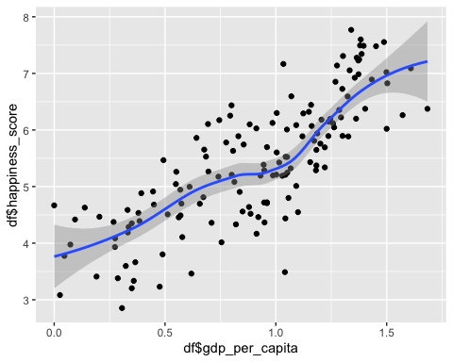

Now let’s run a regression

mod <- lm(happiness\_score ~ gdp\_per\_capita, data = df) # mod = "model"  
  
library(broom) # Broom is a package which produces neat tables of results  
  
tidy(mod) # This is a broom function which tidies up the statistical results for reporting

## # A tibble: 2 × 5  
## term estimate std.error statistic p.value  
## <chr> <dbl> <dbl> <dbl> <dbl>  
## 1 (Intercept) 3.38 0.141 24.1 1.72e-52  
## 2 gdp\_per\_capita 2.26 0.143 15.8 2.04e-33

Now, let’s have a look at the structure of this model. There are two ways to do this:

1. Use the str function, e.g. str(mod)

str(mod)

## List of 12  
## $ coefficients : Named num [1:2] 3.38 2.26  
## ..- attr(\*, "names")= chr [1:2] "(Intercept)" "gdp\_per\_capita"  
## $ residuals : Named num [1:147] -0.97 -0.801 -0.434 0.238 -0.742 ...  
## ..- attr(\*, "names")= chr [1:147] "1" "2" "3" "4" ...  
## $ effects : Named num [1:147] -65.731 -10.842 -0.339 0.347 -0.67 ...  
## ..- attr(\*, "names")= chr [1:147] "(Intercept)" "gdp\_per\_capita" "" "" ...  
## $ rank : int 2  
## $ fitted.values: Named num [1:147] 4.17 5.52 5.64 5.85 5.3 ...  
## ..- attr(\*, "names")= chr [1:147] "1" "2" "3" "4" ...  
## $ assign : int [1:2] 0 1  
## $ qr :List of 5  
## ..$ qr : num [1:147, 1:2] -12.1244 0.0825 0.0825 0.0825 0.0825 ...  
## .. ..- attr(\*, "dimnames")=List of 2  
## .. .. ..$ : chr [1:147] "1" "2" "3" "4" ...  
## .. .. ..$ : chr [1:2] "(Intercept)" "gdp\_per\_capita"  
## .. ..- attr(\*, "assign")= int [1:2] 0 1  
## ..$ qraux: num [1:2] 1.08 1.02  
## ..$ pivot: int [1:2] 1 2  
## ..$ tol : num 1e-07  
## ..$ rank : int 2  
## ..- attr(\*, "class")= chr "qr"  
## $ df.residual : int 145  
## $ xlevels : Named list()  
## $ call : language lm(formula = happiness\_score ~ gdp\_per\_capita, data = df)  
## $ terms :Classes 'terms', 'formula' language happiness\_score ~ gdp\_per\_capita  
## .. ..- attr(\*, "variables")= language list(happiness\_score, gdp\_per\_capita)  
## .. ..- attr(\*, "factors")= int [1:2, 1] 0 1  
## .. .. ..- attr(\*, "dimnames")=List of 2  
## .. .. .. ..$ : chr [1:2] "happiness\_score" "gdp\_per\_capita"  
## .. .. .. ..$ : chr "gdp\_per\_capita"  
## .. ..- attr(\*, "term.labels")= chr "gdp\_per\_capita"  
## .. ..- attr(\*, "order")= int 1  
## .. ..- attr(\*, "intercept")= int 1  
## .. ..- attr(\*, "response")= int 1  
## .. ..- attr(\*, ".Environment")=<environment: R\_GlobalEnv>   
## .. ..- attr(\*, "predvars")= language list(happiness\_score, gdp\_per\_capita)  
## .. ..- attr(\*, "dataClasses")= Named chr [1:2] "numeric" "numeric"  
## .. .. ..- attr(\*, "names")= chr [1:2] "happiness\_score" "gdp\_per\_capita"  
## $ model :'data.frame': 147 obs. of 2 variables:  
## ..$ happiness\_score: num [1:147] 3.2 4.72 5.21 6.09 4.56 ...  
## ..$ gdp\_per\_capita : num [1:147] 0.35 0.947 1.002 1.092 0.85 ...  
## ..- attr(\*, "terms")=Classes 'terms', 'formula' language happiness\_score ~ gdp\_per\_capita  
## .. .. ..- attr(\*, "variables")= language list(happiness\_score, gdp\_per\_capita)  
## .. .. ..- attr(\*, "factors")= int [1:2, 1] 0 1  
## .. .. .. ..- attr(\*, "dimnames")=List of 2  
## .. .. .. .. ..$ : chr [1:2] "happiness\_score" "gdp\_per\_capita"  
## .. .. .. .. ..$ : chr "gdp\_per\_capita"  
## .. .. ..- attr(\*, "term.labels")= chr "gdp\_per\_capita"  
## .. .. ..- attr(\*, "order")= int 1  
## .. .. ..- attr(\*, "intercept")= int 1  
## .. .. ..- attr(\*, "response")= int 1  
## .. .. ..- attr(\*, ".Environment")=<environment: R\_GlobalEnv>   
## .. .. ..- attr(\*, "predvars")= language list(happiness\_score, gdp\_per\_capita)  
## .. .. ..- attr(\*, "dataClasses")= Named chr [1:2] "numeric" "numeric"  
## .. .. .. ..- attr(\*, "names")= chr [1:2] "happiness\_score" "gdp\_per\_capita"  
## - attr(\*, "class")= chr "lm"

1. Type mod$, and then use autocomplete.

We can see that the $ symbol has a dual function in R: firstly, to specify variables within dataframes, and secondly to specify subcomponents of an object.

It is useful to be able to refer to subcomponents of an object so that we can integrate into our report, e.g. the regression yielded a value of 0.6335398

## EX 6: Let’s put it all together!!!

1. Download the data for [life expectancy by country](WHO_life_expectancy.csv)
2. The data covers many years. Select the most recent year.
3. Merge the data with the “WHR” data (you will need to merge using the “country” variable)
4. Draw plots of (a) life expectancy against GDP per capita, (b) life expectancy against family values

Once you get stuck have a look at the first code chunk below. This contains the solution but with pesky errors added! See if you can sort out the errors.

whr <- read\_csv("WHR\_2019.csv")  
  
le <- read\_csv("WHO\_life\_expectancy.csv")  
  
whr %>% # NB we need to ensure that the "country" variable has exactly the same name in both datasets  
 rename(country = Country) ->  
 whr  
  
le %>%   
 filter(Year == 2015) %>%   
 merge(whr) %>%   
 df  
  
plot(df$`Life expectancy`, df$GDP)  
plot(df$`Life expectancy`, df$family)

The code in this chunk shows the solution!

whr <- read\_csv("WHR\_2019.csv")  
  
le <- read\_csv("WHO\_life\_expectancy.csv")  
  
whr %>%   
 rename(Country = country) ->  
 whr  
  
le %>%   
 filter(Year == 2015) %>%   
 merge(whr) ->  
 df  
  
plot(df$`Life expectancy`, df$GDP)

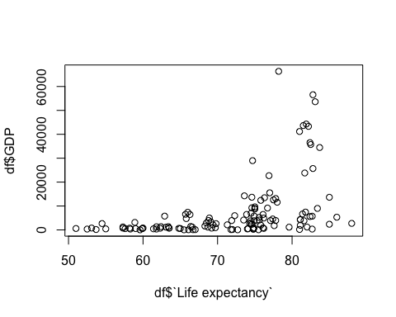

plot(df$`Life expectancy`, df$family)

