ECI 249: Probabilistic Design and Optimization Winter 2019

Homework #1

Due: 16 January

**Decision Theory Applications**

# 1. Hazardous Waste Disposal

a. Develop mathematical functions for the expected present value cost (or expected annualized cost) of each alternative. Draw a decision tree to illustrate the logic of your expected cost functions.

# Decision Tree

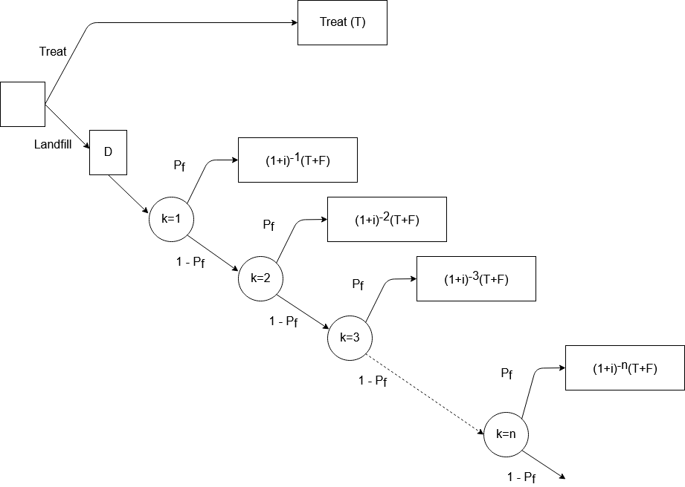

Though we included “LF” (which I assume is D, the cost of choosing to landfill) as an added cost alongside the present value cost of treatment and remediation in class, I broke it out separately in the decision tree because, though we can reasonably infer that, given enough time and Pf > 0, eventually all costs defined in a consequence node of the tree will be incurred, the cost of choosing to landfill will also be incurred *regardless* of that probability. In other words, should the landfill never fail, the cost will still be incurred. Because of this structure, I moved it as a consequence in front of the remaining decision nodes in that branch of the tree since the cost is incurred immediately.

# Equations

The expected present value cost of Treatment is simply the cost of treatment since all costs are incurred immediately.

CT = T

The cost of landfilling will vary based on quite a few factors, including the probability the landfill will fail. There is an initial cost, D, that must be paid at the time one chooses to landfill, but then if in any year (t) in the future, the landfill fails, a cost of (1+r)t-1(T+F) must be paid, reflecting the present value cost of treating (T) and remediating the failed landfill (F). This can be better expressed as a sum:

CLF = D +

This equation can then be converted to a continuously compounding present value calculation in the form

CLF = D +

Expressed instead as an integral, this equation takes the form:

CLF = D +

The integral portion (which we’ll call G) evaluates to the indefinite form as:

=

Taken from 0 to infinity, we’d evaluate indefinite form at t=infinity and subtract the result at t=0. At t=infinity, the result approaches 0 since when t=infinity approaches 0 faster than approaches infinity. Conceptually this makes sense, since the present value cost of *anything* an infinite time in the future would be assumed to be 0 today. That leaves us with the result at t=0, which can be simplified as:

=

This is also where my analytical solution falls apart – I do not believe this to be the actual equation – it might make more sense at t=1, where it simplifies to:

=

Even still, each of these results, when evaluated, fail to shift much as the probability of failure increases, even though, logically, the probability of failure should be a significant driver of costs. Further, my results using these equations failed to align with my results when building a sum in a spreadsheet. With all values set to their typical values, a manual summation over 200 timesteps resulted in G= 0.038462. 200 timesteps appeared to be more than sufficient, even with low probabilities and discount rates, and values of G for each timestep approach values that won’t affect the total.

b. Briefly discuss when each alternative is preferred. Provide graphics and tables which illustrate this choice.

First, I compiled graphs showing the expected lifetime cost as each individual parameter varied, with other parameters held to their typical values. This would help us understand how changes in each parameter might contribute to our overall result, even if the picture is incomplete for each chart. Then I built a graph using dimensionless parameters to be used for decision support.

**Dimensionless parameter graph**

This plot can be used for decision support. If one knows the inputs of Pf, r, F, and D, a choice between landfilling and treating is possible. The plot shows lines representing the function “G” for a few different values of Pf and r.

|  |  |
| --- | --- |
| Value | Reasoning |
| 0.5 | This value results from using the high value of Pf (1) and the low value of r (1) |
| 0.0909 | This value results from using the high value of Pf (1) and the high value of r (10). A similar value results from using a Pf of 0.1 and an r of 2. |
| 0.0039 | This value of G results from the typical values of Pf and r |
| 0.2 | This value results from Pf = 0.2 and r=2 |

Each line on the chart represents a different scenario combining the probability of dam failure in each year and the discount rate. For decisions support, one can calculate the value of T/D based on the values of F/D using the equation (or other algebraically equivalent equations):

If the resulting value for T/D is above the line with slope G drawn in that space, then it makes more financial sense to landfill. If the value is below the line, then treatment makes more sense. As we can see, with higher failure probabilities and lower discount rates, the space for choosing to treat grows. As the discount rate increases and failure probabilities decrease, then the space to landfill grows.

**2. Value of an imperfect test.**

For the example in class, in lecture 6, if a new treatment is 99% effective with only a 3% fatality from treatment, is the test now worthwhile? Develop a spreadsheet for this calculation.

In short, yes, the test is now worthwhile, but barely. First, the spreadsheet results

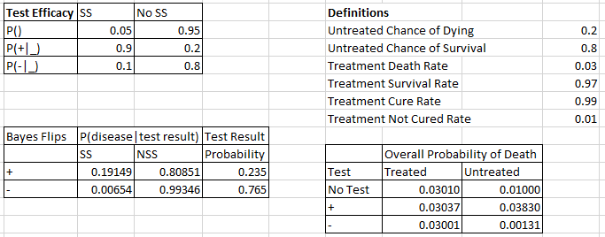

We can see that the test now gives some actionable information – without the test or with a negative test, your probability of death is higher if you choose to get treated versus choosing not to. Looking at it a different way though, the overall probability of death for anyone who chooses treatment is very similar, regardless of test result! Yet those who go untreated when the test is positive have the highest death rate. Given this information, were I in the unfortunate position of making the decision of whether or not to be treated, I’d get tested and then determine whether or not to be treated based on the results of my test. This path would give me the best likelihood of survival.