ECI 249: Probabilistic Design and Optimization Winter, 2019

**Homework No. 3: Probabilistic Evaluation - Monte Carlo Studies**

DUE: 11 February

# 1. Frat House Optimal Lifetime

Fraternity houses are always burning down. So how much effort should be put into the quality of their construction? Consider the alternatives, with a discount rate of 5%.

A. Build a fire-proof frat house. Cost = $1,000,000; annual probability of fire = 0.0

B. Build a fire-resistant house. Cost = $300,000; annual probability of fire = 0.05

C. Build a normal house. Cost = $150,000; annual probability of fire = 0.1

Assume there is no loss of life for any alternative.

What is the average time between house-burnings for the three alternatives?

Develop cost equations for each alternative.

What is the best alternative? Solve this problem using:

a) a reasonable deterministic method,

b) a probabilistic analytical solution (simplified if necessary), and

c) a Monte Carlo approach.

Some analytical solutions:

a. Deterministic estimate:

W = C + We-rT, or

W = , where T is the average return period for house burnings and W is the present value of all present and future costs.

b. Analytical solution:

W = C + e-rt, where pt = the probability that the house burns down for the first time at time t (that t is the return interval of the next house burning). Derive this, if it is right.

Deterministic Estimate

Using the equations for a deterministic estimate given above, we get the following values:

|  |  |  |  |  |
| --- | --- | --- | --- | --- |
|  | Up-front cost | Failure probability | Period of failure | W (Present cost of all present and future costs) |
| Normal | $150,000 | 0.1 | 10 | $381,224 |
| Fire-Resistant | $300,000 | 0.05 | 20 | $474,593 |
| Fire-Proof | $1,000,000 | 0 | ∞ | $1,000,000 |

These values assume that a given probability for fire corresponds with a fixed return interval (that is, an annual probability of fire of 0.1 results in a fire exactly every 10 years). Though flawed, they provide a decent starting estimate of expected costs for each method. Already we can see that, assuming no loss of life, the cost of a fire-proof house is likely not worth it. We may want more evidence that the differences between the normal house and the fire-resistant house aren’t due to the deterministic estimate though.

Analytical Estimate

Monte Carlo Estimate

This estimate comes from a Monte Carlo simulation, which ran 100,000 iterations over 150 years each. In each year, the simulation determines if a fire occurs (according to each structure’s annual probability of fire) for each house and attaches the present value cost of rebuilding that same house to the costs for that simulation. The 150 year time horizon was chosen because that appeared to be where the cost of rebuilding the $150,000 normal variant became approximately $1 dollar in present value, which should negligibly affect the result. The results shown here are summary statistics for each of the 100,000 scenarios. The fire-proof house was not simulated because its probability of burning is 0, so its cost is fixed at $1,000,000.

|  |  |  |  |
| --- | --- | --- | --- |
|  | Mean Lifetime Present Value Cost | Standard Deviation of Lifetime Cost across 100k iterations | Maximum PV cost in 100k iterations |
| Normal | $449,749 | $140,495 | $1,371,047 |
| Fire-Resistant | $600,671 | $204,341 | $1,874,865 |

Though these values differ from the deterministic estimate, they align with our analytical estimate, and each method still results in the same decision. The normal house results in a lower present value cost than the fire resistant house and has a smaller standard deviation, resulting in higher information content from the simulation. On this basis, one could feel comfortable choosing the normal house as the most cost effective option.

# 2. Selecting the least-cost number of filtration units in series.

The concentration of a contaminant in a water source is log-normally distributed on a weekly basis with a mean of 5 units/liter and a standard deviation of 3 units per liter.

The removal efficiency of a standard filter unit is also log-normally distributed with a mean of 0.9 and a standard deviation of 0.05. (Assume removals over 1.0 are equal to one.) A standard filter has a weekly cost of $100,000.

The probability of a disease outbreak increases linearly from zero at a finished water quality of 0.05 units/liter to 1 at 2 units/liter. The cost of a disease outbreak is $1,000,000.

1. What is the probability distribution for removal after each number of filters? Approximate this by both Monte Carlo and analytical methods.

# Analytical Method

# Monte Carlo Method

1. How many filter stages should be employed?

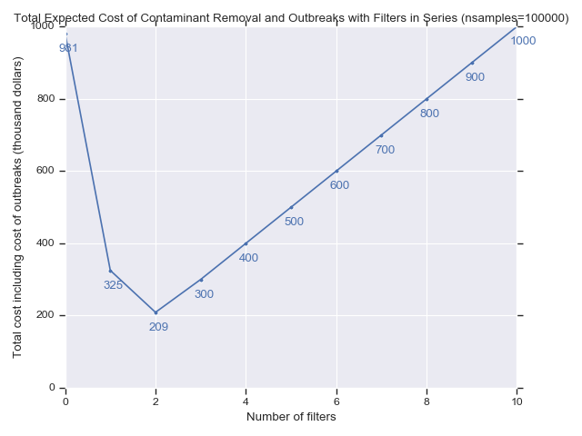

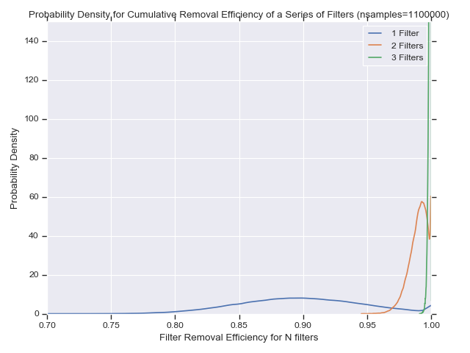

Figure 1: Probability density curves for filter removal efficiency for 1, 2, and 3 sequential filters

Note that, according to both plots, after 3 sequential filters, all contaminants are removed and thus, the only incurred costs are for the filters themselves. Still, it financially does not make sense to employ 3 filters since 2 filters will remove more than 95% of contaminants in almost every case, and reduce the risk of outbreak to where the average additional cost from outbreaks relative to employing the filters is only $9,000, on average, across all simulations. The standard deviation on the total cost of $209,000 is large though, at $95,884, with all additional variability coming from outbreaks, meaning there will be plenty of scenarios where the total cost of employing only two filters costs more than the cost of employing three filters. An organization that values certainty, or has nonfinancial values on public safety may oft for three filters, where the average cost was $300,010, reflecting almost no outbreaks, with a standard deviation of $3,162, indicating high information content and certainty with respect to costs. This characteristic can be seen in Figure 2, where the probability density curve for 3 filters is narrow and goes off the y axis.

# 3. Probabilistic peak flood flows.

From high water marks and estimates of channel cross-sections, the hydraulic slope, cross-sectional area, and hydraulic radius of a flood flow can be quickly estimated. Let these estimates be 0.01, 500 ft2, and 30 ft respectively. If the Manning's n is uniformly distributed between 0.060 and 0.080, what is the probability distribution of the peak flows?

This problem can be solved simply with a Monte Carlo using the following code:



Figure 2: Code for generating distribution of peak flows using Monte Carlo

This code produces the plot, showing the effective probability distribution of the peak flows for the input parameters. Lower peak flow values are naturally more common, with peak flows ranging from approximately 950 up to 1250.

