

**Tribhuvan University**

**Faculty of Management**

**Chitwan College of Technology**

**A PROJECT REPORT ON**Vehicle Rental Management System

Submitted to

**Department of Information Management**

**Chitwan college of Technology**

*In partial fulfillment of the requirement for the Bachelors in Information Management*

**Submitted By:**

TARA PAUDEL  
**TU Registration Number: 7-2-1133-29-2021**

2025

Under the Supervision of:

Rabin Shrestha

**TABLE OF CONTENT**

LIST OF FIGURES iii

Chapter 1: INTRODUCTION 1

1.1 Introduction 1

1.2 Problem Statement 1

1.3 Objectives 2

1.4 Scope and Limitations 2

1.4.1 Scopes 2

1.4.2 Limitations 2

1.5 Report Organization 2

Chapter 2: BACKGROUND STUDY AND LITERATURE 3

2.1 Background Study 3

2.2 Literature Review 3

Chapter 3: SYSTEM ANALYSIS AND DESIGN 4

3.1 System Analysis 4

3.1.1 Required Analysis 4

3.1.2 Feasibility Study 5

3.2 System Design 6

3.2.1 Architecture Design 6

3.2.2 Database Schema Design 7

3.2.3 Interface Design 7

REFERENCES 8

# LIST OF FIGURES

Figure 1: Use Case Diagram 7

Figure 2: Gantt Chart 9

# Chapter 1: INTRODUCTION

## 1.1 Introduction

This report documents the development of the **Vehicle Rental Service Management System**, a web-based application created as part of the Bachelor's in Information Management program. The system aims to provide a seamless, real-time platform for users to rent vehicles, manage reservations, and track vehicle availability. It allows administrators to efficiently manage the fleet, customer details, and rental transactions, ensuring an organized and streamlined process for vehicle rental.

By offering an intuitive interface, the system empowers users to make informed decisions on vehicle rentals based on availability, price, and location. Admins have the ability to manage vehicle listings, monitor bookings, and update rental terms, ensuring smooth operations. While the website does not facilitate direct payments, it serves as a reliable platform for vehicle rentals, offering users an overview of options available.

The **Vehicle Rental Service Management System** addresses a growing need for efficient vehicle rental management and streamlined user experience. This project contributes to improving customer satisfaction, operational efficiency, and overall transparency within the vehicle rental industry.

1.2 Problem Statement

* Consumers struggle to find accurate, real-time information on vehicle availability and rental prices.
* Lack of centralized tools for managing bookings and fleet leads to inefficient operations.
* Existing vehicle rental systems lack intuitive interfaces for users to easily browse and reserve vehicles.
* Admins face difficulties in tracking vehicles, customer reservations, and payment status in an organized manner.
* There is limited transparency in pricing and availability, which hinders customer trust.

1.3 Objectives

The primary objectives of this project are:

* To provide users with real-time vehicle availability and pricing information.
* To allow users to make bookings, view vehicle details, and manage their rental history.
* To empower admins with tools for managing the fleet, customer bookings, and rental terms.
* To ensure an intuitive, user-friendly interface for a seamless experience.
* To improve operational efficiency and transparency in vehicle rental service.

## 1.4 Scope and Limitations

### **1.4.1 Scopes**

* User Registration and Authentication.
* Real-time Vehicle Availability and Price Information.
* Booking and Reservation Management.
* Admin Dashboard for Fleet and Booking Management.
* User-Friendly Interface with Interactive Search Features.

1.4.2 Limitations

* Requires stable internet connectivity for real-time data updates.
* Non-Transactional Features (does not support online payments).
* Potential security risks in managing customer and vehicle data.
* Compatibility across devices may vary.
* Initial focus is limited to a specific region or city for fleet management.

1.5 Report Organization

The report begins with an introduction to the **Vehicle Rental Service Management System**, including its objectives and problem statement. The next chapter provides a review of related systems and technologies. The analysis chapter outlines the requirement gathering process and feasibility study. The design chapter includes diagrams such as flowcharts and ER diagrams to represent the system architecture. The implementation chapter details the development process, followed by testing and evaluation results. Finally, the conclusion discusses the system’s strengths, limitations, and potential enhancements. Appendices include supplementary details for a comprehensive understanding of the project.

# Chapter 2: BACKGROUND STUDY AND LITERATURE

2.1 Background Study

The **Vehicle Rental Service Management System** solves the problem of inefficient, time-consuming vehicle rental processes. Traditional methods of booking vehicles involve a lot of manual work, leading to potential errors, double bookings, and delays. This project offers a solution by automating the rental process, giving users real-time access to available vehicles and prices. With a user-friendly interface and admin controls, the system streamlines both the user and administrative experience.

2.2 Literature Review

Existing systems like “Turo” [1] and “Get around” [2] allow users to book vehicles but lack a centralized system for fleet management or easy accessibility for both customers and administrators. These systems can be complicated to navigate and may not offer the features necessary for efficient management of vehicle rental services. The **Vehicle Rental Service Management System** improves upon these by focusing on real-time availability, simple booking processes, and admin tools for managing vehicles, customers, and rental histories.

# Chapter 3: SYSTEM ANALYSIS AND DESIGN

3.1 System Analysis

For the **Vehicle Rental Service Management System**, the **Waterfall model** was chosen as the development approach. This step-by-step process ensures that every aspect of the project is thoroughly planned, designed, built, and tested before final deployment. The analysis phase identified the challenges faced by both users and administrators in managing vehicle availability, making bookings, and tracking rental details. The Waterfall model serves as a roadmap for structured development and delivery of the system.

### 3.1.1 Required Analysis

**Functional Requirements**:

* **User Registration:** Allow customers to create accounts for personalized experiences.
* **Login:** Secure authentication for accessing features.
* **Vehicle Search:** Enable users to search for vehicles based on location, type, and price.
* **Booking Management:** Enable users to reserve vehicles and manage their booking details.
* **Admin Dashboard:** Admins can add vehicles, manage fleet status, track bookings, and update rental prices.

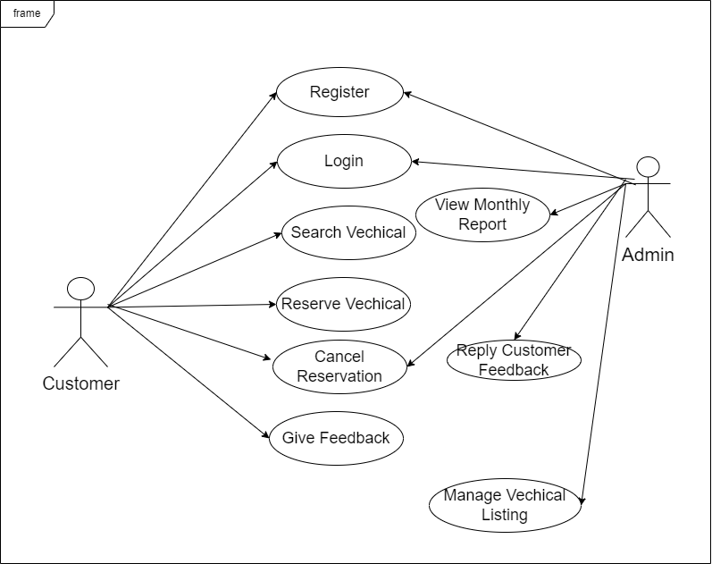

Figure 1: Use Case Diagram

**Non-Functional Requirements**

* **Accessibility:** Ensure compatibility across various devices and browsers.
* **Scalability:** The system must be able to handle increasing numbers of users and vehicles.
* **Security:** Data protection with encryption and secure authentication.
* **Performance:** Provide fast, responsive interactions.
* **Usability:** The interface should be intuitive and easy for users to navigate.

3.1.2 Feasibility Study

* **Technical Feasibility**:

The website leverages compatible technologies for front-end (e.g., HTML, CSS, Bootstrap) and back-end (Python Django). Integration with databases and APIs ensures technical reliability.

* **Operational Feasibility**:

The system meets the operational needs of vehicle rental services by providing features like real-time vehicle search and reservation management.

* **Economic Feasibility**:

The project is cost-effective, requiring minimal investments in hardware and software, with long-term benefits in market transparency and user satisfaction.

* **Schedule Feasibility**:

The project follows a clear development timeline, ensuring timely delivery of features like user registration, search functionalities, and booking management.

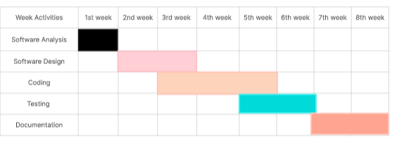

Figure 2: Gantt Chart

## ****3.2 System Design****

### ****3.2.1 Architecture Design****

The Vehicle Rental System follows a **Two-Tier Architecture**, consisting of the **front-end (user interface)** and **back-end components**:

* The **front-end** provides users with an intuitive interface to search for vehicles, view availability, book rentals, and manage their reservations.
* The **back-end** processes user requests, manages business logic, and communicates with the database to store and retrieve vehicle and rental information.

This project adopts the **Agile methodology**, focusing on iterative development, collaboration, and continuous feedback from stakeholders. The system progresses through the following stages:

* **Requirement Analysis**: In the initial sprints, detailed user stories are gathered, which define key requirements like vehicle listings, user authentication, booking management, and payment processing. Requirements are continually refined and prioritized based on feedback from stakeholders.
* **System Design**: During the iterative design phase, the system architecture and database schema are created and refined based on user feedback and technical needs. The design evolves with each sprint.
* **Implementation**: Development proceeds in short iterations (sprints), with front-end and back-end components built incrementally. Features are developed, tested, and deployed at the end of each sprint.
* **Testing**: Continuous testing occurs throughout each sprint, ensuring that functionality, usability, and performance meet the defined requirements. User feedback is gathered and integrated during each sprint review.
* **Deployment**: After successful testing in each sprint, parts of the system are deployed progressively, with the system continuously evolving based on user feedback and performance.

### ****3.2.2 Database Schema Design****

The database schema for the Vehicle Rental System is designed to support core functionalities like vehicle inventory, user management, booking details, and payment records. Key tables include:

* **Users**: Stores user details such as user ID, name, email, password, and role (admin or customer).
* **Vehicles**: Contains vehicle information, including vehicle ID, type, brand, model, availability status, rental price, and location.
* **Bookings**: Tracks rental transactions with booking ID, user ID, vehicle ID, booking date, start date, end date, and payment details.
* **Payments**: Logs payment information with payment ID, booking ID, amount, payment method, and status.

### ****3.2.3 Interface Design****

The interface design prioritizes a clean and user-friendly experience, ensuring seamless navigation for all stakeholders. Key components include:

* **Home Page**: Displays available vehicles, featured offers, and a quick search bar for browsing by location, type, or brand.
* **Search Page**: Enables users to search for vehicles by various filters, including location, category, rental price, and availability.
* **Booking Page**: Provides a detailed view of the selected vehicle, rental options, and an easy booking process.
* **User Dashboard**: Allows users to manage their bookings, payment history, and personal information.
* **Admin Dashboard**: Empowers administrators to manage vehicle inventory, monitor bookings, and handle customer queries.

# REFERENCES

|  |  |
| --- | --- |
| [1] | "Turo," 12 08 2009. [Online]. Available: https://turo.com/. [Accessed 25 12 2024]. |
| [2] | "getaround," 24 05 2011. [Online]. Available: https://getaround.com/. [Accessed 25 12 2024]. |