No .of Islands

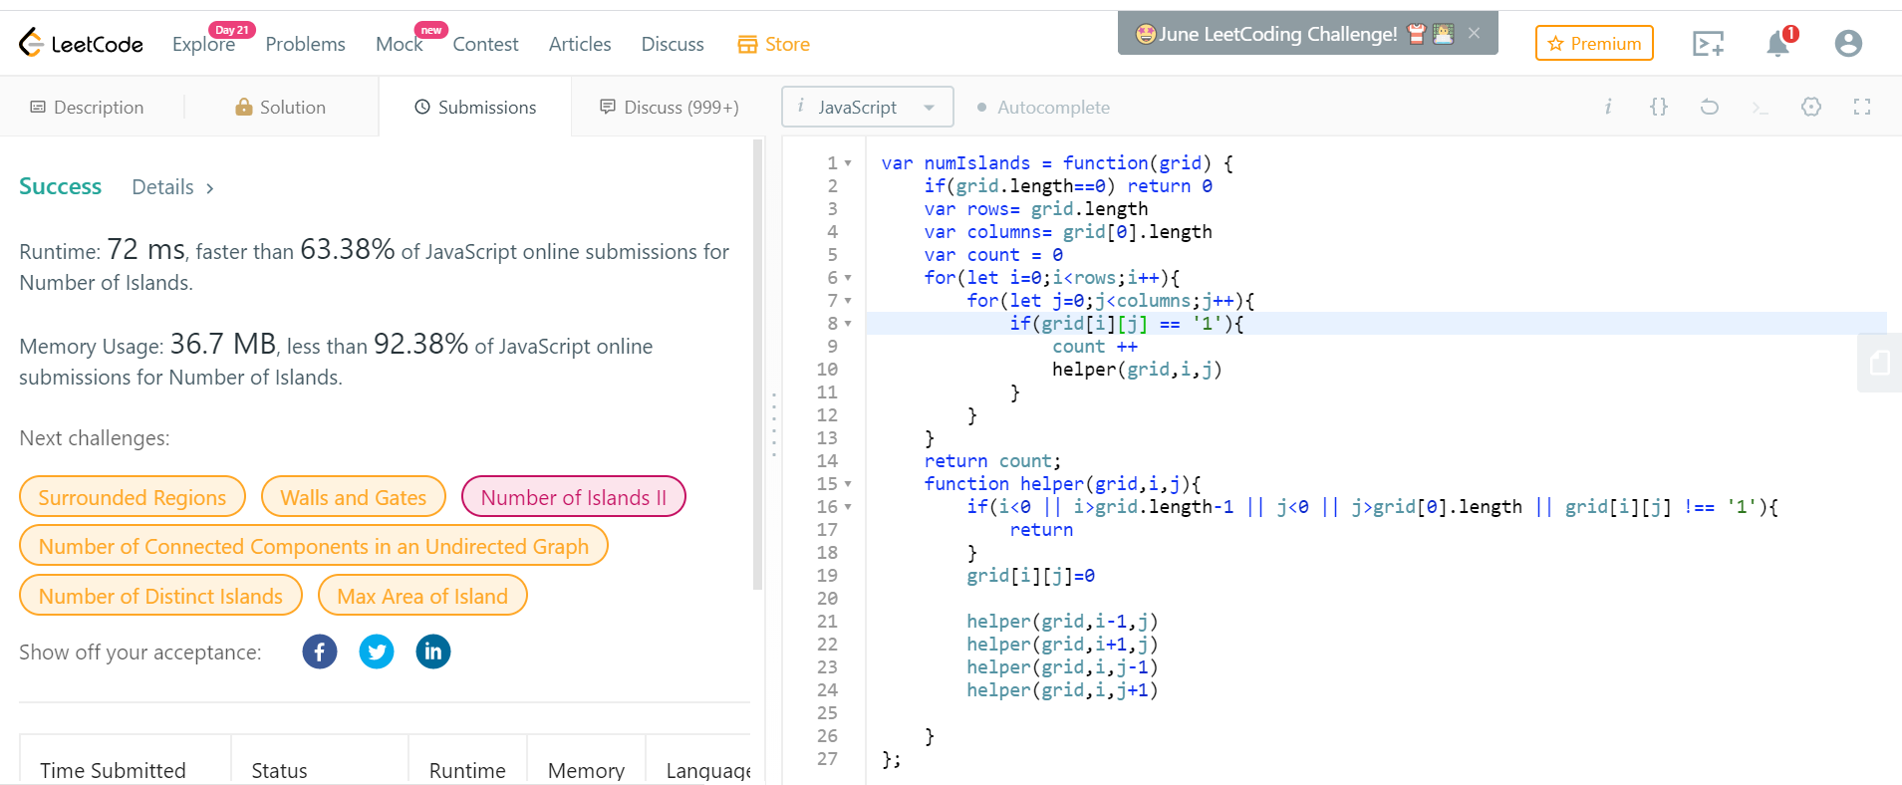

Time complexity = rows \* column \* time taken by each recursive call