1. **FIND-PIVOT-INDEX**

T 🡪 O(n)

S 🡪O(1)

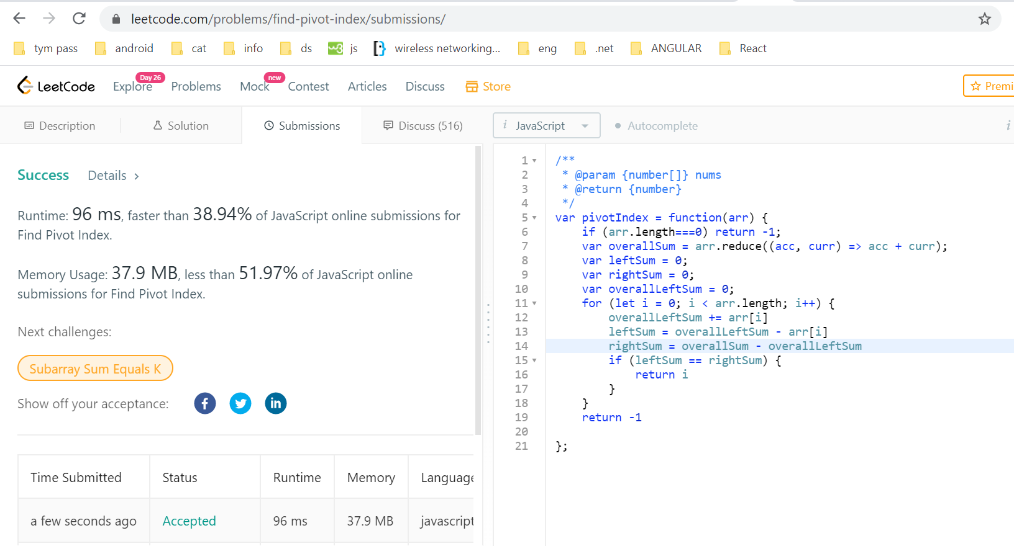

1. **MAXIMUM SUM SUBARRAY OF SIZE K, APPLYING SLIDING WINDOW PATTERN**

T 🡪 O(n)

S 🡪O(1)

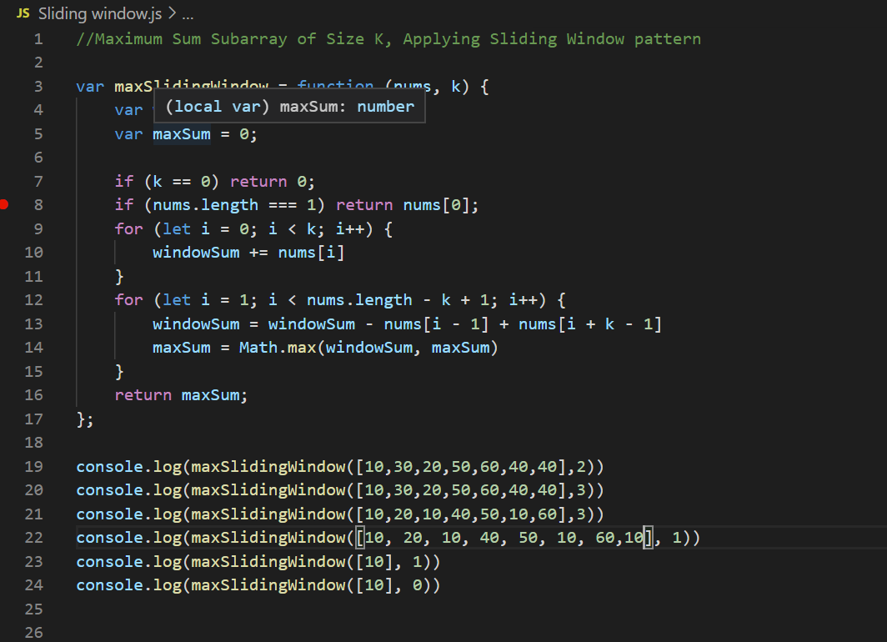

Ref: <https://dev.to/akhilpokle/maximum-sum-subarray-of-size-k-applying-sliding-window-pattern-59fa>