On the False Collision Errors of NGSIM Data
Nick Sangwa¹, Lu Sun² and Wusheng Hu^{3, *}
(National ASIC System Engineering Center, Southeast University, Nanjing, 210096)
Abstract: The Next Generation Simulation (NGSIM) project was started to gather vehicle trajectory data and the NGSIM dataset has become the existing standard, fundamentally a considerable part of empirically well-known progressions of the past decade. However, some researchers have discovered impractical associations within NGSIM datasets. Up to the present moment, the key findings have nearly entirely came from the current NGSIM database. Inopportunely, as this paper shows, NGSIM errors are outside whatever could be improved strictly through data interpolation of the described NGSIM datasets. This report takes a slight assessment of the errors in NGSIM data.
Keywords: NGSIM; Error; Dataset; Calibration; Model Development; and Algorithm

- Introduction
Macroscopic traffic data can be collected from devices like loop detectors, infrared sensors, radar, and cameras. Undependable measurements and instabilities influence the raw data from these devices. These raw data normally display together, noise (random errors) and bias (structural errors).
The Federal Highway Administration’s Next Generation Simulation (NGSIM), an open source dataset, which has been used in various earlier analyses, was chosen to mine motor vehicle trajectories and construct lane-changing forecast models. At intervals of a tenth-of-a-second, the dataset documented the position, velocity, acceleration, and headway statistics for every vehicle on U.S. 101 (United States Highway 101), I-80 (The Interstate 80 Freeway), and other sites. NGSIM, as a program, has created a large quantity of microscopic vehicle
Authors’ Introduction: Nick Sangwa, Southeast University, Male, Master’s student, E-mail: nicksangwa@outlook.com; Sun Lu, University of Maryland, Male, Professor, E-mail: workingworking123@163.com; Hu Wusheng, Southeast University, Male, Professor, E-mail: wusheng.hu@163.com.
trajectory data for the calibration and verification of lane-changing models. Knowledge of the errors inside of these datasets are essential. The impacts of data errors can seriously affect calibration results, which are the foundations for all models made from NGSIM datasets.
The presentation of models, in assessment studies or in short term predictions, entails high quality, processed data that delivers models with the mandatory inputs. In many circumstances, raw data produced by diverse types of devices cannot be used directly, and additional data processing is necessary. Contingent on the objective of the study, the probable influences of measurement errors on the results may be significant. Traffic microsimulation models are turning out to be extensively used and beneficial tools in modeling current and planned upcoming transportation networks and conditions. These models can aid transportation specialists in making key choices on such topics as innovative roadway arrangements and structures, novel interchange formations and locations, the addition of interstate auxiliary lanes, work zone management plans and tactics, operational and intelligent

transportation system (ITS) plans and tactics, organization and timing of traffic signals, and the adding of high-occupancy toll lanes. While several microsimulation models utilized today are strong and deliver an extensive range of analysis options, some holes and limitations still exist that can disturb the accurateness of their results. This is important due to NGSIM being used for the microsimulation modeling of congested conditions.
The significance of these errors and this topic includes the fact that multi-million dollar decisions are being made based on results of microsimulation models. Transportation resources are constricted, so the necessity for the most efficient solutions is current. Solutions are increasingly challenging and demanding. It is no longer just about choosing the number of lanes anymore. Entities are looking at innovative solutions: HOV/HOT lanes, ITS Solutions, Complex merges/weaves, and Complex signal timing. These solutions have influences on entire regions. Gaps in functionality require high quality algorithm development. Consumers not sure how valid these models are, or how the results are computed.
In the FHWA Traffic Analysis Process, the order is as follows: Scope Project, Data Collection, Base Model Development, Error Checking, Model Calibration, Alternatives Analysis, and Final Report. It is clear that their first aim is to improve the quality, trust, and use of simulation tools, and distribute algorithms and datasets freely on the NGSIM repository. Their second aim is to aid to attainment the full understanding of true-to-life driving behaviors. For this, a large number of driving and lane-changing trajectories are required for the learning procedure.
This research attempts to classify a specific NGSIM error from observed positions and continuous speeds marked by short-term times of great acceleration displayed by the NGSIM data that is not completely obvious in the recently mined trajectories. This fact is mainly worrying for applications that depend on acceleration, such as car following models. The amount of errors display a dependence on vehicle length, speed, and position. We will list out examples in this report using Alteryx Designer. In the past, examples have been seen where an actual driver halted but the NGSIM trajectory did not and then. There are also examples of lead and following vehicles overlapping positions in the same lane. This study takes up the ordeal of inspecting the inclusive set of the datasets accessible online inside the NGSIM program, offering an inspection based on a specified statement of the problem, specifically concerning the subject of trajectory data reliability. In addition to affirming an overall standard to assess a trajectory.
- Terminology and Nomenclature
Trajectory - The path followed by a projectile flying or an object moving under the action of given forces.
Lane-Changing Model – First intended for microscopic traffic simulation tools (Gipps, 1986), the original lane-changing model covers various urban driving situations in which traffic signals, transit lanes, obstructions, and the presence of heavy operating vehicles affect drivers’ lane selection.
Lane Change – The transfer of a vehicle from one lane to an adjacent lane.
Freeway – An express highway, especially one with controlled access (Toll-Free Highway).
Algorithm – A process or set of rules to be followed in calculations or other problem-solving operations, especially by a computer.

Calibration – Adjusting (experimental results) to consider external factors or to allow comparison with other data.
Intelligent Transportation Systems – Aims to achieve traffic efficiency by minimizing traffic problems. It enriches users with prior information about traffic, local convenience real-time running information, seat availability etc. which reduces travel time of commuters as well as enhances their safety and comfort.
Traffic Flow – The study of interactions between vehicles, drivers, pedestrians, cyclists, other travelers, and infrastructure, with the aim of understanding and developing an optimal road network with efficient movement to traffic and minimal traffic congestion problems.
Traffic Simulation – The mathematical modeling of transportation system through the application of computer software to better help plan, design, and operate transportation systems.
Microsimulation – A category of computerized analytical tools that perform highly detailed analysis of activities such as highway traffic flowing through an intersection, financial transactions, or spreading of disease. It is also a term used in traffic modelling and typified by software packages simulating the behavior of individual vehicles within a predefined road network and used to predict the likely impact of changes in traffic patterns resulting from changes to traffic flow or from changes to the physical environment.
- NISIM Data
NGSIM is an exclusive public-private conglomerate between FHWA and commercial microsimulation software developers, the academic research community, and the traffic microsimulation community. NGSIM data has been utilized to assess the probability distribution of discretional lane change decision parameters in highway driving. The NGSIM databases have also been used to authenticate models such as the kinematic equation-based vehicle queue location estimation method for signalized intersections using mobile sensor data; and for artificial intelligence car-following models. Since the NGSIM datasets are microscopic from video camera instead of inductive loops, distance mean speed and vehicle count can be valued immediately.
NGSIM datasets are considered high-value vehicle trajectory data. Nearly 100% of all vehicle position traced at 0.1 second intervals. Thorough lane position and disposition to other vehicles are recorded. The data was expensive to collect, so few non-NGSIM datasets exist. Trajectory data are significant data for microsimulation development and verification. The contents of NGSIM data files include Vehicle trajectory data, raw and processed videos, aerial photos, CAD diagrams, GIS files, detector data, signal timings and signs, weather information, and open source licenses.
The goal of NGSIM is to develop a foundation of open interactive algorithms in promotion of traffic simulation with a focus on microscopic modeling, together with maintaining documentation and validation datasets that define the relation of vehicles and freeway systems, and relations given to them from traffic control devices, congestion, and other attributes.
Researchers have discovered some impractical results like overlapping vehicles by evaluating the NGSIM data. Another disadvantage of the NGSIM vehicle trajectory dataset are that the distance of the highway sections are less than one mile. Regardless of the disadvantages of these datasets, the NGSIM program offers essential vehicle trajectory data for the standardization and validation of microsimulation models^{[3]}. To improve the accuracy of lane-changing models, large vehicle trajectory datasets are mandatory at the microscopic level. Data such as velocity, acceleration, lane changes, and the variables defining the relationship between the subject vehicle and other vehicles including relative speed, relative position, time, and space headways are required with great time resolution to estimate lane-changing model parameters. Calibration of any microsimulation/lane-changing model parameters entails thorough trajectory data, which includes vehicle locations at discrete points in time, in addition to additional variables like, the number of lane changes, speeds, accelerations, headways, and spacing in road traffic^{[1]}. These important data and the connection between the subject vehicle and surrounding vehicles can be produced from the NGSIM trajectory datasets.
The NGSIM database has four major datasets: Lankershim Boulevard, Los Angeles, CA; US-101, Los Angeles, CA; I-80, Emeryville, CA; and Peachtree Street NE, Atlanta, GA (see Figure 1). The dataset we will mainly focus on for errors is the I-80 dataset.
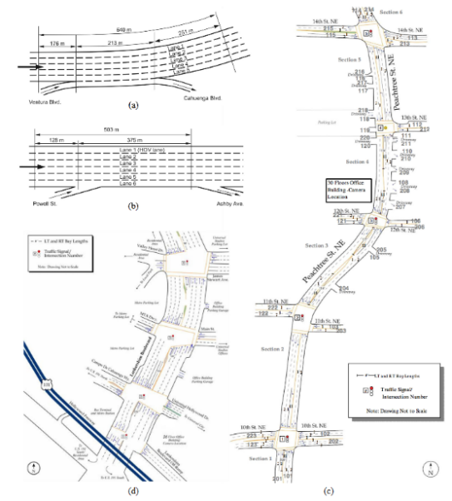
Figure 1. NGSIM dataset sites: a) US-101 b) Interstate 80 c) Peachtree Street NE d) Lankershim Boulevard
3.1 I-80 Trajectory Dataset
The I-80 trajectory dataset used in this study was collected in April 2005 by FHWA on a segment of Interstate freeway I-80 in Emeryville, California. The data represents travel in northbound direction of Interstate 80. Seven video cameras were installed on a 30-story building, Pacific Park Plaza, which is located on 6363 Christie Avenue. The seven cameras recorded seven sub-sections of the study area, respectively. I-80 trajectory dataset has three subsets each in 15-minute intervals (4:00 p.m. ~ 4:15 p.m., 5:00 p.m. ~ 5:15 p.m., and 5:15 p.m. ~ 5:30 p.m.), 45 minutes in total. Figure 2, provides the location covered by the I-80 vehicle trajectory and detector dataset. The study site is approximately 1650 feet in length, with six mainline lanes including high occupancy vehicle (HOV) lane and with an on-ramp at Powell Street. Therefore, this dataset is largely useful for the approximation of the suggested errors because of the structural features of the site including MLC merge area and data being collected during rush hour.
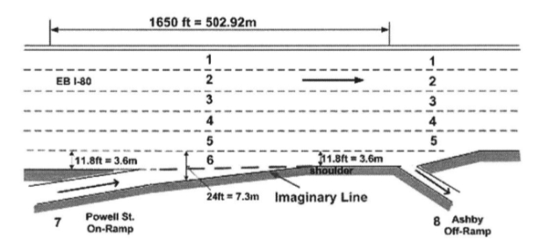
Figure 2. I-80 structural layout
3.2 Respondents
The frames were taken at 10 fps (frames per second) and the trajectory data was recorded in that interval. The variable “global time” represents the specific times the data was recorded in epoch time. In the I-80 dataset there were a total of 5,678 drivers recorded & more than 10,000 frames, resulting in about 4.5 million lines of data.

- Identification of Data Errors
In spite of the importance of NGSIM data for research on traffic flow theory, these datasets have shown to be immensely influenced by measurement errors in vehicles’ coordinates. Errors were intensified in the procedure of speed and acceleration values being calculated. If this is not appropriately accounted for, these errors will make the NGSIM datasets unusable for any microsimulation model or study on traffic flow theory.
The quality of the processed data occasionally is not functional. However, new lane-changing models with diverse driving systems often need datasets from lengthy road sections that can accurately portray driving behaviors in diverse driving routines. Furthermore, it is challenging to extract driver individual information from video data. Such data can be valuable in creating microsimulation models. Consequently, datasets composed through video detectors alone may not be adequate for constructing high-fidelity models to define lane-changing behavior^{[11]}.
Measurement errors in available data are increasingly attracting the attention of researchers. As there is a multitude of errors in NGSIM trajectory datasets, the trajectories were naturally taken as study objects in the findings regarding vehicle trajectory data cleaning. Punzo et al. (2011) pointed out that there are some major errors in the NGSIM datasets, in particular in the instantaneous data of speed and acceleration. So far, there have been five papers aiming at pointing out errors and data cleaning for NGSIM trajectories^{[8]}. To examine trajectory data accuracy and reduce random disturbances, Punzo et al. (2011) constructed quantitative approaches comprising of consistency analysis, jerk analysis, and spectral analysis, and utilized them on the four NGSIM datasets^{[8]}. The prepared NGSIM datasets were afterwards published and projected to be a standard for trajectory data quality. In 2012, Zheng and Washington examined the topic of choosing an optimum wavelet to identify irregular structures and transient phenomena in traffic flow data, and suggested the Mexican hat wavelet for cleansing traffic data^{[17]}. In 2015, Montanino and Punzo suggested the traffic-informed technique to remove noise and rebuild trajectories^{[6]}. For a related goal, in 2017, Fard et al. suggested a two-step method built on wavelet analysis, which is primarily identifying and adjusting outliers, and then removing them through utilizing a wavelet-type filter^{[4]}. In 2016, to assure that all the missed types of noise were addressed, Zheng and Su suggested a compressed sensing procedure to improve traffic data with partial data missing, Gaussian measurement noise, and corrupted noise^{[16]}. Furthermore, total variation regularization and Markov random field were utilized to better the accurateness of the traffic state estimation (Li and Coifman, 2017)^{[2]}.
Despite the high frequency of the measurements at 10 Hz, errors of a few centimeters in space can produce significant errors in acceleration and speed. Though errors due to frequency can be neglected because of the state of technology in our era, there are other error types that cannot be neglected. Because of the measurement procedure, the locations studied are spread in the areas of true points as well as around the initial path followed by the vehicle (see Figure 3).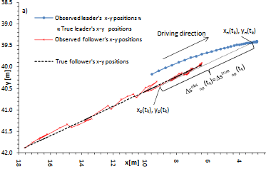
Figure 3. Absolute positions (x-y) of two following vehicles (Punzo & Cuiffo 2011)^{[8]}
Errors in coordinates are unavoidable, errors caused from the spread in those areas travelled may not have a zero mean (even if the coordinate errors are zero mean). This means that errors in the areas travelled will have both noise and bias.
4.1 Specific Error of “False Collision” (Noise)
The component that we will focus on “false collision” is a type random error, which is commonly referred to as noise. Noise is identified as error caused by instantaneous values in NGSIM data. The areas travelled through by a vehicle in two successive 0.1-second intervals, that is the distances of two successive segments along the piecewise linear curve, can fluctuate, up to unphysical values in difference. Noise in the estimated vehicle trajectory function is even greater in the speed and acceleration functions, since the differentiation procedure increases the noise from whatever the numerical arrangement took on (Punzo & Cuiffo 2011)^{[8]}.
In NGSIM, trajectories follow the front bumper of vehicles. We calculate the position of the rear bumper by subtracting the vehicle length from the front bumper position. When the there is an instance in data where a vehicle overlaps or overruns its preceding vehicle, it is defined as a “False Collision”. These false collisions appear in the NGSIM data frequently and have been noticed by other researchers. Identifying false collisions can be tedious due to the millions of lines of data for each dataset. In this study, we identify the false collision occurrences through using the Alteryx Designer software (see Figure 4).
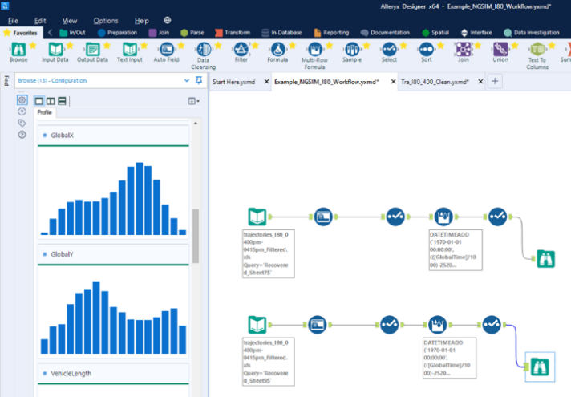
Figure 4. Alteryx Designer tool configuration
First, we insert the raw data through the input data tool. In the input data tool, users can specify which section of the data to look through. Afterwards, the auto field tool is used to take the data and specify which string fields to auto-change into different field types. Then the select tool is used to rename fields into their proper variables and select their types & sizes. For convenience, the multi-row formula tool is used to convert global (epoch) time to the local date-time for the I-80 site using a specific equation that will bring it to the exact Pacific Daylight Time that was present during the observation. Once that is done, we use the browse tool to analyze the data. The data is analyzed in groups to find these false collision instances. We chose to sort these groups by vehicle length, since it is an essential part for our method to detecting false collisions. We noticed that trucks (vehicle class 3) varied the most in size, going from 20ft to 65ft in length. Cars (vehicle class 2), in our observation, were between 10ft to 20ft in length. Lastly, motorcycles (vehicle class 1) were between 4ft to 9ft. We began filtering the spacing while filtering vehicle lengths to see which vehicles had preceding vehicles that were longer than the spacing. Through this procedure we were able to find a multitude of false collisions. Our example of one of the instances we discovered can be found in Figure 5.

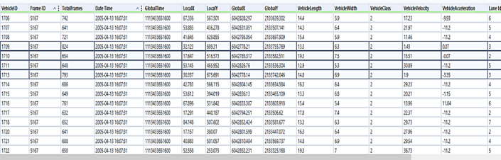
Figure 5. False Collision of Trajectories 1713 and 1709 in Alteryx Designer
Table 1. False Collision of Trajectories 1713 and 1709
Vehicle ID | Frame ID | Global X | Global Y | Vehicle Length | Lane ID
1709 | 5167 | 6042173.2 | 2133755.7 | 13.3 | 3
1710 | 5167 | 6042185.3 | 2133582.5 | 19.3 | 2
1711 | 5167 | 6042825.8 | 2133536.3 | 12.9 | 5
1713 | 5167 | 6042173.1 | 2133743.1 | 14.8 | 3

The figure and table show an example of data from lane 3 in Alteryx from the 4:00 PM to 4:15 PM period of the I-80 dataset. Once taking account of the rear bumper positions by subtracting vehicle length from global Y positions and verifying the error through spacing, we see there is a false collision present: trajectory 1713 overruns trajectory 1709 at 4:07:31 PM. We also observe another instance of false collision in trajectory 1497 around the same time. Vehicle 1486 is overrun by vehicle 1497 in this false collision.
Throughout the I-80 dataset there are instances of vehicles overlapping/overrunning each other. Through the complete I-80 dataset, at least 13% of the trajectories overrun their leader. Obviously, 747 rear-enders did not happen during 45 minutes of study. These enormous errors on its own ought to make us reconsider the quality of the NGSIM trajectory datasets. Thiemann al. (2008) acknowledged the collision issue in another trajectory in the I-80 dataset (between vehicle trajectory 1444 and vehicle trajectory 1441)^{[12]}. Subtracting the vehicle length from the Global Y position makes these false collisions apparent.
- Possible Causes of False Collision
These errors could be caused by the neighborhood of true points surrounding the original path. For errors in detected vehicle trajectories, the prerequisite of constancy is the simple graphic inspection of the projected trajectory, speed or acceleration functions normally uncovers the existence of measurement errors inadequately treated in the estimation process. In a way they display that the inconsistency of positions, the key element of noise, is intensified by the differentiation by the second power of the measuring interval dt (Thiemann 2008)^{[12]}. As previously mentioned, trajectory data accessible through video devices or GPS are a time sequence of vehicle locations in a local or global reference system that may be utilized to derive the vehicle trajectory function, S(t). Given a time-space field, the comprehensive set of vehicle trajectories comprises the complete data on the traffic flow in that field. Certainly, any other variable or parameter valuable to define traffic occurrences may be frankly derived from trajectory functions (Li and Coifman, 2017)^{[2]}.
- Discussion
6.1 Preliminary Work
Thiemann et al. (2008) proposed an application of the following data smoothing techniques to reduce the noise that causes the overlapping and speed & acceleration errors:
1. Velocities and accelerations will be promptly valued from their longitudinal positions.
2. Locations (including longitudinal and longitudinal coordinates), velocities, and accelerations of motorists will be smoothed by the symmetric exponential moving average filter (SEMA).
The smoothing times of the SEMA method should be set as suggested values for both the Interstate 80 Freeway dataset and U.S. Highway 101 dataset.
Smoothing is the solution also provided by Punzo 2009 for all random component errors^{[10]}. Smoothing can only correct the noise errors, but cannot fix the structural issues. Averaging is one form of smoothing, which in turn is one form of filtering. Punzo et al. suggested that we start valuing our speed and acceleration from space travelled (Local X & Y) values instead of using the direct values given by NGSIM, due to the errors caused by noise. Montanino and Punzo (2015) built their own smoothing solution to exclusively remove these occurrences of overlapping from their cleaned trajectory data^{[6]}. They pointed out that noise could be corrected by linear smoothing of signals with symmetric exponential moving average or low-pass filters. This also removes instances of extreme values of maximum acceleration and deceleration that are not plausible. Through these many instances, we can see that data given by NGSIM cannot be immediately used under any circumstance. Only after smoothing, can the vehicle trajectories of US-101 and Interstate 80 merging & diverging processes can be extracted successfully for lane-changing model purposes.
6.2 Further Consistency Checking of Data
A further consistency checking and accuracy checking of all the data subsets from US-101 and I-80 datasets can be done. First, the frame ID can be checked along with the number of frames, vehicle length, vehicle width and vehicle type and find if: 1) the frame ID’s of each vehicle in US-101 and I-80 datasets have any variations; 2) the total numbers of frames in column 3 in US-101 and I-80 datasets are correct; 3) each vehicle in US-101 and I-80 datasets has unique length in column 9, width in column 10, and vehicle type in column 11. Then, frame ID and global time can be checked as Wen-Long Jin (2009) did and checked for consistency^{[5]}. Afterwards, the consistency of the local and global coordinates can be checked. A thorough procedure can be conducted to examine the consistency of the local coordinates and global coordinates using the Alteryx application’s spatial information tool. Primarily, I searched numerous data points that have identical global coordinates among the three data subsets of both sites. Subsequently, I checked the local x and y coordinates, and discovered if the three data subsets of I-80 are consistent in local and global coordinates. The beginning position of the auxiliary lanes were checked for samples. Therefore, three subsets are united by using the local coordinates of dataset 2. This step is very vital, since the statics of driver behavior like merging & diverging position can be changed by the inconsistency of the local coordinates.
- Conclusions
This paper was dedicated on the issue of approximating vehicle trajectories from detected locations. As examinations are clearly continuously disturbed by measurement errors, data must be efficiently post-processed. It was logged that in the works less than a handful of attempts have been dedicated to this issue, possibly due to the underestimation of the bias in outcomes of applications that are able to result from using data that is not correctly processed. Unquestionably, even NGSIM datasets, although important for the variety of potentials accessible, are influenced by errors. Nonetheless, this is only slightly documented and numerous studies have used NGSIM datasets without including any data analysis or processing. This topic is an essential issue towards model calibration and validation and cannot be ignored. More studies should be done in the future analyzing false collision and other specific types errors of noise and bias in the U.S. 101, Peachtree NE, and Lankershim Blvd datasets.
- Acknowledgement
This study is sponsored in part by the United States National Science Foundation [grants BCS 0527508], by American Association of Highway and Transportation Officials [grant 15-0084], by the National Natural Science Foundation of China [grants 51050110143 and 51250110075], and CSC Scholarship, to which the authors are very grateful.
- References
- Analyse-it Software, Ltd. (n.d.). Parameter estimates,https://analyse-it.com/docs/user-guide/fit-model/linear/parameter-estimates.
- Coifman, B., & Li, L. (2017). A critical evaluation of the Next Generation Simulation (NGSIM) vehicle trajectory dataset. Transportation Research Part B: Methodological, 105, 362–377. doi: 10.1016/j.trb.2017.09.018
- CRC Pr I Llc. (2017). Traffic Simulation and Data Validation Methods and Applications.
- Fard, M.R.; Mohaymany, A.S.; Shahri, M. A new methodology for vehicle trajectory reconstruction based on wavelet analysis. Transportation Research Part C 2017, 74, 150–167.
- Jin, W.-L. "Asymptotic traffic dynamics arising in diverge-merge networks with two intermediate links" Transportation Research Part B, 43(5):575-595. 2009
- Montanino, M., & Punzo, V. (2013). Making NGSIM Data Usable for Studies on Traffic Flow Theory. Transportation Research Record: Journal of the Transportation Research Board, 2390(1), 99–111. doi: 10.3141/2390-11 “Next generation simulation factsheet,”inops.fhwa.dot.gov/trafficanalysistools/ngsim.htm. Federal Highway Administration, 2011.
- Montanino, M.; Punzo, V. Trajectory data reconstruction and simulation-based validation against macroscopic traffic patterns. Transportation Research Part B: Methodological 2015, 80, 82–106.
- Punzo, V., Borzacchiello, M. T., & Ciuffo, B. (2011). On the assessment of vehicle trajectory data accuracy and application to the Next Generation SIMulation (NGSIM) program data. Transportation Research Part C: Emerging Technologies, 19(6), 1243–1262. doi: 10.1016/j.trc.2010.12.007
- Punzo, V., D.J Formisano and V. Torrieri. Nonstationary Kalman filter for estimation of accurate and consistent car-following data. In Transportation Research Records: Journal of the Transportation Research Board Vol. 1934, 2005, pp. 3-12
- Punzo, V., Borzacchiello, M.T., & Ciuffo, B. (2009). Estimation of vehicle trajectories from observed discrete positions and Next-Generation Simulation Program (NGSIM) data.
- Sopasakis, A., & Katsoulakis, M. (2016). Information metrics for improved traffic model fidelity through sensitivity analysis and data assimilation. Transportation Research Part B: Methodological, 86, 1–18. doi: 10.1016/j.trb.2016.01.003
- Thiemann, C. & Treiber, M., and A. Kesting, “Estimating acceleration and lane-changing dynamics from next generation simulation trajectory data,” Transportation Research Record: Journal of the Transportation Research Board, vol. 2088, pp. 90–101, 2008.
- Zheng, L., Jin, P. J., Huang, H., Gao, M., & Ran, B. (2015). A vehicle type-dependent visual imaging model for analysing the heterogeneous car-following dynamics. Transportmetrica B: Transport Dynamics, 4(1), 68–85. doi: 10.1080/21680566.2015.1055618
- Zhengbing He, Research based on high-fidelity NGSIM vehicle trajectory datasets: A review, doi:10.13140/RG.2.2.11429.60643, 2017
- Zheng, Z., 2014. Recent developments and research needs in modeling lane changing. Transportation Research Part B 60(1), 16-32.
- Zheng, Z.; Su, D. Traffic state estimation through compressed sensing and Markov random field. Transportation Research Part B: Methodological 2016, 91, 525–554.
- Zheng, Z.; Washington, S. On selecting an optimal wavelet for detecting singularities in traffic and vehicular data. Transportation Research Part C: Emerging Technologies 2012, 25, 18–33.

