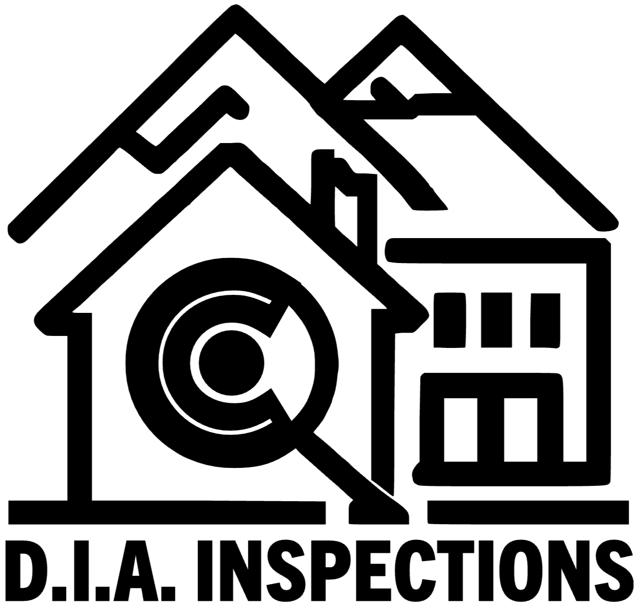
D.I.A. INSPECTIONS
Home & Commercial Inspection Services
Denver Metro Area | (303) 720-6890 | diainspections.com

★ Infrared Thermal Imaging INCLUDED with every home inspection at no extra charge

Home Inspection Pricing
Property Size | Price | Duration | Includes
Under 1,000 sq ft (condo / townhome) | $375 | 2–2.5 hrs | IR + Report
1,000 – 1,500 sq ft | $425 | 2.5–3 hrs | IR + Report
1,500 – 2,500 sq ft | $475 | 3–3.5 hrs | IR + Report
2,500 – 3,500 sq ft | $525 | 3.5–4 hrs | IR + Report
3,500+ sq ft (estate / custom) | $575+ | 4+ hrs | IR + Report
Pre-1980 Home Surcharge | +$75 | — | —

Every home inspection includes: structural, mechanical, electrical, plumbing, roofing, interior/exterior evaluation, infrared thermal imaging, and same-day digital report with photos.
Bundle & Save
Bundle | Price | You Save | Report
Buyer’s Bundle  Home Inspection + Radon Testing + Sewer Scope | $699 | ~$100+ | Same-day
Complete Package  Home Inspection + Radon + Sewer Scope + Pest/WDO | $849 | ~$120+ | Same-day

Bundle savings calculated vs. mid-tier inspection + individual add-ons. Exact savings depend on home size.
Specialty Add-Ons
Service | Price | Turnaround | Notes
Radon Testing | $175 | 48 hrs | EPA-certified
Sewer Scope | $195 | Same-day | Video inspection
Pest / WDO Assessment | $125 | Same-day | Termites, rot
Re-Inspection | $150 | Same-day | Verify repairs
Infrared Thermal Imaging | INCLUDED | Same-day | With every inspection
Commercial Inspections
Property Type | Starting At | Duration | Report
Small Commercial (under 5,000 sq ft) | $600 | 4–6 hrs | 2–3 days
Mid-Size Commercial | Custom | Varies | 2–3 days
Multi-Family (4+ units) | Custom | Varies | 2–3 days

Commercial inspections include: structural, HVAC, electrical, plumbing, roof, infrared thermal imaging, and detailed report.
Every Inspection Includes
- Infrared thermal imaging at no extra charge
- Same-day digital report with high-resolution photos
- Clear, actionable findings — no jargon
- Full structural, mechanical, electrical, and plumbing evaluation
- Roof, interior, exterior, and accessible attic/basement/garage
- Follow-up support — call with questions anytime

Not included in standard inspection (available separately or by referral):
Mold/air quality testing • Well/septic evaluation • Pool/spa inspection • Asbestos/lead paint testing • Engineering calculations • Code compliance certification

Ready to Book?
Call or Text: (303) 720-6890
Book Online: diainspections.com/appointments
Tues – Sat | 8am – 5pm MT | Commerce City, CO
Licensed & Insured | Same-Day Reports | No Upsells

