CSE 578 Unit 5 Project Progress Report

Dr. Ghayekhloo

3/28/2021

**Project** **Name**: Data Visualizers

**Group** **Members**: Rosty Hnatyshyn, Kyle Gonzalez, Nicholas Seah, Sang-Hun Sim, ~~Andrew Gregory~~

**Project** **goal**:

Build a machine learning model that is able to predict whether or not a person makes more than $50k a year. From the model, figure out what attributes are critical to determining a person’s salary; use these attributes to create a visualization that clearly explains the relationship between these attributes and a person’s yearly salary.

**Plan**:

First, we’ll need to analyze and clean the data given to us so that its ready to be put into a machine learning model. Then, we’ll need pick a model that works best for this problem and train it. Then, we’ll need to analyze what factors were important in its predictions and build a visualization that describes them. We will meet on 2pm MST on Thursdays.

**Work** **distribution**:

Rosty – Clean up data, help with machine learning

Kyle – Machine Learning

Sang-Hun – Analyze machine learning model

Nicholas – Visualization

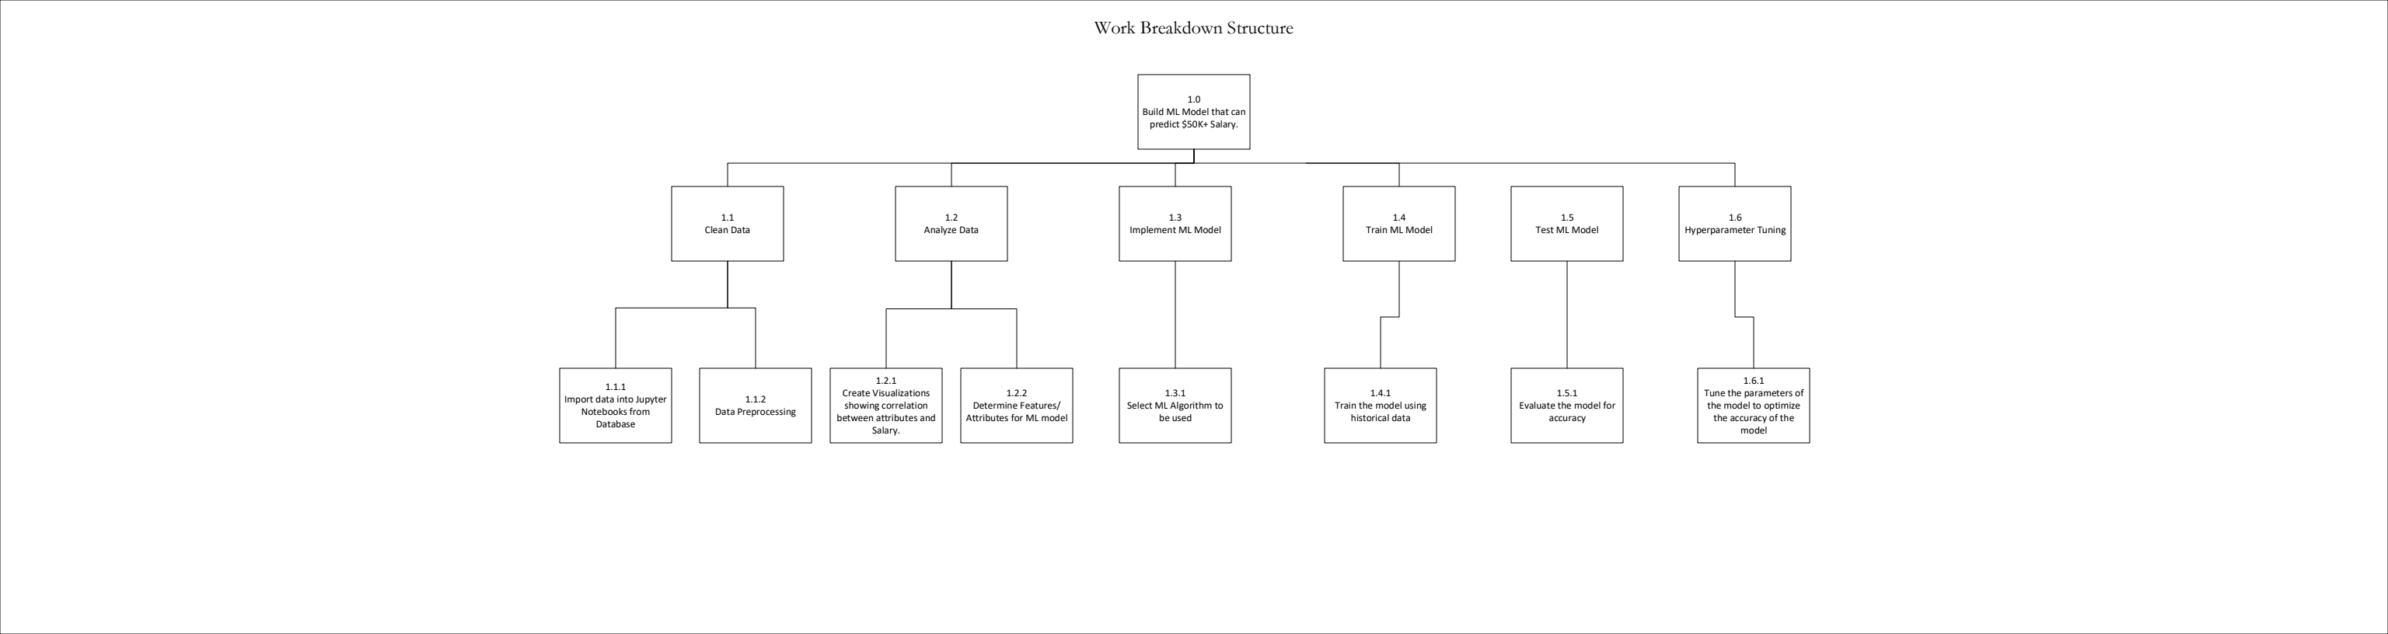**Deadlines**:

Analyze and clean data: 3/21

Build machine learning model: 3/28

Analyze machine learning model: 4/3

Finish visualization describing relationships in model: 4/10