TECHNICAL REPORT: IDB2
Sochi 2014 Winter Olympics
by “4 Is Better Than 6”
Members:
- Austin Hooper
- Ardhimas Kamdani
- Nickson Dalimarta

INTRODUCTION
Description:
Have you ever found yourself wanting to know the events that went on during the 2014 Sochi Winter Olympics? Or the athletes that took part in said games? How about how well your favorite country did in said events? Then we have a site that is right up your alley!

Use cases (Phase 1) :
* From the Home Page a user can use the navigation bar to be directed to any Athlete, Event, and Country page.
* Navigation Bar exists in all pages. In phase 1, because of limited pages, a user may go to any page by making use of the navigation bar.
Use Case Diagram
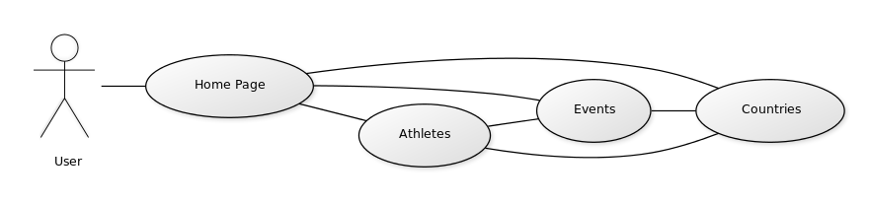

DESIGN
RESTful API:
API exists for retrieving information of all available athletes/ events/ countries. Due to the limited functionality, there are only 2 GET methods for each model. One to retrieve a list of all available datas for a model. Each element is a key-value pair of the model's id and name, separated by an equal sign. The other method is used retrieve the details of an object of a specified id (the only parameter of this method). A user who would like to get the information on Ireen Wust, for example, may first use the first method to get this list
"ID=Athletes":["1=Meryl Davis","2=Tobias Arit","3=Ireen Wust"]
He can then use the second method to get these details
{
"Id":3,
"First Name":"Ireen",
"Last Name":"Wust",
"Gender":"Female",
"Nationality":"Netherlands",
"Date of Birth":"1 April 1986",
"Age":28,
"Height":"1.68m (5'6")",
"Weight":"63 kg (139 lbs)",
"Place of birth":"Goirle, Netherlands",
"Total Medals":5,
"Gold Medals":["Speed Skating:Ladies' 3000m", "Speed Skating:Ladies' Team Pursuit"]
"Silver Medals":["Speed Skating:Ladies' 1000m", "Speed Skating:Ladies' 1500m", "Speed Skating:Ladies' 5000m"]
"Bronze Medals":[]
}

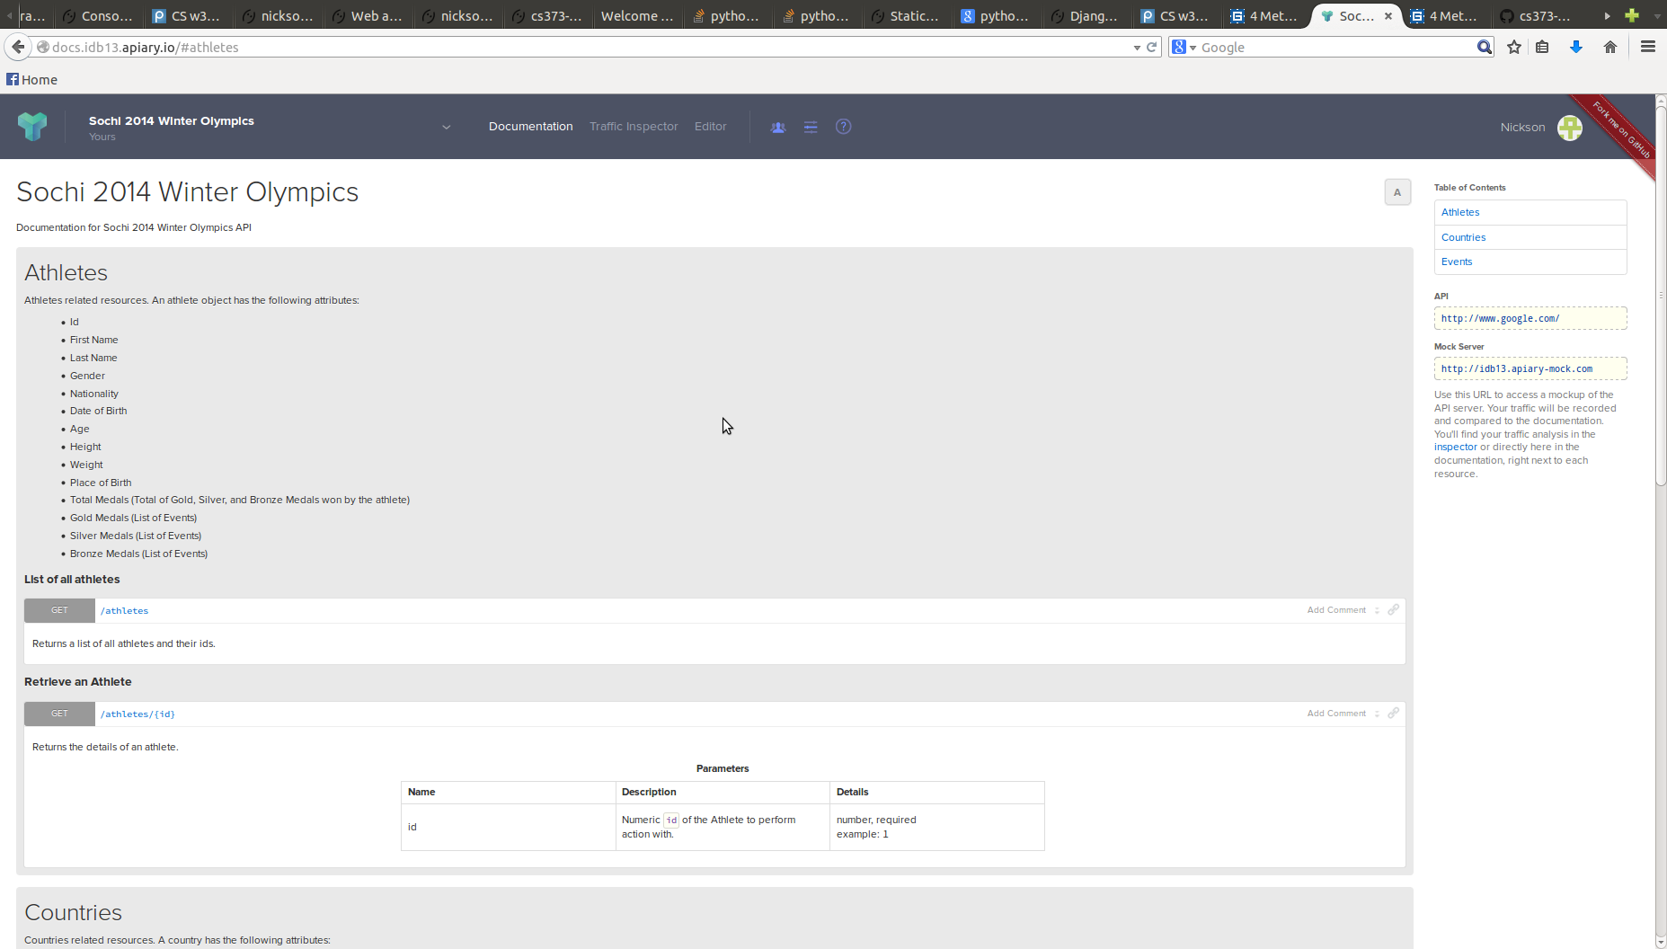

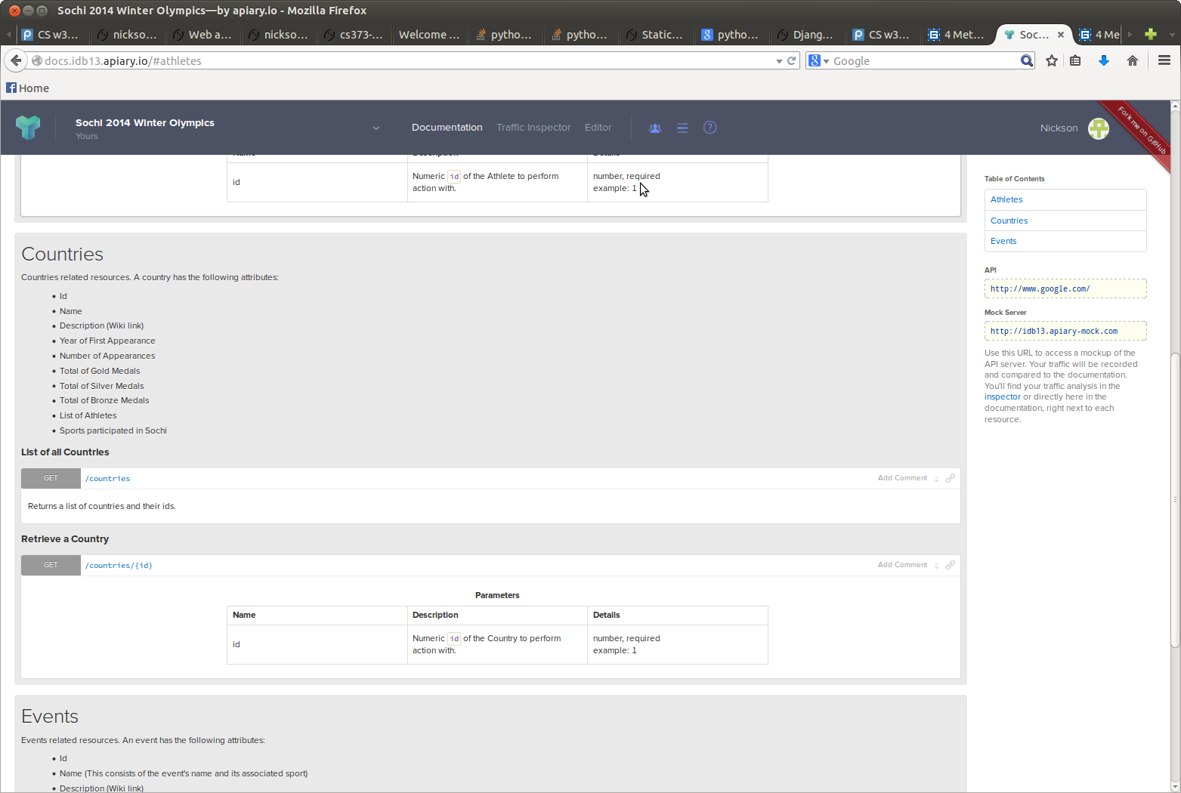

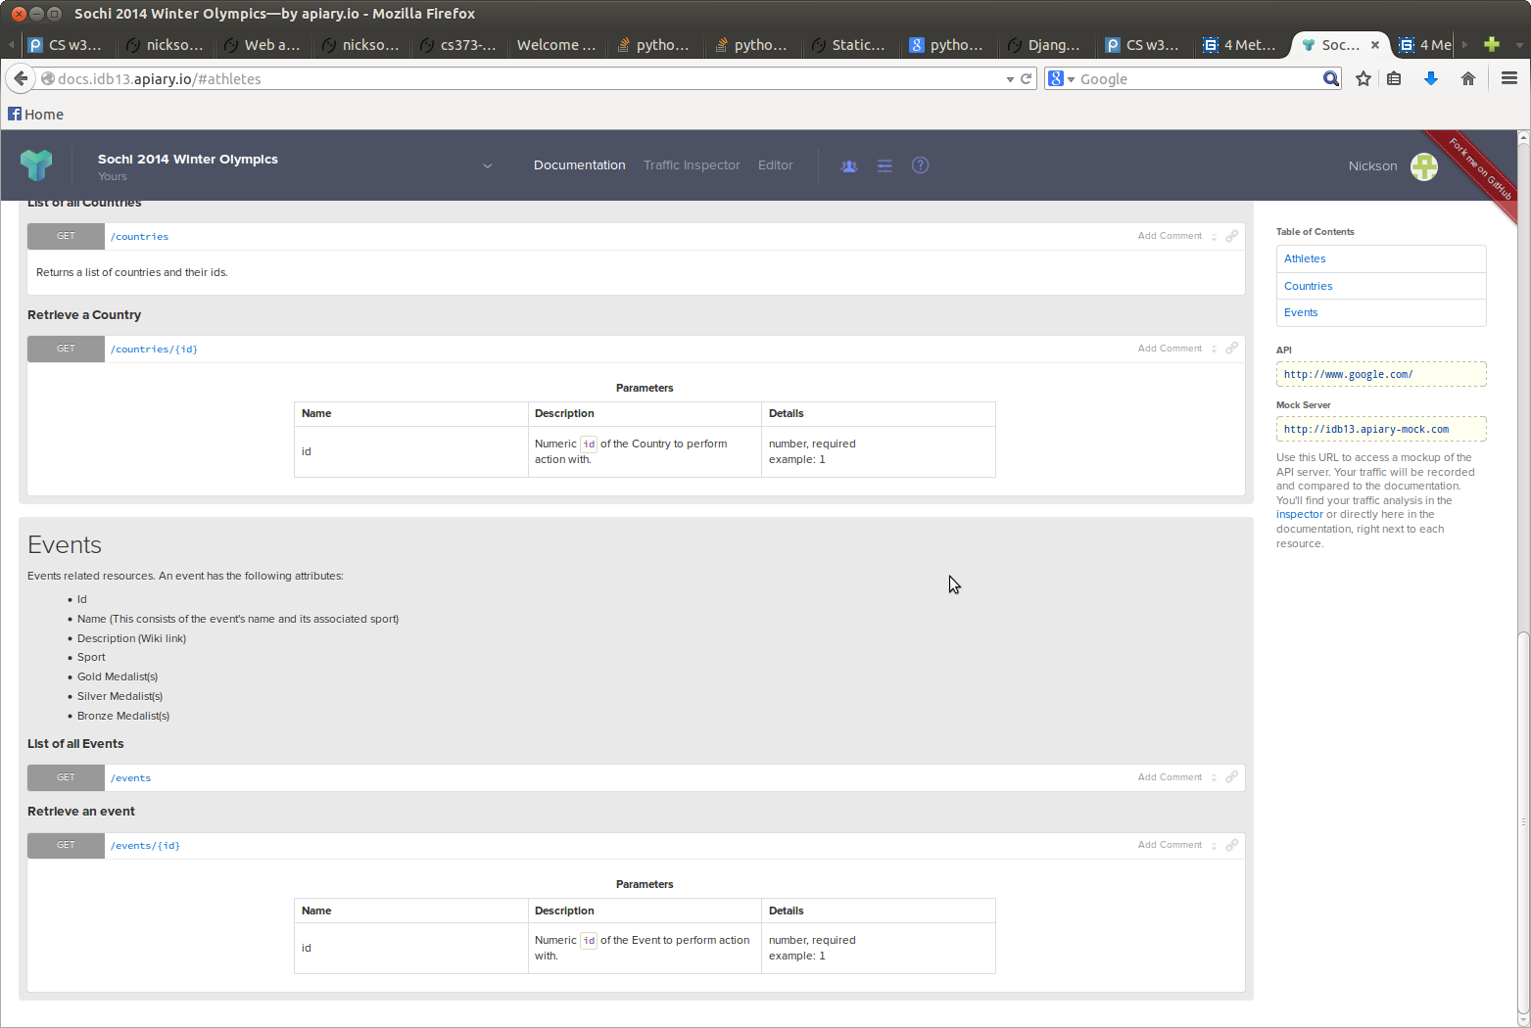

Django Models & Attributes:
- ATHLETES
* First Name
- Primary Key
- Athlete's first name
- Type: String
* Last Name
- Primary Key
- Athlete's last name
- String
* Country
- Athlete's Country
- String
* Gender
- Athlete's Gender
- String
* Date of Birth
- Primary Key
- Athlete's Date of birth
- Date
* Gold Medals
- List of events the athlete won the gold medal from
- Foreign Key
* Silver Medals: Events
- List of events the athlete won the silver medal from
- Foreign Key
* Bronze Medals: Events
- List of events the athlete won the bronze medal from
- Foreign Key
FirstName, LastName, and DateofBirth are chosen as the primary keys to prevent conflicts. It is highly unlikely that participating athletes have the same name and date of birth.

- COUNTRIES
* Name
- Primary Key
- Name of the coutnry
- String
* Athlete List
- List of participating athletes from the country
- String
* Description
- Brief description of the country
- String
* Gold Medals Won
- Total of gold medals won by the country
- Dynamically calculated from the medals won by the athletes
- Integer
* Silver Medals Won
- Total of silver medals won by the country
- Dynamically calculated from the medals won by the athletes
* Bronze Medals Won
- Total of bronze medals won by the country
- Dynamically calculated from the medals won by the athletes

- EVENTS
* Name
- Primary Key
- Name of the associated sport followed by the name of the event
- String
* Sport
- Primary Key
- Name of the associated sport
- String
* Description
- A brief description of the event
- String
* Gold Medalist(s)
- The name of the gold medalist(s). Can be multiple athletes.
- Foreign Key
* Silver Medalist(s)
- The name of the silver medalist(s). Can be multiple athletes.
- Foreign Key
* Bronze Medalist(s)
- The name of the bronze medalist(s). Can be multiple athletes.
- Foreign Key

Django Models Diagram

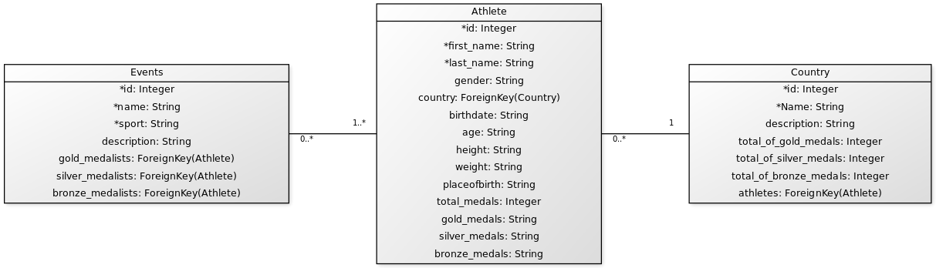

TESTS
Django Models:
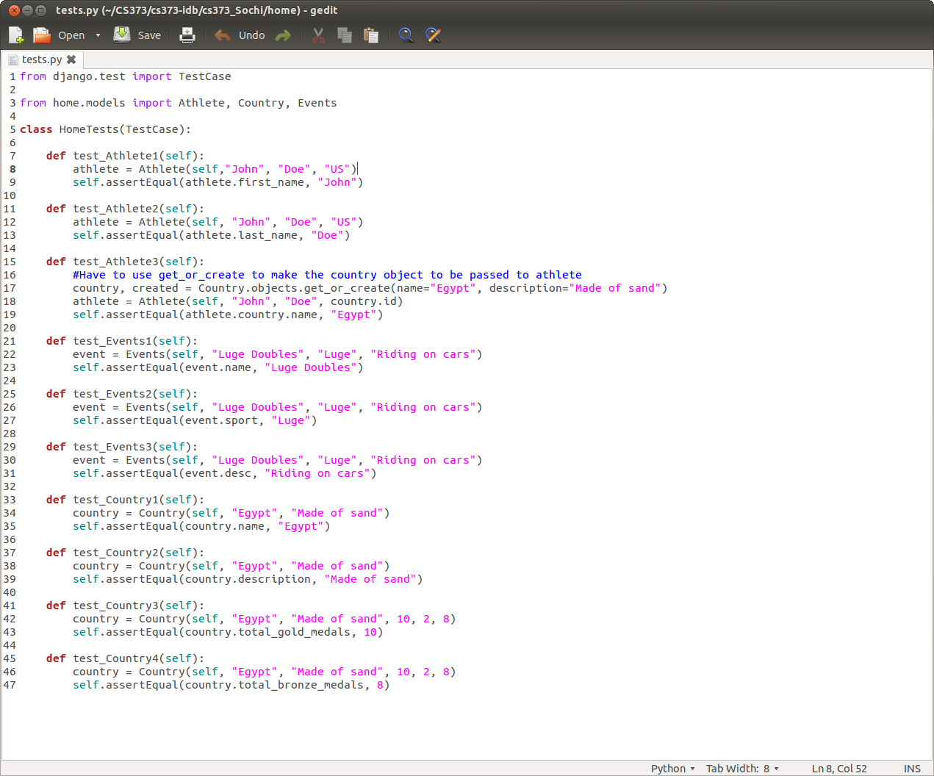
Simple tests that test if objects were created successfully.

DATABASE
Fortunately Django handles the sql database for us and we do not have to write any sql queries to manage our database. The database can be accessed by going to the admin page. The picture following is the look of the admin page.
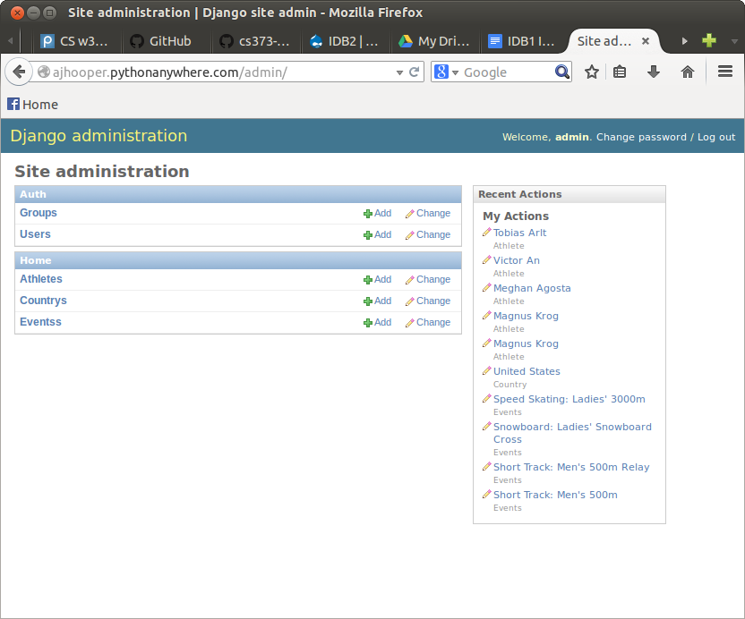
Admin page of our website.

We can easily add a new data to our database by clicking add which will direct us to a form with all the attributes of a particular model. We can just fill in the form to add the desired data.
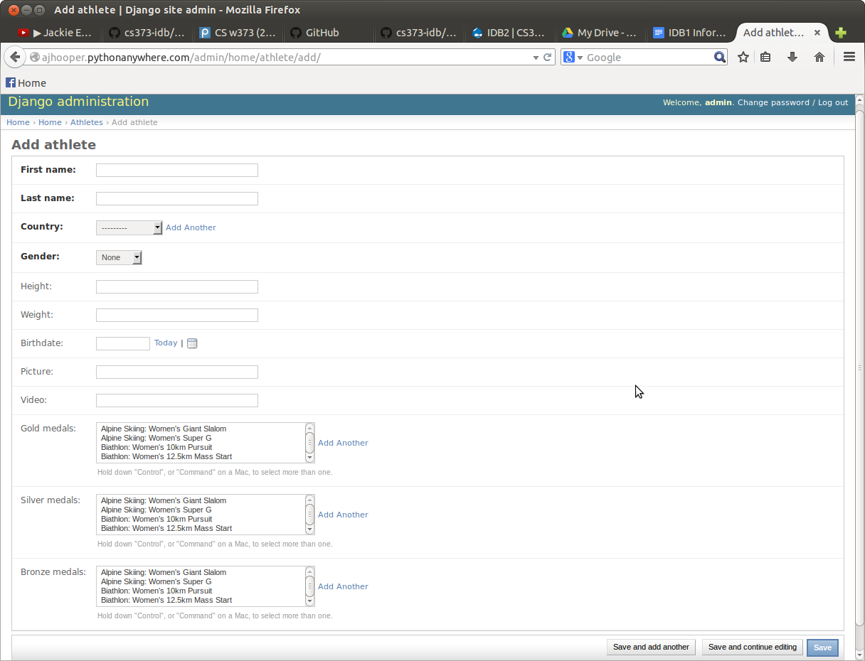
Add form of athlete.
One important thing to notice is that Django automatically creates a drop-down list for foreign keys. This list is automatically updated whenever there is a change in the relevant databases. In this case, all Events, which are foreign keys for are listed in the drop-down list for Gold, Silver, and Bronze medals.

For updating the existing datas, we can click Change which directs us to the list of existing datas for a particular model.
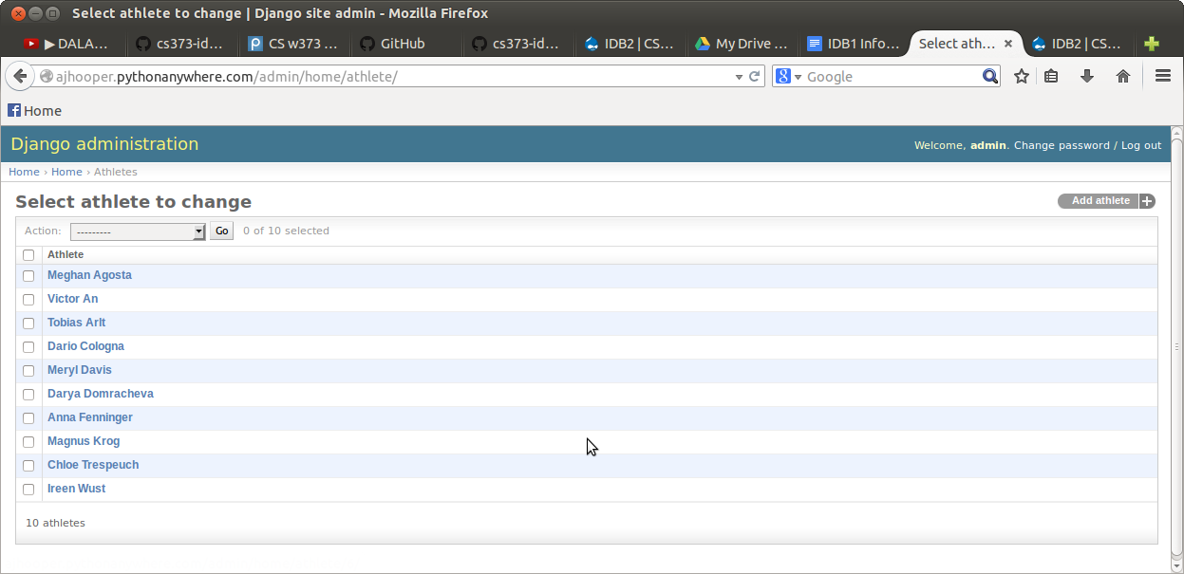
List of existing athletes
To update an athlete, say Ireen Wust, we just have to click her name which directs us to a filled form. We can then change the attributes and click save to update.

API (Django REST framework or Tastypie?)
There were two options to the software that we can use to build the API. One was the Django Rest Framework, the other one is Tastypie. We decided to create both versions and see which one suited better for our site.

A. Django REST framework
The core file is api.py in which we decribe the kind of APIs that we want as described in DESIGN section for RESTful API (list and details).
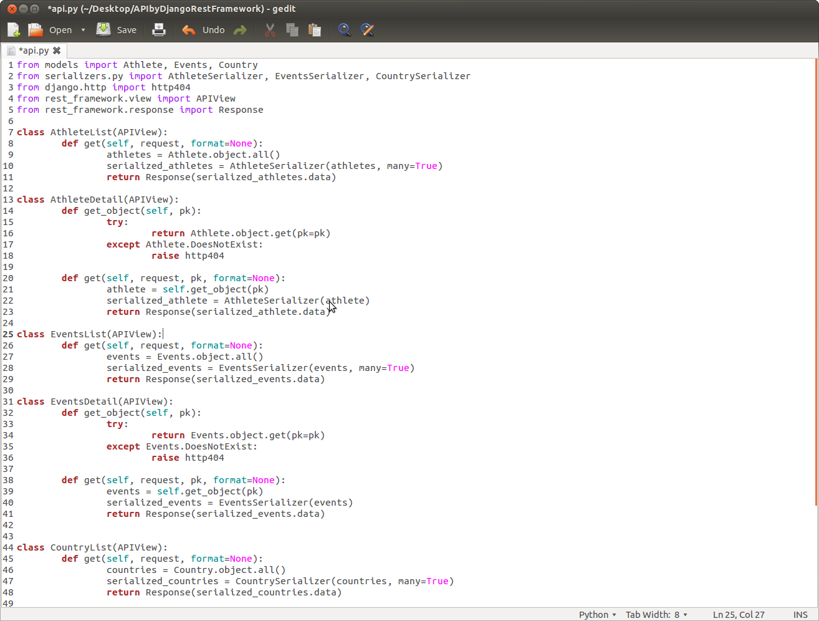
api.py for Django REST framework

For Django Rest Framework, we had to create another file called serializers.py that allows the data to be easily rendered to JSON, XML format.
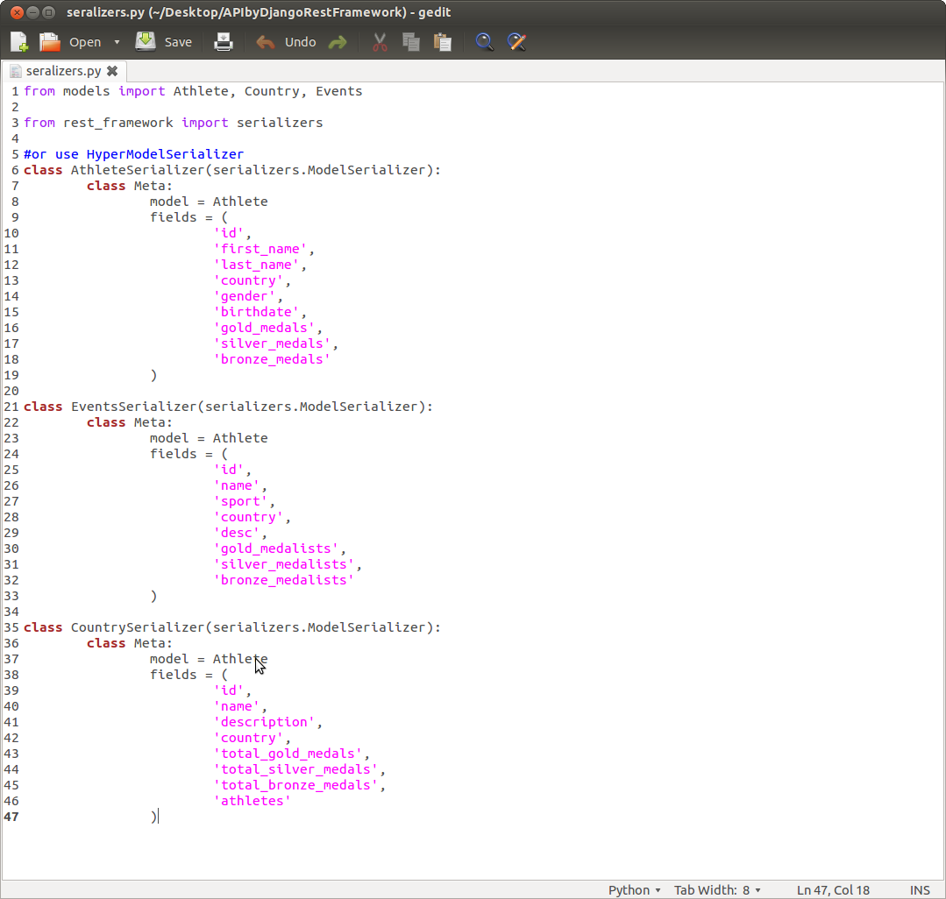
Django Rest Framework Serializers.py

Finally, to make sure that the API pages are running, we update the urls.py to include the new API pages.
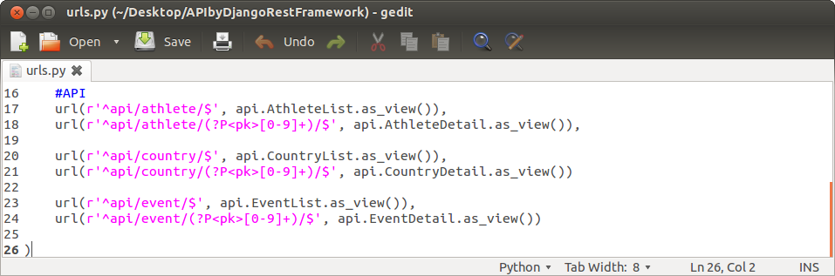
Added URLs for API

B. Tastypie
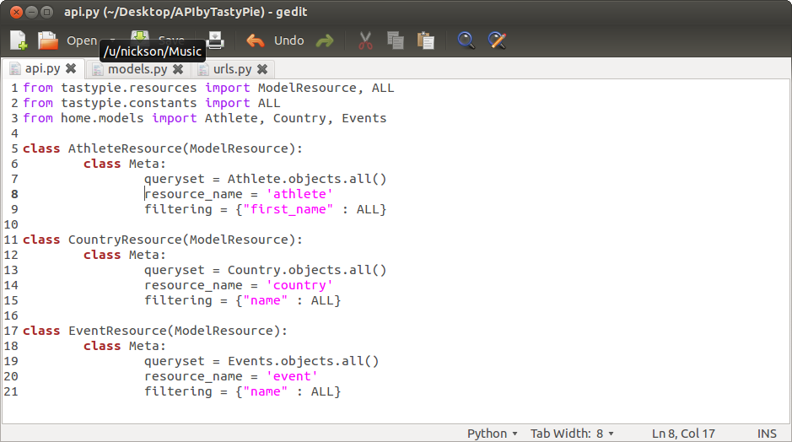
Here, we also included the core code for API in a file called api.py.
api.py for Tastypie
We also had to add the API. However, the ModelResource amazingly handled all the urls and we do not have to create any regular expression.
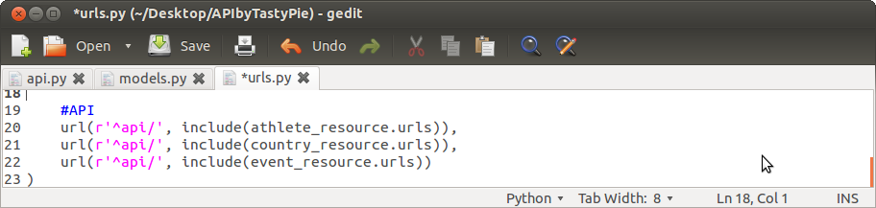
urls.py for Tastypie

C. Conclusion

