**Experiment of Image Analysis for Shape and Color to determine Most Efficient Color Space for different Light Sources**

**By: Nicholas Szakal and Michael Hudson**

**5/11/2016**

**Problem Statement and Literature:**

There is a need for software within our society today that allows us to analyze fruits and vegetables through image processing according to their specific shape and color. This is done for the sake of a computer being able to identify a specific fruit or vegetable for it to be sorted, analyzed for ripeness and health, or to accomplish other automated tasks. Furthermore, this is done within a wide variety of color spaces such as HSV, XYZ, CIE Lab, and many others with clearly defined areas for use within image analysis. This is further documented in Fruit Recognition Technique using Multiple Features and Artificial Neural Network by Bhattacharya [1] in explaining the color spaces used while also explaining while others are not. Bhattacharya states that HSV is the best color space for extracting color via hue of a particular fruit given little difficulty as the color hue values and variation can be analyzed on a specific fruit basis. This analysis of patterns allows for better sorting algorithms to be places than those that can be obtained from the normal RGB color space [1]. This is further supported by Khojastehnazhand and Tabatabaeefar’s document in the African Journal of Plant Science that details a lemon sorting system based on color and size [4]. Khojastehnazhand and Tabatabaeefar state that hue color spaces are less dependent on light sources and thus prove themselves to be more reliable for image processing [4].

For our particular experiment, we will analyze three varieties of peppers within three different light sources and three different color spaces. The three peppers being a red bell pepper, a yellow bell pepper, and a green jalapeno pepper. The three light sources are reveal 75, compact fluorescent, and “illuminant A” otherwise known as regular incandescent. The three different color spaces are HLS, CIE Luv, and normal RGB. The HLS color space is thoroughly documented in “Color spaces for computer graphics" by Joblove and Greenburg [3]. This document served as the introduction of the color space and directly compared it to the HSV color space as they share hue as a common factor between the two and the difference being that HLS highlights “intensity” or lightness of the image being processed [3]. The CIE Luv color space is described in detail in the document “CIE Luv Color System Footnote” found on Anywhere.com [2]. This document describes the RGB color space and its use with, now outdated, CRT monitors while also commenting of Luv purpose in color analysis as a whole. To further elaborate, the Luv color space is better suited for large variations in color and distinguishing between them than RGB as it is a larger color space that can store and display what RGB cannot [2]. The complete analysis of all combinations of the color spaces, peppers, and lighting sources in twenty seven different images with the goal of determining through data analysis the best color space for each light source given the purpose of identifying shape and color qualities of our peppers. This will all be done within openCV to provide a solid logical and mathematical basis for our results.

**Proposed Approach and Deliverables:**

The approach the experiment will take to obtain all the data necessary to make an educated assessment to which color space is best given a particular light source is using a pixel-wise analysis of each of the three data channels a color spaces possesses. Standard deviation of each color space channel will be taken given that we calculate the average, minimum, maximum, and variance values beforehand. Additionally, we will calculate the three dimensional distance treating each of the three channels as a value in the X, Y, or Z coordinate plane. The only exception for this will be for the HLS color space as H-spaces utilize cylindrical coordinates. The processes taken for this is using this data to convert the numbers found within the channels into X,Y, and Z coordinates using a simple coordinate conversion (figure 1).

The deliverables for the experiment will be the overall data output from our openCV analysis, a results explanation that provides reasons with examples pulled from our data, and summary and possible improvements discussion. The results explanation will name the preferred color space within each light source and give reasoning with examples pulled directly from our data. The discussion will cover possible sources of error within our experimental procedure and give a list of improvements that we could have taken into account in a later experiment to obtain better data for a more clear result.

**Experimental Procedures:**

The procedure of the experiment can be divided into two parts, the physical act of taking pictures of our peppers for the sake of image processing and the step taken within openCV to accomplish our image processing.

The process we took while taking our pictures was first positioning our light source and background in order to ensure that there was a little shadows as possible while maintaining the light background for the pictures. These steps will ensure that the conditions for light to reflect off off the pepper in question in a way such that the picture is of suitable quality for meaningful image processing. After this was accomplished, settings such as contrast, gamma, and shutter speed were adjusted to create an even better RGB histogram as provided to us by the camera software. For our setting specifically, we used the defaults on all except for a slight increase in both gamma and contrast to emphasize the edges of our object. This, in retrospect, also created shadows which were later detrimental to the image processing portion which is detailed later in the results and discussion section. Due to the peppers varying size and shape, the pictures had to be taken with the peppers in varying positions. For instance, while the yellow bell pepper was of similar shape and size, it wasn't of suitable shape to remain upright like the red bell pepper. As a result, we had to lay it on its side. This will reflect differently in the data, however the result should not be so significant to say that it invalidates it in terms of say the two peppers have completely dissimilar shape. After these steps were completed and the pictures were seen of suitable quality, they were placed in the openCV environment to be analyzed and data collected.

For the openCV programming portion of the procedure, steps were needed to be taken to ensure that the primary focus of the data collection was the actual pepper in the pictures. To ensure this was the case, masks were needed to be created with the purpose of serving as high-pass filters on our color space histogram to ensure a more perfect data result free of “noise” coming from other objects in the image. This was accomplished through thresholding the image within each color space with the intent to create the basis for a mask. The thresholded image was then run through the “imgDEOC” program to erode and dilate the thresholded image and create a more suitable mask if possible. For some color spaces, creating a mask for more difficult than others. This can be attributed to many factors and is detailed within the results and discussion section. The next step taken was to overlay the mask with the image within its respective color space and extract the data. The data extract was maximum value of a color channel, minimum value of a color channel, average value of a color channel, standard deviation of the values of a color channel, maximum distance all color channels relating them to an three dimensional coordinate system, and average distance all color channels relating them to an three dimensional coordinate system. These statistics were taken to look for outliers in the data for proper data analysis as well as provide a basis for different color spaces with different representations within each color channel a medium to be compared to each other. The experimental processes concluded when the statistical data taken was then used to make an assessment of which color space is more suited for shape and color identification within each light source.

**OpenCV Code Development:**

The process of developing the code for image processing revolves around the process already described in our experimental procedure: Thresholding, Mask creation, and data extraction.

The first step in developing code was to incorporate a save feature into our thresholding program. This was done by taking the method “savePicture” from Thresholding-H and incorporating it into our thresholding program. Our thresholding program is essentially a modified variant of “Threshold-H save”. It takes in Mat buffer as an argument and according to whichever value we set to be our lowest accepted pixel value and highest pixel value it creates a binary image in grayscale color space that will serve as the base for a mask. This thresholded image is then saved as “thresh” with a number corresponding to which save number it is.

The second step taken was incorporating our image into the pre-made “imgDEOC” program. This program takes an greyscale Mat binary image buffer as an argument and manipulates the pixels to either a value of zero or two hundred fifty-five. This is done by either “erode” or “dilating” the pixel values as mentioned before that are in proximity to pixels that are already of that value. For instance, white pixel areas, or areas of pixels with value two hundred fifty-five, will become larger when “dilated” and vice versa for black areas of pixels with value of zero. This processes is done until the white area is roughly the shape of the object, in our case our pepper, which is the target of our data extraction program. The image is then saved as “mask” followed by a hard coded string designator that states in what color space and pepper the mask was created for.

The third and most extensive part of our openCV coding procedure is the data extraction portion. Three different programs were created to extract data for each color space we had to analyze: RGB, HLS, and CIE Luv. The program takes two Mat image buffers as our arguments. The first argument is our image to be analyzed. This image is later converted to a color space other than RGB such as HLS or Luv for our extraction programs for those color spaces. The second argument is the mask image saved directly from “imgDEOC” which is later overlaid onto the first argument image by using a separate “destination” Mat image buffer and the “and/ &” logical operator. To extract the data from each color space channel of the “destination” image, two nested “for” loops were created. These “for” loops parse through the rows and columns of the pixels of the “destination” image and, through simple logic, obtain the average, minimum, maximum, average, center, and bounds of our image color channels being processed. For the standard deviation, another set of nested “for” loops are created with the same functionality and purpose. The variance is calculated using the previously calculated average value of each color space respectively along with the current value at the specific pixel at that time. Outside of the “for” loops, the square root of the variance is taken in order to obtain standard deviation. For our distance calculation, the max color space channel value is subtracted from the minimum color space channel value, the difference is squared, and then the square root is taken of the summation of all squared differences originating from each of the three color space channels. The only difference in this process is for the HLS color space as H- spaces use cylindrical coordinates. First the H channel was converted to degrees by dividing by 180 and multiplying by 360. The division by 180 is due to the fact 180 is the max value of the H channel. This degree value is then assumed to be theta and the X, Y, and Z coordinates are calculated through the conversion found in figure 1. For further clarification, the S channel is assumed to be radius and L channel is assumed to be height or z value. Through both these processes we are also able to calculate the average distance to compensate for possible outliers in the data.

Through these three steps we were able to process each of our 27 images to be processed and gathered data in order to determine which color space, being HLS, RGB, or LUV, is most effective for each of our light sources.

**Data Analysis:**

We are using three different color spaces and each one has different parameters that data can be collected about them. With the RGB color space we collected the intensities of red, green, and yellow pixels. With Luv we find the values of luminance and u, v which are chromaticity coordinates of a specified white object. With the HLS color space we found values for hue, saturation, and lightness. Of course because these values are all very different it is difficult to compare these figures and see which is performing better in certain situations. To make it possible to analysis the color spaces we use 3-D distances and standard deviations to determine which color space is best for separating our samples.

The same data can be used to analysis the different light sources we used to see which makes it easiest for us separate our samples. When looking at the HLS color space for saturation fluorescent light gives both green and red the highest values which means they are easier to detect, but reveal 75 has the lowest standard deviation for every light source which makes it the most consistent for saturation. When looking at lightness fluorescent light gives the largest average values, and the standard deviation is about the same for all of them. When looking at hue incandescent has the lowest standard deviation. When looking at the Luv color space the values for v and u are all about the same for every light source (average, standard deviation). For luminescence reveal 75 gets much better values for green than the other light sources do. When looking at the RGB color space red gets a better average value and standard deviation with florescent light. Green gets higher average values with florescent light, for standard deviation though reveal 75 has better values. Blue gets higher average values with florescent light, but lower standard deviation values with reveal 75.

To determine which color space is best for separating our samples we must look at the average three dimensional distance and standard deviation for each light source in each color space. This can easily be done with RGB and Luv since their parts already correspond to a three dimensional orthogonal axes but to compare them to HSL we must convert its cylindrical coordinate system to three dimensional orthogonal axes. We did this with our code and after doing so we were able to apply the normal three dimensional distance formula to the HSL values to get an average distance and standard deviation. When looking at the standard deviations HLS is a clear winner, with significantly lower numbers and when the standard deviation for all the light sources is added up it is 113. After that RGB has the second lowest standard deviation of 205 with all the deviations added up from all the light sources. And last is Luv with a standard deviation total of 230 from all the light sources. For average distances Luv had a much larger distances than the other two, which we suspected would happen from our research (CIE Luv Color System Footnote “figure 2”. Luv had an average distance of 1823, RGB had an average distance of 1159, and HLS had an average distance of 1129. This shows that if the purpose of our project was to display and find the most colors or most of those colors Luv would be superior. But it is the worst when it comes to a standard deviation of data making the data not as reliable.

**Results and Discussion:**

The conclusion that we drew from our data, standard deviation and distance values in particular, was that HLS was the most suitable color space for identifying shape and specific color of our peppers given each light source.

This conclusion is also drawn from what exact each color space serves what purpose. This is shown in our data (figures 3, 4, 5) that HLS contained the most ideal standard deviation that supports our claims. CIE Luv still is not considered the best source as its purpose is to find variation in color which is fairly difficult given our consistently monochromatic peppers. This is put into contrast as H- color spaces such as HLS excel in monochromatic situations where objects that are generally a solid color are able to be differentiated. Additionally, a high standard deviation also points to a very unspecific data profile which can be hard to measure or corrupted given any sort of noise or “false positive”. HLS is the happy medium of standard that shows a large amount of data collected that is differentiable between each different pepper in each light source regardless of their physical color as we may see it.

Our choice of HLS is additionally supported by our distance values. In our data (figures 3, 4, 5), the average distance for the HLS space is more consistent and close to the same distance. From this the assumption can be made that there are consistently less outliers in the HLS data showing a cleaner data collection method.

In regards to how the experiment could be improved, the main sources of error came from the orientation of our light sources. The way we positions our lights for each pepper created a shadow which was difficult or impossible to threshold and mask out. The shadow being present in some of our masked images slightly corrupts the data collected as the image being processed was not exclusively the pepper. If we were to repeat the experiment, this would be done differently and data collected would suit the peppers exact shape more precisely. However, Hue color spaces are not as sensitive to light sources [4] and this perhaps this further demonstrates the effectiveness of HLS as the best color space available out of all the color spaces demonstrated for the analysis we are completing regardless of lighting conditions. As cited before, Khojastehnazhand and Tabatabaeefar’s documentation on the effectiveness of hue color spaces regardless of light source [4] is demonstrated in our data and thus our conclusion is seen to be correct that HLS is the best color space for space and color analysis for our experiment.

## 

## 

## 

## 

## 

## 

## 

## 

## 

**References:**

**[1]**

Fruit Recognition Technique using Multiple Features and Artificial Neural Network

Bhattacharya, Tanmay. "Fruit Recognition Technique Using Multiple Features And Artificial Neural Network". N.p., 2016. Web. 5 May 2016.

**[2]**

"CIE Luv Color System Footnote". Anyhere.com. N.p., 2016. Web. 10 May 2016.

**[3]**

Joblove, George H. and Greenberg, Donald (August 1978). "Color spaces for computer graphics". *Computer Graphics* 12 (3): 20–25. doi:10.1145/965139.807362.

**[4]**

M. Khojastehnazhand, M. Omid, and A. Tabatabaeefar, "Development of a lemon sorting system based on colour and size," African Journal of Plant Science, vol. 4(4), pp. 122-127, April 2010

**Appendix:**

**Figure 1:** X, Y, and Z conversions for cylindrical coordinates

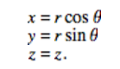

**Figure 2** (**CIE Luv Color System Footnote**)**:** Graphical Representation of CIE Luv Color Space

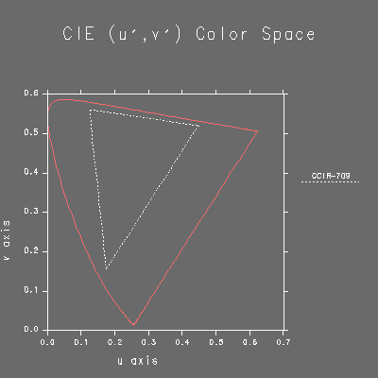

**Figure 3: Statistical data for Incandescent Light Source**

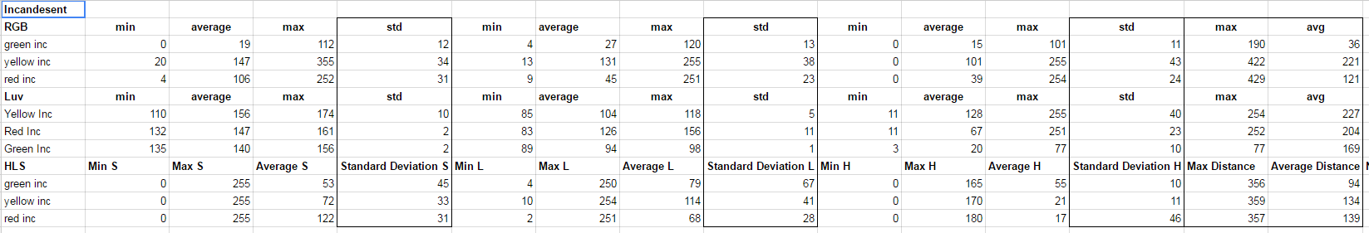

**Figure 4: Statistical data for Fluorescent Light Source**

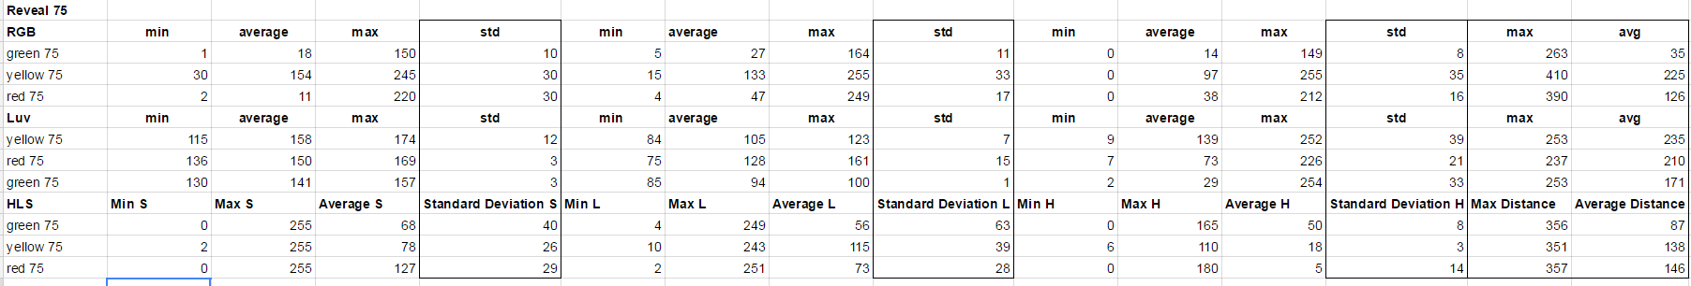

**Figure 5: Statistical data for Reveal 75 Light Source**

