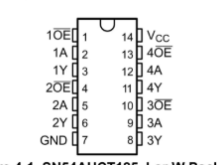
Logic Shifter:

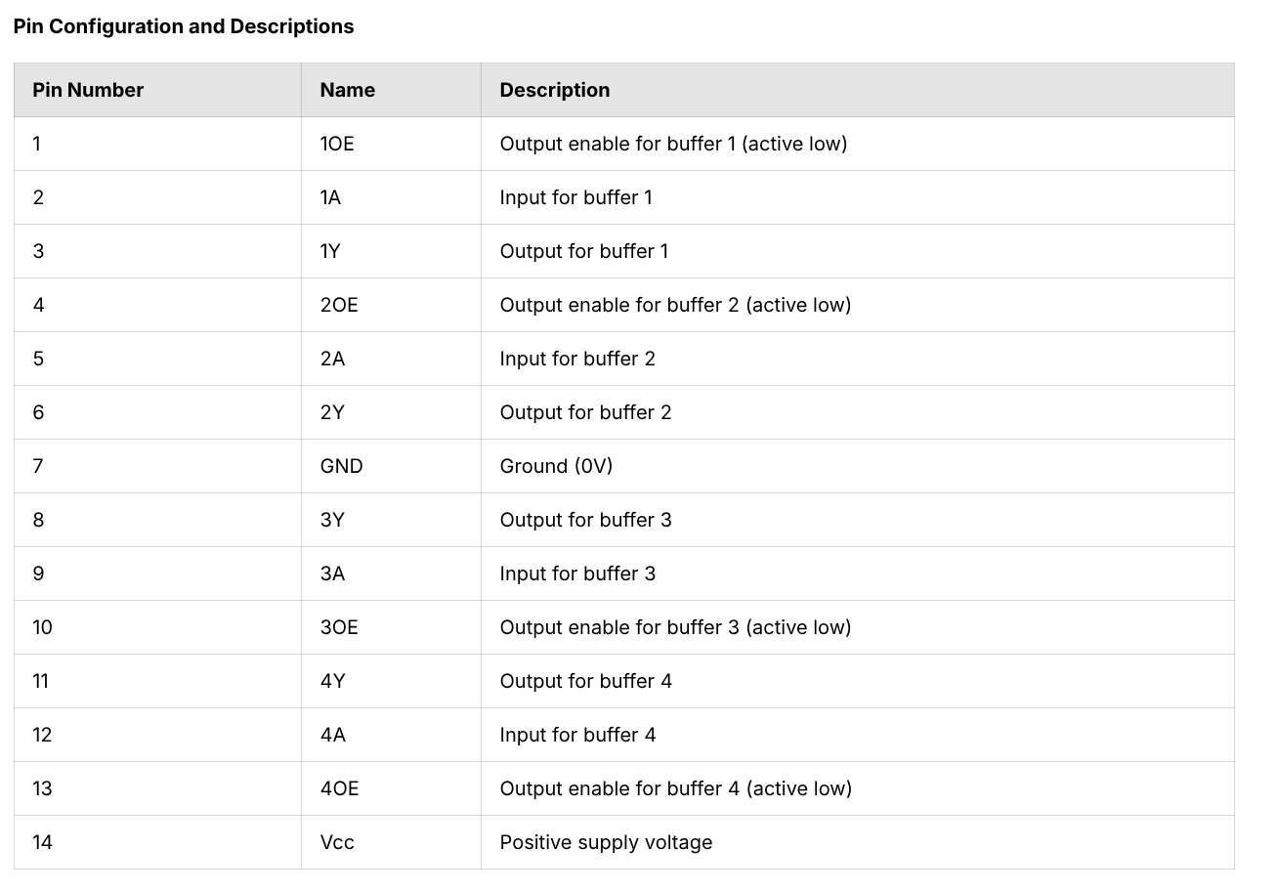
https://docs.cirkitdesigner.com/component/649238c0-55da-47bc-8142-ed92a750da12/sn74ahct125n

