AOI_PackML

Description:
This AOI (Add-On-Instruction, encapsulated and protected code) is meant to control the mode and state of a machine, as defined in the ISA report “ISA-TR88.00.02, Machine and Unit States: An Implementation Example of ISA-88, August 1 2008”. Chapters 4-6 of this document provide a detailed understanding of modes and states. The following is list of the functionality included in this AOI:
- Mode Manager: Controls the mode of the machine, allowing the mode to be changed only if the machine is in the correct state to leave and enter the new mode.
- State Manager: Controls the state of the machine, conforming to the model in the PackML standard.

PackML State Model:
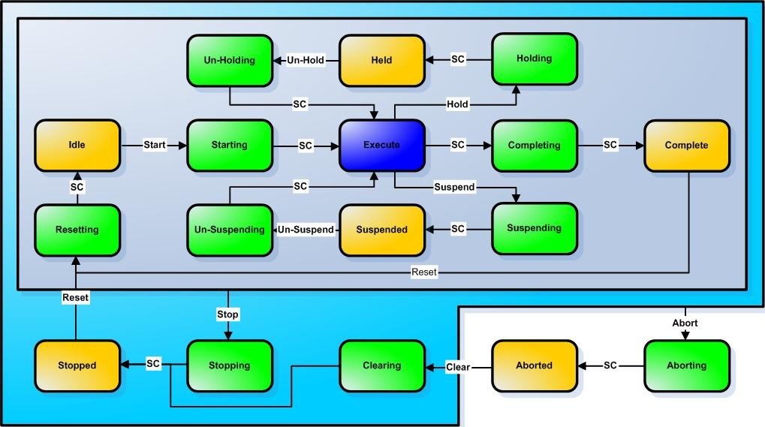
SC = State Complete
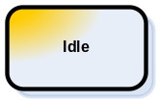= Wait State 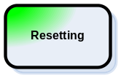= Acting State 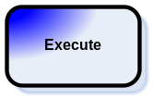= Dual State

Ladder Instruction:
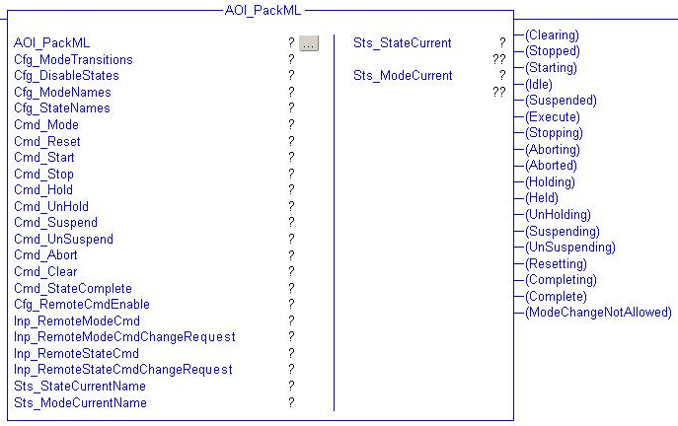

Function Block Instruction:
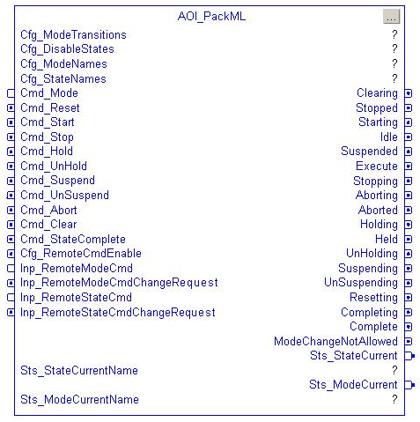

Structured Text Instruction:
AOI_PackML(AOI_PackML, Cfg_ModeTransitions, Cfg_DisableStates, Cfg_ModeNames, Cfg_StateNames, Sts_StateCurrent, Sts_StateCurrentName, Sts_ModeCurrent, Sts_ModeCurrentName);

Parameters:
Name | Data Type | Req? | Usage | Units | Acceptable Values | Description
AOI_PackML | AOI_PackML | Y | InOut |  |  | This is the AOI control tag
EnableIn | BOOL |  | Input
EnableOut | BOOL |  | Output
Cfg_ModeTransitions | DINT[32] | Y | InOut |  |  | An array of acceptable mode transitions. Each element in the array represents a mode, and each bit in the array element represents a state. See Mode Transitions later in this document.
Cfg_DisableStates | DINT[32] | Y | InOut |  |  | An array representing each mode and their states. Each mode can individually disable certain states. For example, to disable the Held state in Mode 1, set Cfg_DisableStates[1].11 to TRUE (1). In this example, Cfg_DisableStates[1] represents mode 1 and bit 11 represents the Held state. For more information about the state values, see OutStateCurrent.
Cfg_ModeNames | STRING[32] | Y | InOut |  |  | A list of mode names for display on an operator interface or line controller. The value inside Cfg_ModeNames[1] represents the name of Mode 1.
Cfg_StateNames | STRING[18] | Y | InOut |  |  | A list of state names for display on an operator interface or line controller. The value inside Cfg_StateNames[1] represents the name of State 1, i.e. “Clearing”.
Cmd_Mode | DINT |  | Input |  | only modes 1-32 are defined in this AOI | Commanded Mode. If the value of the commanded mode is different from the current mode, the mode will transition only if the Cfg_ModeTransitions bit elements are set to true for both modes for the current state. If the commanded mode is invalid, then the ModeChangeNotAllowed bit will become true and the Cmd_Mode will change back after 3 seconds.
Cmd_Reset | BOOL |  | Input |  |  | Reset Command
Cmd_Start | BOOL |  | Input |  |  | Start Command
Cmd_Stop | BOOL |  | Input |  |  | Stop Command
Cmd_Hold | BOOL |  | Input |  |  | Hold Command
Cmd_UnHold | BOOL |  | Input |  |  | Un-Hold Command
Cmd_Suspend | BOOL |  | Input |  |  | Suspend Command
Cmd_UnSuspend | BOOL |  | Input |  |  | Un-Suspend Command
Cmd_Abort | BOOL |  | Input |  |  | Abort Command
Cmd_Clear | BOOL |  | Input |  |  | Clear Command
Cmd_StateComplete | BOOL |  | Input |  |  | State Complete Command
Cfg_RemoteCmdEnable | BOOL |  | Input |  | 0 = Disable  1 = Enable | The AOI can accept remote state commands instead of programming the bits for Cmd_Reset, Cmd_Stop, etc. To enable this feature, this enable bit must be TRUE (1). Go to the data table to view this value.
Inp_RemoteModeCmd | DINT |  | Input |  | 1-31 | Value of the remote mode command.
Inp_RemoteModeCmdChangeRequest | BOOL |  | Input |  | 1 = Accept Remote Mode Cmd | This value must be TRUE (1) to accept the remote mode command.
Inp_RemoteStateCmd | DINT |  | Input |  | 0 = Undefined  1 = Reset  2 = Start  3 = Stop  4 = Hold  5 = Un-Hold  6 = Suspend  7 = Un-Suspend  8 = Abort  9 = Clear | Value of the remote state command.
Inp_RemoteStateCmdChangeRequest | BOOL |  | Input |  | 1 = Accept Remote Cmd | This value must be TRUE (1) to accept the remote state command.
Clearing | BOOL |  | Output |  |  | Machine state is Clearing
Stopped | BOOL |  | Output |  |  | Machine state is Stopped
Starting | BOOL |  | Output |  |  | Machine state is Starting
Idle | BOOL |  | Output |  |  | Machine state is Idle
Suspended | BOOL |  | Output |  |  | Machine state is Suspended
Execute | BOOL |  | Output |  |  | Machine state is Execute
Stopping | BOOL |  | Output |  |  | Machine state is Stopping
Aborting | BOOL |  | Output |  |  | Machine state is Aborting
Aborted | BOOL |  | Output |  |  | Machine state is Aborted
Holding | BOOL |  | Output |  |  | Machine state is Holding
Held | BOOL |  | Output |  |  | Machine state is Held
UnHolding | BOOL |  | Output |  |  | Machine state is UnHolding
Suspending | BOOL |  | Output |  |  | Machine state is Suspending
UnSuspending | BOOL |  | Output |  |  | Machine state is UnSuspending
Resetting | BOOL |  | Output |  |  | Machine state is Resetting
Completing | BOOL |  | Output |  |  | Machine state is Completing
Complete | BOOL |  | Output |  |  | Machine state is Complete
ModeChangeNotAllowed | BOOL |  | Output |  |  | Mode change was not allowed. This indicates that either an invalid mode number was commanded or that the Cfg_ModeTransitions word does not allow a mode change for the machine current state. This bit will stay on for 3 seconds.
Sts_StateCurrent | DINT | Y | Output |  | 0 = Undefined  1 = Clearing  2 = Stopped  3 = Starting  4 = Idle  5 = Suspended  6 = Execute  7 = Stopping  8 = Aborting  9 = Aborted  10 = Holding  11 = Held  12 = UnHolding  13 = Suspending  14 = Unsuspending  15 = Resetting  16 = Completing  17 = Complete | Current state of the machine
Sts_StateCurrentName | STRING | Y | InOut |  |  | Name of the current state
Sts_Mode | DINT |  | Output |  | Sts_Mode.1 = Mode 1,  Sts_Mode.2 = Mode 2, etc. | Array of bits that represents the current mode. This can be used in the machine program to condition logic that is mode dependent. Go to the data table to view this value.
Sts_ModeCurrent | DINT | Y | InOut |  |  | Current mode of the machine
Sts_ModeCurrentName | STRING | Y | InOut |  |  | Name of the current mode
Sts_DisableStates | DINT |  | Output |  |  | Lists the currently disabled states for the current mode. For example, OutDisableStates.5 indicates the Suspended state has been disabled for the current mode.

Mode Transitions
The following example will show how to use the Cfg_ModeTransitions and Cfg_DisableStates bits.

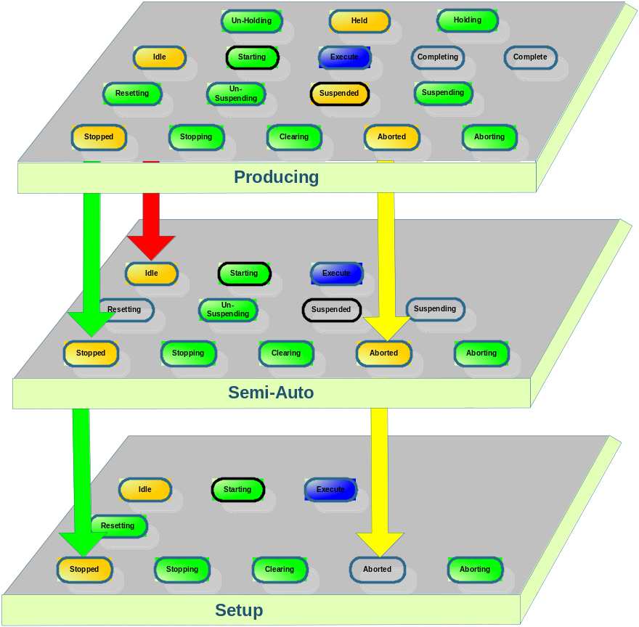

 | Producing Mode | Semi-Auto Mode | Setup Mode
Mode Value | 1 | 2 | 3
Acceptable Mode Transitions | Cfg_ModeTransitions[1].4 = 1 (enable transition to/from idle),  Cfg_ModeTransitions[1].9 = 1,  Cfg_ModeTransitions[1].2 = 1,  All other Cfg_ModeTransitions[1] bits=0 | Cfg_ModeTransitions[2].4 = 1 (enable transition to/from idle),  Cfg_ModeTransitions[2].9 = 1,  Cfg_ModeTransitions[2].2 = 1,  All other Cfg_ModeTransitions[2] bits=0 | Cfg_ModeTransitions[3].9 = 1,  Cfg_ModeTransitions[3].2 = 1,  All other Cfg_ModeTransitions[3] bits=0
Disabled States | All Cfg_DisableStates[1] bits=0 | Cfg_DisableStates[2].10 = 1 (disable Holding state),  Cfg_DisableStates[2].11 = 1,  Cfg_DisableStates[2].12 = 1,  Cfg_DisableStates[2].16 = 1,  Cfg_DisableStates[2].17 = 1,  All other Cfg_DisableStates[2] bits=0 | Cfg_DisableStates[3].5 = 1,  Cfg_DisableStates[3].10 = 1,  Cfg_DisableStates[3].11 = 1,  Cfg_DisableStates[3].12 = 1,  Cfg_DisableStates[3].13 = 1,  Cfg_DisableStates[3].14 = 1,  Cfg_DisableStates[3].16 = 1,  Cfg_DisableStates[3].17 = 1,  All other Cfg_DisableStates[3] bits=0

With this setup, if the machine is in the producing mode and in the stopped state, then mode transitions to semi-auto and setup are permitted. If the machine is in the producing mode and in the idle state, then a mode transition to semi-auto is permitted and to setup is not permitted. If the machine is in the setup mode and in the idle state, then no mode transitions are permitted.

Note that if the Held state is disabled in a particular mode, the Holding and UnHolding states will automatically become disabled and the Cmd_Hold and Cmd_UnHold commands will be unobserved for that particular mode. Similarly if the Suspended state is disabled in a particular mode, the Suspending and UnSuspending states will automatically become disabled and the Cmd_Suspend and Cmd_UnSuspend commands will become unobserved for that particular mode. Finally if the Complete state is disabled in a particular mode, the Completing state will automatically become disabled for that mode as well.

Typical Instruction Use
The AOI is designed to be run with no rung input conditions. The following rungs show the instruction and sample command and state complete logic.
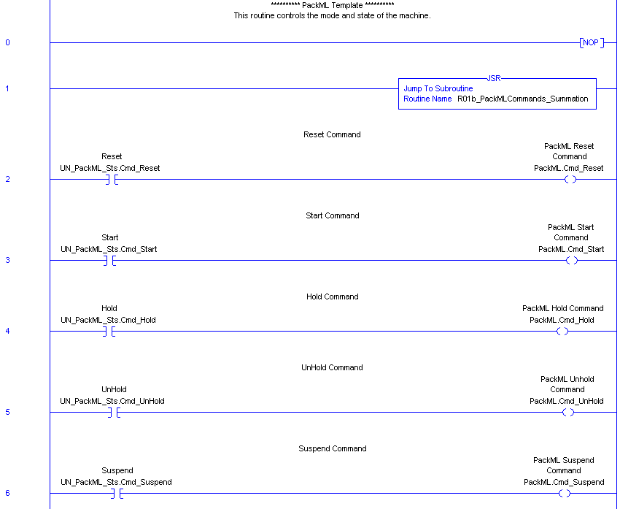

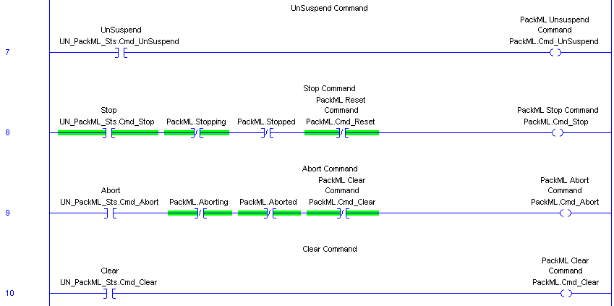
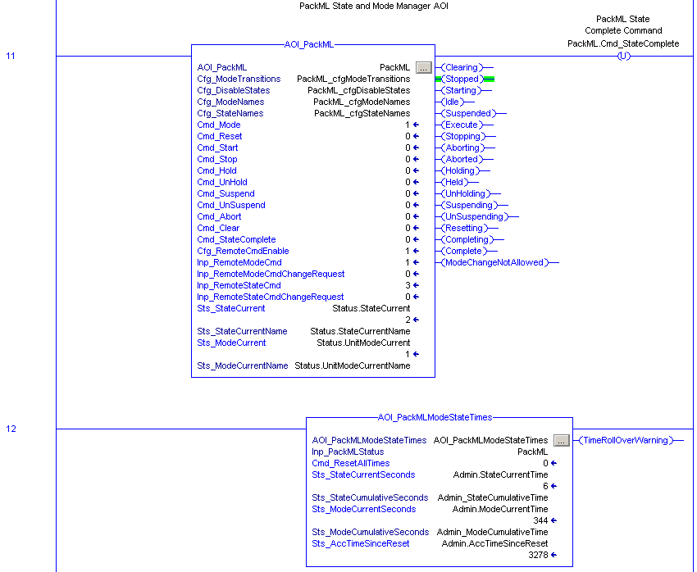
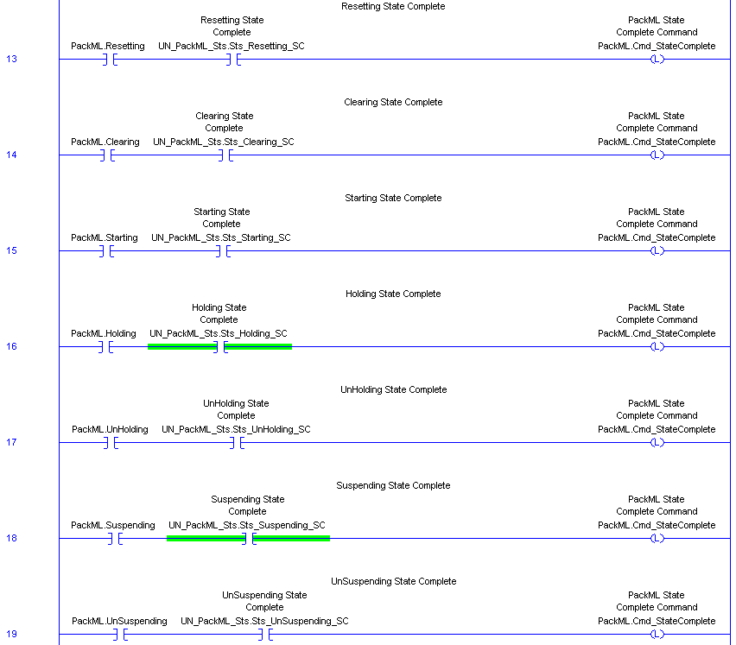
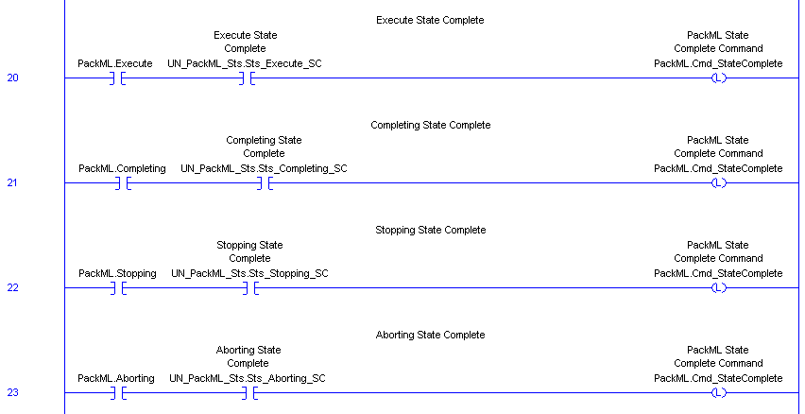

AOI Revision History
1.0 Initial Release
- Initial Release

1.1 Remote Mode Capability
- Added remote mode control capability
- Displayed remote interface on the AOI faceplate
- Removed OutError and Error bit since they are not needed

1.2 Adjusted logic slightly to reduce scan time
- Adjusted logic slightly to reduce scan time

1.3 Remove Mode and State Timers
- Removed Mode and State Timers and put into a separate AOI
- Updated naming conventions

