Project 2: SplashTable
Test has been conducted by generating random 32 bit keys and payloads using the attached program test, based on TestTable.cpp. Our results can be replicated by running the program with the following parameters:
test B R S h N
Where the first four arguments are the usual while N is the number of repeated tests to be performed.
If nothing else mentioned, R = 1000, as in the reference paper, and a table size of 2¹⁶ has been used, a tradeoff between reasonable table size for reliable results and time when running the same test multiple times to collect more data.
In table 1, load factors have been derived based on 100 tests each:
B | H | Load factor
2 | 2 | 0.889
4 | 2 | 0.976
4 | 3 | 0.998
4 | 4 | 0.9996
8 | 2 | 0.997
Table 1: Load factors in relation to different B and H.
It is clear that compared to the results in the reference document, we have achieved close to similar results.
In figure 2, the different load factors as a function of R are presented. It is clear that R is important for performance, and increases the load factor by around 20 % for even the best performing combinations of B and H.
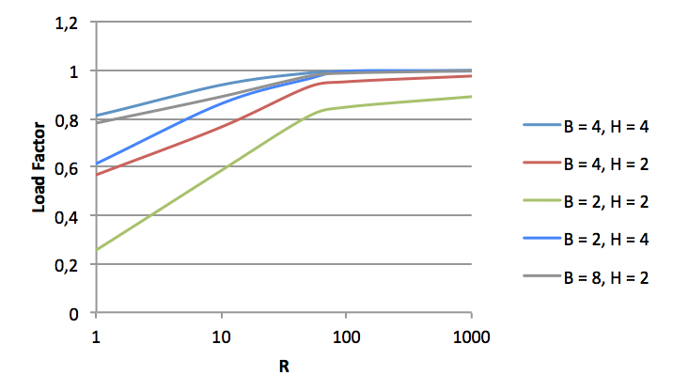
Figure 2: Load sizes as a function of R.
When performing a test with B = 1, we experienced a load factor similar to research results achieved with tables based on constant time lookups, as shown in table 2.

H | Load Factor
2 | 0.51 (0.49)
3 | 0.906 (0.91)
4 | 0.968 (0.97)
5 | 0.986 (0.99)
Table 2: Load factor with B = 1. Load factor shown in parentheses are data from referenced research.
We did, however, experience stable results when B = 1, H = 2, and did not experience any exceptionally low performance. However, this can happen in cases if H1(K1) = H2(K1) for a key K1 that are to be re-inserted in the table in a bucket where H1(K2) = H2(K2). This is, though, an extremely rare case.
Lastly, testing when S > 16 takes considerable longer time to perform, however, an interesting factor are revealed when testing different table sizes, as seen in figure 2.
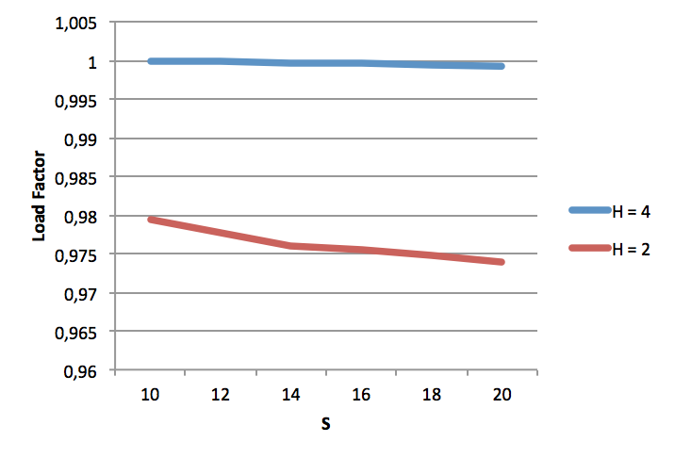
Figure 1: Different H values in respect to S while B = 4.
The more entries in the table, the more important the number of hash functions, it seems. However, in the case above, going from 1,024 to 1,048,576 entries only result in a 0,55 % decrease in the load factor when H = 2.

D. Fotakis et al. Space efficient hash tables with worst case constant access time. Theory Comput. Syst., 38(2):229–248, 2005.

