Exercise 1:

PUSH M2

PUSH M4

MUL //M2*M4

POP M5

PUSH M5

PUSH M3

ADD //M3+(M2*M4)

POP M6

PUSH M1

PUSH M2

ADD //M1+M2

POP M7

PUSH M6

PUSH M7

MUL

POP M2 //(M1+M2)*(M3+(M2*M4))

Exercise 2:

**__attribute__**(( naked )) **void** **asm_test**(**int** *a, **int** *b, **int** *c, **int** *d)

{

**asm** **volatile**

(

"push {r4, r5, r6, r7} \n"

"ldr r4, [r0] \n"

"ldr r5, [r1] \n" //r5 = M2

"adds r6, r4, r5 \n" //r6 = M1+M2

"ldr r4, [r3] \n" //r4 <- M4

"muls r4, r5, r4 \n" //r4 = M2*M4

"ldr r5, [r2] \n" //r5 <- M3

"adds r7, r4, r5 \n" //r7 = M3+(M2*M4)

"muls r7, r6, r7 \n" //r7 = (M1+M2)*(M3+(M2*M4))

"str r7,[r1] \n"

"pop {r4, r5, r6, r7} \n"

"bx lr \n"

);

}

**void** **fail**() {

**printf**("Failed\n"); // set a break point here

}

Exercise 3:

Part A:

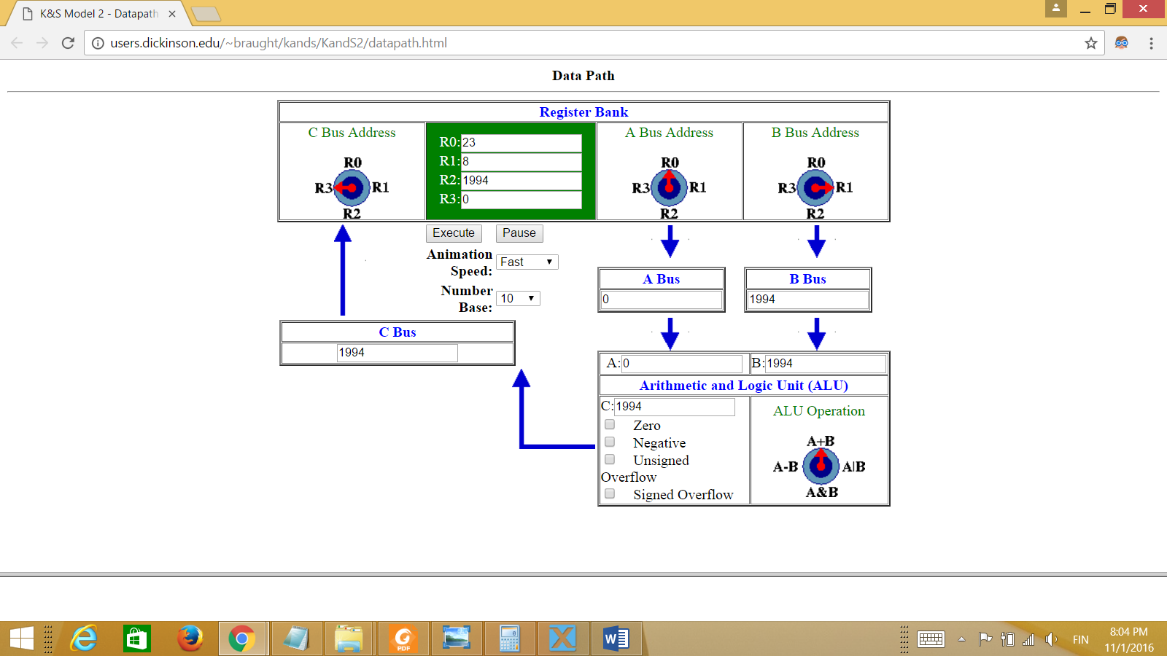

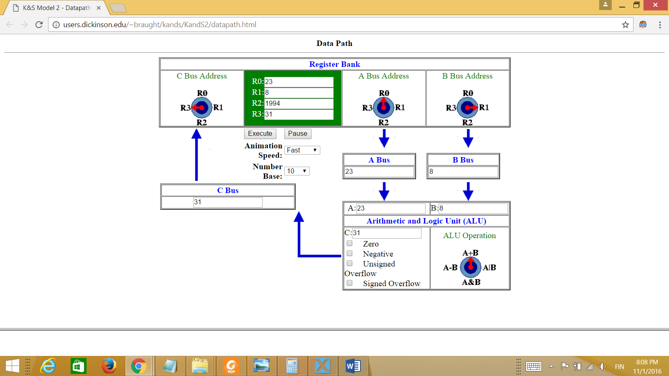

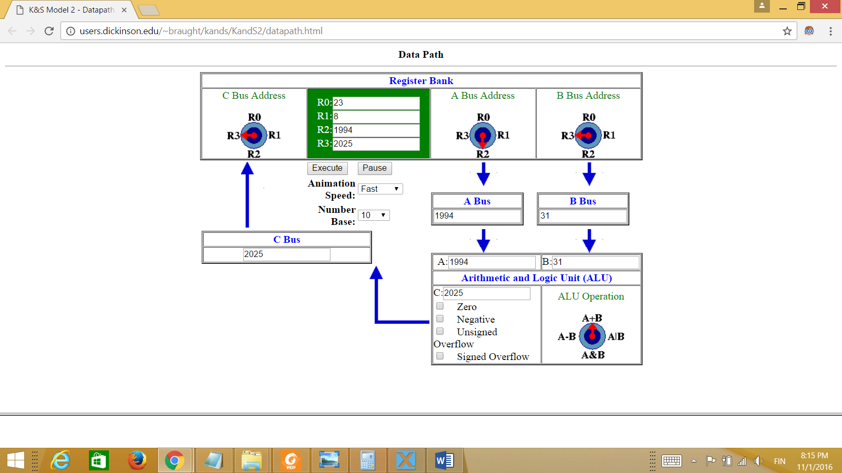

Part B:

