MEMORY ASSIGMENT

Vo Hieu Nghia

# 1.

Processor have 24bit address bus 🡺 2^24 = 16 MB

The total capacity of the memory (not including EEPROM): 2 MB Flash + 1 MB static RAM + 6 MB reserved flash + 3 MB RAM expansion + 2 MB reserved unspecified = 14 MB

Therefore, EEPROM can be extended up to: 16 MB – 14 MB = 2 MB

* The capacity that EEPROM can be extended: 2 MB – 256 kB = 2048 kB – 256 kB = 1792 kB

# 2.

Memory map:

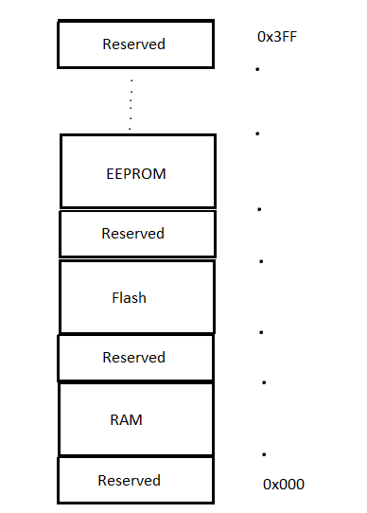

# 3.

1 chip 128 M x 8 (8 bits = 1 Byte) 🡺 128 MB

Therefore, the number of needed chips are: 4 GB / 128 MB = 4096 MB / 128 MB = 32

And it will be organized like the picture below:

