Plots

Bank <- read.csv("~/Desktop/MSA_6440/customer_churn/data/processed/BankChurners_filtered.csv")

## Exploratory Plots

# Plot of attrition flag  
plot(Bank$Attrition_Flag)

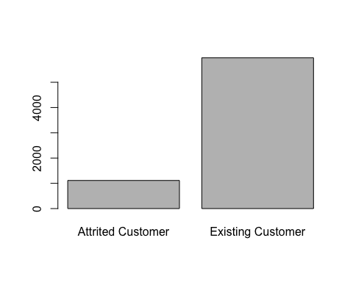

library(plyr)  
count(Bank, 'Attrition_Flag')

## Attrition_Flag freq  
## 1 Attrited Customer 1113  
## 2 Existing Customer 5968

1113/7081 # Percent customer attrition

## [1] 0.1571812

# Histogram of customer age  
hist(Bank$Customer_Age, main = 'Customer Age')

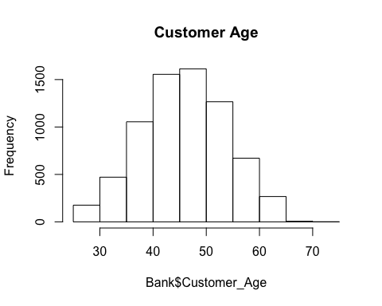

# Plot of gender  
plot(Bank$Gender, main = 'Gender Distribution')

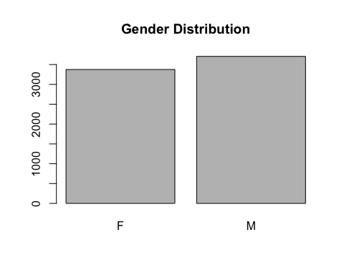

# Plot of education level  
plot(Bank$Education_Level, main = 'Education Level')

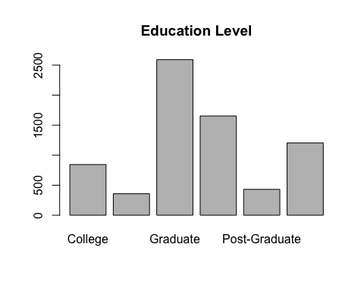

# Plot of marital status  
plot(Bank$Marital_Status, main = 'Marital Status')

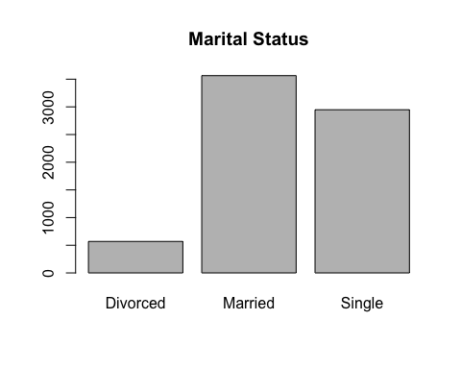

# Plot of income  
plot(Bank$Income_Category, main = 'Income Category')

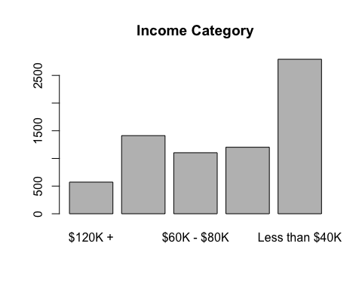

# Histogram of months on book  
hist(Bank$Months_on_book, main = 'Months on Book')

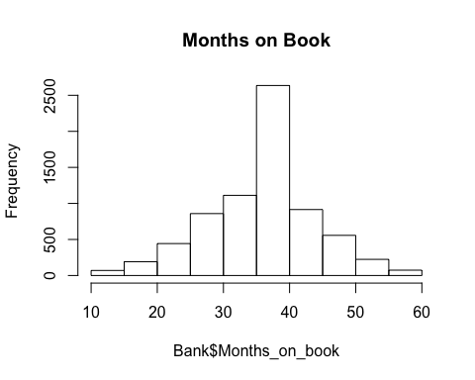

# Histogram of credit limit  
hist(Bank$Credit_Limit, main = 'Credit Limit')

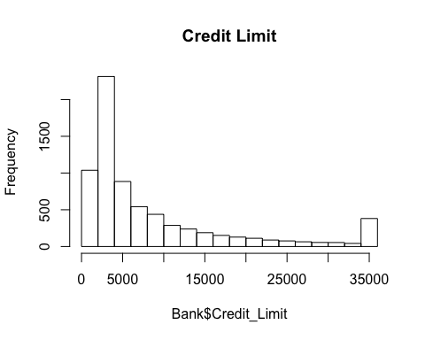

# Histogram of average utilization ratio  
hist(Bank$Avg_Utilization_Ratio, main = 'Average Utilization Ratio')

