Model Results

Nick Wawee

4/6/2021

## Overall Results Plot

### Input Data

rn = c('Accuracy', 'Sensitivity', 'Specificity', 'Kappa')  
  
#all samples  
df_all = data.frame('Stepwise Logit'= c(0.8644, 0.8780, 0.7923, 0.5689),  
 'CCT' = c(0.8701, 0.8786, 0.8249, 0.5911),  
 'MLP' = c(0.9077, 0.9116, 0.8872, 0.698),  
 'KNN' = c(0.8781, 0.9692, 0.3947, 0.4434),  
 'Random Forest' = c(0.956, 0.819, 0.982, 0.83),  
 'ADABoost'= c(0.968, 0.875, 0.986, 0.879))  
  
row.names(df_all) = rn  
df_all$Metric = rn  
df_all.m = melt(df_all)

## Using Metric as id variables

#undersample  
  
df_under = data.frame('Stepwise Logit'= c(0.8013, 0.7862, 0.8813, 0.4729),  
 'CCT' = c(0.8484, 0.8372, 0.9080, 0.5675),  
 'MLP' = c(0.8202, 0.8058, 0.8961, 0.5103),  
 'KNN' = c(0.8084, 0.8114, 0.7923, 0.4569),  
 'Random Forest' = c(0.924, 0.944, 0.921, 0.753),  
 'ADABoost'= c(0.938, 0.953, 0.935, 0.792))  
row.names(df_under) = rn  
df_under$Metric = rn  
df_under.m = melt(df_under)

## Using Metric as id variables

### All Sample Plot

df_all.m$Labels = round(df_all.m$value, 2)  
p = ggplot(data = df_all.m, aes(y = value, x = variable, fill = Metric))+  
 geom_col(position=position_dodge(), colour="black")+labs(x = 'Model', y='Evaluation Metric', title = 'Model Performance with All Samples')+ geom_text(aes(label=Labels), position = position_dodge(width=0.9),color="white", size=4, hjust = 1.1, fontface = 'bold')+plot_opts+theme(axis.text.x = element_text(face = 'bold'), axis.text.y = element_text(face = 'bold'), legend.title = element_text(face = 'bold'))+coord_flip()+scale_fill_brewer(palette = 'Set1')+ylim(0,1)  
p

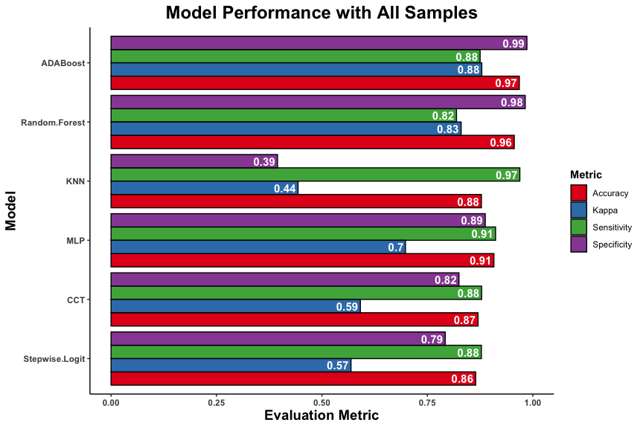

ggsave('../plots/allsample_metrics.png',plot = p, device = 'png', height = 6, width = 9, units = 'in', dpi = 600)

### Undersample Plot

df_under.m$Labels = round(df_under.m$value, 2)  
p = ggplot(data = df_under.m, aes(y = value, x = variable, fill = Metric))+  
 geom_col(position=position_dodge(), colour="black")+labs(x = 'Model', y='Evaluation Metric', title = 'Model Performance with Downsampling')+ geom_text(aes(label=Labels), position = position_dodge(width=0.9),color="white", size=4, hjust = 1.1, fontface = 'bold')+plot_opts+theme(axis.text.x = element_text(face = 'bold'), axis.text.y = element_text(face = 'bold'), legend.title = element_text(face = 'bold'))+coord_flip()+scale_fill_brewer(palette = 'Set1')+ylim(0,1)  
p

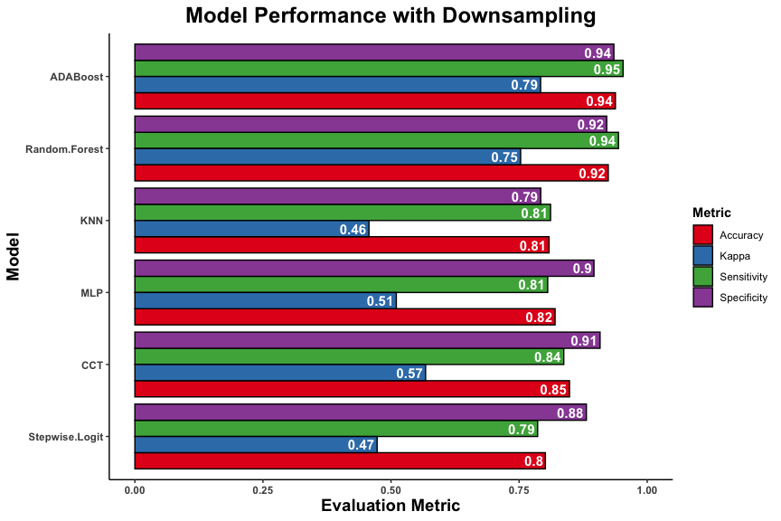

ggsave('../plots/undersample_metrics.png',plot = p, device = 'png', height = 6, width = 9, units = 'in', dpi = 600)