Reverberation and Clarity

Reverberation is defined as the phenomenon in which sound persists after it is stopped being produced. This occurs when sound bounces off walls, objects, or people and remains in the air until it is finally absorbed or escapes the confining space. Some frequencies may remain in the space longer than others, or even cancel one another out. Reverberation is one major player in the acoustic fingerprint of a room, and ultimately how fit that room is for a desired function. Architectural acoustics places a large emphasis on the reverberation time of a room for this reason. A short reverberation time can make a room sound “dry” or “dead”. This is perfect for rooms where speech needs to be easily discernible but can be problematic for music, making an orchestra sound less impressive. As reverberation time increases, clarity decreases. If a room has a lot of reverberation, noise can easily overwhelm the desired sound. For example, human speech can be hard to interpret in a noisy room if there is a lot of reverberation because even previously spoken words drown out the desired, present signal. Reverberation is a major source of errors in automatic speech recognition.

Concert halls and performing arts centers like the Ferst Center have unique requirements when it comes to reverberation time and clarity. In an ideal situation, the stage would have very dry acoustics and the audience seating areas would have live acoustics. This makes it easy for performers to hear themselves and their ensemble to make quick, on-the-fly adjustments while still producing a broad and impressive listening experience. These design constraints are why the fields of architectural acoustics and sound engineering exist.

To measure the reverberation time of a room, one can find how long it takes for an impulse to decay by 60 dB. This is called the $T_{60}$ time. However, it can be hard to find when the signal passes the 60 dB threshold because of the noise floor, so instead the $T_{30}$ and $T_{20}$ times can be used to estimate the $T_{60}$ value.

$T_{60} ≈\frac{2* T_{30}+ 3* T_{20}}{2}$

A $T_{60}$ time of a classroom should be kept around 0.6 to 0.8 seconds to maintain speech clarity while a $T_{60}$ time of a concert hall hosting a symphonic band should be in the range of 1.7 to 2.3 seconds. We took a recording of a wood block clap occurring onstage in four locations in the Ferst Center: onstage, in the middle of the auditorium, and both sides of the auditorium. The reverberation time ($T_{60}$) was then evaluated for all the signals to get an insight into how “live” or “dry” sounds coming from the stage sound to the human ear in the different locations.

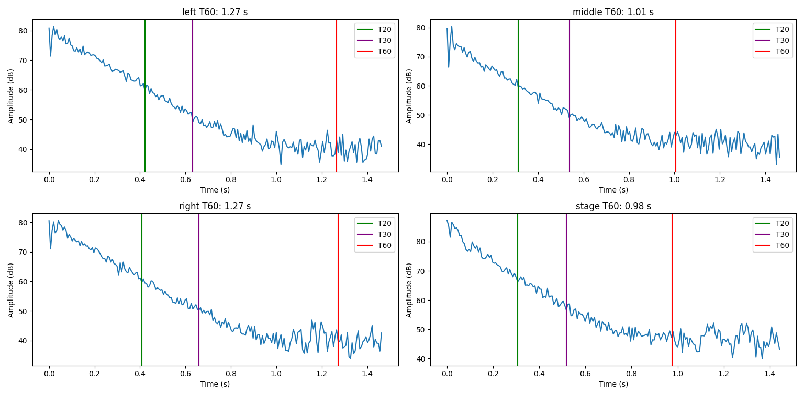

**Figure 1. Plotted reverberation times for a wood block clap measured at different locations in the Ferst Center at Georgia Tech**

Interestingly, the reverberation time at the sides of the Ferst center is significantly higher than the reverberation time on the stage and in the middle seats. This could be a result of proximity to walls, as the side seats might hear reflections from the opposite walls at later times than the middle seats. The average reverberation time of just over a second seems a bit low for a performing arts center, but maybe the architects wanted a balance between a presentation setting and a theatrical/musical setting. Aso, reverberation time is a frequency dependent measurement so a wood block clap may not be the best way to interrogate this property of the space. Usually, the reverberation is measured independently for target frequency ranges, but the wood block clap provides a signal composed of a very wide range of frequencies at once.

A related measurement is the clarity index, which is inversely proportional to the reverberation time. As reverberation time increases, clarity decreases. The clarity index is measured as a proportion of the energy at the front of an impulse response to the back of an impulse response in decibels. The most popular objective clarity measurement is the $C_{80}$ clarity index defined as:

$C_{80}=10*log⁡(\frac{Energy in the First 80 Milliseconds}{Late Sound Energy})$

This was computed for the signals as mentioned before, as well as a hand clap in a large lecture hall at Georgia Tech. To compute the energy ratio, the squared amplitude was summed over the respective time intervals. The beginning of the impulse was found at the maximum derivative of the amplitude, and the end was found with a sliding window until the average amplitude was at the noise floor.

**Figure 2. Plotted clarity indices for a wood block clap at different locations in the Ferst Center at Georgia Tech**

**Figure 3. Plotted clarity index for a hand clap in a large lecture hall at Georgia Tech**

As expected, the areas with a high reverberation time have a low clarity index. This means that if one were to sit towards the sides of the auditorium, music and speech coming from the stage would be less crisp than if listening from the center of the auditorium. To compare this to a space that was engineered for a different purpose, we ran the same analysis for a large lecture hall in the Center for Undergraduate Learning Commons (CULC) at Georgia Tech. The clarity index was considerably higher for this room, and that makes sense for a room that is meant for lectures. A large part of what contributes to this difference is the shape of the room, as well as the sound dampening panels on the wall which eliminate a good portion of sound reflections. The quick pulse of energy at about 0.14 seconds shows that some of the reflections can create a sizable sound well after the initial clap.

One major problem with our recording was an improper level adjustment. As you can see in some of the plots, the amplitude reached the maximum gain for some of the impulses, and therefore cut off some of the peaks. The overarching relationships between signals were maintained, but some of our calculations may have sizable errors.