In this part of the experiment, you will see words one at a time. Each trial begins with exclamation marks (‘!!’), and is then followed by a circle that can appear in a red, blue, or white color. After a brief delay filled with a ‘+’, you will be presented with the word, which can also appear in a red, blue, or white color. The color of the circle or word indicate which judgment you will make about the word. The two judgments are: **shoebox** and **manmade.** The **shoebox** judgment is associated with red circles and words, whereas the **manmade** judgment is associated with blue circles and words.

**Shoebox:** For this judgment, you will answer the question, “Does the item fit inside of a shoebox?” If you think it will, answer yes by pressing the “f” key with your left index finger. If not, answer no by pressing the “d” key with your left middle finger. Please be aware that responding to the shoebox task with your right hand is an incorrect response.

**Manmade:** For this judgment, you will answer the question, “Is the item a manmade object?” If you think the item is manmade, answer yes by pressing the “j” key with your right index finger. If not, answer no by pressing the “k” key with your right middle finger. Please be aware that responding to the manmade task with your left hand is an incorrect response.

The four types of trials are shown in the below image. Circles that appear in red or blue, and will be followed by a word in white. For these trials, the color of the circle indicates which judgment you will make about the following word. During the delay, keep the judgment in mind so you can make the appropriate judgment when you see the word.

White circles indicate that a red or blue word is about to appear, and that you will be instructed which judgment to make when you see the word. On these trials, the word will always be presented in red or blue font, and you should use this to make the appropriate judgment on the word.

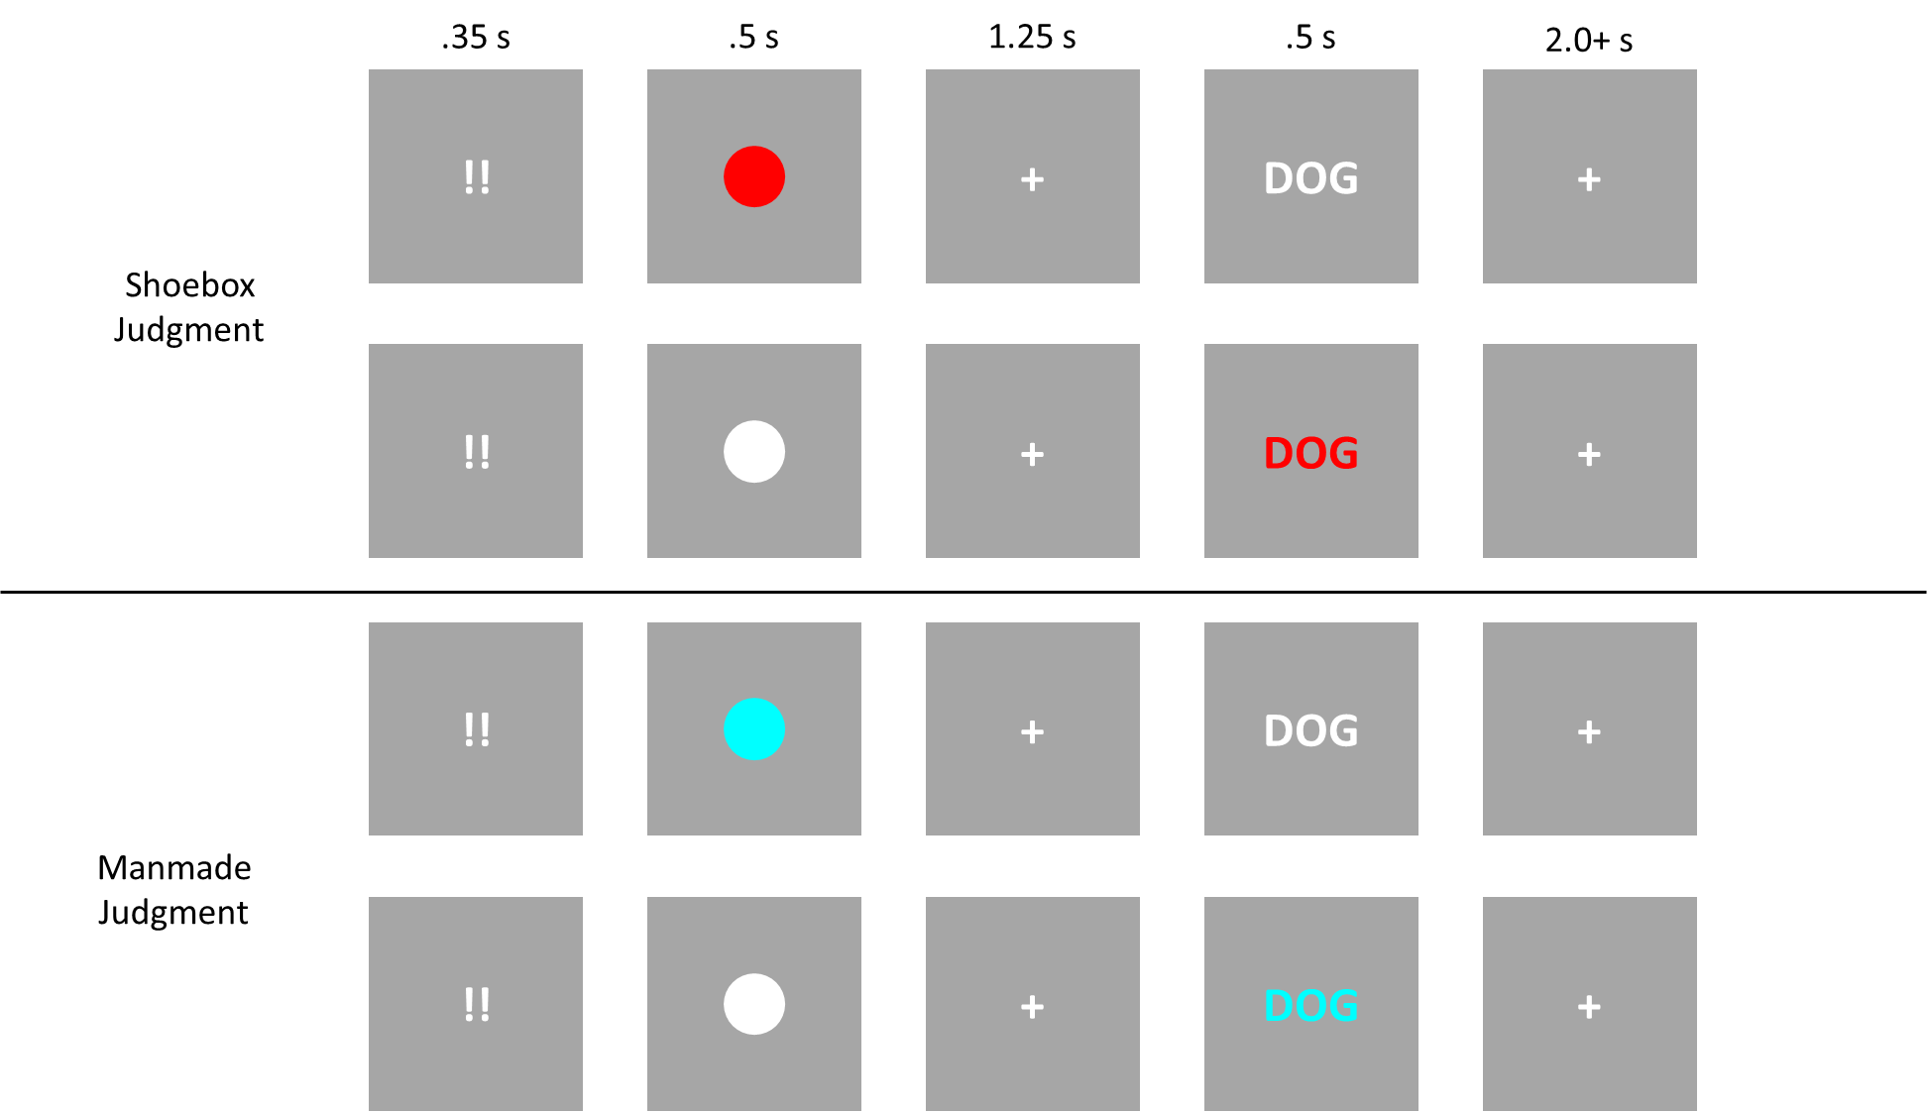

Please enter your responses as quickly and accurately as possible after the word appears. Responses should be entered before the next trial begins. Do you have any questions?