Week 4: Visualizing Proportions and Relationships

Proportions
We often encounter datasets in which we want to visualize parts of a whole – how some amount breaks down into a sum of component categories. We call these proportions. When we talk about visualizing proportions, pie charts are the first thing that typically come to mind. In todays lecture, I want to not only offer some helpful guidelines around the use of pie charts, but also provide some alternatives that can be more useful in some situations.
Pie Charts - when they work (multiple pies from policy viz article)
- The case against: As I just said, the pie chart is the archetype data visualization choice for showing part-to-whole relationships in data, or proportions. However, there are a few fundamental problems with the pie chart, and it’s why, in the data viz and data science community, they are despised. The major problem with them is that they make comparisons extremely difficult. This comes down to the fact that we don’t truly understand how the human brain perceives quantities from pie slices. It could be from the angle that’s created at the center of the pie, it could be from the total area of the pie slice, or it could be from the length of the arc, or the “crust” of the pie slice on the outside. Research has been done to try to determine this, but has thus far been inconclusive. Regardless, determining the area of various slices becomes incredibly difficult both when you have many categories, and when you have categories of similar size.
Having too many categories can make the chart illegible. For example, look at this breakdown of all majors at the Business school at St. John’s University by enrollment. Can anyone make sense of that? It’s simply too many categories to make sense of, but you’d be surprised at how often I see people making pie charts like this, or worse, ASKING ME to make pie charts with data like this.
Having multiple categories of similar size can make comparison difficult or impossible, even if there are only a few categories. Let’s look at a now-famous example. Look at each of the pie charts, A, B, and C, and without looking at the bar charts underneath, try to order the slices by size. You’ll find that it’s nearly impossible, though when you use bars to display the values instead, it becomes blatantly obvious how to rank them. This is an important point to remember, because you might think that only having 5 categories, as in this example, might make a pie chart a fine choice. However, because the data values are so close together, the pie chart does not work very well.
Another thing to avoid with pie charts is using pairs, or multiple pie charts to show the changes in proportions over time or between groups. This can be confusing, as they force the viewer to go back and forth between the charts to try to make comparisons. This data from our book is a great example. It shows the changing market share of 5 hypothetical companies (A,B,C,D, and E) over 3 years. Can anyone make a conclusion from this? Did the market share of C grow or shrink? What about B? It’s nearly impossible to tell.
- The case for: With all of that being said, pie charts can sometimes be useful. Take for example the charts used in the Policy Viz article that we read this week. The author was looking at fundraising data for a non-profit organization, and was trying to show that most of the money raised came from a few donors who gave extremely large donations. They start by showing a few different attempts at avoiding the bar chart – like using bars to represent the % of all donation dollars that fell into different “amount” buckets, or to represent the share of donors that gave donations of varying sizes. They also tried a scatterplot version with different axes representing different values. The point that they wanted to communicate was that a small handful of donors gave most of the money – and there are many different ways of getting that point across, none of which are by any means “wrong”. After going through these alternatives, ultimately the most intuitive design was a pair of pie charts – one in which the slices represented the share of donation dollars, and another in which the slices represented the share of donors. There are two important takeaways here: the first is to know your audience – and that is the main reason I asked you all to read this article. The author mentions that this project was going to be presented to a “general” audience, not a group of data analysts, researchers, or students. This fact had a major impact on the decision of how to visualize the data. Ultimately, they decided that a pie chart was something so familiar that it would be the best way to communicate the findings. I cannot stress this point enough – your audience should always be the most important consideration when you make design choices. Having a beautiful visualization is worthless if people can’t understand what it is telling them. The second takeaway from the article is that the author didn’t just take the standard out-of-the-box pie chart that excel, or name your favorite data viz software, spits out and call it a day, they went with the “start with gray” approach, and then carefully decided what mattered on the chart. From that point, it was a simple choice of what needed highlighting. What do we think about these pie charts? Would you change anything or do you think they work? I would add that this could have probably been simplified even further by just combining all of these slices into one big gray slice, and just call it “sub $1M”. I think the point would still hit home, that a majority of the money raised came from these large donations.
Notable angles: Another situation in which pie charts can work well is when your data can create right angles (ie, a slice represents 25, 50, or 75% of the whole). If you encounter a situation like this, take advantage of the fact that our brains are really good at noticing right angles when they are oriented correctly. Take a look at my example here. Both of these pie charts have the exact same data. However, in the chart on the left, can you tell that the red slice is 25% of the data? Probably not immediately – you probably had to look closer at the text to realize that. But if I just rotate the chart a bit, this becomes obvious with or without the labels. Again, if the point of your story is to show how a certain proportion of your data is one of these “right angle” percentages, use that to your advantage!
Donut Charts: As we mentioned earlier, it isn’t clear how we perceive values from a pie chart. We have three possibilities: We could perceive it from the angle at the center, the area of the slice, or the length of the outer arc. If it turns out that we perceive it from the length of the outer arc, then that would make a strong case for the donut chart – which is just a pie chart with the center punched out. Sometimes these can be a bit more engaging than a simple pie chart, and they also give you the opportunity to put some text, including the number representing the “whole”, at the center. All of the rules we discussed for pie charts apply to the donut charts: avoid them when there are too many slices, avoid them when your slices are of similar size, and if you have right angles, take advantage of it!
Side by Side Bars – Let’s go back to our example of looking at our 5 fake companies and comparing how their market share changed over the course of 3 years. We made the case for why a pie chart is the wrong approach here – it’s really hard to see what’s going on from year to year, and perhaps even harder to compare the slices within the same year. They are all about 20%, so the viewer can’t tell what’s going on. Well, another alternative here is to use a stacked bar chart. The stacked bar chart can be scaled such that the y-axis represents the proportion (ie, all components add up to 100%), and then each category is assigned a different color. We looked at some of these last week, so it might look familiar. But what do we notice? Well, it’s pretty easy to see that company A increased it’s market share from year to year, and company E decreased, so it’s safe to say this is an improvement over the pie chart. But what about everything in between? Companies B, C, and D are still perfectly ambiguous, for the same reasons we discussed last week. Since the bars don’t start at 0, it makes comparison really tough. IT’s still also really hard to get a sense of the proportions within a given year. For instance, who had a larger market share in 2016, company B or C?
In this case, using side-by-side, or the “grouped bar chart” approach is going to be the most legible for your audience. Now I’ll ask the same question – who had a larger market share in 2016, company B or C? Now it is clear that company B edged out company C in 2016, and was neck and neck with company A. Now, the drawback to this is that the grouped bar method doesn’t make it clear that the components of each category, or “year” in this case, sum to 100%. The viewer could maybe figure that out with enough time and the right labels, but the pie chart and stacked bars make the “proportional” nature of the data really obvious.
Stacked Bars – We’ve talked quite a bit now about the drawbacks of lots of stacked bars side-by-side. However, this problem isn’t relevant when our data is only divided into two groups. In this case, stacked bars can be an effective way of showing how a proportion of a categorical variable has changed over time. This chart, for example, shows the gender breakdown of Rwanda’s national parliament over the course of about 20 years. Because there’s only two components to each bar, it is perfectly clear how it’s changing over time. I also like the line drawn at 50%. Naturally, we know that the world is about 50% men and 50% women, so showing when a dataset crosses that threshold indicates how a distribution becomes “disproportionate”.
Another instance in which stacked bars can work is if your data is divided into 3 groups, but you only really care about 2. This chart on the bottom I think is a perfect example of this. In this case, each bar has 50 slots, each representing a state. And states are colored based on whether democrats or republicans control the state legislatures. In the middle, the white blocks are showing states where dems and republicans are evenly split, and I do think you still have the problem where these are difficult to compare. For instance, it’s not super easy to see if the “split control” group got bigger or stayed the same from 1979 to 1980. However, I don’t think it really matters in this case. If the point of this article, or this paper, was to show how the share of republican and democratic-controlled states changed over time, this chart still accomplishes that really well. They also employ the 50% mark to show where the country tips into a disproportionate state.
Density Plots – Stacked and faceted approaches – So far, we’ve looked at how a proportion changes over a categorical variable, such as “years”. In other words, we calculated the proportion at discrete intervals across a span of time. But what if we wanted to see how a proportion changed across a continuous variable? In this case, bars simply don’t work. We can use density plots instead to show changes across a continuous variable.
Here we have a stacked density plot showing how health status changes across age, which we use as a continuous variable in this case. Before we move on though, does age HAVE to be a continuous variable? Or is it a choice?
While we typically avoid stacking quantities like this with more than 2 groups, this one might actually work. If the point you’re trying to get across is that young people have a higher rate of good/excellent health than older people, then I think this accomplishes that.
However, something that this approach doesn’t do (and none of the approaches we’ve looked at so far) is that it obscures the distribution of age in our dataset. Because every age is broken down into health statuses all adding up to 100%, we can’t tell that there are actually very few older people in the dataset, and tons of younger people. We can try to address that in a few ways.
If we take the faceting approach, which we talked about a bit last week, in which we create a separate density plot for each category, we can clearly see the distribution of ages in our dataset (in gray) while also seeing the relative proportion of the health statuses as age changes. Using this approach, we see that most of the participants in our survey were around 30 years old. By the time we get up to 80+ years old, we have very few participants. This might be an important part of your story.
Density plots do not work well for all data sets. If your proportions are changing dramatically within a short interval of your x-axis, the density plots become really hard to read. For instance, this is a dataset showing survey participants marital status as it changes with age. Notice how steep the line is between never married and married from the far left of the plot to about 40 years old. So here’s a question – at what age does the proportion of “married” participants reach it’s peak? Well, it seems like the “fattest” part of the married category is somewhere between 50 and 60 years old.
If we break this down into facets by marital status, we quickly see that marriage peaks around the late 30s. But looking at our density plot, this was unclear because of the quick change. Be careful with density plots when you have data of this nature.
Nested Proportions
If a proportion shows how an amount is broken down into it’s component parts, a nested proportion is when those component parts can be further broken down. For instance, we can breakdown the total enrollment of a college or university by “school”, but then we can further break that down by gender, major, students who live on-campus vs commuters, etc.
Incorrect approaches (pie charts with >100%, bar charts that don’t show the nesting aspect) – Imagine we have a dataset on all the bridges in a given city. Bridges are either made of steel, wood, or iron, and can be classified as either “modern” or “craft” depending on the year they were constructed. If we simply found the percentage of bridges in each category and put them on a pie chart, that would be a huge mistake – why? Because these proportions are nested. The categories steel, iron and wood are mutually exclusive, as are modern and craft – but modern bridges can be made of iron or steel, and iron bridges can either be modern or craft. In other words, the material of the bridge and the era of the bridge have overlap. The pie chart completely removes this "nesting” nature of the variables, and also makes our slices add to more than 100%, which looks silly.
Mosaic Plots – One approach that conserves the overlapping nature of nested variables is the mosaic plot. We talked about these briefly last week, but let’s look at how it can apply to our problem here. So remember, a mosaic plot is very similar to a stacked bar chart, but both the height AND the width of the bars give us information about the relative proportion. So in our plot here (and notice we’ve added a few more “era” categories), we show how our craft-era bridges are all iron or wood. Then, steel comes into play in the emerging-era, and over time it completely pushes out all other building materials until we get to the modern era, in which all bridges are steel. Now, we could just as easily flip this and have materials on the x-axis and eras on the y-axis, but as we’ve said, it usually makes more intuitive sense to put any variable involving time along the x-axis, as we think of time as moving from left to right.
Tree Plots
Nested Pies (concentric circles vs color coding)
Parallel Sets (Sanke Diagrams)

Relationships
In the field of data analytics, we are often interested in showing how quantitative variables relate to each other. Understanding relationships between variables can help us tremendously with prediction/forecasting problems, and also just make for interesting analysis. The most common approach to this problem is the scatterplot, but we’ll look at a few variations that might help depending on your context. We won’t get too much into the math behind quantitative relationships today, but just focus on the visual representations. We’ll briefly cover some of the statistical concepts in week 9, as I believe you should have some background in these concepts if you are presenting data in this way.
Scatter Plots (test score, hours studied)
- Color coded dots
- Faceted plots
- Lmplots (seaborn)
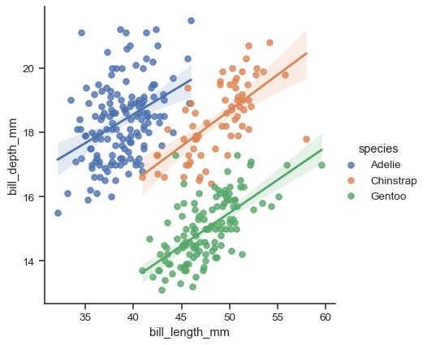
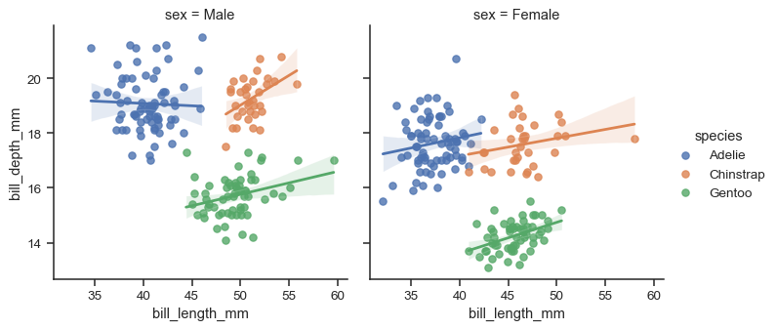
- All against all scatter plots
- Correlograms
  - Correlation coefficient only measures linear relationships. Not useful for non-linear relationships. Show Anscombes quartet
- Dimension Reduction
- Paired Data

