1. Following things need to be installed on your system -

i) Git

ii) chrome browser (Version 87.0.4280.141 (Official Build) (64-bit))

iii) python 3.7

1. Clone the engineering-experiences repo.
2. UI Automation code is in the **“integration-test”** folder

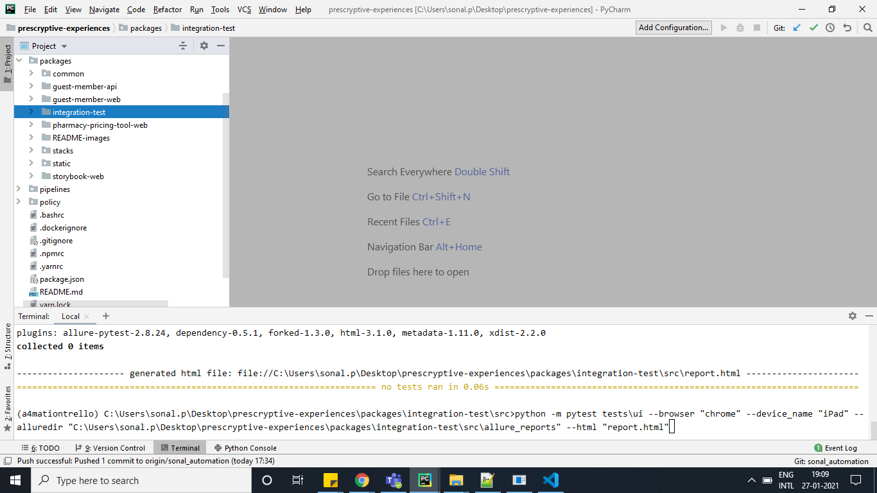

1. Open command prompt in the integration-test folder
2. Go the location - packages/integration-test/docs
3. Execute the command at the docs location -

pip install -r requirements.txt(If using vs code please install tools from link -": [https://visualstudio.microsoft.com/visual-cpp-build-tools/](https://visualstudio.microsoft.com/visual-cpp-build-tools/" \t "https://dev.azure.com/prescryptive/Engineering/_git/prescryptive-experiences/pullrequest/_blank) )

1. Go to the location -packages\integration-test\src\testdata\ui\login.json
2. Edit the required url,phone number and pin number(We have kept mobile number and pin as empty string so that user can set it accordingly)
3. 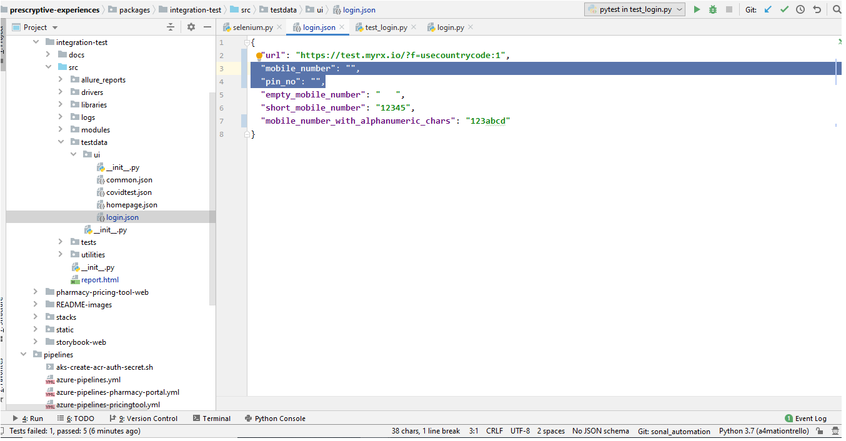
4. Go to the location - packages\integration-test\src
5. To run the UI Automation - Execute the command -

python -m pytest tests\ui\ --browser <browser name> --device_name <device name> --alluredir=<path of allure_reports folder> --html "report.html"

E.g. -

1. For chrome browser use browser name as "chrome" or "ch"
2. For device name - enter any device name same as browser’s mobile emulation device names

Note:If nothing is passed by default it takes value of browser as “chrome” and device as “iPhone X”

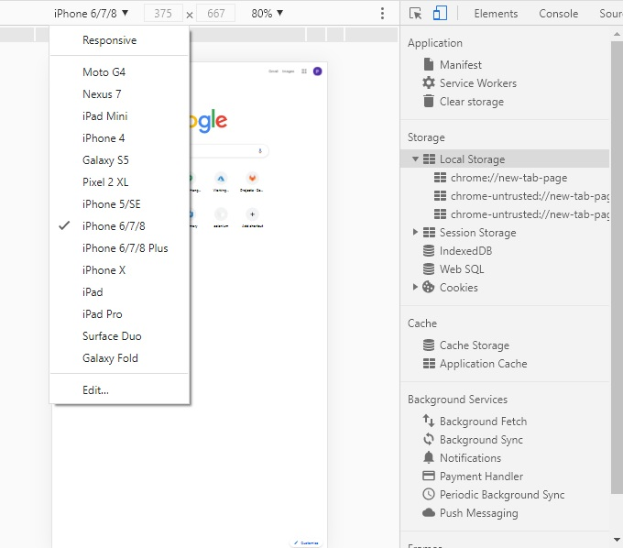

python -m pytest tests\ui\ --browser "chrome" --device_name "iPhone 6/7/8" --alluredir="path to folder\packages\integration-test\src\allure_reports" --html "report.html"

1. To generate the allure reports - Execute command -

allure serve <path of the allure reports folder>

E. g. -

allure serve “path to folder\packages\integration-test\src\allure_reports”

Wait for few seconds it will launch server for the report as displayed below:

