From Ashley Jardina, White Identity Politics (2019). Cambridge University Press: New York.

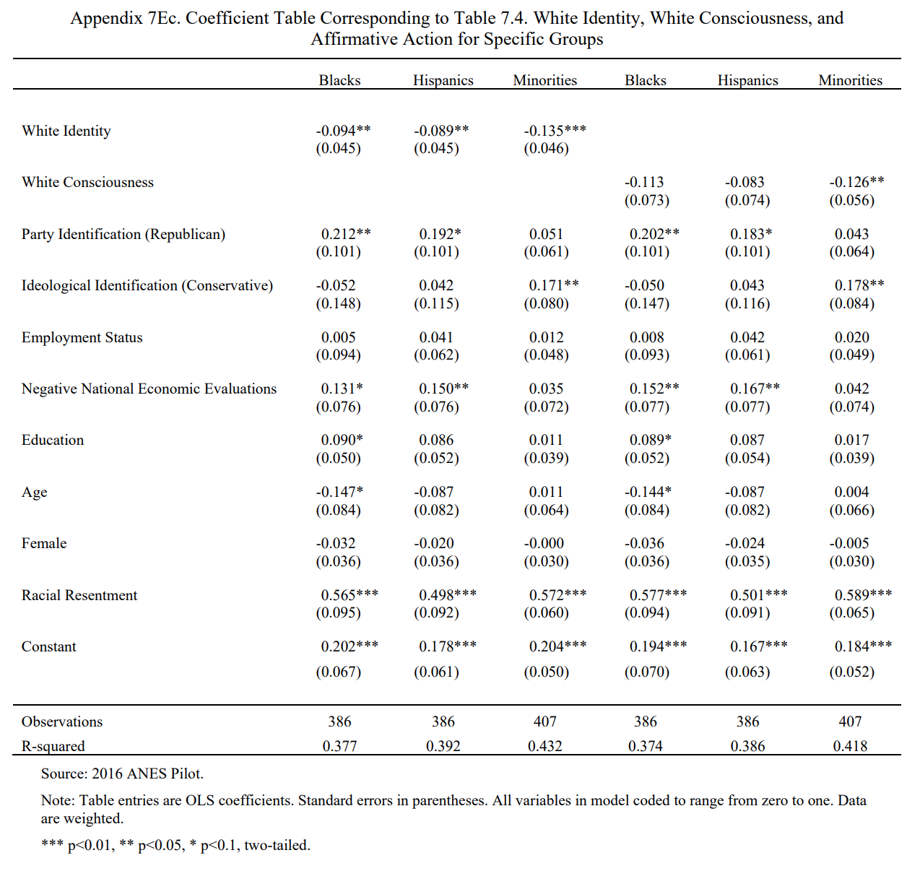
Coefficient of
Determination
p-values
Dependent
(outcome)
variables
Intercept
Coefficients (and standard errors)
Independent (explanatory)
variables
p-values

- This is a linear probability model because the dependent variable is binary (0s and 1s). We measure coefficients on the probability scale.
Coefficients (and standard errors)
- E.g., someone with white consciousness is 12.6% less likely to support affirmative action for Minorities, holding all other independent variables constant.

