Download & Connect - winscp s/w

commends - puTTY terminal fire ////

sudo apt install git

------------------

Step by Step Guide to Build your coin(Commends)

**Step** **1**: Install the prerequisite

sudo apt-get update

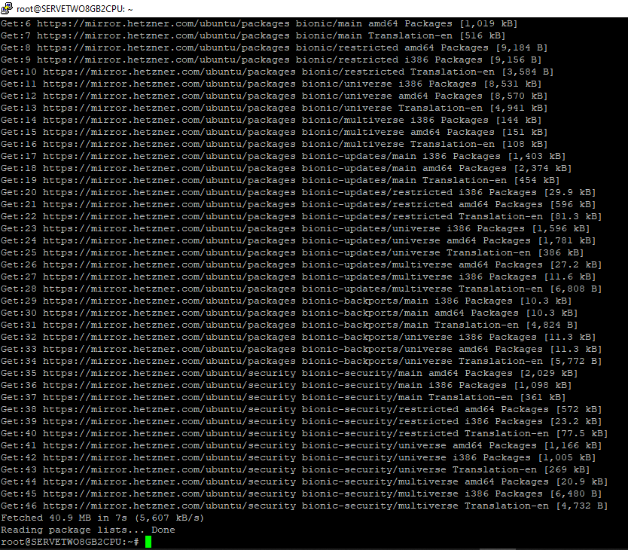

sudo apt-get install build-essential

* --------- sudo apt-get install build-essential libssl-dev

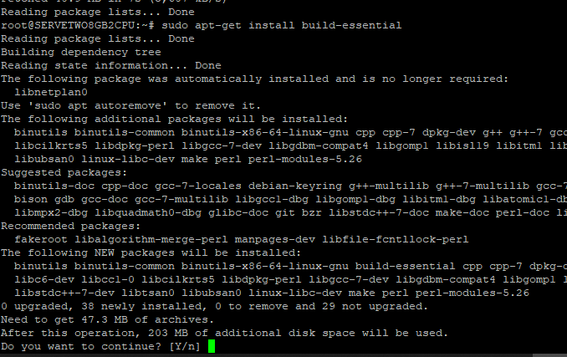

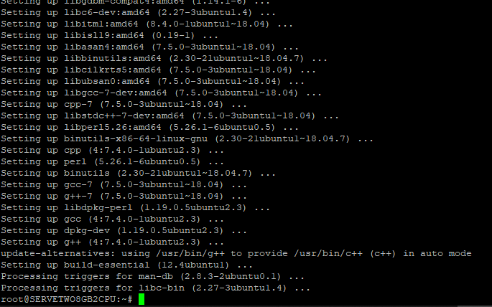

sudo apt-get install autoconf libtool pkg-config libboost-all-dev libssl-dev libprotobuf-dev protobuf-compiler libevent-dev libqt4-dev libcanberra-gtk-module libdb++-dev

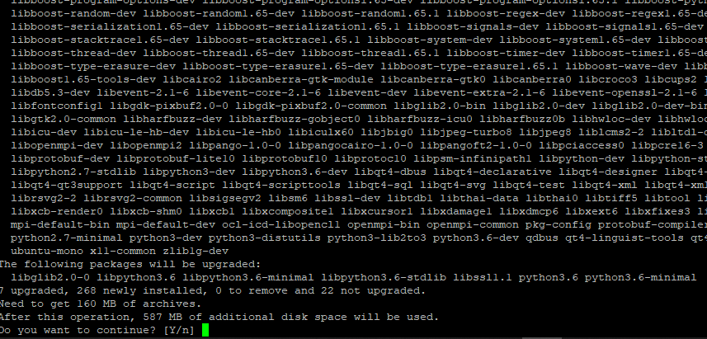

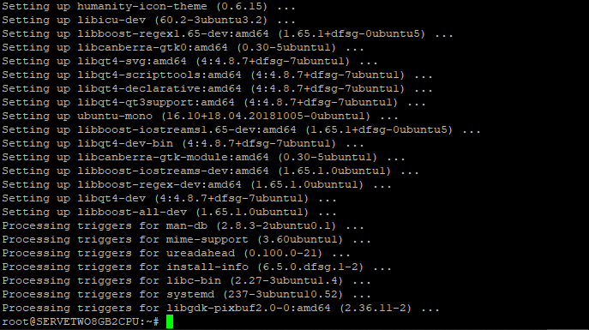

**Step** **2**: Install BerkeleyDB using the below commands (If not already Installed)

wget <http://download.oracle.com/berkeley-db/db-4.8.30.NC.tar.gzcd>

wget <http://download.oracle.com/berkeley-db/db-4.8.30.NC.tar.gz>

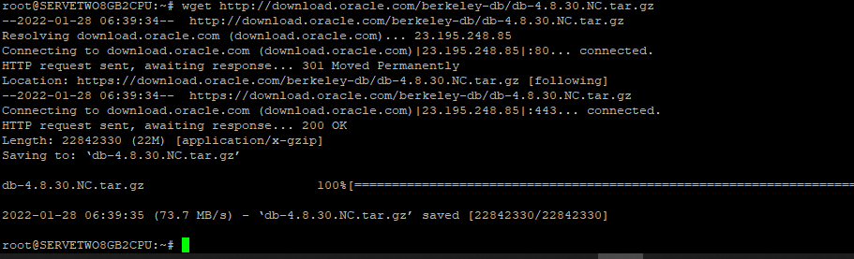

tar -xvf db-4.8.30.NC.tar.gz

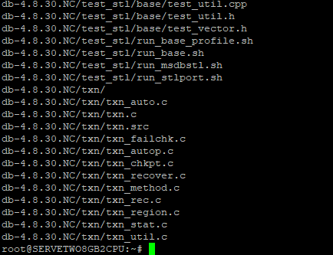

cd db-4.8.30.NC/build_unix

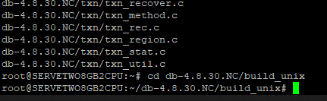

mkdir -p build

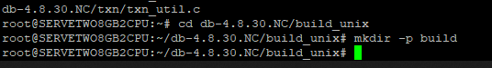

BDB_PREFIX=$(pwd)/build



cd../dist/configure --disable-shared --enable-cxx --with-pic --prefix=$BDB_PREFIX

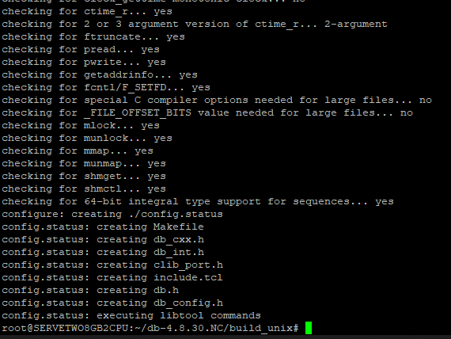

cd

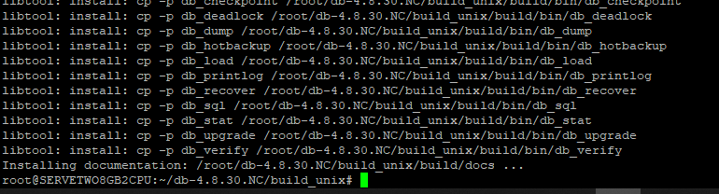

**Step 3**: Build the Coin

cd /home/ubuntu/bleumintcoin/

./autogen.sh

cd ~

If permission denied – run >> sudo chmod –R 775 /home/ubuntu/bleumintcoin/

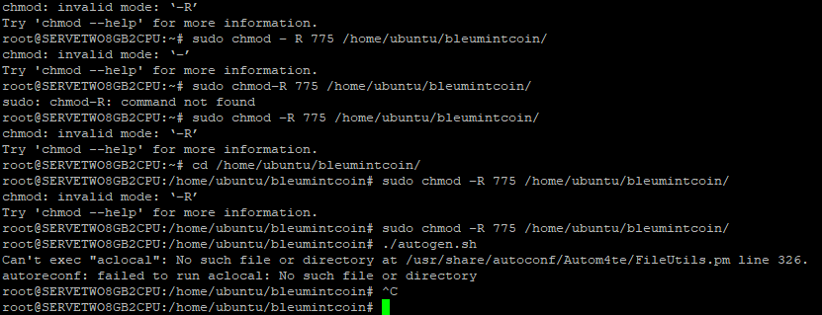

apt install automake libtool

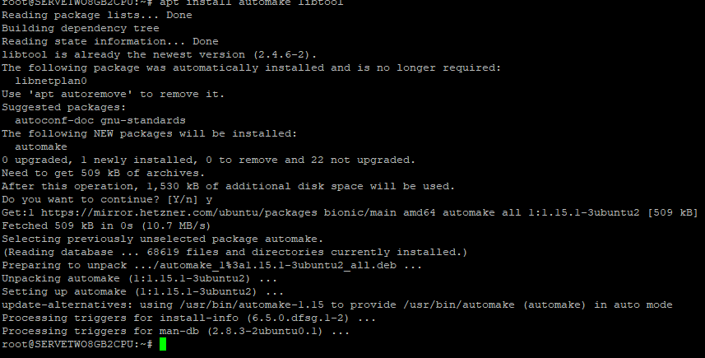

cd /home/ubuntu/bleumintcoin/

./autogen.sh

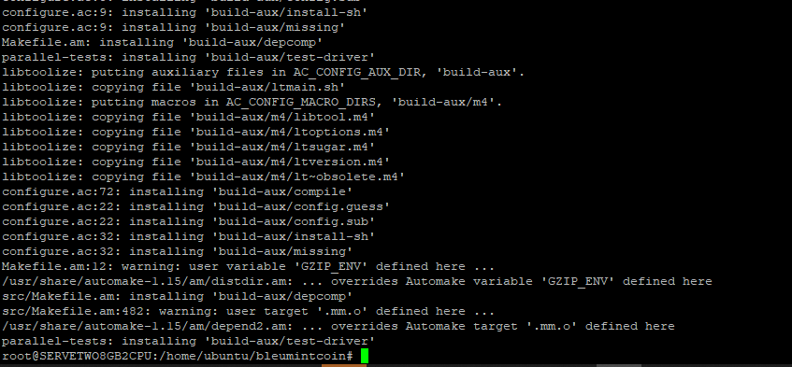

./configure CPPFLAGS="-I${BDB_PREFIX}/include/ -O2" LDFLAGS="-L${BDB_PREFIX}/lib/"

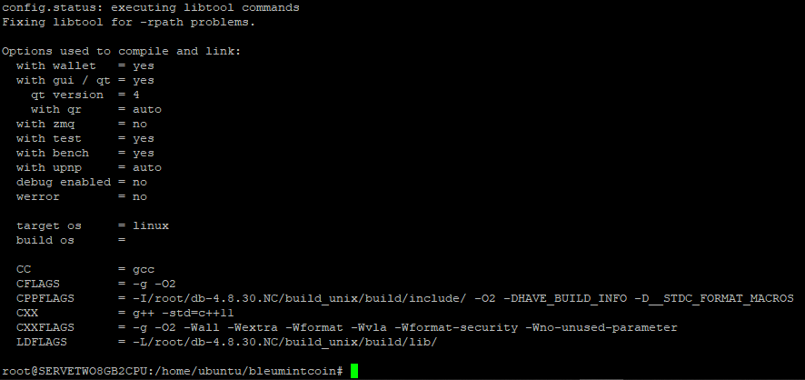

 ./autogen.sh && ./configure --with-incompatible-bdb && make

make

cd /home/ubuntu/bleumintcoin/

cd src

./bleumintcoind

cd src/bleumintcoind

root/Nicky@2022

root@SERVERONE16GB4CPU:~#

/home/ubuntu/bleumintcoin/

sudo chmod –R 775 /home/ubuntu/bleumintcoin/

1 000 000 0

1 000 000 000

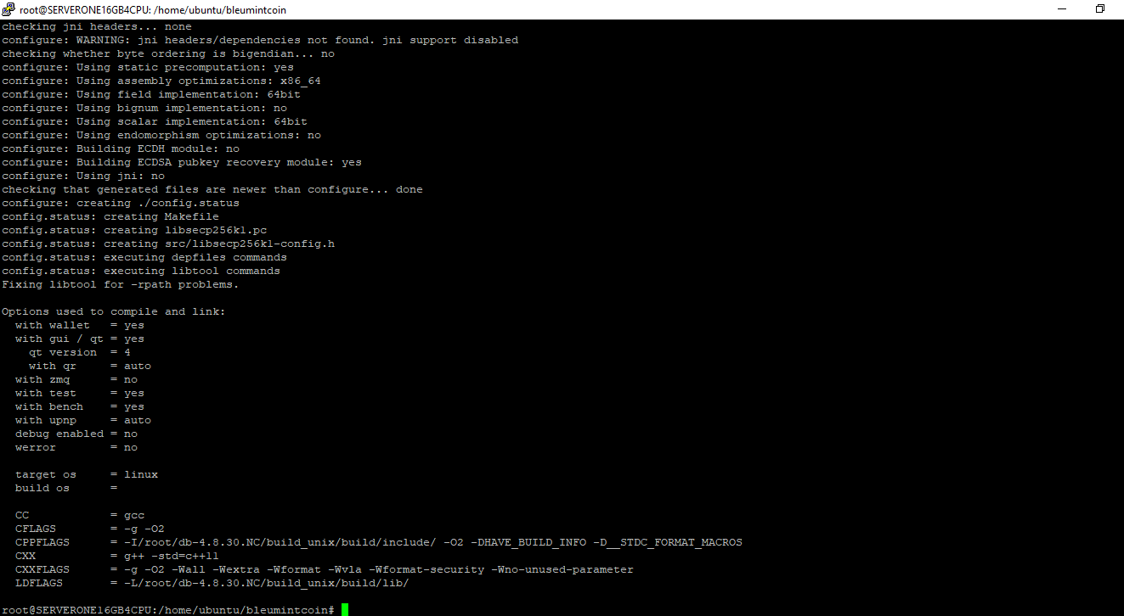

Last login: Thu Jan 27 06:15:47 2022

root@SERVERONE16GB4CPU:~#

/home/ubuntu/bleumintcoin

