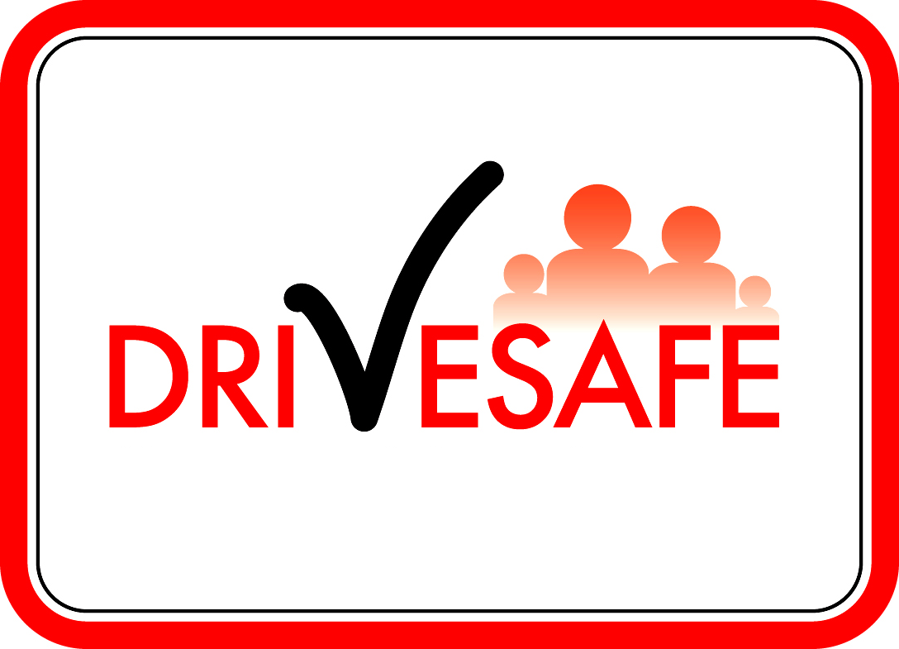****

**Course Venue**

**<!VenueAddress!> <!VenuePostcode!>**

**Course Date**

**<!CourseStartDate:Day!>**

**<!CourseStartDate!>**

**Start Time**

**<!CourseStartTime!>**

**Finish Time**

**<!CourseEndTime!>**

**IMPORTANT**

It is essential you bring **photographic identification** with you to your course.

If you have a **photocard style driving licence** this is the easiest way for us to check your identification.

If you do **not** have a photocard style licence - you must bring a passport or similar **photographic means of identification.**

**Helpline:** 0300 123 1518 *

**Website:** drivesafe.org.uk

**Driving Licence No:** <!LicenceNumber!>

**Course Type:**  Speed Awareness Course

**Date:** <!TodaysDate!>

**\*Helpline open Mon-Fri 8.30am-3.00pm. Calls are monitored and recorded.**

*Calls to 03 numbers charged at standard geographic rate and included in any inclusive minutes (from landlines and mobiles).*

.

**DriveSafe**

**PO Box 1155**

**Manchester**

**M61 0FF**

**Your Client ID:**

**<!ClientId!>**

<!Title!> <!FirstName!> <!Surname!>  
<!Address!>  
<!Postcode!>

**Your Course Details**

Dear <!Title!> <!Surname!>

Thank you for booking a **Speed Awareness Course**. A place has been reserved for you as shown opposite. Please note that **late arrivals will not be allowed to participate**. We recommend that you locate the course venue prior to the course date (map enclosed).

The cost of the course is £<!TotalPaymentDueByClient!>. Your outstanding balance is **£ <!AmountPaidByClient!>.** If you have not already done so, payment must be made by <!**paydate!>.** Payment can be made:

 **Online** – using a debit or credit card at: **drivesafe.org.uk**

 **Phone –** 24-hour payment line using a debit/credit card: **0300 123 1518**

 **Post** – by postal order (payable to ‘DriveSafe’) to the address below. Please write on the back of your postal order your Client ID: <!**ClientId!>.** Do not post cash.

If you are unable to attend the course date allocated to you, you must contact us immediately to arrange an alternative date. To **re-arrange** a course with less than **21 days notice** prior to your course date an additional fee of £25 will be payable. To **re-arrange** a course with less than **7 days notice** prior to your course date an additional fee of £35 will be payable. Full course Terms & Conditions are enclosed.

It would be useful if you could bring a copy of *The Highway Code* with you to the course if possible. If you require any further information please see our Frequently Asked Questions online at **drivesafe.org.uk**. We look forward to meeting you.

Yours sincerely



Lee Davies  
**Scheme Manager**

**DriveSafe Course Terms & Conditions**

**1. Course Provider**

The Scheme is administered and delivered by DriveSafe on behalf of the referring Police Force. The Scheme is run in accordance with national guidelines set by the Association of Chief Police Officers.

**2. Time Limits**

It is a condition of the course offer that you complete the course within a period of time imposed by the referring Police Force. If you are unable to complete the course within this timescale for whatever reason, you are no longer eligible and your offer of a course will be withdrawn. The Police are at liberty to withdraw the course offer at any time up to the point that you have successfully completed the course.

**3. Course Fees**

The course fee must be paid in full at least 21 days prior to the course (if booking online the full course fee must be paid at the time of booking a course by debit / credit card). If you are unable to attend the course date allocated to you, you must contact us immediately to arrange an alternative date. To re-arrange a course with **less than 21 days** notice prior to your course date an additional fee of **£25.00** will be payable. To re-arrange a course with **less than 7 days** notice prior to your course date an additional fee of **£35.00** will be payable. You may only book / re-arrange a course a maximum of 3 occasions. Any cheque returned by your bank due to insufficient funds will incur an administration charge of £12.00. Subsequent payment will only be accepted by credit / debit card or postal order.

**4. Identification**

**It is essential you bring photographic identification to the course** (preferably a photocard style driving licence). If you do not have a photocard style driving licence, you must bring a passport or similar **photographic means of identification**. Should you be unable to produce the required documentation, this will be classed as failure to attend. It is an offence to attempt to illegally misrepresent the true identity of another driver of a motor vehicle by attending the course in place of someone else.

**5. Failure to Attend**

If you fail to attend a course, or are refused entry to a course if you are unable to produce the required documentation, it may be possible to offer you an alternative course date subject to availability and the Police time limit. This is subject to payment of an additional fee of **£35.00**. If you fail to attend a course due to illness, the additional fee may be waived upon receipt of medical evidence (e.g. doctor’s note).

**Late arrivals will not be allowed to participate.** We recommend that you locate the venue prior to the course date. You must arrive promptly at the stated time on the day of the course.

If an alternative course is not available, or not requested, your file will be returned to the Police for further action.

**6. Course Checklist**

A course checklist is enclosed. It is recommended you use this checklist to ensure you will be allowed to participate.

It is a condition that you present yourself in a fit state, having had proper rest and not under the influence of alcohol or drugs. You must be appropriately dressed for the consideration of other clients – no work clothes such as overalls or muddy boots. If you need glasses or contact lenses make sure you bring them with you. Every effort will be made to accommodate any special requirements you may have provided you have notified us. If no indication has been made we cannot be held responsible should you be unable to complete the course.

There is no course test, pass or fail. To complete the course you must attend all sessions, complete all course paperwork, make a positive contribution and demonstrate a willingness to improve your driving skills. However, any abusive or inappropriate language, threatening or disruptive behaviour towards either our staff or other clients will result in you being removed from the course.

**7. Non-Completion**

If you fail to comply with these Terms & Conditions, you will be certified as non-completion. In such cases the offer of a Diversionary Course will be withdrawn and your file will be returned to the Police for further action. In these circumstances you are entitled to a partial refund of £40.00 and you should contact us to arrange this.

**8. Course Cancellation**

In the unlikely event we are unable to deliver a course due to reasons beyond our control, we will reschedule your course as soon as possible within the time limit imposed by the Police at no additional cost to you.



**Course Checklist**

*Please use this checklist to ensure you will be allowed to participate.*

* If you have a **photocard style driving licence** please bring this with you to the course as it’s the easiest way for us to check your identification.
* If you do **not** have a photocard style licence - you must bring a passport or similar photographic means of identification.
* If you wear a form of head dress that covers your face (for personal or religious reasons) you will be required to remove or adjust this (in private) to allow our Trainer to establish your identity.

**NO IDENTIFICATION = NO COURSE**

***(If you have a problem producing photographic ID contact the helpline number below)***

* Please bring a copy of the latest edition of ***The Highway Code*** if possible (cost £2.50) available from all good bookshops, newsagents, car accessory shops, some supermarkets or online.
* Check your route and venue location before the day of the course as you must arrive on time – late arrivals will not be allowed to participate. Allow extra time in case of traffic congestion.
* You must be appropriately dressed for the consideration of other clients – no work clothes such as overalls or muddy boots, or clothing motifs that could offend others.
* You must be in a fit state to fully participate in the course and not under the influence of alcohol or drugs.
* Do not bring anyone with you (unless you have made prior arrangements to bring an interpreter or carer – see below).

**If you require any of the following you must telephone the Helpline below immediately**

**(if you have not already done so) to make the necessary arrangements:**

* You have difficulty understanding English and will need an interpreter. (If you are bringingan interpreter they must be at least aged 17 years and preferably a driver).
* You have hearing difficulties and require a sign language interpreter or hearing loop.
* You need to bring a carer or have special requirements due to mobility or other difficulties.

**It is ESSENTIAL you bring PHOTOGRAPHIC IDENTIFICATION**

**with you to the course**

**Helpline: 0300 123 1518**

**Helpline open Mon-Fri 8.30am-3.00pm. Calls are monitored and recorded.**

*Calls to 03 numbers charged at standard geographic rate and included in any inclusive minutes (from landlines and mobiles).*

**Pay online and view Frequently Asked Questions at:**

**www.drivesafe.org.uk**