Coda Heater PWM Info

Similar item to SFT-5528 (used by TSM in shop)
Note that duty cycle and frequency adjustments are interdependent. So, a single pot input may not be doable for heat control. See email 10/20/15 from Hans regarding his tests.

http://www.icstation.com/ne555-pulse-module-duty-cycle-frequency-adjustable-module-square-wave-rectangular-wave-signal-generator-p-2224.html

Video Link:
https://www.youtube.com/watch?v=97CU7WszMO0

Description:
1. Used as a square wave signal generator produces a square wave signal for the experimental development use.
2. Used to generate the square wave signal to drive a stepper motor drive.
3. Produce adjustable pulse for the MCU to use.
4. Generating adjustable pulse to control the associated circuits.

Parameter:
1. Size: 3.5CM * 3.6CM
2. The main chip: NE555
3. Input voltage: 5V-15V
Note: DC 5V power supply, the output current can about 15MA; 12V power supply, the output current can be about 35MA;
4. Input Current: ≥ 100MA
5. Output amplitude: 4.2V V-PP to 11.4V V-PP
(depends on the input voltage, the output amplitude is not the same)
6. Maximum output current:
≥ 15MA (5V power supply, V-PP greater than 50%)
≥ 35MA (12V power supply, V-PP greater than 50%)
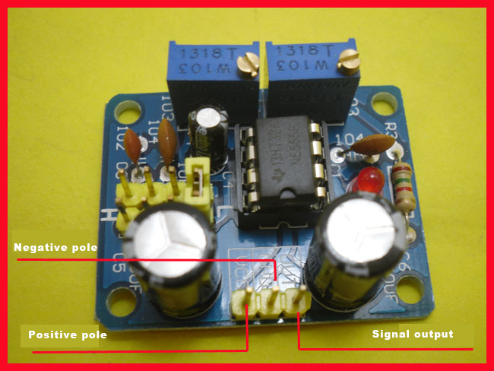
Advantages:
1. Output with LED indication, there is no output LED quantity (low straightforward, high level LED off relatively low frequency LED flashes);
2. Output frequency range grade optional continuously adjustable output frequency;
Low-frequency stall: 1Hz ~ 50Hz
IF stall: 50Hz ~ 1kHz
In the high-frequency stall: 1KHz ~ 10kHz
High-frequency stall: 10kHz ~ 200kHz
3. the output duty cycle can fine-tune the duty cycle and frequency is not adjustable separately adjust the duty cycle will change the frequency
4. the output frequency is adjustable;
Cycle T = 0.7*(Ra + 2*Rb)*C
Ra, Rb:0-10K adjustable;
LF gear C = 0.001UF;
IF file C = 0.1UF;
In the high-frequency file C = 1UF;,
High-frequency gear C = 100UF, the waveform frequency buyers can own calculations.
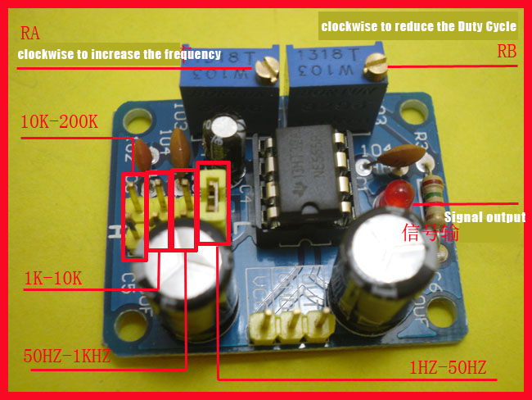
NOTE:Output duty cycle can fine-tune the duty cycle and frequency is not adjustable separately adjust the duty cycle will change the frequency

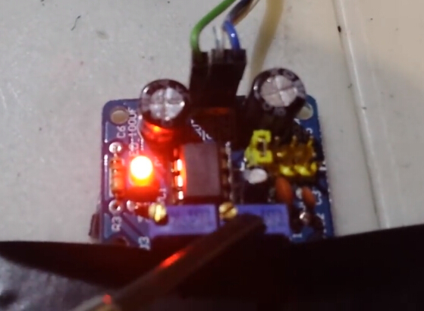
Different waveforms are shown as below:
