Compressor label information: Ford AM64-19D623-AB
The following canbus information was captured from the compressor. The message sent is from node ID 0x439. Canbus baud rate is 500 kbps.
The AC compressor sent the following messages:
439 0300000000000000 when off
439 0000000000000000 when on
Below are the schematics and a few photos. The PCBs are all immersed in a gelatinous sealant. This is to increase insulation between high voltage points, and protect the HV circuits from humidity and moisture.
From the photos it can be seen the HV positive is Orange with a white stripe. HV negative is Orange with a Black stripe.
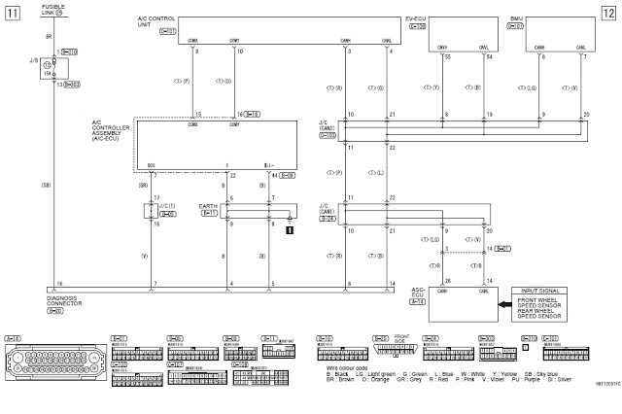
i-MiEV

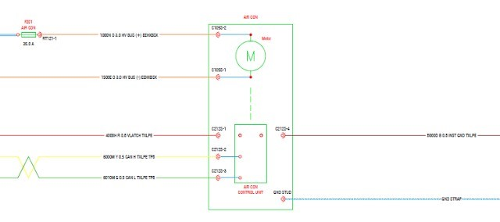

AZD Schematic

