Table of Contents

A Lone Worker System to Improve Staff Safety 2

Preparation and Planning 2

Description and Scope 2

Major Tasks and Subtasks 3

Schedule 4

Associated Risks 9

Lifecycle Model 9

Resources, skills and methods 9

Project Work Completed 10

Informationsources 10

Project Work 11

Future Plan 12

Review and Reflection 13

Appendices 14

Appendix 1 – A screenshot showing a solution employed by a neighbouring Council 15

Appendix 2 – The initial enquiry email from the client 16

Appendix 3 – Initial Meeting with the Client 18

Appendix 4 – My Interpretation of the main user interface 20

Definitions 21

References 22

# A Lone Worker System to Improve Staff Safety

Scope and Requirements

It is good to see the scope and the functionalities being defined. Its clear how these requirements are from a real world situation.

Challenge

You have identified a challenging aspect within this project environment and have some stretch goals in sight.

Stakeholders

It is good to see that there are real world stakeholders. You have explained their role but also state how often you will engage them in the project.

Lifecycle model

You have presented a clear decision on this but a more elaborate set of reasons for your choice would help here. Also the way you have presented the comparison, it is clear what the differences are.

Risk assessment

You have listed very generic risk. More details can be added for each one. The expectation management of the client and what you can deliver within this technology should be carefully managed and you should always focus on it. Likewise, list some mitigation techniques for all the risks identified.

Skills and Resources:

There should be a decent effort put in listing the skills and resources needed to work on this project and relevant technologies. You have not identified and/or evaluated the quality of the resources however.

|  |  |
| --- | --- |
| Learning outcomes | **Mark**  (out of 20) |
| LO2. You should be able to develop and demonstrate the ability to identify and refine the goals and content of your project  **Comment:**  You have provided a working title, well done. The boundaries of the project and the solution that will be delivered were made clearer. | 18 |
| LO3. You should be able to develop and demonstrate the ability to:  ·    identify, list and justify the resources, skills and activities needed to carry out the project successfully; and  ·    identify and address any associated risks  **Comment:**  You have identified some resources but the evaluation of quality (of resources) and risk mitigation (associated with resources and skills development and resource use) is weak. You have listed some of the risks (could also have listed some mitigation techniques) associated with the project. | 12 |
| LO4. You should be able to develop and demonstrate the ability to gather, analyse and evaluate relevant information to complete the project successfully  **Comment:**  You need to find and select more relevant sources of information. An effective and succinct account of what has been found is needed. Revisit this to show how these relate to the work to be done. You must also evaluate the quality of the relevant information in light of the objectives of the project. | 12 |
| LO7. You should develop and demonstrate the ability to communicate information, ideas, problems and solutions clearly  **Comment:**  Your work is mostly very clear, concise, structured.  Initial contact was made in time. | 18 |
| LO8. You should develop and demonstrate the ability to learn independently and reflect on what has been done, with a view to improving skills and knowledge  **Comment:**    Some exploratory work was undertaken and it is a good start, but make sure you focus on issues that are at the core of the project next and control the scope of the work. Make sure you identify a challenge that stretches you to manage your learning and learning needs. Reflection was focused. | 16 |
| LO9. You should be able to develop and demonstrate the ability to plan and organise your project work appropriately, and keep systematic records of plans, progress and outcomes    **Comment:**     You need to show better that you have selected an appropriate lifecycle for the project. The plan seems to follow the model used. | 16 |

**Overall mark = Total of learning outcome marks 92/ 1.2 =77%.**

## Preparation and Planning

### Description and Scope

#### Background

I have been working for Northumberland County Council for 9 years now, and within it there are over 6000 employees across dozens of departments, each providing a role to the Council and the Community. One of the departments in the council is the planning department, who receive planning applications

#### The Problem

The planning department have about 100 users who work out on site. Fiona Charlton, the client, is looking for the development of a system that will allow her and other managers to records whch officers are on site, which site they are at, the time that they arrived. The officer needs to specify an estimated time to leave the site, and if they haven’t checked in when they leave or before this time, an alert needs to be sent to their line manager. See Appendix 2 for a brief description in the client’s words.

Currently there is no standardised reporting procedures for this to happen, and all teams use a different way of recording the information. There is a system already available called Guardian24, but at over £5 per user per month, this isn’t a viable solution for the whole workforce and is only used for the most at-risk officers. Without a standardised solution it could be the case that a site officer has an accident and isn’t able to contact the office, and no-one would be aware that there was a problem.

The officer will need to be able to submit the check in and out times from their mobile phone, and the system must be able to handle a manual input by office staff in the case they are unable to use their phone for whatever reason.

#### My Proposed Solution

To solve the department’s I am planning on designing and implementing a Java system to run on windows devices in the office, a database backend to store all the information about the users and the times on site, and a mobile system to ….. The system will allow office staff to add, edit or delete new site officers, record the visit information including check in/out time, site location and any other notes. The system will respond to updates sent from the site officers and alert their manager if an expected check in time has passed and there hasn’t been any contact made. There will be a manual override so that the office staff can update the system if an officer has made contact by another means.

#### Alternatives to my proposal

|  |  |
| --- | --- |
| **Alternative** | **Justification** |
| Carry on the way they are currently working | Not really an option as it could be a health and safety risk if site operatives have an accident on site and no-one notices that they haven’t checked in |
| Use the app Guardian24 for ever officer | Not feasible due to the cost, it would work out over £500 per month |
| Ask a third party to develop a solution | Another cost implication, high initial cost although there shouldn’t be a monthly cost apart from maybe an annual licensing fee |
| The development team at Northumberland County Council to develop a solution | The development team are unable to develop a solution as it is outside the scope of the services they provide to the council. Resources may become available later, but currently this isn’t an option |

### Major Tasks and Subtasks

After reviewing the TMA’s and EMA required to complete this course, I will compile a list of the tasks required to submit all my assignments on time.

1. **TMA01  
   1.1. Read the module website resources  
   1.2. Find potential projects at work  
   1.3. Preparation and Planning**  
    1.3.1. Working Title  
    1.3.2. Description and scope  
    1.3.3. Major Tasks and Subtasks  
    1.3.4. Lifecycle Model and Schedule  
    1.3.5. Resources, skills and methods  
   **1.4. Project Work Completed**  
    1.4.1. Information Sources  
    1.4.2. Project Work  
   **1.5. Review and Reflection**
2. **TMA02**

**2.1. Preparation and planning**  
 2.1.1. Title and scope   
 2.1.2. Resources  
 2.1.3. Future plan  
**2.2. Project work completed**  
 2.2.1. Information Sources  
 2.2.2. Project Work Completed  
**2.3. Review and reflection**

2.3.1. Ways of working

2.3.2. Evaluating project management

2.3.3. Legal, social, ethical and professional issues.

1. **TMA03**  
   **3.1. Draft Project Report**  
    3.1.1. Problem Description  
    3.1.2. Account of related literature  
    3.1.3. Account of project work and its outcome  
   **3.2. Review**  
    3.2.1. Review of current stage of project work  
    3.2.2. Review Project Management  
    3.2.3. Assess risks to project completion  
    3.2.4. Review of personal development  
   **3.3 Project Work**  
    3.3.1. Second Iteration  
    3.3.2. Final Iteration
2. **EMA  
   4.1 Final Report**  
    4.1.1. Project Title  
    4.1.2. Problem description  
    4.1.3. Account of related literature  
    4.1.4. Account of project work and its outcome  
    4.1.5. Review of current stage of project work  
    4.1.6. Review of project management  
    4.1.7. Review of personal development  
    4.1.8. Check and submit EMA

As well as the above headings given in the TMA and EMA documents, I have also decided to plan for three iterations of the product. They will be inserted as:

2.2.3. First Iteration

3.3.1. Second Iteration

3.3.2 Final Iteration

### Schedule

I have used all the tasks in the previous section to create a timeline of my complete project, and I’ve combined the three iterations of my software development to create a schedule. To visualise this I have used a Gantt-sytle spreadsheet template I found at <https://www.vertex42.com/ExcelTemplates/excel-gantt-chart.html> to format the cells. I have amended it slightly to suit my purpose, but the copyright and terms of use have been left within the document as requested by the author:

TMA01:

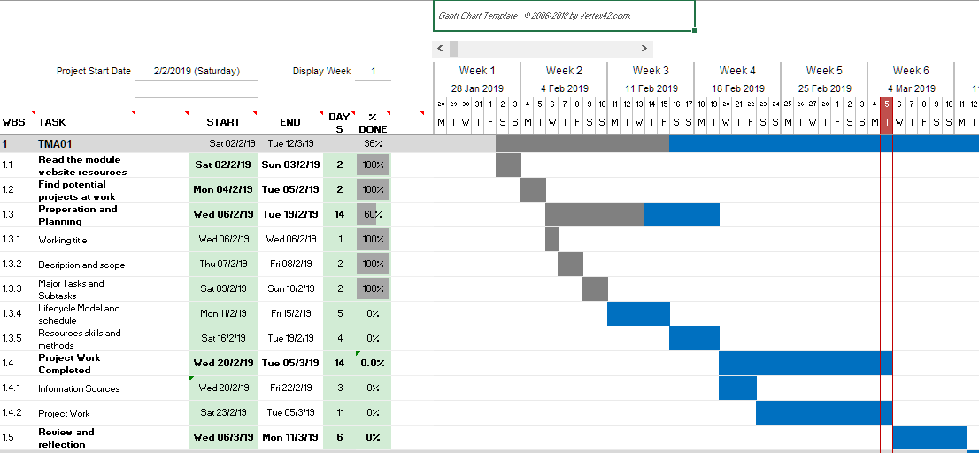

TMA02:

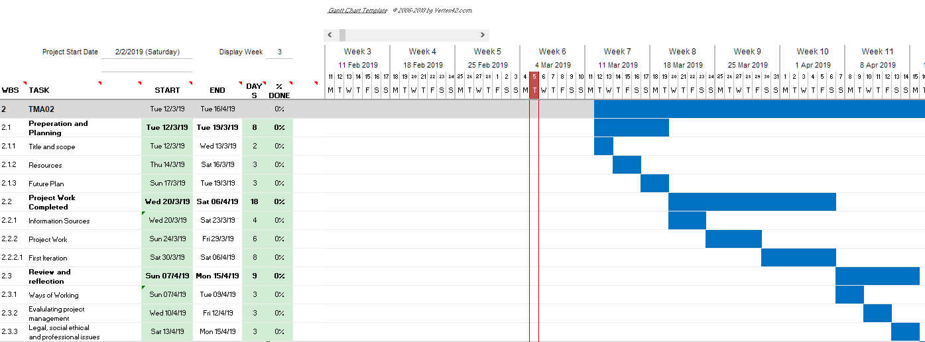

TMA03:

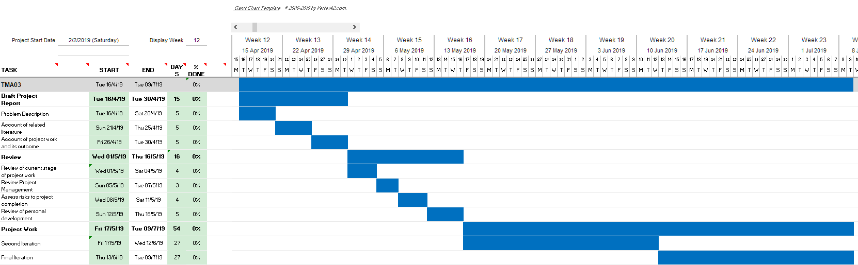

TMA04:

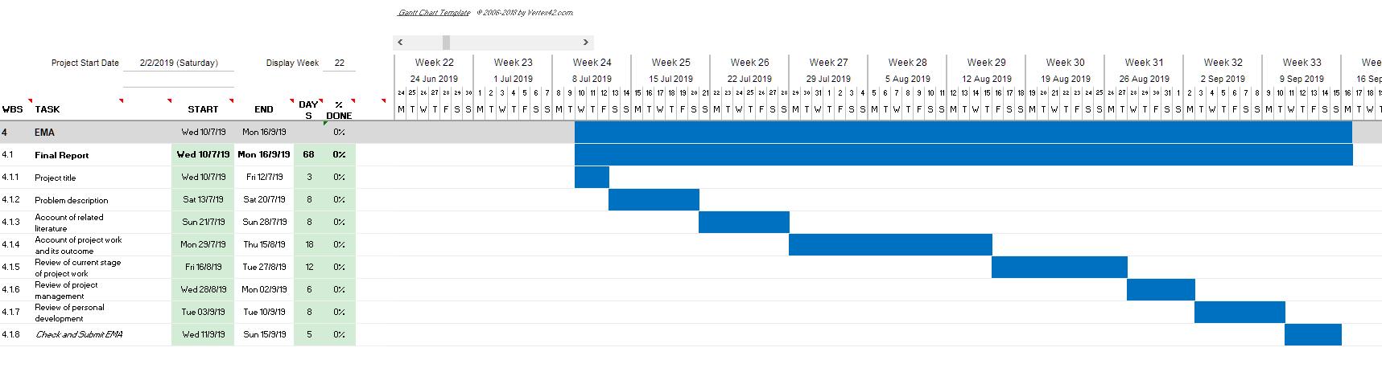

The full version of this document can be found in this zip directory saved as TMA1_Tasks.xlsx

### Associated Risks

Below is a list of all risks that may occur, with their likelihood and their impact on my project:

|  |  |  |
| --- | --- | --- |
| **Risk** | **Impact** | **Chance of Occurrence** |
| Finished product does not work as intended | M | M |
| Client rejects the finished product | H | L |
| Users are unable to access through mobile | M | L |
| Project becomes unmanageable | H | M |
| Lack of co-operation from users | H | L |
| Unable to complete project in the timeframe given | L | M |
| Change in hardware available | L | H |

### Lifecycle Model

To select a lifecycle model, I have listed the pros and cons of the three most suitable, in my opinion:

|  |  |  |
| --- | --- | --- |
| **Model** | **Pro’s** | **Con’s** |
| *Classic Waterfall* | * Structured approach * Each phase has specific deliverable * Each stage is tested before progressing to the next | * Had to go back to a previous stage * Very inflexible * Requires more time |
| *Agile* | * Requires less time * continuous user involvement means its less likely a mistake can be introduced | * Hard to scale the system * Documentation is done at a later stage |
| *Incremental* | * Produces early protypes for the user to see/test * Easily accommodate changes * Detect issues earlier in the project | * Needs more documentation to show processes * Requires more customer involvement than other models |

After reviewing the three lifecycle models above, I think that the incremental model would best suit this project. This will allow me to produce a workable system at the first iteration to show the client and allow any issues to be identified early on. It also ensures that at least the functionality of the system up to that point can be tested, and any user requirement that have been missed can be identified and included in the scope of the project.

### Resources, skills and methods

For this project to be a success I am going to have to use the skills I have been taught in M256 (Software Development with Java), TM354 (Software Engineering), TM351 (Data Management and analysis), M250 (Object Orientated Java Programming) and possibly TM352 (Web, Mobile and Cloud Technologies) depending on the implementation of the mobile interface for use by the site officers when they are out the office.

This project can be though of by the following 4 components:

* An admin system, adding, editing and deleting site officer information.
* An alert system, the alert that is sent to the manager once an officer hasn’t checked in.
* A time management system that site officers use to record when they are going to be going to a particular site.
* A database, to store all information and log files

I have decided on three implementation phases throughout my project, and they will include the following functionality:

1. A working admin system so users can add, edit and delete site officer information. This will be in the form of the user interface for use by office staff.
2. The mobile solution for submitting times when site officers are away from the office. This will be a simple mobile/web app with buttons to check in/out; this with store a datestamp in the database and replicate in the user interface.
3. A working system so visit information can be added using the GUI of the desktop application. The alert system will also be created in this phase.

## Project Work Completed

### Informationsources

After reading a few highlights of several books of interest, I have decided to use the following to help me progress my course:

* One of the big challenges of this project, and something that I haven’t had a chance to study yet, is the issue of concurrency. To learn how to use threads in Java to achieve this I have chosen the book by Gonzalez (2017) to read. I am still only part of the way through the book, but I have already learnt things that will be applicable to this project.
* I have also started to read more about design patterns, met briefly in M256. The information from Sacar (2018) not only has introduced me to new design patterns not previously encountered but has also helped to reinforce previously taught concepts. I am not going to read this book in full, but I will read a little bit about each design type, how it can help this project, then read more in depth the sections I deem relevant.
* During my studies so far, I have been taught Java in a couple of the modules, and I’ve learned SQL in TT284 and TM351, but I haven’t been taught how to use them together. After reviewing several sources I’ve decided to read the relevant sections in ‘Introduction to Programming’ by Samoylov (2018). This will at least give me the fundamentals, and I can search for more sources throughout the module if needed. This book may also be useful in other areas, although I haven’t looked at it in depth enough other than what I originally searched for.

### Project Work

To start the project off I’ve had a meeting with Fiona Charlton on 07/03/19. It was my aim of this initial meeting to get some answers to some fundamental questions regarding the initial brief that was received in Appendix 2. The questions and her responses are in Appendix 3 .

Following this initial meeting I have managed to mock up some initial user interfaces (in Appendix 5) and I have planned a further meeting with Fiona on 24/03/2017 to get some feedback and talk her through the process of using the system. I still need some clarification on what the buttons along the bottom of the screen do (that I’ve labelled a-e) and if she needs this functionality included, and if its within the scope of this project. Once I’ve had the user interfaces confirmed I’ll be able to design them in Java using JSwing, then for the first iteration I’ll get the admin side of the system working.

Once the client is happy with the ideas so far, I’ll design the screens for adding and editing the site users and show the interactions between the different screens. At this moment, I imagine the classes needed and the associations between them will be:

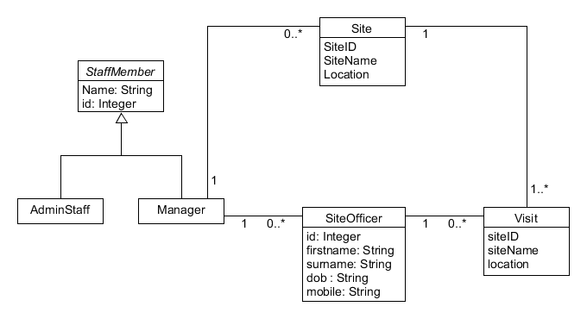

After analysing the problem, my understanding is displayed in the following activity diagram:

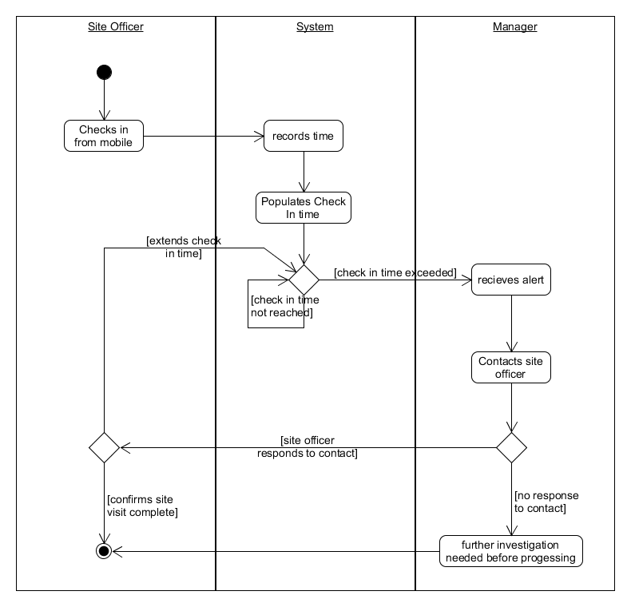

### Future Plan

For the next meeting with the client, I have prepared the following questions to help to strengthen my models:

1. What is the role of the admin user? What do they do that the managers don’t and vice versa?
2. What happens in the event that the site user cant get a mobile signal, or use their phone for some reason.
3. What happens if a manager is not in the office when one of their team members go to site?
4. How would you expect to be able to manually edit the times of the site officers?
5. If an estimated check out time is not specified, would it be helpful to use a default value?
6. What information do you store about the sites that the officers visit?
7. Is a site deleted once the officers have finished all their visits? Is it made inactive?

Once I have the answers to use questions, I will use them to detail the use cases, create appropriate interaction diagrams, prototype the rest of the UI, then start to program the functionality as stated in the first iteration above.

## Review and Reflection

After reading ‘Reflection after action’ (The Open University, 2019), I have decided to answer the questions posed:

* *What went well? What can I learn from that for the rest of my work on this module?* I feel that although I got off to a slow start, I have managed to produce a TMA that matches, in my opinion, the learning objectives adequately. I would like to think that if I keep the pace of work that I have been able to lately, as long as I don’t encounter an problems I haven’t already taken into consideration, I should be able to produce a solution and accompanying report to a high standard.
* *What didn’t go so well? How did I recover from my problems? What can I learn from that for the rest of my work on this module?* Initially, I didn’t put enough thought into my initial idea. This cause delays right at the start of the module, it caused me to doubt myself and left me feleing really stressed and doubting my ability. I wish I had spent more time in the earlier stages, this would enabled me to get the ideas straight in my head before I tried to commit them to paper; a better understanding of the initial problem will lead to a better solution. I feel going forward, time management is going to be a massive element in my overall success.
* *Have I reached an acceptable standard, both according to what the module team and my tutor have told me and according to my own judgement?* I believe my work is of a good standard, although I also think it could have been better. Time constraints meant that I haven’t been able to progress in the project work as much as I would’ve liked, I haven’t got enough foundation to the project to enable me to progress towards my first iteration. This again comes down to time management, so with dedication I believe that I can make my project to a standard that I am not only capable of, but proud of.
* *Have I met the learning outcomes for this piece of work?*I think to an extent I have met all the learning objectives. If I had started the project earlier, I would like to have identified more literary sources, I would have liked to have read more of the sources thoroughly. The main thing that may let me down is my ability to present my work concisely; this is something I am working on personally and I am looking forward to seeing any constructive comments from my tutor.

## Appendices

Appendix 1 – A screenshot showing a solution employed by a neighbouring Council

Appendix 2 – The initial enquiry email from the client

Appendix 3 – Initial meeting with the Client

Appendix 4 – My interpretation of the main user interface

### Appendix 1 – A screenshot showing a solution employed by a neighbouring Council

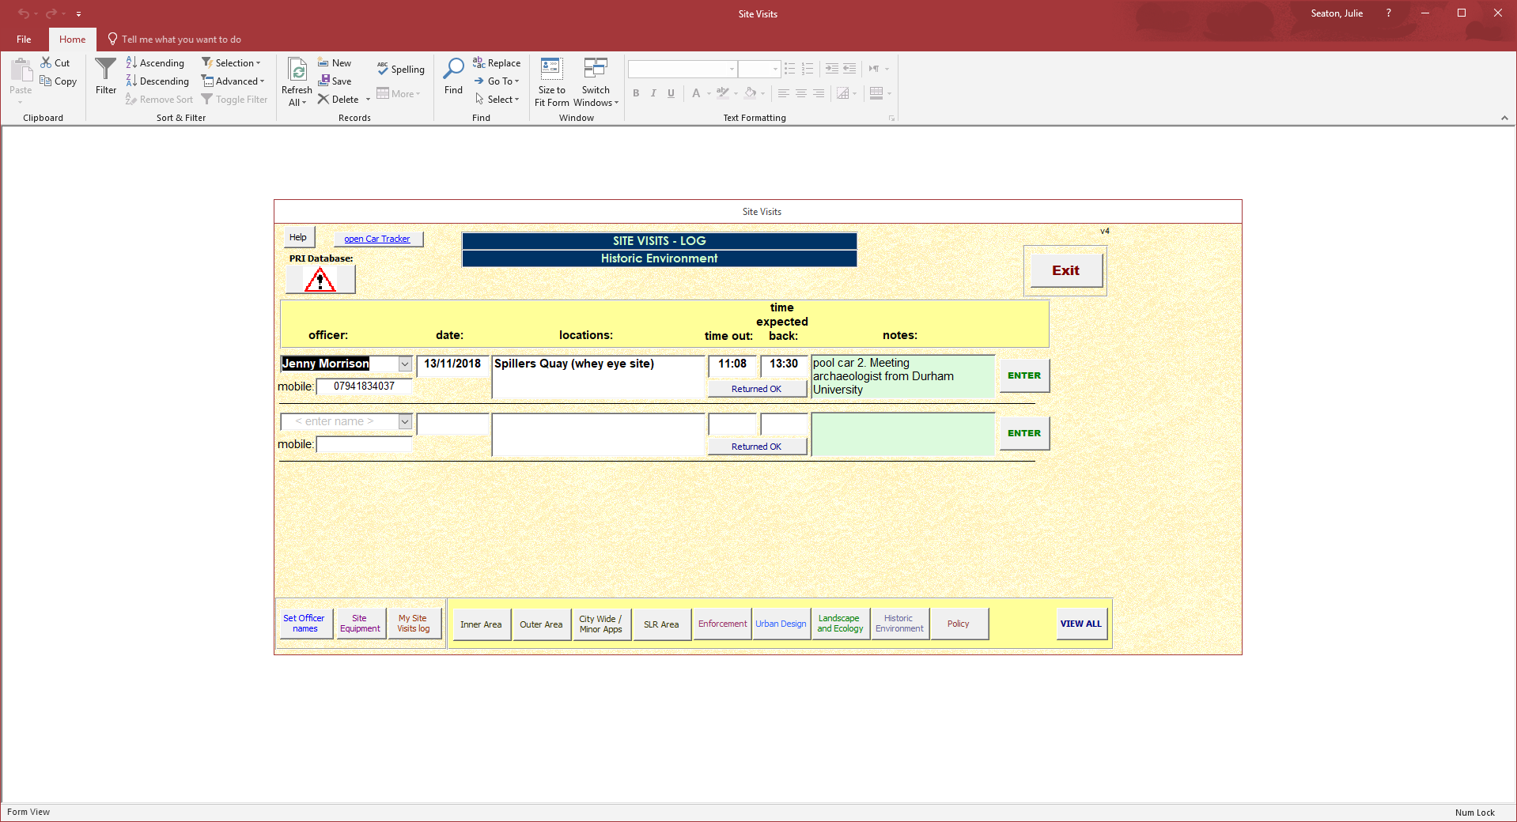

### Appendix 2 – The initial enquiry email from the client

|  |  |
| --- | --- |
| Northumberland County Council Mail | **Nicky Temperley <nicky.temperley@northumberland.gov.uk>** |

|  |
| --- |
| **FW: Lone Working Policy** 1 message |

|  |  |
| --- | --- |
| **Michelle Williams**<michelle.williams@northumberland.gov.uk> | 13 February 2019 at 12:11 |
| To: Nicky Temperley <nicky.temperley@gs.northumberland.gov.uk> | |
| |  | | --- | | Just checking with Joe Murphy/ Joanne Southern that anything has been done yet?  ________________________________ From: Fiona Charleton <[fiona.charleton@northumberland.gov.uk](mailto:fiona.charleton@northumberland.gov.uk)> Sent: 15 November 2018 16:32 To: Michelle Williams; Harri Bellizzi Subject: Fwd: Lone Working Policy  Hi Michelle/Harri  Sorry I know this is quite a bad time for you! I have been speaking with John Froud today about looking at the options of building a lone worker system for our Planning Officers who frequently go out on site. The system we use currently does not work so we need to review how we monitor our lone workers movements so we know where they are, who they are meeting and highlight when they haven't returned as expected.  I have spoken with Julie Seaton at Newcastle City Council. She is a former member of NCC staff and was very complimentary of the Newcastle system when she moved over 3 years ago. She has sent me a screenshot and brief overview as to how their system works. I have forwarded this on to IT for a call to be raised as to whether we can build something similar for our Officers. John has suggested I send this to both of you to look at the possibility of developing this. He is also keen to maybe widen this to other Services if we can build something that would work. Newcastle have been using this for a few years now and it does seem to work for them so we would be foolish to not investigate it when we are struggling with our current process.  Thanks Fiona  ---------- Forwarded message --------- From: Fiona Charleton <[fiona.charleton@northumberland.gov.uk](mailto:fiona.charleton@northumberland.gov.uk)<mailto:[fiona.charleton@northumberland.gov.uk](mailto:fiona.charleton@northumberland.gov.uk)>> Date: Thu, 15 Nov 2018 at 16:21 Subject: Fwd: Lone Working Policy To: John Froud <[john.froud@northumberland.gov.uk](mailto:john.froud@northumberland.gov.uk)<mailto:[john.froud@northumberland.gov.uk](mailto:john.froud@northumberland.gov.uk)>>   Hi John  Further to our discussion. Please see the below email which I mentioned I received from Newcastle City Council which details the home built system that they have been using with success for their Planning Officers.  I will update you when I know more from the call I have raised with IT. I will also send it separately to Michelle and Harri for them to look at.  Thanks for your help.  Fiona  ---------- Forwarded message --------- From: Seaton, Julie <[julie.seaton@newcastle.gov.uk](mailto:julie.seaton@newcastle.gov.uk)<mailto:[julie.seaton@newcastle.gov.uk](mailto:julie.seaton@newcastle.gov.uk)>> Date: Tue, 13 Nov 2018 at 12:26 Subject: RE: Lone Working Policy To: Fiona Charleton <[fiona.charleton@northumberland.gov.uk](mailto:fiona.charleton@northumberland.gov.uk)<mailto:[fiona.charleton@northumberland.gov.uk](mailto:fiona.charleton@northumberland.gov.uk)>>   Hi Fiona  Things are going OK here  We have an IT sytem that all officers must use when going out on site. They need to say where they are going and what time they will be back. It flashes an alert if they are not back by the time they stated and a manager must be notified. We monitor usage and it is a disciplinary offence if it’s not used. There are the odd occasion where people may go home straight from site and then we get them to call a ‘buddy’ back in the office when they are leaving the site – but it must be at a reasonable time when we know there will still be someone in the office who could raise the alarm if they don’t call.  All our pool cars (which staff use) have trackers on them so we could trace a car if we needed to.  This is a screen shot of the site visit database. Simon (our IT guru) put it together so he could possibly do something similar again.  Julie    -- Fiona Charleton Senior Technical Planning Officer Planning Northumberland County Council (01670) 622687   -- Fiona Charleton Senior Technical Planning Officer Planning Northumberland County Council (01670) 622687 | | |

### Appendix 3 – Initial Meeting with the Client

Q. What are you expecting from this system as a minimum requirement

A. I would like a system to record who’s out on site, when they got there, when their expected to leave, and receive an alert if they haven’t left by this time. Id like to be able the add or delete staff as they change too, although that will be mainly be down to the admin staff.

Q. What information do you store about the officers

A. We store their first name, surname, a mobile number, and their date of birth in case we have two people with the same name.

Q. Do you need the users to log in for security, or are their Windows Credentials enough to verify their identity?

A. No, theres no need for them to log in really.

Q. Do you need managers to have a different level of access to the admin staff? If so, what is the difference?

A.

Q. Rather than tracking pool cars, do all the staff have company issued mobile phones?

A. Yes, all staff have a company issued mobile phone and they all have a voice and data package.

Q. How would you like to see the alert to managers? By email, screen notification, text message etc.

A.

Q. Do you need to record historic information, or once the site officer has confirmed they’ve left the site can the information be discarded?

A. Yes, we would need to save the information for a minimum of one year.

Q. On the screenshot you’ve provided, would the user complete the site they are visiting, or is that selected from a list of sites?

A.

Q. Do you need to import any previous information into the system, or will you be using this as a fresh start?

A. No, we’re going to use this system as new, no previous data will be imported into it, it’ll all be stored in its original state. If we need to refer back to it we’ll do it manually, there’s no need to link this new system to it.

Q. Do you a unique identifier for Officers and locations, or would a generic ID be enough?

A. We use the staff payroll number as a unique ID for staff members, but the site ID isn’t relevant to anything we hold in our systems.

### Appendix 4 – My Interpretation of the main user interface

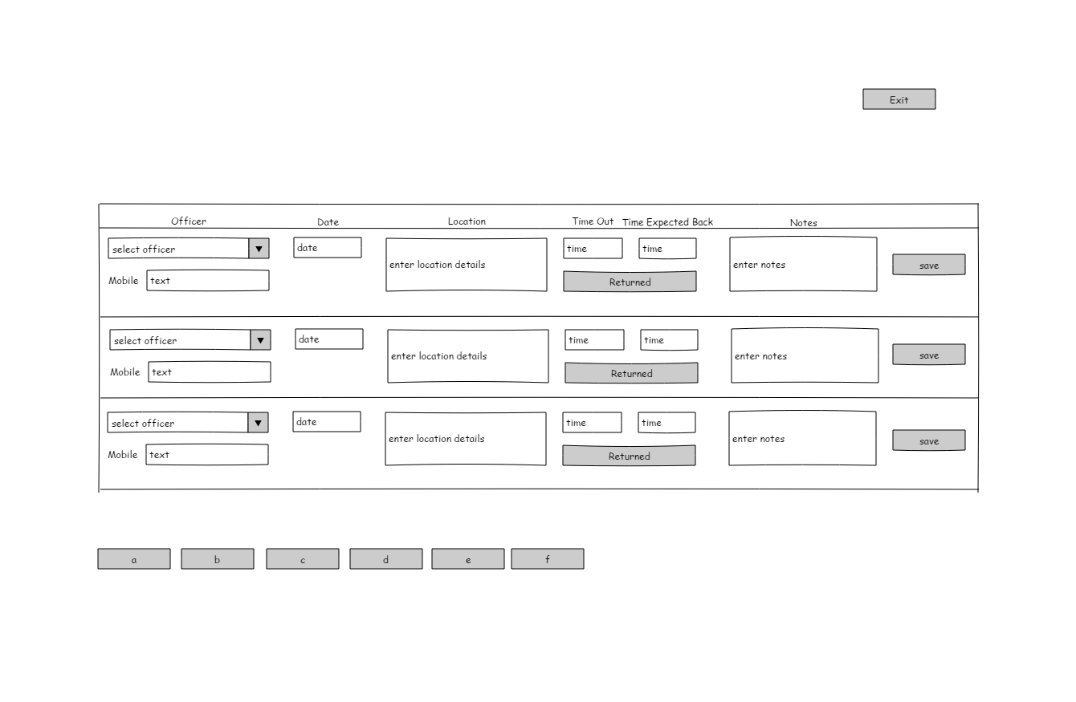

This file is saved as ‘My interpretation of the Main User Interface.epgz’ which can be opened with Pencil, or as an image as ‘My interpretation of the Main User Interface.png’

## Definitions

Site Officer – An employee of Northumberland County Council that participates in site visits on behalf of the Planning Department

Check In – When a site officer arrives to site

Check Out – When a site officer leaves site

## References

Gonzalez, J. F. (2017) *Java 9 Concurrancy Cookbook – Second Edition* [Online], Packt Publishing. Available at <https://www-safaribooksonline-com.libezproxy.open.ac.uk/library/view/java-9-concurrency/9781787124417/cover.xhtml> (Accessed 06/03/2019)

Sami, M, (2012) *Software Development Life Cycle Models and Methodologies* [Online], available at <https://melsatar.blog/2012/03/15/software-development-life-cycle-models-and-methodologies/> (Accessed 06/03/2019)

Samoylov, N (2018) *Introduction to Programming* [Online], Packt Publishing. Available at <https://www-safaribooksonline-com.libezproxy.open.ac.uk/library/view/introduction-to-programming/9781788839129/> (Accessed 06/03/2019)

Sarcar, V. (2018) *Java Design Patterns: A Hands-On Experience with Real-World Examples* [Online], Apress. Available at <https://www-safaribooksonline-com.libezproxy.open.ac.uk/library/view/java-design-patterns/9781484240786/html/395506_2_En_BookFrontmatter_OnlinePDF.xhtml> (accessed 06/03/2019)

The Open University (2019), ‘3.2 Reflection after action’, TM470 *Evalulating your work* [Online]. Available at <https://learn2.open.ac.uk/mod/oucontent/view.php?id=1393180&section=3.2> (Accessed 08/03/2019)