Telecom Customer Churn Analysis
Exploratory Data Analysis & Business Recommendations Report
Prepared by: Nicky Kumari
September 2026

1. Business Problem
The company is losing a significant portion of its customers to churn. This analysis examines customer demographics, account details, and subscribed services to identify which customers are at risk of churning and why — so the business can act early, reduce churn, and maximize customer lifetime value.

2. Dataset Overview
The dataset contains 7,043 customer records from a telecom company, with 21 columns covering demographics, account information, subscribed services, and churn status.
- Demographics: customerID, Gender, SeniorCitizen, Partner, Dependents
- Account Information: Tenure, Contract, PaperlessBilling, PaymentMethod, MonthlyCharges, TotalCharges
- Subscribed Services: PhoneService, MultipleLines, InternetService, OnlineSecurity, OnlineBackup, DeviceProtection, TechSupport, StreamingTV, StreamingMovies
- Target Variable: Yes / No — whether the customer has left the company

3. Methodology

3.1 Data Cleaning
- Blank values in TotalCharges were replaced with 0 and the column converted from text to numeric.
- SeniorCitizen was recoded from 1/0 to Yes/No for readability.
- Checked for and confirmed no missing values or duplicate customer records.
- Renamed columns for consistency (gender → Gender, tenure → Tenure).

3.2 Analysis Approach
With the data cleaned, churn was analyzed against each customer attribute in turn — demographics, contract terms, tenure, subscribed services, payment method, and billing amounts — to identify which factors most strongly correlate with churn.

4. Key Statistics at a Glance
Total Customers | 7,043
Churned Customers | 1,869 (26.54%)
Retained Customers | 5,174 (73.46%)
Avg. Tenure (Churned) | 18.0 months
Avg. Tenure (Retained) | 37.6 months
Avg. Monthly Charges (Churned) | $74.44
Avg. Monthly Charges (Retained) | $61.27

5. Exploratory Data Analysis — Findings

5.1 Overall Churn Rate
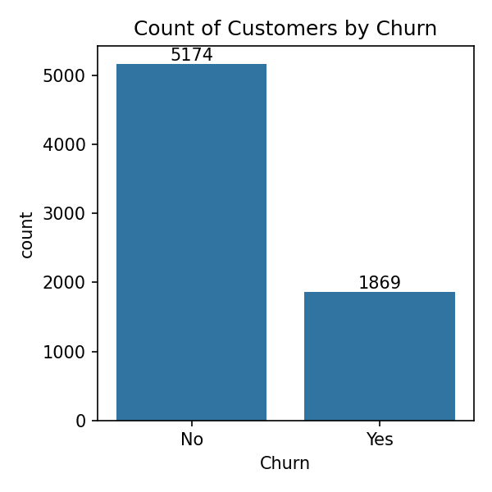
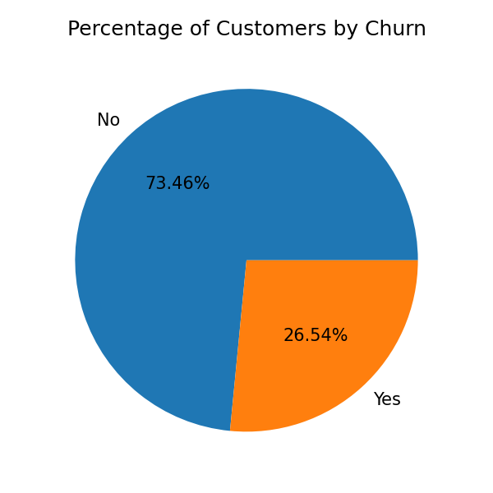
Figure 1 & 2: Churn count and percentage — 26.54% of customers have churned.
Roughly 1 in 4 customers has churned (1,869 of 7,043), confirming this is a material revenue risk worth addressing.

5.2 Churn by Contract Type
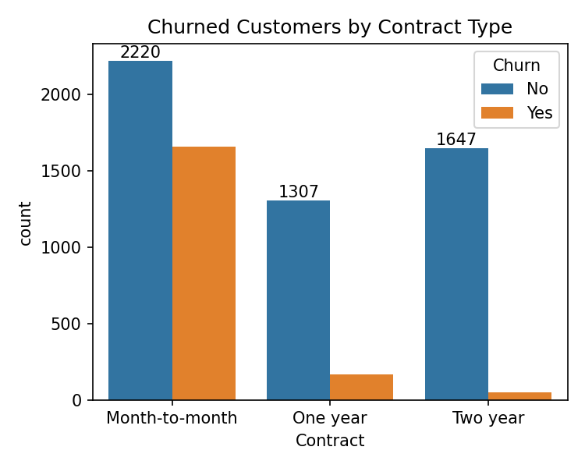
Figure 3: Churn count by contract type.
Contract type is the single biggest driver of churn. Month-to-month customers churn far more than One-year or Two-year customers, and most of that churn happens within the customer's first year on the plan.

5.3 Tenure vs. Contract Type
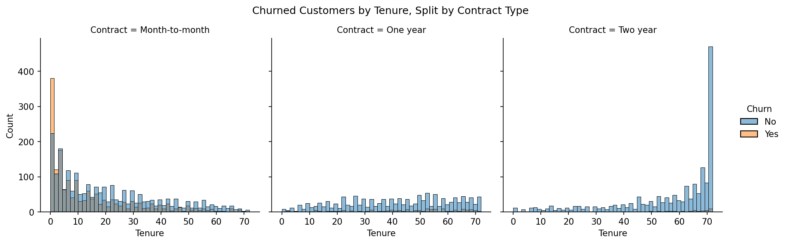
Figure 4: Distribution of tenure by contract type, split by churn.
Month-to-month customers churn heavily within their first year, with churn risk highest in the earliest months of the relationship. Longer contracts show much flatter, lower churn across all tenure ranges.

5.4 Monthly Charges by Churn Status
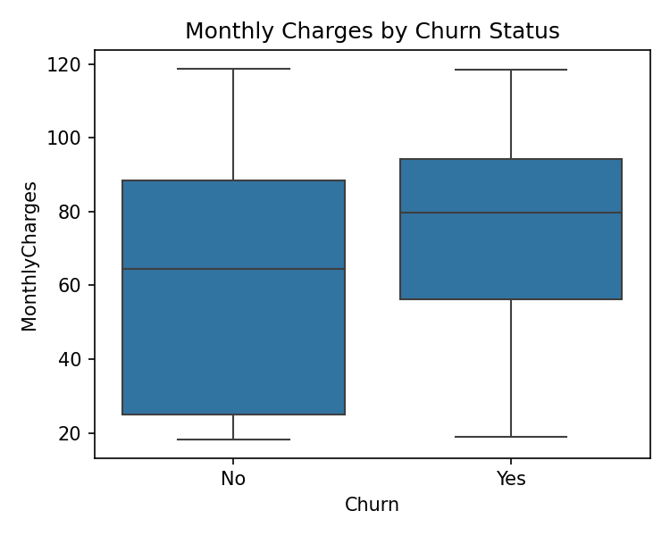
Figure 5: Monthly charges distribution by churn status.
Churned customers tend to pay higher monthly charges than retained customers, reflected in a higher median and 25th percentile. Despite paying more per month, their shorter tenure (18 vs. 37.6 months average) means they generate roughly 40% less total revenue over their lifetime ($1,531.80 vs. $2,549.91).

5.5 Payment Method
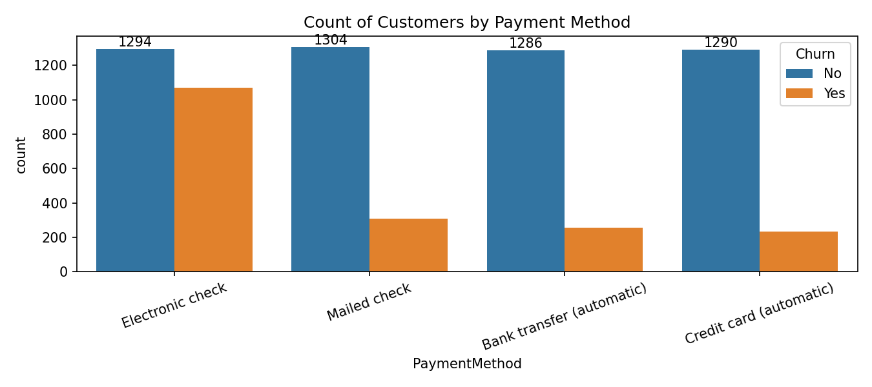
Figure 6: Churn count by payment method.
Customers paying via Electronic Check churn noticeably more than those on automatic payment methods (bank transfer or credit card), which likely correlates with the same non-committal, month-to-month customer segment.

5.6 Senior Citizens
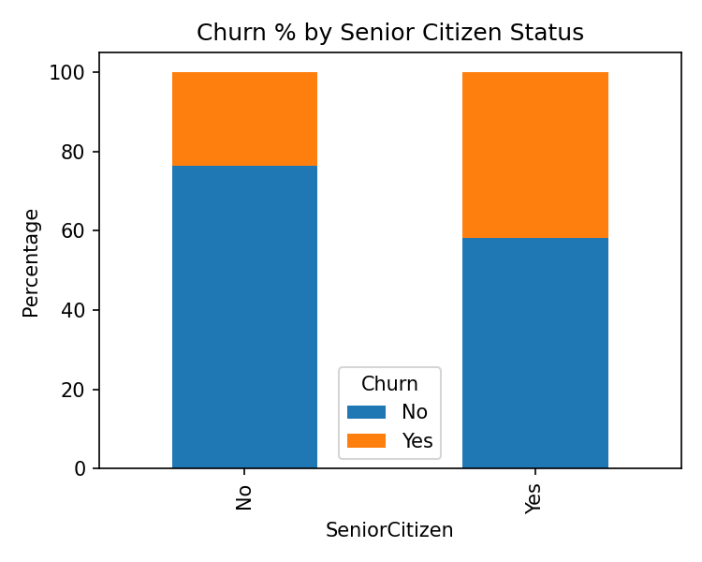
Figure 7: Churn percentage by senior citizen status.
Senior citizens churn at 41.68%, well above the 26.54% overall average — roughly 1.5x the typical rate.

5.7 Add-on Services
Customers without protective add-on services churn considerably more than those who have them:
- OnlineSecurity — Customers without it churn at 41.8%, vs. 14.6% for those who have it — the strongest single retention lever in the dataset.
- OnlineBackup — 39.9% churn without it, vs. 21.5% with it.
- DeviceProtection — 39.1% churn without it, vs. 22.5% with it.
- TechSupport — 41.6% churn without it, vs. 15.2% with it — customers lacking support churn nearly 3x more.
- StreamingTV / StreamingMovies — Streaming add-ons barely move the churn needle either way.
Fiber optic internet users churn at 41.9% — more than double DSL users (19.0%) and far above customers with no internet service (7.4%), suggesting a service-specific issue (pricing, reliability, or competition) rather than a simple add-on gap.

6. Key Findings Summary
- Overall churn rate: 26.54% of customers have churned (1,869 of 7,043) — roughly 1 in 4.
- Tenure: Churn risk drops sharply the longer a customer stays — 47.7% churn in the first year vs. just 9.5% after 49+ months.
- Contract type: The single biggest driver — Month-to-month customers churn far more than annual/biennial customers, mostly within their first year.
- Add-on services: Customers without TechSupport, OnlineSecurity, OnlineBackup, or DeviceProtection churn 2–3x more than those who have them.
- Internet service: Fiber optic users churn at 41.9% — more than double DSL users (19%).
- Monthly charges: Churned customers pay more per month ($74.44 vs $61.27) but stay about half as long, generating far less total revenue.
- Senior citizens: Churn much more than average — 41.68% vs. 26.54% overall.
- Payment method: Electronic Check users churn the most.
- Gender: No meaningful impact — churn is nearly identical across genders.

7. Recommendations
- Target the first year of the customer lifecycle — Focus onboarding support, check-ins, and loyalty perks on a customer's first 12 months, where churn risk is highest.
- Incentivize longer contracts — Offer discounts or perks to convert Month-to-month customers into One-year or Two-year plans.
- Bundle protective add-ons — Promote TechSupport and OnlineSecurity (e.g. free trial or discounted bundle), since customers without them churn 2–3x more.
- Investigate Fiber optic service — High churn there may point to pricing, reliability, or competitor issues specific to that service.
- Review pricing for high-paying customers — Consider loyalty discounts or value-add perks for customers on higher-priced plans to reduce price-driven churn.
- Prioritize senior citizens in retention programs — This group churns nearly 1.5x the average rate and may benefit from simplified support or tailored plans.
- Encourage other payment methods — Investigate why Electronic Check users churn more, and nudge them toward automatic payment methods.

8. Conclusion
Contract type, tenure, and the absence of protective add-on services emerge as the primary drivers of churn in this dataset. Customers on month-to-month contracts, in their first year, and without services like TechSupport or OnlineSecurity are consistently the highest-risk segment. These findings give the business clear, actionable levers — from contract incentives to service bundling to targeted retention outreach — to meaningfully reduce churn and improve customer lifetime value.

9. Tools Used
- Python (Pandas, NumPy) — Data manipulation and cleaning
- Matplotlib, Seaborn — Data visualization
- Jupyter Notebook — Analysis environment

