Zepto Inventory & Pricing Analysis
A SQL-Based Exploratory Data Analysis Report
Prepared by: Nicky Kumari
August 2026

1. Business Problem
Zepto's product catalog contains raw pricing, stock, and category data pulled directly from the platform. This analysis cleans that data and uses SQL to answer practical business questions: which products offer the best value, which high-priced items are sitting out of stock, which categories carry the most inventory value, and how pricing compares across product weights — insights that support pricing strategy and inventory planning.

2. Dataset Overview
The dataset contains 3,732 product listings across 14 grocery and household categories, including Fruits & Vegetables, Dairy Bread & Batter, Beverages, Munchies, Packaged Food, Personal Care, and Home & Cleaning.
- Product identity: Category, name
- Pricing: mrp, discountedSellingPrice, discountPercent — originally stored in paise
- Stock status: availableQuantity, outOfStock, quantity
- Weight: weightInGms, used for price-per-gram value analysis

3. Methodology

3.1 Data Exploration
- Checked row counts, sampled records, and confirmed no NULLs across key columns.
- Reviewed in-stock vs. out-of-stock split and identified products listed multiple times (e.g. across pack sizes).

3.2 Data Cleaning
- Removed 1 invalid record with MRP = 0.
- Converted mrp and discountedSellingPrice from paise to rupees (divided by 100).

3.3 Analysis
Using T-SQL in Microsoft SQL Server, the cleaned data was queried to surface best-value products, high-MRP out-of-stock items, category-level inventory value, discount patterns, and price-per-gram value — full queries are in zepto_SQL_project.sql.

3.4 Advanced SQL Techniques
The analysis was extended using CTEs, window functions, and a view to demonstrate deeper SQL proficiency beyond basic aggregation — covered in detail in Section 6.

4. Key Statistics at a Glance
Total Products | 3,732
Product Categories | 14
Out of Stock | 453 products (12.1%)
Invalid Records Removed | 1 (₹0 MRP)
Highest Discount Offered | 51% (Dukes Waffy Wafers range)
Products with High MRP + Low Discount (<10%) | 82
Top Category by Avg. Discount | Fruits & Vegetables (15.46%)

5. Findings

5.1 Stock Status
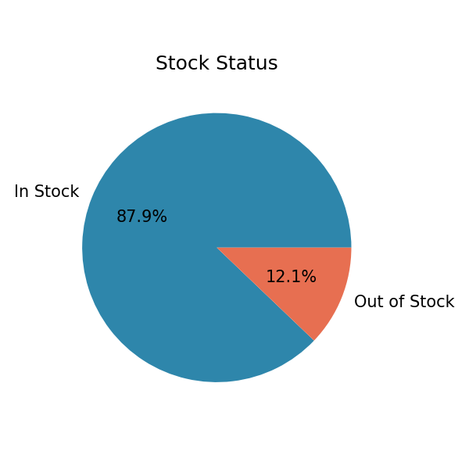
Figure 1: Share of products in stock vs. out of stock.
453 of 3,732 products (12.1%) are currently out of stock. Within the top 25% highest-priced products specifically, 4.5% are out of stock — including premium items like Patanjali Cow's Ghee and MamyPoko Pants diapers — representing lost sales on higher-margin products.

5.2 Inventory Value by Category
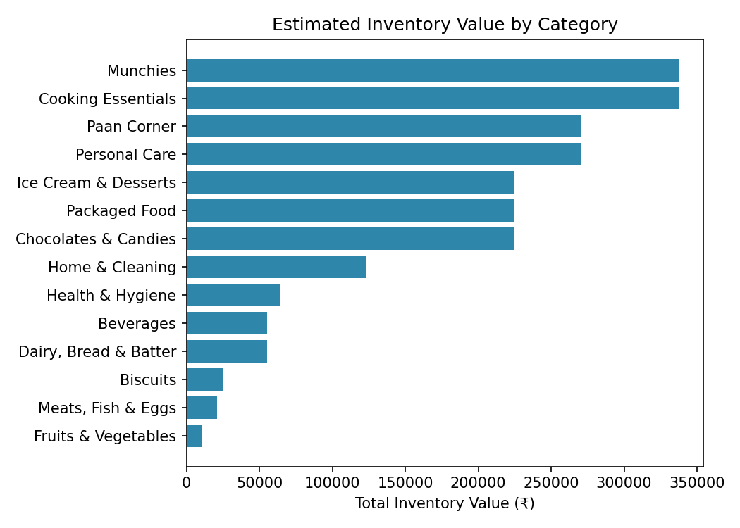
Figure 2: Estimated inventory value (available quantity × selling price) by category.
Cooking Essentials and Munchies carry the highest estimated inventory value, followed by Paan Corner and Personal Care. Fruits & Vegetables and Meats, Fish & Eggs carry comparatively low inventory value, consistent with their smaller catalog size and lower per-unit pricing.

5.3 Discounting by Category
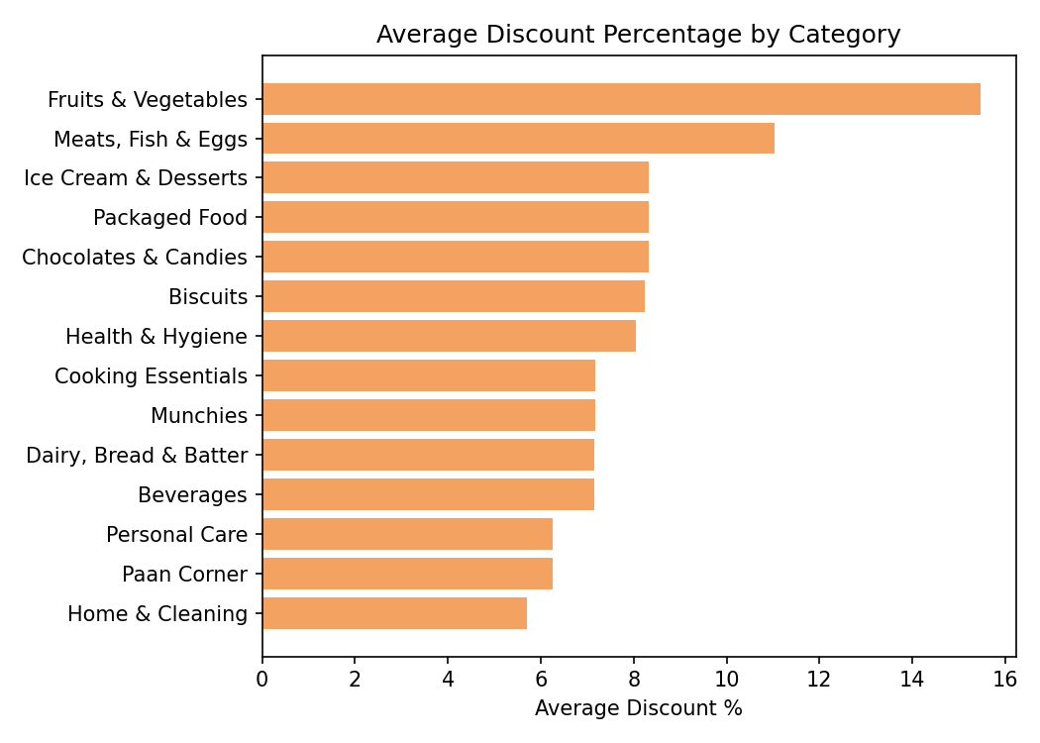
Figure 3: Average discount percentage by category.
Fruits & Vegetables carries the highest average discount (15.46%), followed by Meats, Fish & Eggs (11.03%). Packaged goods categories (Ice Cream & Desserts, Packaged Food, Chocolates & Candies) cluster around 8.3% average discount — noticeably lower than fresh categories.
82 products have an MRP above ₹500 but a discount under 10% — mostly cooking oils and ghee (e.g. Dhara Mustard Oil, Saffola Gold, Fortune Rice Bran Oil) — a segment with little price incentive for customers, worth reviewing for promotional opportunities.

5.4 Best-Value Products
The steepest discounts (51%) were found on Dukes Waffy wafer variants (Orange, Chocolate, Strawberry). Several Moi Soi sauces and Chef's Basket pasta also offer 50% discounts, making them standout value picks in the catalog.

5.5 Product Weight Distribution
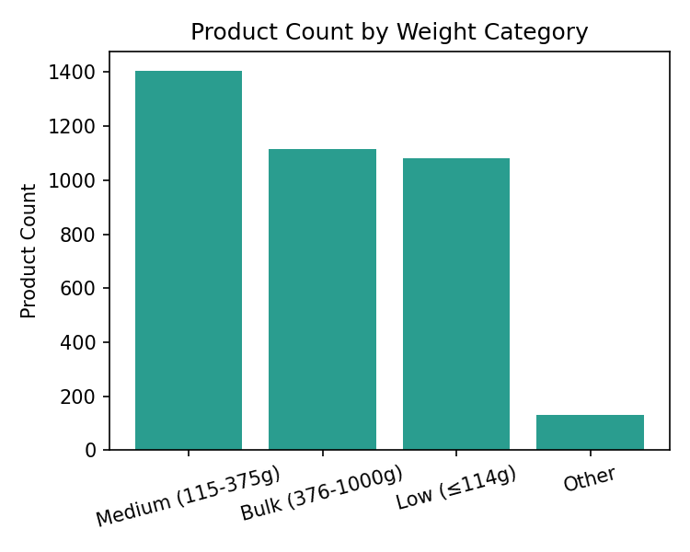
Figure 4: Product count by weight segment (Low ≤114g, Medium 115-375g, Bulk 376-1000g).
Medium-weight products (115-375g) are the most common segment (1,406 products), followed closely by Bulk items (1,115) and Low-weight items (1,080). Price-per-gram analysis shows personal care items — particularly hair color products — carry the highest per-gram cost in the catalog, far above grocery staples.

6. Advanced SQL Techniques
Beyond the core exploration and insights queries, the analysis was extended using more advanced SQL constructs to demonstrate deeper querying proficiency and produce reusable reporting logic.
- CTEs (Common Table Expressions) — Used to structure category-level aggregations (inventory value, product count, average discount) as a named, reusable result set, then filtered to categories exceeding ₹100,000 in inventory value.
- Window Functions — RANK() with PARTITION BY identified the most-discounted product within each category (rather than overall); LAG() compared each product's price to the next most expensive item in its category to surface pricing gaps.
- Running Totals — A running total of inventory value per category was calculated using SUM() OVER() with an explicit row frame, showing cumulative value product by product.
- View — Created vw_category_summary — a reusable view pre-aggregating product count, out-of-stock count, average discount, and inventory value per category — so future reports or BI tools can query it directly without repeating the aggregation logic.
Together, these techniques go beyond basic SELECT/GROUP BY queries and reflect patterns commonly used in ETL and reporting workflows.

7. Key Findings Summary
- Stock availability: 12.1% of the catalog (453 of 3,732 products) is out of stock, including several premium items.
- Inventory value: Cooking Essentials and Munchies hold the highest estimated inventory value among all categories.
- Discounting: Fruits & Vegetables receives the deepest average discounts (15.46%); packaged food categories are discounted far more conservatively (~8.3%).
- Pricing gaps: 82 high-MRP products (mostly oils and ghee) carry minimal discounts, a possible area to review pricing strategy.
- Value analysis: Personal care items (hair color, in particular) carry the highest price-per-gram in the catalog.
- Product mix: Medium-weight products (115-375g) make up the largest share of the catalog.

8. Recommendations
- Address out-of-stock premium products — Prioritize restocking high-MRP, high-demand items to avoid losing premium-margin sales.
- Review pricing on low-discount essentials — Consider light promotional discounts on staples like cooking oils and ghee, which currently see minimal discounting despite high price points.
- Monitor high-inventory-value categories — Since these categories hold the most inventory value, monitor stock turnover closely to avoid overstock or spoilage risk (especially for perishables).
- Highlight best-value products — Promote well-discounted items (Dukes Waffy, Moi Soi sauces, Chef's Basket pasta) as featured deals to drive volume.

9. Conclusion
This SQL-based analysis of Zepto's product catalog surfaces clear, actionable patterns: stock gaps on premium items, uneven discounting between fresh and packaged goods, and a small set of high-price, low-discount staples worth a pricing review. Together, these findings give the business concrete levers — restocking priorities, targeted discounting, and inventory monitoring — to improve both customer value and inventory efficiency.

10. Tools Used
- Microsoft SQL Server (T-SQL) — Data storage, cleaning, and querying
- SQL Server Management Studio (SSMS) — Query development and execution

