CEO Gender and Firm Performance
Nicky Punt

Introduction
Over these past 20 years, women have outnumbered men in higher education. In figure 1, you can see this increase of females in higher education, having stabilized at a 1.13 ratio for the past four years. Regardless of women comprising over half of the educated labor force in the United States, the larger part of leadership roles in businesses tend to consist of men. Only about 11% of United States-based companies have a female CEO. This number is also low in other leadership positions, such as on boards of directors, where 16% of the board seats at Russell 3000 firms are held by women and 21% of these boards do not have a single female director. Women are not just under-represented as CEO’s or on boards, but on all levels in business. However, compared to other levels, the smallest proportion of women is in the CEO area. As the position becomes higher up in a corporation, we see less women which is visualized in figure 2. Due to these numbers, the debate whether more women should be appointed to leadership positions has been gaining increasingly more attention over the past decades. Advocates propose that women would be better leaders due some leadership styles that females are more likely to have, such as demonstrating transformational leadership and emphasizing team collaboration. This paper examines how the gender of a CEO affects firm performance, measured by EBITDA margin, among S&P 500 companies in the United States. 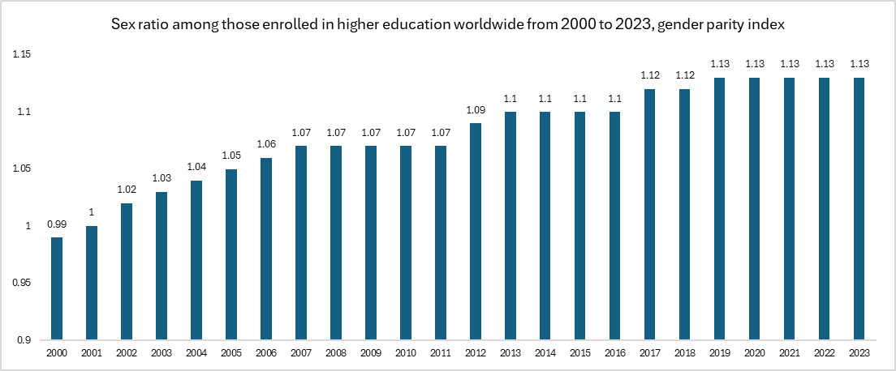 Figure 1

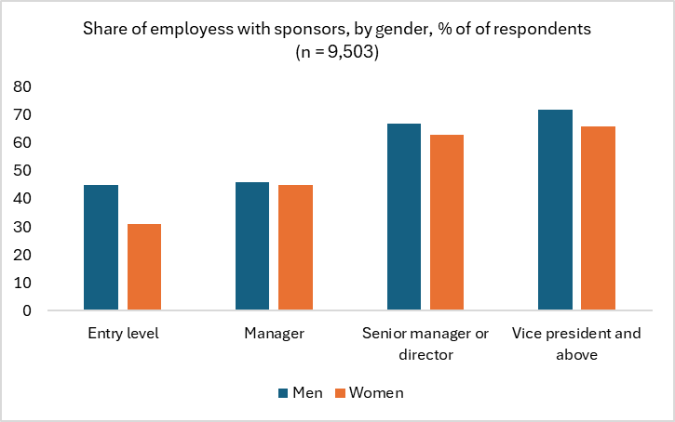
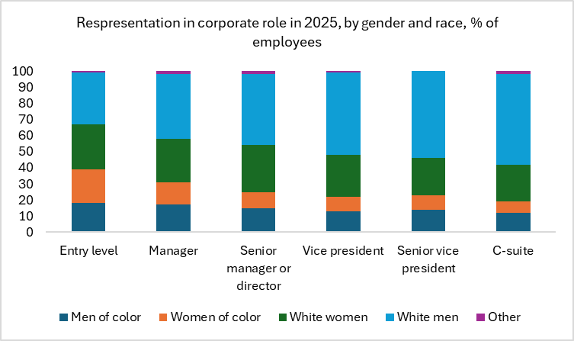
These subject matters because investors, boards, and lawmakers use this evidence to justify diversity policies and hiring decisions. In multiple studies it was found that, on average, female CEOs allocate capital more carefully, leading to higher margins. This could benefit investors as their goal is to get higher returns. A firm's decision to choose for a female CEO is therefore not just for ethical reasons, but also financially responsible. More research on this topic should also help inform boards and investors to make more thoughtful decisions. Men get sponsored for promotions more often than women as shown in Figure 3. By becoming more knowledgeable on the topic of women in leadership roles, investors and boards don’t just have ethical reasons to appoint more women in leadership positions, but also financial reasons. Over the past decades, many studies were done about gender diversity in leadership positions which even led to some policy changes. Take Norway for example, who implemented a law in 2018 that requires public companies to have at least 40% of each gender represented on their board. Or, California 826, implemented in 2018, that requires all public companies to include at least one woman on their board of directors. Policy makers are already acting on the relationship between gender and firm performance. Even though these policies are about gender diversity on boards, we want to find out the influence of women at the very top decision-making position in a firm.
Figure 2 Figure 3

Literature Review
CEO gender and firm performance by Lumin Shao and Zhiqing Liu explores the relationship between CEO gender and firm performance. The main research question is whether the gender of a firm’s CEO has a significant effect on firm performance. The dependent variable that the authors used is stock returns. As secondary research question they look at whether a CEOs gender and has a significant relationship with the company’s systematic risk (beta). The results conclude no significant correlation between the CEO gender and firm performance. However, the authors do note that there are limitations to their findings, such that the sample of female CEOs is small, and the data is only limited to the United States. The paper mentions a phenomenon called “glass cliff” which causes women to be more likely to be appointed in leadership roles in times of struggles. This could be a confounding variable that causes bias in our model. Lastly, the sample only includes the first three to four years of the CEO’s tenure which could cause bias as well.
Women on boards and firm performance by Mijntje Lückerath investigates the financial performance of Dutch companies both with and without women on their boards. The analysis extends on earlier research methods done by Catalyst and McKinsey. The results from these studies show that firms with women directors perform better than those without women on their boards. Overall, Lückerath found that having women on the board of directors has a significant and positive relationship with return on equity. The relationship appears to stay significant after controlling for firm size, board size, and the financial sector. However, she is careful to claim causality and rather claims correlation as there are many factors that influence the performance of a company. It also could be that larger, more successful companies are more likely to appoint women on their board. Lastly, not all financial performance measures, such as total shareholder return (TSR), showed positive effects.
CEO and Chairperson characteristics and firm performance by Amilia Peni focuses on the CEO and the Chairperson the board’s characteristics and firm performance, using a sample of S&P 500 companies. Multiple characteristics are being examined, such as gender, age, quality, and experience. The results indicate a positive relationship between firm performance and the presence of a female CEO or Chairperson, as well as more experience and higher quality. They also concluded that one person holding both the CEO and Chairperson roles has a positive impact on market valuation and return on assets (ROA). Overall, the findings suggest that individual leadership characteristics are significant determinants of a firm’s market performance.

Theoretical Framework
Decades of studies show that female leaders help increase productivity, enhance collaboration, inspire organizational dedication, and improve fairness. An extensive analysis in 2019 showed that women excel in several key areas of leadership and surpassed men in 17 out of 19 capabilities, which marks the difference between excellent, average or poor leaders. Of course, not all women possess the same qualities, just like how not all men have the same qualities. However, on average, there is much data that supports the evidence that women contain some of the following characteristics: bold decision-making, relationship building, prioritizing well-being, driving results, inspiring others, and enhancing collaboration. These characteristics allow employees to be more content with their jobs and reduce employee turnover. This improves productivity and execution quality, which ultimately leads to better firm performance. When employees are happy, they do their jobs better, which leads to better outcomes firm wide, which can be measured through EBITDA margin.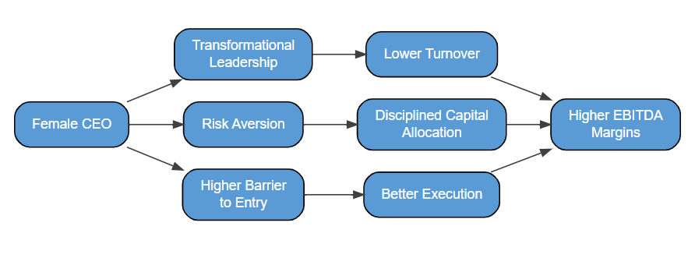
Figure 4

Looking back at Figure 3, we saw that women get sponsored less for promotions at every level, and when they do, they still get promoted less than their male counterparts. So, the women who do reach the CEO position are more precisely selected compared to men. In labor economics, the female CEO has a higher boundary to enter than the male CEO. So, female CEOs outperform male CEOs, on average, given that it is harder for them to be appointed for the role.
As mentioned before, female CEOs tend to take less risks than their male counterparts. This risk-averse behavior leads to more careful allocation of capital. More disciplined capital allocation reduces expenses and increases margins.
However, we should be aware of an important economic phenomenon called “The Glass Cliff”. The glass cliff states that women or minorities are more likely to be appointed into leadership roles when the organization is struggling. In this case, female CEOs are more likely to be appointed to struggling firms with worse margins. There has been extensive research on this topic, and it has been proven to be true, not just for CEO positions or females, but also other minorities for any leadership position. In our model, this could mean that our explanatory variable, having a female CEO, could be endogenous and correlated with the error term. As females are more likely to be appointed CEO when a firm is struggling, their margins could be lower, especially when a female hasn’t been in the position for that long. CEO gender is then correlated with firm conditions from before a female was the CEO, which themselves are a determinant of EBITDA. This could cause downward bias in our model and may cause an underestimation of the true effect of having a female CEO.
Overall, women would be correlated with higher firm performance due to three main reasons. Their leadership style tends to be more transformational. This causes employees to be content, a lower employee turnover, and better job execution, which ultimately leads to better margins. Additionally, women tend to be more risk averse than their male counterparts and allocate capital more carefully, which leads to higher margins as well. Lastly, to be appointed as CEO, females have higher barriers to enter, which makes the women who do make it to the position to be extremely qualified. This indirectly also leads to higher margins.

Econometric Model
Our main research question is whether firms with a female CEO led to better firm performance than firms led by male CEOs, after controlling for size, age, and industry. Because female appointments are not randomly assigned, a simple OLS regression would likely suffer from omitted variable bias (OVB). Unobserved variables such as company culture or board composition might influence whether a woman gets appointed CEO. To address this endogeneity concern, we use a 2:1 matching model with replacement. The regression is run after we match a female CEO with two male CEOs based on the control variables and which lie closest to each other.

(1)
$$EBITDAmargin_{i}= β_{0}+β_{1}Female_{i}+β_{3}\log\left(Employees\right)+$$
$$β_{4}FinSector_{i}+ β_{5}California_{i}+ v_{i}$$

The dependent variable, EBITDAmargin, is the firm’s EBITDA as a percentage of their total revenue. FemaleCEO is the treatment variable which is binary and equals 1 when the firm’s CEO is female and 0 if the firm's CEO is male. As our theory states, we expect this to have a positive relationship and therefore have a positive coefficient. The model controls for firm size using log(Employees) which we expect to be positively correlated with EBITDA margin. FinSector is a binary control variable equaling 1 if the firm is in the financial sector and 0 otherwise. We expect a negative sign for the coefficient. Firms in the financial sector have a different financial structure which tends to make their EBITDA margins a bit lower. Lastly, we include an indicator variable for California which is 1 for firms with their headquarters located in California and 0 otherwise. Firms in California are legally obliged to have at least one female on their board of directors. This could make the firms based in California to be more likely to have female CEOs or other leadership positions and therefore have higher margins. The regression is run after we matched a female CEO with two male CEOs based on their values of the control variables.

(2)
$$EBITDAmargin_{i}= β_{0}+β_{1}Female_{i}+β_{3}\log\left(Employees\right)+$$
$$β_{4}FinSector_{i}+ β_{5}California_{i}+FinSector_{i}*Female_{i}+ v_{i}$$

Additionally, a second model is included that contains an additional interaction term. The interaction term of FinSector and Female is included to learn whether the effect of female is different in the financial sector compared to any other industry. We expect this sign to be positive as the financial sector tends to have a stronger pipeline of female executives.
Since we are utilizing a 2:1 matching model, each female CEO will be paired with two male CEO’s before running the regression. The reason for using 2:1 matching instead of 1:1 is because the data set contains a smaller number of females (~10.5%). Having more matches will give more reliable regression results. The observations are matched according to their values for the control variables. Each female CEO is matched with male CEOs who have similar values for the control variables. How good two observations match is represented by their propensity score.
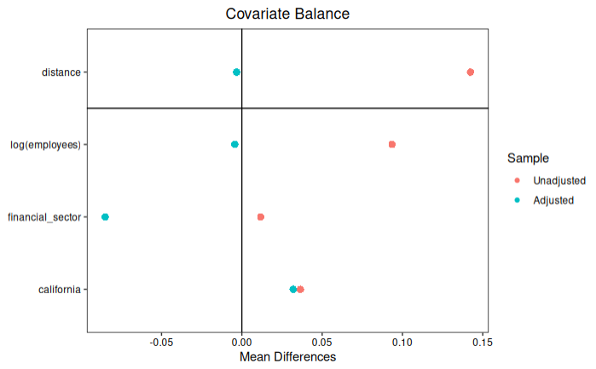
The love plot in figure 5 represents how well the data is balanced before and after matching. The distance represents the propensity score itself. Matching should collapse this gap which is done in this case since the adjusted score is almost at zero. The matching process also reduced the imbalance for the log of employees. California was not too far away from zero before matching and only improved slightly after the process, but the differences are not too far away from zero to be concerned. Lastly, the unadjusted financial sector was close to zero but moved further from zero after matching. This suggests that the matched sample has a difference in financial sector representation between treated and control groups. This could be due to underrepresentation of females in financial firms. However, the comparison is between the financial sector and all other sectors so it would make sense that there are relatively less women.

Figure 5

In figure 6, a set of histograms is displayed which shows the distributions of the propensity scores for treated and control groups before and after matching. All four histograms have roughly similar looking distributions. Before matching, the control group showed larger propensity scores compared to the matched control groups, After matching both the treatment- and control group showed similar propensity scores with both having the majority of propensity scores between 0.08 and 0.14. These similar looking distributions confirms that matched control firms are comparable to firms with female CEOs based on the control variables. Regarding the treatment group, the raw and matched data seems to be fairly similar to each other.

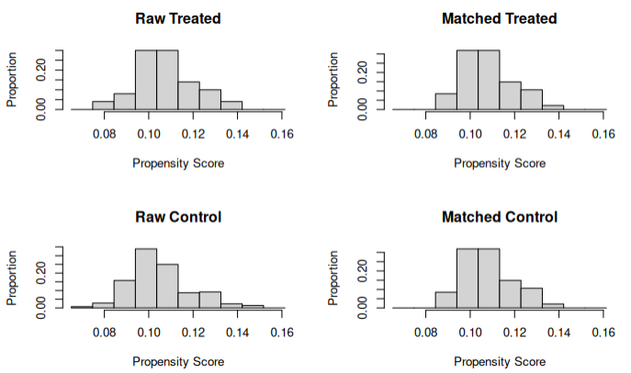
Figure 6

The Data
The data that is used comes from a sample of all the U.S. based S&P 500 companies which is sourced from Capital IQ in March 2026. The sample exists out of 476 firms of which 50 have female CEOs. The lower number of samples is because the non-U.S. and the “N.A.” inputs were dropped.
In Table 1, all the variables in the econometric model are defined. The dependent variable, $EBITDAmargin_{i}$, is a ratio between below 1. There are a few negative observations which we assume to be outliers as these firms could be going through restructuring. EBITDA margin is a fitting measure of operating efficiency that accounts for a firm's size and is directly comparable across firms of different sizes and industries. The treatment variable, $FemaleCEO_{i}$, is a binary indicator variable that captures whether the firm’s current Chief Executive Officer is female. $California_{i}$, is also a binary indicator variable and indicates whether a firm’s headquarters is located in California, the state whose SB 826 mandate created pressure on corporate leadership gender diversity.
The size control variable, $log(Employees_{i})$, is log transformed to reduce large outliers and skewness, and make the coefficients easier to interpret. $Age_{i}$ is measured in calendar years from the founding year until 2026 and represents a company’s maturity. Lastly, $FinSector_{i}$, is a binary control variable that identifies whether a firm’s primary industry is finance, given that the financial sector tends to have higher revenues and different structures that affect EBITDA margins.

Variable | Type | Units | Definition
$$EBITDAmargin_{i}$$ | Dependent Variable (Y) | Ratio (<1) | EBITDA divided by total revenue (LTM), measures operating profitability
$$FemaleCEO_{i}$$ | Treatment Variable | Binary (1=female, 0=male) | Equals 1 if the firm’s current CEO is female, 0 otherwise
$$California_{i}$$ | Control | Binary (1= HQ in CA, 0=otherwise | Equals 1 if the firm is headquartered in California, 0 otherwise
$$log(Employees_{i})$$ | Control | Log of employees, as count | Log of global full-time employee headcount,  Controls for firm size
$$FinSector_{i}$$ | Control | Binary (1=Financial sector, 0=other) | Equals 1 if the firm’s primary sector is in the financial industry, 0 otherwise
$$FinSector_{i}*Female_{i}$$ | Control | Binary interaction term (1=Financial Sector and female, 0=other) | Equals 1 if the firm’s primary sector is in the financial industry and has a female CEO, 0 otherwise
Table 1: Variable Definitions

Table 2 reports the numerical summaries for all of the variables in the model. The final dataset has 474 S&P 500 firms located in the United States, after accounting for a small amount of missing values. The mean EBITDA margin of 26.09% reflects the overall high profitability which is expected as these are large cap firms. The minimum of 147.1% is an extreme outlier and there could be various reasons for this such as restructuring. This shows that the data provides good variation. The maximum of 91.9% is much more consistent with extremely high margin sectors such as technology. The female CEO indicator variable has a mean of 10.5% which aligns with the count of the number of female CEOs, 50, in this dataset. The California indicator variable has a mean of 14.71%, meaning that about 1 in 7 firms are headquartered in California.
Regarding the control variables, the log of employees shows similar numbers with a mean equal to 9.97 and a 1.44 standard deviation. Firm age has a large range going from 2 years to a maximum of 252 years. The mean is approximately 79 years and has a large standard deviation of about 52 years. This reflects the various maturity of firms such as young technology firms and centuries old firms within the S&P 500. About 15% of the firms primarily operate in the financial sector, which confirms it is relevant to control for. Lastly, the interaction term of financial sector and female has a mean of 0.0168 and a standard deviation of 0.1288 which indicated that 1.68% of our sample contains firms that primarily operate in the financial sector and have a female CEO.

Variable | N | Mean | Standard Deviation | Minimum | Maximum
$$EBITDAmargin_{i}$$ | 474 | 0.2609 | 0.1959 | -1.4707 | 0.9114
$$FemaleCEO_{i}$$ | 474 | 0.105 | 0.3069 | 0.0000 | 1.0000
$$California_{i}$$ | 474 | 0.1471 | 0.3545 | 0.0000 | 1.0000
$$log(Employees_{i})$$ | 474 | 9.9727 | 1.4414 | 3.3322 | 14.5575
$$FinSector_{i}$$ | 474 | 0.1491 | 0.3567 | 0.0000 | 1.0000
$$FinSector_{i}*Female_{i}$$ | 474 | 0.0168 | 0.1288 | 0.0000 | 1.0000
Table 2: Numerical Summaries

Results
Variable | Estimate | Standard Error | Observations (N)
Female CEO | 0.012 | 0.027 | 476
Log(employees) | -0.050*** | 0.011 | 475
Financial Sector | -0.074* | 0.033 | 476
California | 0.010 | 0.039 | 476
Adjusted R-Squared |  | 0.1398
Table 3: Results model 1

The results of model 1 are reflected in table 3. The main variable of interest, FemaleCEO, has a positive coefficient of 0.012. This would mean that firms led by female CEOs are associated with about 1.2 percentage points higher EBITDA margin compared to firms led by male CEOs. However, this estimate is not significant as it has a p-value of 0.66. Therefore, we fail to reject the null hypotheses that the gender of a CEO has no effect on EBITDA margins. This result is consistent with existing literature, such as “CEO Gender and Firm Performance” by Lumin Shao and Zhiqing Liu. However, they do recognize that there are limitations to their findings which could also be our case. These limitations could include the sample size and the glass cliff phenomenon.
Between the control variables, log(Employees), has the most statistical evidence to be precisely estimated. The coefficient is -0.050. This result implies that relatively more employees can decrease EBITDA margins which could be related to the fact that more employees increase the costs for a firm. FinSector is also statistically significant and has a negative coefficient, -0.074, which indicates that a firm that primarily operates in the financial services is associated with smaller EBITDA margins than firms in other sectors. The California indicator variable is positive but statistically insignificant with an estimate of 0.010, indicating that firms that are headquartered in California are associated with higher EBITDA margins compared to firms that are not headquartered in California. The overall model explains about 14% of the variation in EBITDA margin (adjusted R-squared = 0.1398).

Variable | Estimate | Standard Error | Observations (N)
Female CEO | 0.002 | 0.031 | 476
Log(employees) | -0.052*** | 0.012 | 475
Financial Sector | -0.092* | 0.040 | 476
California | 0.008 | 0.039 | 476
Financial Sector * Female | 0.054 | 0.071 | 476
Adjusted R-Squared |  | 0.1367
Table 4: Results model 2

Now looking at model 2, the coefficient for female CEO is 0.002 which indicates that having a female CEO increases the EBITDA margin of a firm by 0.002, on average. Even though this effect is not statistically significant, the value is positive, which confirms the results from model 1. Like model 1, the log of employees is the highest statistically significant variable. The coefficient is -0.052 which means that for a 1% increase in employees, the firm’s EBITDA margin decreases by 0.00052. Both in model 1 and 2, the effect of the log of employees and EBITDA margin have a negative relationship which makes sense as more employees increase costs which decreases margins. The financial sector variable is somewhat significant and has a coefficient of -0.092, meaning that if a firm primarily operates in the financial sector, their EBITDA margin decreases by 0.092, on average. This is a larger effect than the -0.074 in model 1. If a firm is headquartered in California their EBITDA margin increases by 0.008 compared to firms that are not headquartered in California. However, this effect is not statistically significant. Lastly, the interaction between the financial sector control variable and female treatment variable gives an effect of 0.054 which means that firms who operate in the financial sector and have a female CEO have a 0.054 higher EBITDA than firms who don’t. Even though this result is insignificant, it is important to note that this is a positive and has a larger effect than the effect on just female. This indicates that females in the financial sector have better firm performance than the average firm performance in the financial sector. Additionally, note that the individual financial sector effect is negative, meaning that female CEOs in the financial sector outperform the average firm performance in the industry. Lastly, the adjusted R-squared value is 0.1367, meaning that about 13.67% of the variability in EBITDA margin is explained by this model. This is slightly lower than the adjusted R-squared value in model 1 which was 0.1398. However, it is such a small difference that this is not alarming.
Overall, the results show that firm characteristics, such as employee headcount and industry classification, are more reliable predictors of EBITDA margin than CEO gender in this sample of the S&P companies located in the United States. While the direction of the coefficient is consistent with the theoretical framework and other literature, the estimate is too imprecise to support a causal relationship.

Conclusion
The paper examines the relationship between CEO gender and firm performance. Specifically, whether a female CEO is positively correlated with firm performance. The results show that the gender of the CEO did not have a statistically significant impact on EBITDA margins in this S&P 500 sample. However, the coefficient, 0.012, is positive, which does align with the theoretical framework.
These findings do suggest that the choice of diversity in leadership does not come at a financial cost. It confirms that biases against female leadership are unnecessary, as the relationship we found is not negative.
However, we do need to take some limitations into account such as sample size, control variables, and the glass cliff phenomenon. The sample size only consists out of 476 firms of which 50 have female CEOs. This is relatively small as there can be much other noise in data. Additionally, the dependent variable, EBITDA margin, is a good financial measure overall, but there are better ways to measure firm performance, such as Tobin’s Q. Additionally, there might be some important control variables such as how long a CEO has been at the firm, or the EBITDA margin from a few years before. However, this data set is limited and we were not able to use those variables. Lastly, the “Glass Cliff” phenomenon, where women are more likely to be selected for leadership roles, could underestimate the true added value that female CEOs. An extension on this research should include a larger data set or panel data

Bibliography
Ryan, M. K., & Haslam, S. A. (2005). “The glass cliff: Evidence that women are over-represented in precarious leadership positions.” British Journal of Management, 16(2), 81–90.

Shao, Lumin, and Zhiqing Liu. “CEO Gender and Firm Performance.” Simon Fraser University, 2014.

Lückerath-Rovers, Mijntje. “Women on Boards and Firm Performance.” Journal of Management & Governance, vol. 17, no. 2, 2013, pp. 491–509. Springer, https://doi.org/10.1007/s10997-011-9186-1.

Peni, Emilia. "CEO and Chairperson Characteristics and Firm Performance." Journal of Management & Governance, vol. 18, no. 1, Feb. 2014, pp. 185-205. SpringerLink, https://doi.org/10.1007/s10997-012-9224-7.

McKinsey & Company. (2025). Women in the workplace. https://www.mckinsey.com/capabilities/people-and-organizational-performance/our-insights/women-in-the-workplace
American Psychological Association. (n.d.). Female leaders make work better. https://www.apa.org/topics/women-girls/female-leaders-make-work-better
Zenger, J., & Folkman, J. (2019). Research: Women score higher than men in most leadership skills. Harvard Business Review. https://hbr.org/2019/06/research-women-score-higher-than-men-in-most-leadership-skills
Faccio, M., Marchica, M.-T., & Mura, R. (2016). CEO gender, corporate risk-taking, and the efficiency of capital allocation. SSRN. https://doi.org/10.2139/ssrn.2021136
Ryan, M. K., Haslam, S. A., Morgenroth, T., Rink, F., Stoker, J., & Peters, K. (2016). Getting on top of the glass cliff: Reviewing a decade of evidence, explanations, and impact. The Leadership Quarterly, 27(3), 446–455. https://doi.org/10.1016/j.leaqua.2015.10.008

