
CMN/CMP 224 Software Engineering
Task 4 Design and Modelling
Kina Ridge Primary School
Name: Nicky Saroa
Lecturer: Mr. Hombiku

Introduction
The Kina Ridge Fee-Tracking System is a desktop-based application developed to assist school administration staff in managing student fee records, recording payments, generating receipts, and producing management report. The system is design to operate in an environment with unreliable network connectivity and power continues outrage.
The reports present the designing and modelling of the system. The design model translates the requirement identified during system analysis into set of UML diagrams and architecture models that guide the implementation. The documentation includes:
- Use Case Diagram
- Class Diagram
- Activity Diagram
- State Diagram
- Package Diagram
- Deployment Diagram
- Design Pattern
- Design Rationale
System Architecture (Package Diagram)
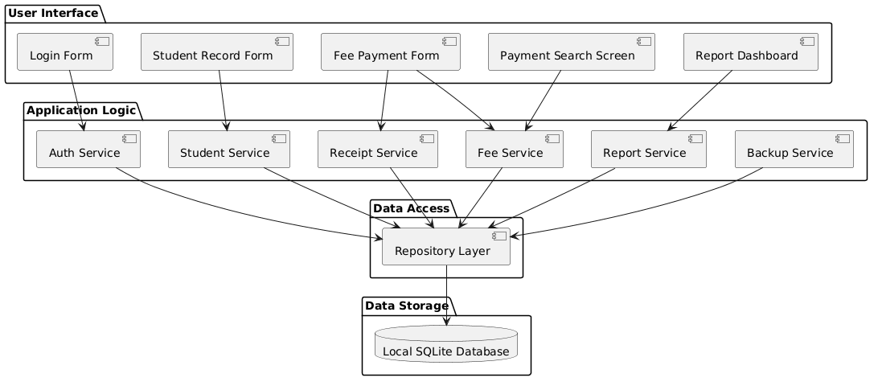
The Package diagram provides a clear level of view of the software architecture and shows how the system is organized into the logical layers.
The system is done using the layered architecture which consist of four layers:
- User Interface
- Application Logic Layer
- Data Access Layer
- Data Storage Layer
User Interface
The user interface layer contains the screen that users interact directly, it consists of:
- Login Form
- Student Record Form
- Fee Payment Form
- Payment Search Screen
- Report Dashboard
Application Logic Layer
The application contains the business processes and services responsible for enforcing the business rules. Services included
- Auth Service
- Student Service
- Fee Service
- Receipt Service
- Report Service
- Backup Service
This layer processes request received from the user interface and communicate with the data access layer.
Data Access Layer
This layer contains the Repository Layer, which control the access to persistent data, which includes the:
- Retrieving records
- Saving records
- Updating records
- Maintaining database consistency
Data Storage Layer
This system uses a Local SQLite database to store the following:
- Student Information
- Fee account records
- Payment transaction
- Receipts
- Reports
The choice of choosing Layered Architecture is because it separates the presentation, processing and data concerns. This helps improves the maintainability, reliability and future scalability.
Use Case Diagram
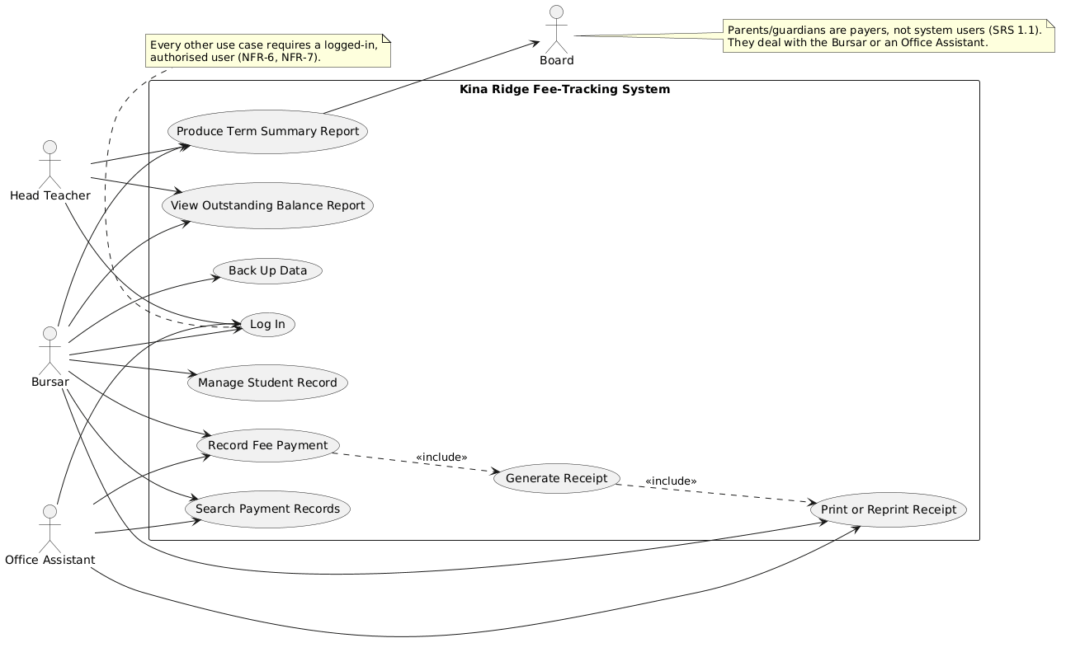
The use case diagram helps to identifies the users and the functions that are available to each user. Listed below are the Actors and their function:
- Head Teacher
  - Log In
  - Produce Term Summary Report
  - View Outstanding Balance Report
- Bursar
  - Log In
  - Manage Student Records
  - Record Fee Payment
  - Search Payment Records
  - Generate Receipts
  - Print/Reprint Receipts
  - Back Up Data
- Office Assistance
  - Log In
  - Record Fee Payment
  - Search Payment Records
  - Print/Reprint Receipts
- Board
  - Produce Term Summary Report
Inclusive Relationship
- Record Receipt Record Receipt → Print/Reprint Receipt – when payment is recorded, receipt is automatically generated
- Generate Receipt Reprint/Receipt – generated receipt can be reprinted
- Security Requirement – all functions require authenticated access through the login process.
Class Diagram
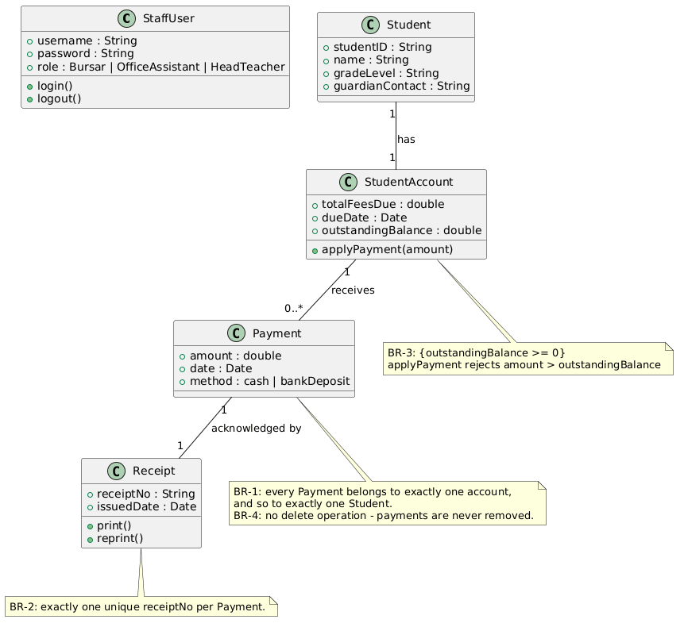
The Class Diagram describes the static structure of the Kina Ridge Fee-Tracking System. Listed below are the classes and their attribute:
StaffUser – authorised user of the system.
- Attributes
  - Username : String
  - Password : String
  - Role : Bursar | OfficeAssistant |HeadTeacher
- Operations
  - login()
  - logout()
Student – stores student information
- Attributes
  - studentID : String
  - name : String
  - gradeLevel : String
  - guardianContact : String
StudentAccount – maintain fee-related information
- Attributes
  - totalFeesDue : Double
  - dueDate : Date
  - outstandingBalance : Double
- Operations
  - applyPayment(amount)
Payment – stores payment details
- Attributes
  - amount : Double
  - date : Date
  - method : Cash | BankDeposit
Receipt – proof of payment
- Attributes
  - receiptNo : String
  - issuedDate : Date
- Operations
  - print()
  - reprint()
Business Rules
BR-1 | Every payment belongs to one and only one student account.
BR-2 | Every payment generates one unique receipt number
BR-3 | Outstanding balances cannot become negative.  Payments greater than the outstanding balance are rejected.
BR-4 | Payments cannot be deleted after being recorded.

Activity Diagram
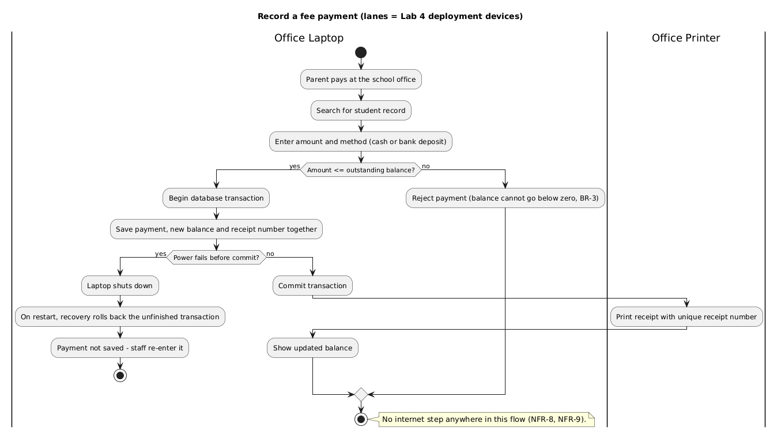
The Activity Diagram illustrates the workflow for recording a fee payment.
Step 1 | A parent or guardian visits the school office and makes a payment.
Step 2 | The staff member searches for the student record.
Step 3 | The payment amount and payment method are entered.
Step 4 | The system validates the amount against the outstanding balance.
Step 5 | If the amount exceeds the outstanding balance:  - Payment is rejected.  - Transaction ends.
Step 6 | If the amount is valid:  - Database transaction begins.  - Payment details are saved.  - Updated balance is calculated.  - Receipt number is generated.
Step 7 | The transaction is committed.
Step 8 | The receipt is printed.
Step 9 | The updated account balance is displayed.

Exception Handling
If power fails before transaction:
- Laptop shuts down.
- Recovery mechanism executes upon restart.
- Incomplete transaction is rolled back.
- Payment is not saved.
- Staff member re-enters the transaction.
This protects data integrity and prevents corruption.
Non-Functional Requirement
The payment process operates completely offline and does not depend on internet connectivity.
State Diagram
The State Diagram models the lifecycle of a StudentAccount. Listed below is state and their function:
- Outstanding – The account contains unpaid fees and still requires payment.
- In Arrears – The payment due date has passed while a balance remains outstanding.
- Settled – The outstanding balance has been fully paid.
State Transitions
- Outstanding → In Arrears
  - Due date passes
  - Outstanding balance remains unpaid
- Outstanding → Settled
  - Outstanding → SettledIn Arrears → Settled
  - Outstanding amount is completely paid
- Settled → Outstanding
  - New school term fees are charged
Validation Rule
- The system rejects any payment exceeding the outstanding balance.
- This enforces Business Rule BR-3 and prevents negative balances.
Deployment Diagram
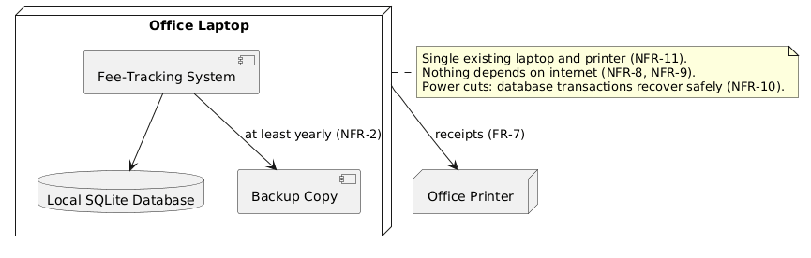
The Deployment Diagram illustrates the physical environment in which the system operates. Listed below are components and their functions:
- Office laptop – the main processing device
  - Fee-Tracking System
  - SQLite Database
  - Backup Files
- Local SQLite Database
  - Student information
  - Student accounts
  - Payments
  - Receipts
  - Reports
- Backup Copy – A backup copy is maintained periodically to protect against data loss and support recovery.
- Office Printer
  - Payment receipts
  - Reprinted receipts
- Connectivity
  - SQLite Database
  - Office Printer
- Data Protection – backup copies and transaction recovery
Design Pattern
Repository - The Repository Pattern is implemented within the Data Access Layer. It acts as an intermediary between application services and the SQLite database. Below are some of the benefits
- Reduces system complexity
- Improves maintainability
- Simplifies testing
- Promotes separation of concerns
- Supports future database migration
Application
The following services access the data through the Repository Later:
- Student Service
- Fee Service
- Receipt Service
- Report Service
- Backup Service
- Authentication Service
Traceability Between Models
Requirement: Record fee payment
Model | Representation
Use Case Diagram | Record Fee Payment
Activity Diagram | Payment Workflow
Class Diagram | Payment, StudentAccount, Receipt
State Diagram | Outstanding, In Arrears, Settled
Package Diagram | Fee Service, Receipt Service
Deployment Diagram | Office Laptop and Printer

Conclusion
The design of the Kina Ridge Fee-Tracking System provides a practical and reliable solutions for managing school fee payments. The layered architecture promotes maintainability, the use case model captures user interactions, the class model defines data structures, the activity and state diagrams model system behaviour, and the deployment model demonstrates a cost-effective offline implementation. Collectively, these design models ensure that the system satisfies both the functional and non-functional requirements identified during requirements analysis.

