[Treble Quest] Site Plan

[Carissa Jager]

WDD 130

Overview

Purpose
[Treble Quest is a beginner-friendly piano website designed to help new and returning musicians learn the fundamentals of reading music and playing piano. The website provides simple lessons, interactive practice activities, and beginner-friendly resources while encouraging users to learn through music they already enjoy, especially video game music.]

Audience
[Treble Quest is intended for complete beginners, returning musicians, and anyone interested in learning to read music. It is designed for people who may feel intimidated by traditional music lessons and would rather learn at their own pace through interactive activities and familiar songs.]

Branding

Website Logo

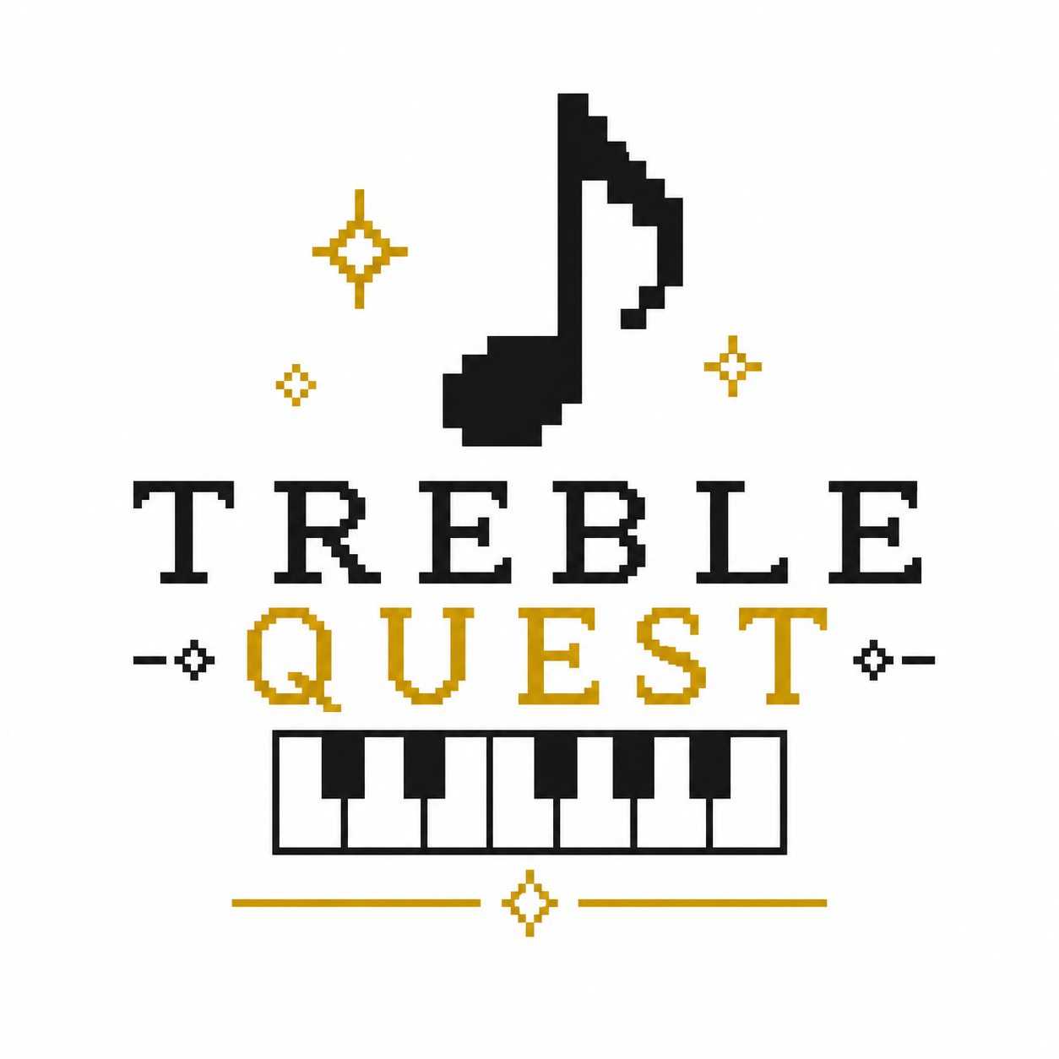

Style Guide

Color Palette
Primary | Secondary | Accent 1 | Accent 2 | Accent 3
#F7F5F2 | #2F2F2F | #D2AF26 | #6F8FAF | #6E8B5E
Backgrounds | Text, headers, footers | Buttons, hovers/highlights | Links, interactive things? | Small accents, fun bits, hover?

Typography

Heading Font: [Cinzel, Georgia]

Paragraph Font: [Open Sans, Arial]

Navigation
Home Training Grounds Resources

Content

Home
Hero Section
Headline: Learn Piano One Note at a Time
Text:
Learning piano doesn't have to be intimidating. Whether you're starting from scratch or returning after years away, Treble Quest provides beginner-friendly lessons designed to help you build confidence while learning music you already love.
Button:
Start Your Quest

Learn the Basics
- Reading Treble Clef
- Reading Bass Clef
- Note Values
- Time Signatures
- Practice Tips
Include simple pics of the musical staff and keyboard.

Featured Songs
Examples of beginner-friendly music:
- Zelda
- Mario
- Pokémon
- ?
- ?

Why Treble Quest?
Learning is easier when you're excited about what you're playing. Treble Quest focuses on building strong musical foundations while keeping practice enjoyable through familiar songs and interactive learning tools.

Page 2 - Training Grounds

Purpose: Interactive practice activities that reinforce music-reading skills

Interactive practice page featuring:
- Interactive piano keyboard
- Treble clef flashcards
- Bass clef flashcards
- Note identification exercises
- Keyboard note matching
- Beginner practice challenges
Images
- Piano keys pic
- Musical staffs
- Pixel icons
- Achievement stars

Page 3 - Resources

Purpose: Provide learners with additional resources, practice materials, and beginner-friendly references to support their piano journey

Helpful learning materials include:
- Practice routines
- Beginner tips
- Links to sheet music websites
  - Herbalcell https://herbalcell.com/free-sheet-music
    - Printable practice sheets
    - Piano mp3’s
- Additional beginner resources

Images
- Sheet music?
- Metronome?
- Practice checklist?

Wireframes

Home

—------------------------------------------------------------------------------------------------------------------
LOGO Home | Training Grounds | Resources
—------------------------------------------------------------------------------------------------------------------

Hero Image

Learn Piano One Note at a Time

[Start Your Quest]

—------------------------------------------------------------------------------------------------------------------

Learn the Basics

- Treble Clef
- Bass Clef
- Note Values
- Time Signatures

—------------------------------------------------------------------------------------------------------------------

Featured Songs

- The Legend of Zelda
- Mario
- Pokemon
- (open to suggestions/ideas)

—------------------------------------------------------------------------------------------------------------------

Why Treble Quest?

Learn through music you already love.

—------------------------------------------------------------------------------------------------------------------

Footer
Child Page (Training Grounds)

—------------------------------------------------------------------------------------------------------------------
LOGO Home | Training Grounds | Resources
—------------------------------------------------------------------------------------------------------------------

Training Grounds

—------------------------------------------------------------------------------------------------------------------

Choose an Activity

[ Interactive Piano/Keyboard ]

(Interactive Activities)

- Treble Flashcards

- Bass Flashcards

- Note Matching

- Rhythm Challenge

Progress: (grade system??)
★★★★★☆☆☆☆☆

[Try Again]

—------------------------------------------------------------------------------------------------------------------

Footer
Child Page (Resources)

—------------------------------------------------------------------------------------------------------------------
LOGO Home | Training Grounds | Resources
—------------------------------------------------------------------------------------------------------------------

Resources

Beginner Tips

—------------------------------------------------------------------------------------------------------------------

- Practice Routine
- Online Metronome
  - Google Metronome https://share.google/MBYpbnWeolu8uDk3w
- Sheet Music
  - Herbalcell - Has labeled and normal sheets, mp3’s
  - https://herbalcell.com/free-sheet-music
- Frequently asked questions?
—------------------------------------------------------------------------------------------------------------------

Footer

