Act 2 of 1998

**ACT**

**To do something.**

**PREAMBLE**

**WHEREAS** stuff;

**CHAPTER 1**

**DEFINITIONS**

**1. Definitions**

In this Act, unless the context indicates otherwise—

**“accreditation”** means the screening, evaluation, provisional and final accreditation by the Regulatory Authority that will, amongst other things, allow a social housing institution access to grants available under the social housing programme;

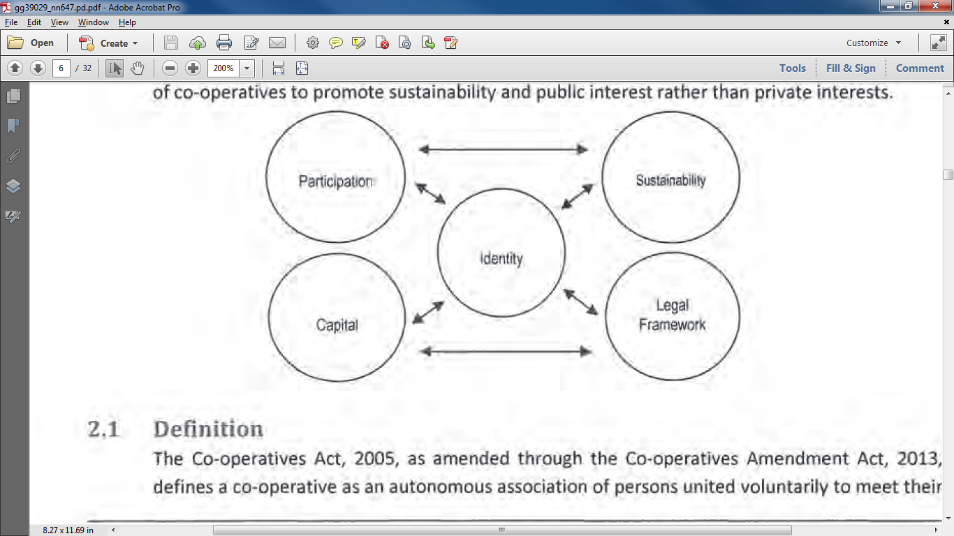

**“accreditation”** means the screening, evaluation, provisional and final accreditation by the Regulatory Authority that will, amongst other things, allow a social housing institution access to grants available under the social housing programme;