使用者無法開啟TEAMS檔案處理

此狀況會發生在回鍋人員，因帳號停用或是刪除帳號後重件相同名稱帳號的情況下發生，使用者會無法開啟TEAMS上任何檔案，需要去清除快取後可以恢復正常。
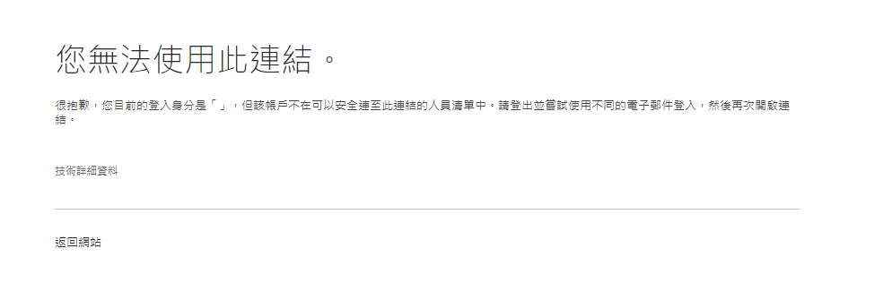
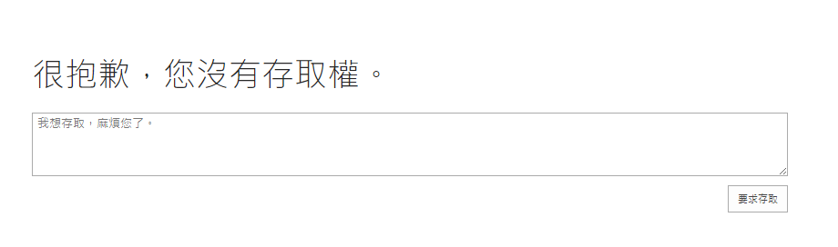
1.與使用者確認有過傳送檔案給他的人員，進入M365管理介面，找到該人員後，切換到onedrive介面，點擊建立檔案連結後，進入產生出來的連結網頁。
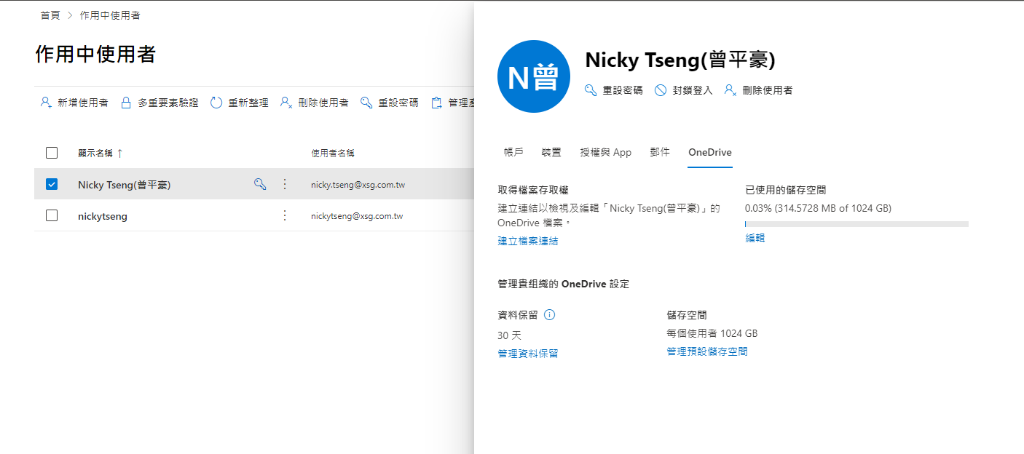
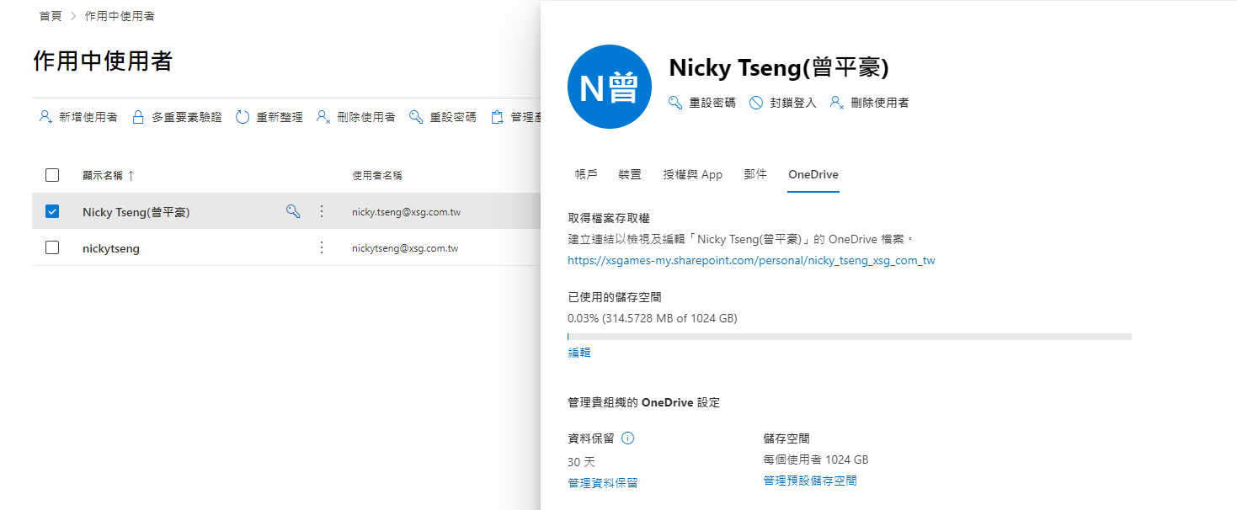
2.變更連結網址，改用這串” _layouts/15/people.aspx?MembershipGroupId=0”取代部分網址內容，進入快取介面。
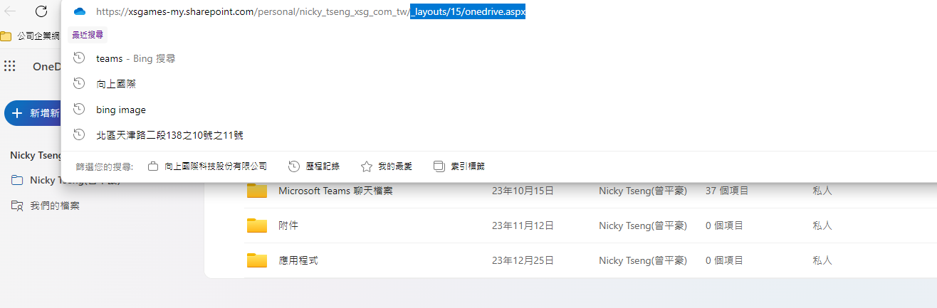
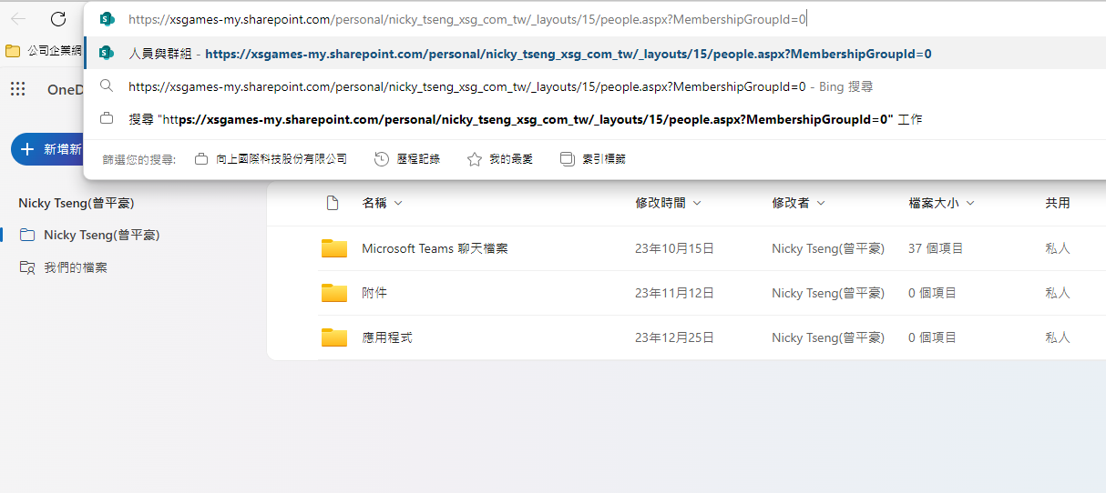
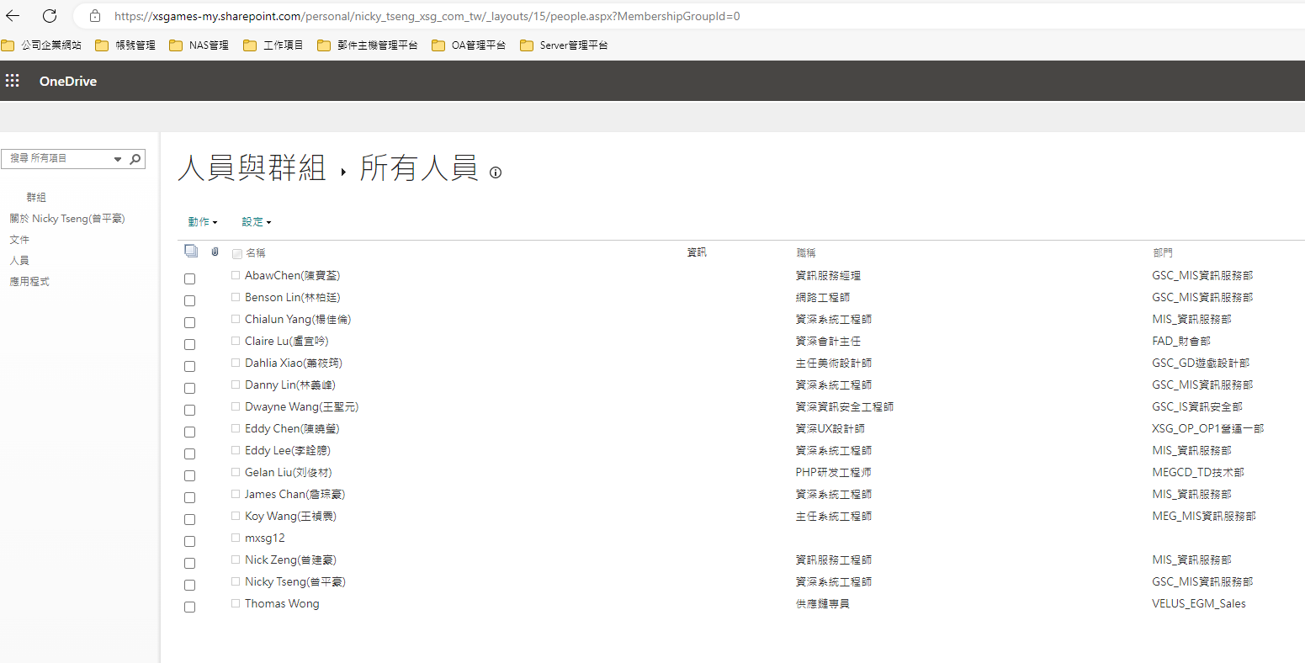

3.點選開啟異常人員的快取做刪除，後續傳輸給對方的檔案就可以正常開啟了
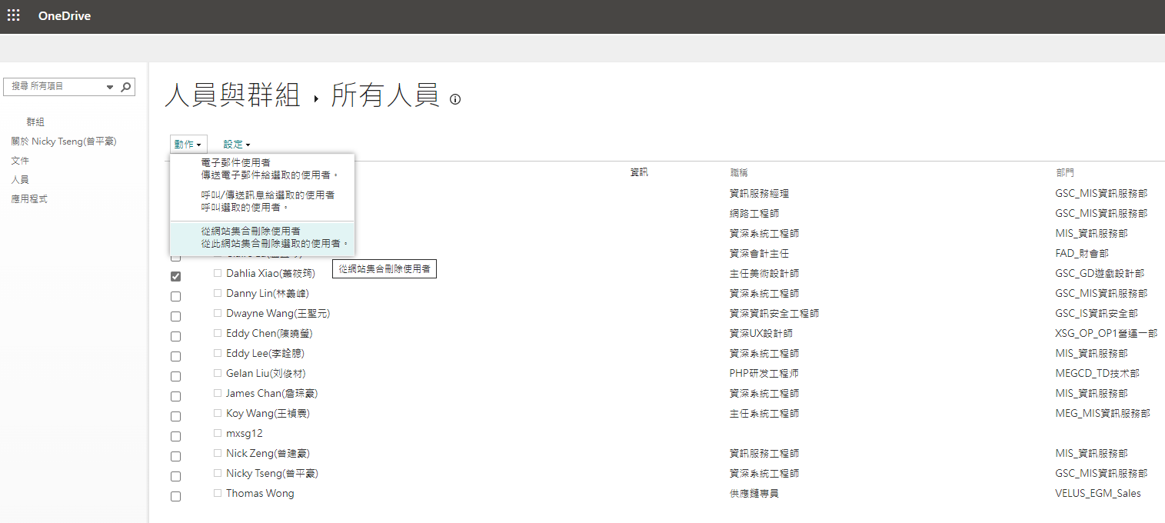

第二種解決方案
Onedrive批量執行刪除舊使用者帳號緩存Powershell如下

Install-Module -Name Microsoft.Online.SharePoint.PowerShell
$AdminSiteURL="https://tenant-admin.sharepoint.com"
$SiteCollAdmin="管理員的帳號"
$AccRemove="刪除的目標帳號"

Connect-SPOService -Url $AdminSiteURL
$OneDriveSites = Get-SPOSite -Limit ALL -includepersonalsite $True -Filter "Url -like 'sharepoint.com/personal/'"
Write-Host -f Yellow "Total Number of OneDrive Sites Found: "$OneDriveSites.count

===============================================添加管理員=========================================================================

Foreach($Site in $OneDriveSites)
{
Write-Host -f Yellow "Added Site Collection Admin to: "$Site.URL
Set-SPOUser -Site $Site.Url -LoginName $SiteCollAdmin -IsSiteCollectionAdmin $True
}
Write-Host "Site Collection Added to All OneDrive Sites Successfully!" -f Green

===============================================刪除目標=========================================================================

Foreach($Site in $OneDriveSites)
{
Write-Host -f Yellow "Delete Site Collection Admin to: "$Site.URL
Remove-SPOUser -Site $Site.Url -LoginName $AccRemove
}
Write-Host "Delete specific user in All OneDrive Sites Successfully!" -f Green

===============================================移除管理員=========================================================================

Foreach($Site in $OneDriveSites)
{
Write-Host -f Yellow "Delete Site Collection Admin to: "$Site.URL
Set-SPOUser -Site $Site.Url -LoginName $SiteCollAdmin -IsSiteCollectionAdmin $False
}
Write-Host "Site Collection Admin deleted to All OneDrive Sites Successfully!" -f Green

第三種解決辦法：
如果遇到onedrive url 非正規狀況下(結尾多一個1之類的)
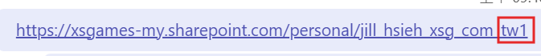
修正 SharePoint 或 OneDrive 中的網站用戶標識碼不符 - SharePoint | Microsoft Learn

