|  |  |  |
| --- | --- | --- |
|  |  |  |

Campaign Information System

Tài liệu Thiết kế - Học kỳ II

|  |  |  |  |
| --- | --- | --- | --- |
| **Giáo viên hướng dẫn:** | Lê Thanh Nhân | | |
| **Lớp:** | GC0862 | | |
| **Tên nhóm:** | 1 | | |
| **Tên thành viên trong nhóm:** | Tên đầy đủ | | Mã số Sinh viên |
|  | 1. | Võ Minh Nhựt | GC60222 |
|  | 2. | Trần Nguyễn Công Nguyên | GC60263 |
|  | 3. | Nguyễn Ngọc Kiều Trinh | GC60229 |
|  | 4. | Đỗ Ngọc Quý | GC60257 |
|  |  |  |  |

# <05 – 2013>

Campaign Information System

Tài liệu Thiết kế - Học kỳ II

|  |  |  |  |
| --- | --- | --- | --- |
| **Giáo viên hướng dẫn:** | Lê Thanh Nhân | | |
| **Lớp:** | GC0862 | | |
| **Tên nhóm:** | 1 | | |
| **Tên thành viên trong nhóm:** | Tên đầy đủ | | Mã số Sinh viên |
|  | 1. | Võ Minh Nhựt | GC60222 |
|  | 2. | Trần Nguyễn Công Nguyên | GC60263 |
|  | 3. | Nguyễn Ngọc Kiều Trinh | GC60229 |
|  | 4. | Đỗ Ngọc Quý | GC60257 |
|  |  |  |  |

# <05 – 2013>

 

This is to certify that

**Mr. VO MINH NHUT**

**Mr. TRAN NGUYEN CONG NGUYEN**

**Ms. NGUYEN NGOC KIEU TRINH**

**Mr. DO NGOC QUY**

Have successfully Designed & Developed

**CAMPAIGN INFORMATION SYSYTEM**

Submitted by:

**LE THANH NHAN**

Date of Issue: 20-May-2013

Authorized Signature:

 

--Menu of Contents--

|  |  |
| --- | --- |
| Page | Contents |
|  |  |
| 5 | Problem Definition |
| 8 | Customer Requirement |
| 9 | Entity Relationship Diagram |
| 13 | Data Flow Diagram |
| 17 | Database/Table Design |
| 20 | Database Diagram |
| 21 | Algorithm |
| 26 | Screenshots |
| 40 | Checklist Of Validation |
| 41 | Submission Checklist |
|  |  |
| *Enclosed :* |  |
| *42* | Tasksheet |

**PROBLEM DEFINITION**

**❖ Introduction**

-An insurance company wants to start campaigns for its new products to be sold to

the prospective customers. Campaign means advertising of the products through

channels like Tele marketing, letters, signboards, TV Commercials, etc. There are

different campaigns for different products and there is a specific period for each

campaign.

**❖ Existing Scenario**

-Before the campaign starts, estimates are made on sales to be achieved, budget

allocation for each campaign and variance allowed (%) both for sales and budget.

When the actual data is captured, the actual variance (%) is calculated. The

difference between the actual and the estimated variance gives the insurance

company an insight into their estimation and it helps in making strategic decisions

about budgets and campaign periods.

**❖ Proposed Solution**

-You have to develop the system, which captures the data related to various proposed

campaigns, products details, and sales related data. It will also store the actual sales

details so that necessary reports/ comparisons can be generated for analysis.

There will be different users of the system with restricted access.

**❖ Functional Requirements**

Users of the system:

- Employees of the Campaign department. There will be registered people in the system. In an organization, the hierarchy will be Employee/Administrator

User Interface:

-User will start with the login page in which username and password are entered. This screen should also provide a functionality to change the password.

-To change the password, it should ask for the old password, new password and confirm new password.

All users should be able to:

* Login to the system through the first page of the application.
* Change the password after logging into the system.
* See his/her personal details.

**Employee** should be able to:

* Query the current campaign’s details.
* Create a new entry for new customer.
* Update customer’s details if necessary.
* View customer’s details.
* Enter a new “Sale-Details” entry.
* Update or delete “Sale-Details”-entries if necessary.
* View all of his/her “Sale-Details”-entries.

**Administrator** should be able to:

* Query all of the current database details.
* Manage all of the current campaigns:
  + Campaign Information.
  + Campaign’s Product.
  + Campaign’s Period.
* Manage Products:
  + Create new products, update product’s information, delete products.
  + Create new product categories, update product categories’ information, and delete product categories.(This function will be available in the next version)
* Manage Campaign:
  + Start a new campaign.
  + End an existing campaign.
* Create reports about:
  + Campaigns’ overall information.
  + Campaign periods.
  + Budget information.
* System Management:
  + Add a new user to system.
  + Decide if a user is belonged to Director-group.
* Get help about the system on how to use the different features of the system.

**CUSTOMER REQUIREMENT SPECIFICATION**

* **Business /Project Objective:**

Campaign Information Systems (CIS) help the organization can easily manages the data related to various proposed campaigns, products details, and sales related data. It will also store the actual sales details so that necessary reports/ comparisons can be generated for analysis.

* **Input provided by the Client:**
  + Login information (Employee’s ID, passwords).
  + Advertisement type.
  + Product category details.(This function will be available in the next version)
  + Product details. (ID, Name).
  + Campaign details (name, budget, sale, income)
  + Employee's details (name, type, age, mail, phone, password)
  + Customer's details (name, address, mail, phone)
  + Sale details.
* **Process involved in the application:**
  + Check if login information is corrected.
  + Validate inputted data.
  + Execute queries: view, insert, update and delete.
* **Output from app:**
  + Products details.
  + Employee’s details.
  + Customer’s details.
  + Campaigns details.
  + Budget statistics.
* **Software Requirement:**
  + Netbeans IDE 7.1 or higher.
  + JDK 1.7.0 or higher.
  + Microsoft SQL Server 2005 or higher.
* **Scope Of The Work:**
* Registration of new user and authentication of existing user.
* A GUI containing text boxes, button, and label ... which will provide a friendly interface to user to work with the application.
* Allow user search information and view report.

**ENTITY RELATIONSHIP DIAGRAM**

Have

Have

Advertisement Type

Employee

1

1

1

Campaign

Product

Category

N

N

1

Have

*Advertisement*

*Employee*

*Category*

*Product*

*Campaign*

**DATA FLOW DIAGRAM**







Admin

Employee

Employee

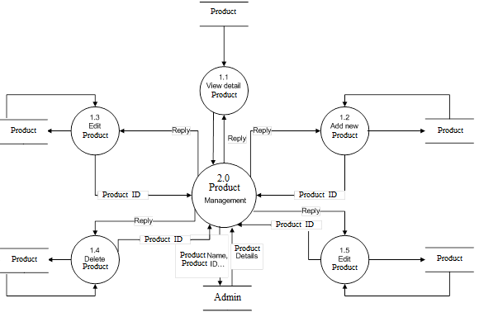

**TABLE DESIGN**

|  |  |  |  |  |
| --- | --- | --- | --- | --- |
| **Employee Table** | | | | |
| **Field Name** | **Data Type** | **Allow Nulls** | **Key/Constrain** | **Description** |
| EmpId | Varchar(10) | No | PK | Store Employee’s ID |
| EmpType | Bit | No |  | Store Employee’s Type |
| EmpName | Varchar(50) | No |  | Store Employee’s Name |
| EmpAge | Int | Yes |  | Store Employee’s Age |
| EmpMail | Varchar(50) | Yes |  | Store Employee’s Email Address |
| EmpPhone | Varchar(15) | Yes |  | Store Employee’s Phone Number |
| EmpPass | Varchar(40) | No |  | Store Employee’s Password |

|  |  |  |  |  |
| --- | --- | --- | --- | --- |
| **Advertisement Table** | | | | |
| **Field Name** | **Data Type** | **Allow Nulls** | **Key/Constrain** | **Description** |
| AdId | Varchar(10) | No | PK | Store Advertisement’s ID |
| AdType | Varchar(30) | No |  | Store Advertisement’s Type |
| AdPrice | Float | No |  | Store Advertisement’s Price |
| AdPartner | Varchar(30) | Yes |  | Store Advertisement’ Partner |
| AdDes | Varchar(50) | Yes |  | Store Advertisement’s Description |

|  |  |  |  |  |  |  |  |  |
| --- | --- | --- | --- | --- | --- | --- | --- | --- |
| **Product Table** | | | | | | | | |
| **Field Name** | | **Data Type** | | **Allow Nulls** | **Key/Constrain** | | **Description** | |
| ProId | | int | | No | PK,identity(1,1) | | Store Product’s ID | |
| CateId | | Varchar(10) | | No |  | | Store Category’s ID to which the Product belongs | |
| ProName | | Varchar(50) | | No |  | | Store Product’s Name | |
| ProDes | | Varchar(150) | | Yes |  | | Store Product’s Description | |
|  | | | | | | | | |
| **Category Table** | | | | | | | | |
| **Field Name** | **Data Type** | | **Allow Nulls** | | | **Key/Constrain** | | **Description** |
| CateID | Varchar(10) | | No | | | PK | | Store Category’s Id |
| CateName | Varchar(50) | | No | | |  | | Store Category’s Name |
| CateDes | Varchar(150) | | Yes | | |  | | Store Category’s Description |

|  |  |  |  |  |
| --- | --- | --- | --- | --- |
| **Campaign Table** | | | | |
| **Field Name** | **Data Type** | **Allow Nulls** | **Key/Constrain** | **Description** |
| CampID | Int | No | PK, Identity(1,1) | Store Campaign’s ID |
| CampName | Varchar(50) | No |  | Store Campaign’s Name |
| ProId | Int | No | FK Reference Product(ProId) | Store Product’s ID of Campaign |
| StartDate | Datetime | Yes |  | Store the beginning date of campaign |
| EndDate | Datetime | Yes |  | Store the finish date of campaign |
| Period | Int | Yes |  | Store the time of Campaign (in days) |
| AdID | Varchar(10) | No | FK Reference Advertisement(AdID) | Store Advertisement’s ID of Campaign |
| estBudget | Float | Yes |  | Store the estimated budget for Campaign |
| actBudget | Float | Yes |  | Store the actual budget of Campaign |
| estSale | Float | Yes |  | Store the estimated sale of Campaign |
| actSale | Float | Yes |  | Store the actual sale of Campaign |
| estVariance | Float | Yes |  | Store the estimated variance between estSale and actSale |
| actVariance | Float | Yes |  | Store the actual variance between estSale and actSale |
| fnVariance | Float | Yes |  | Store the uneven value between estVariance and actVariance |
| CampDes | Varchar(150) | Yes |  | Store Campaign’s Description |
| CampEnded | Bit | No |  | Show if the campaign is finished |

**DATABASE DIAGRAM**

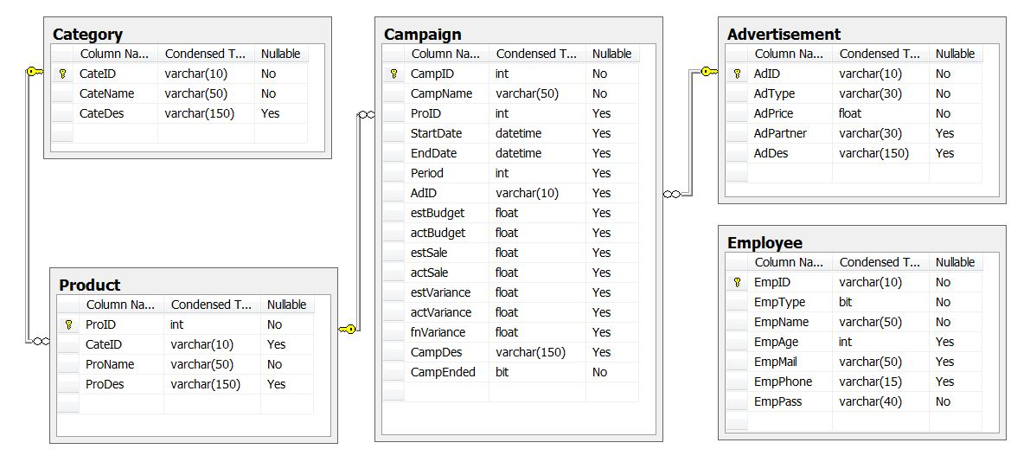

**ALGORITHM**

***Figure 1: Login***

Start

Input Account

**False**

Alert

Check Login

**True**

Employee

End

***Figure 2: Insert Data***

Start

Input ID Data

**False**

Check Valid

Alert

**True**

Output Insert successfully

End

***Figure 3: Edit Data***

Start

Input ID Data

**False**

Check Valid

Alert

**True**

Output Edit successfully

End

***Figure 4: Remove Data***

Start

Input ID Data

Check Valid

**False**

Alert

**True**

Output Remove successfully

End

***Figure 5: Search***

Start

Input key ID or Name

**False**

Check Valid

**True**

Output Search Display

End

**APPLICATION INTERFACE**

**1.Login**

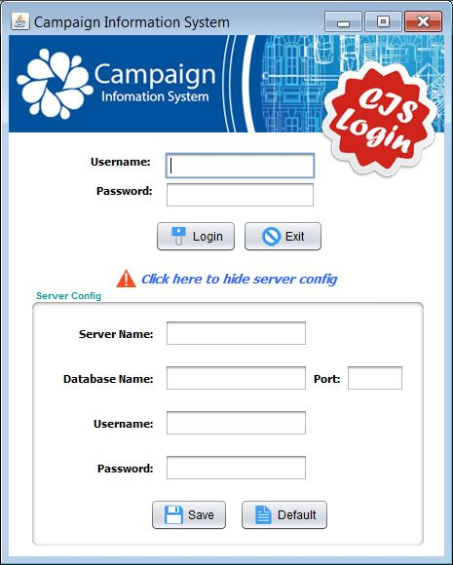

**2.Login after logout ( Connection has been created)**

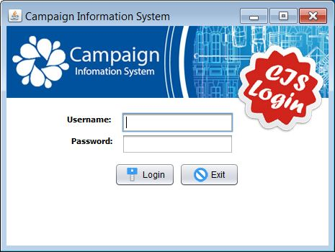

**3.Home**

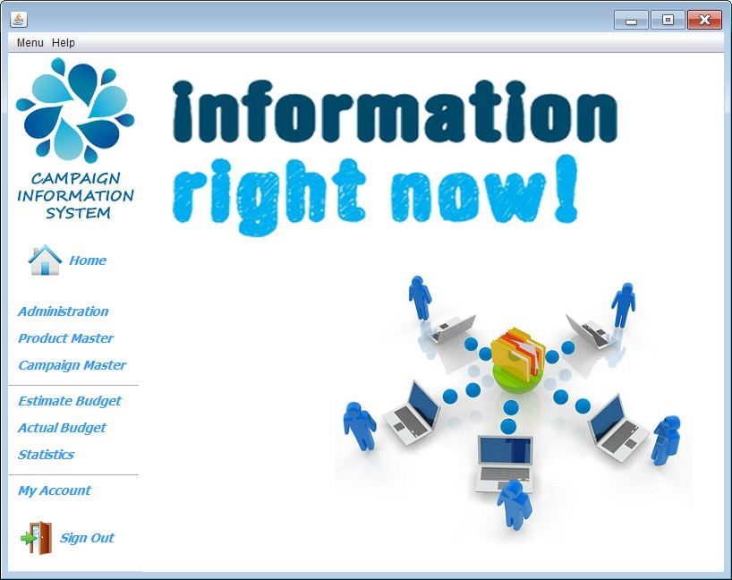

**4.Administration**

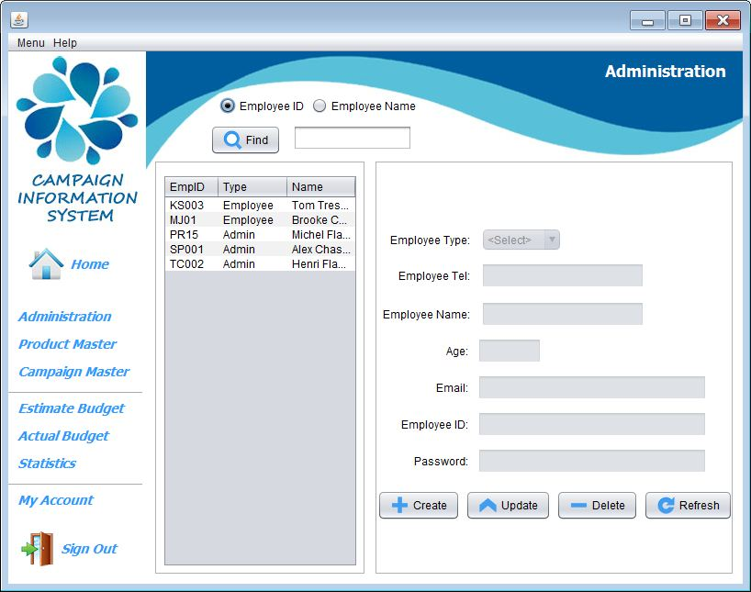

**5.Product Master**

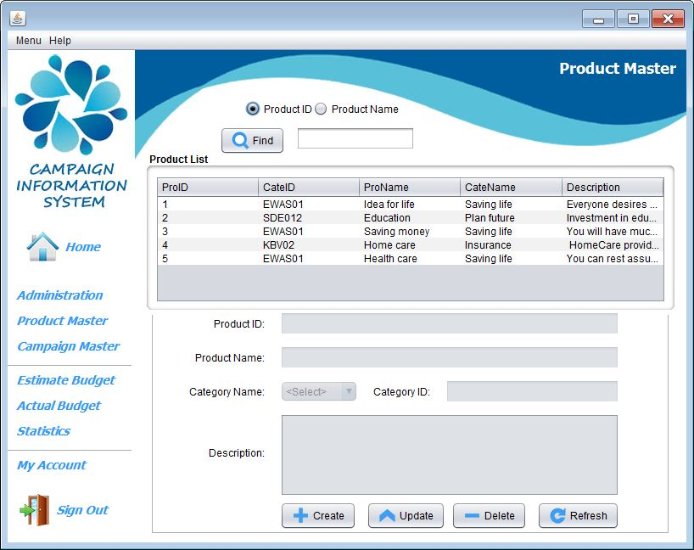

**6.Campaign Master**

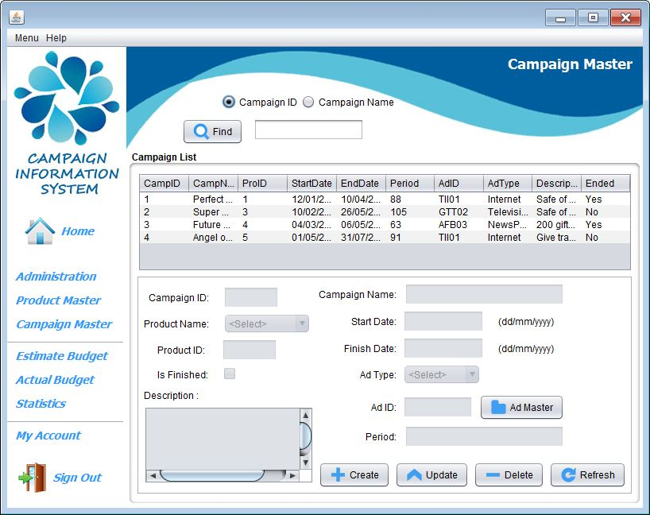

**7.Advertisement Master**

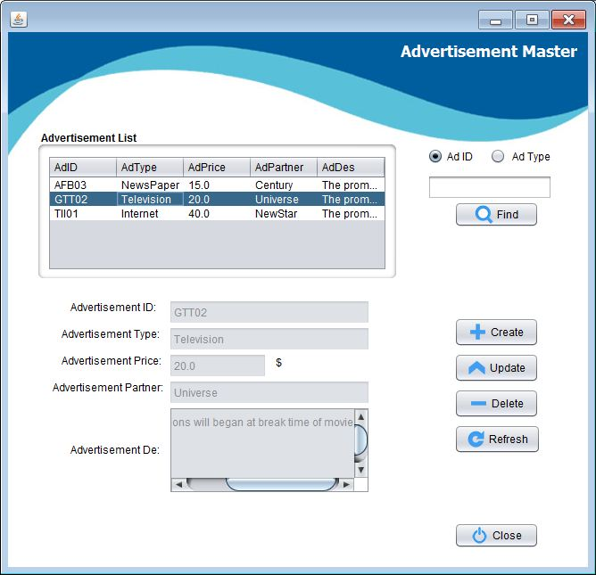

**8.Estimate Budget**

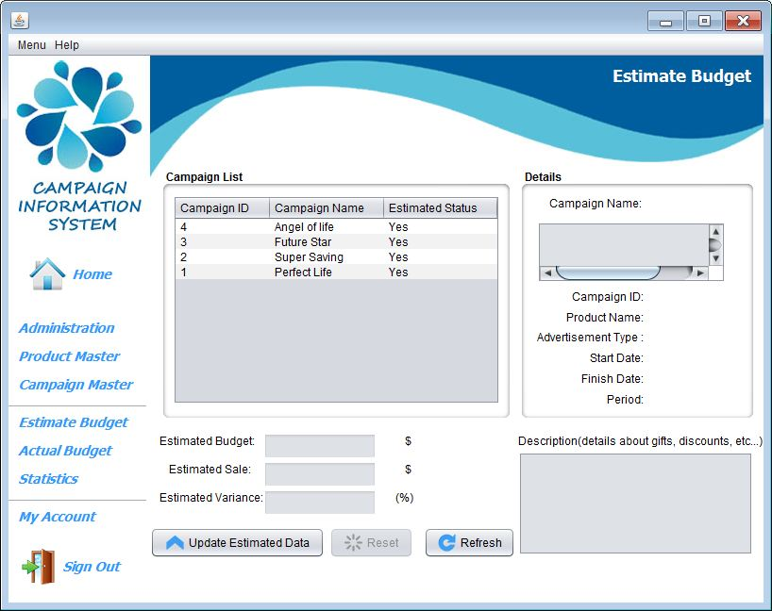

**9.Actual Budget**

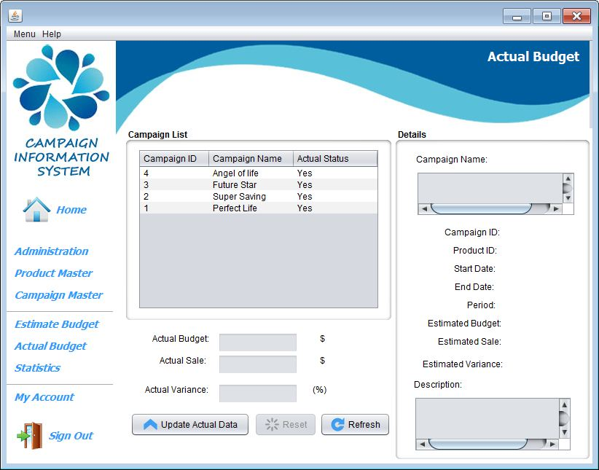

**10.Statistics**

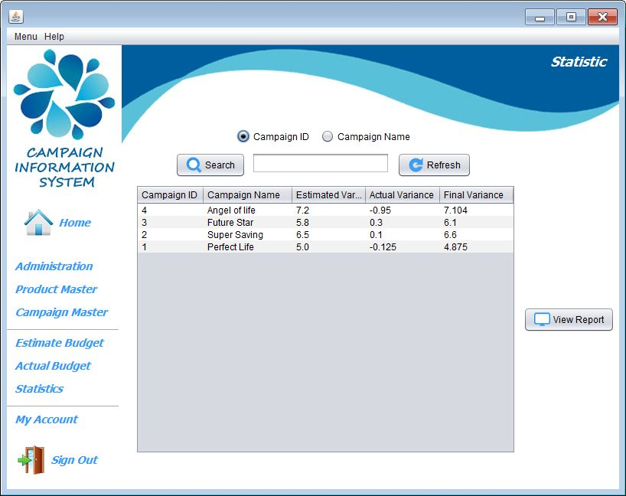

**11.Statistics Dialog**

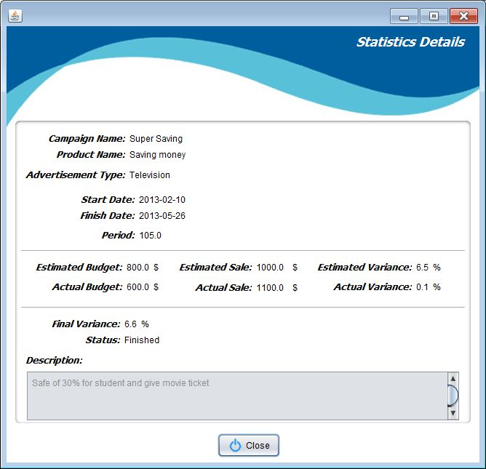

**12.Account Details**

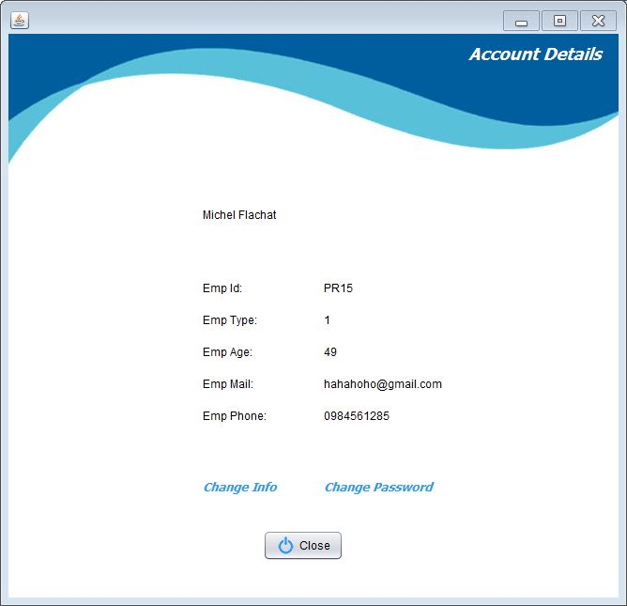

**13.Information Change:**

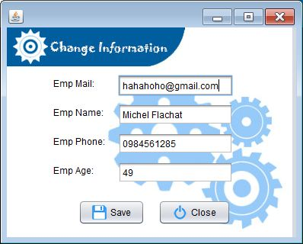

**14.Password Change:**

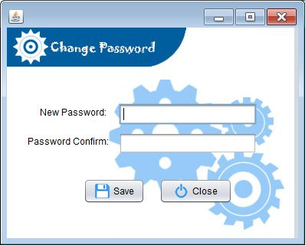

## CHECK LIST OF VALIDATION



|  |  |
| --- | --- |
| **Option** | **Validated** |
| Can a new user who gets registered, enter the application after logging in? | Yes |
| Do all the options present in the application display the correct result? | Yes |
| Does the application’s functionality resolve the user problem, and satisfy their needs? | Yes |
| Has the hardware and software been correctly chosen? | Yes |

## SUBMISSION CHECKLIST

|  |  |  |  |  |  |
| --- | --- | --- | --- | --- | --- |
| **Sr.No.** | **Particulars** | **Yes** | **No** | **NA** | **Comments** |
| 1 | Are the users able to log in to the application after validation is performed on the user name and password? | Yes |  |  |  |
| 2 | Are the users able to modify their details after getting registered? | Yes |  |  |  |
| 3 | Are all the screen contents devoid of spelling mistakes? | Yes |  |  |  |
| 4 | Is the application user-friendly? | Yes |  |  |  |

|  |  |  |  |  |  |  |
| --- | --- | --- | --- | --- | --- | --- |
| **No** | **Member** | **Contents** | **Activity Plan** | **Date of Preparation of Activity Plan** | | |
| **Planed Start Date** | **Actual Start Date** | **Actual Days** | **Status** |
| 1 | Vo Minh Nhut (Leader) | View Campaign | 2-May-13 | 1-May-13 | 9 | OK |
| 2 | Insert Campaign | 2-May-13 | 1-May-13 | 9 | OK |
| 3 | Update Campaign | 2-May-13 | 1-May-13 | 9 | OK |
| 4 | Delete Campaign | 2-May-13 | 1-May-13 | 9 | OK |
|  | | | | | | |
| 1 | Tran Nguyen Cong Nguyen | View Employee | 2-May-13 | 1-May-13 | 9 | OK |
| 2 | Insert Employee | 2-May-13 | 1-May-13 | 9 | OK |
| 3 | Update Employee | 2-May-13 | 1-May-13 | 9 | OK |
| 4 | Delete Employee | 2-May-13 | 1-May-13 | 9 | OK |
|  | | | | | | |
| 1 | Do Ngoc Quy | View Product | 2-May-13 | 1-May-13 | 9 | OK |
| 2 | Insert Product | 2-May-13 | 1-May-13 | 9 | OK |
| 3 | Update Product | 2-May-13 | 1-May-13 | 9 | OK |
| 4 | Delete Product | 2-May-13 | 1-May-13 | 9 | OK |
|  | | | | | | |
| 1 | Nguyen Ngoc Kieu Trinh | View Advertisement | 2-May-13 | 1-May-13 | 9 | OK |
| 2 | Insert Advertisement | 2-May-13 | 1-May-13 | 9 | OK |
| 3 | Update Advertisement | 2-May-13 | 1-May-13 | 9 | OK |
| 4 | Delete Advertisement | 2-May-13 | 1-May-13 | 9 | OK |