|  |  |  |
| --- | --- | --- |
|  |  |  |

Campaign Information System

Tài liệu Hướng Dẫn Cài Đặt - Học kỳ II

|  |  |  |  |
| --- | --- | --- | --- |
| **Giáo viên hướng dẫn:** | Lê Thanh Nhân | | |
| **Lớp:** | GC0862 | | |
| **Tên nhóm:** | 1 | | |
| **Tên thành viên trong nhóm:** | Tên đầy đủ | | Mã số Sinh viên |
|  | 1. | Võ Minh Nhựt | GC60222 |
|  | 2. | Trần Nguyễn Công Nguyên | GC60263 |
|  | 3. | Nguyễn Ngọc Kiều Trinh | GC60229 |
|  | 4. | Đỗ Ngọc Quý | GC60257 |
|  |  | | |

# <05 – 2013>



# PROJECT: Campaign Information System GROUP NO: 1 BATCH: GC0862

# A. System requirement:

|  |  |  |
| --- | --- | --- |
| **Sr.** | **Item** | **Description** |
| 1. | OS | [Windows 7] |
| 2. | Database | [SQL Server 2008] |
| 3. | JRE | [JRE version 6 or later] |
| 4. | Fonts | Only use font Unicode: Arial, Tahoma, Lucida Console, Times New Roman |

# B. Setup MS SQL Server TCP/IP and Port:

1. Open SQL Server Configuration Manager.

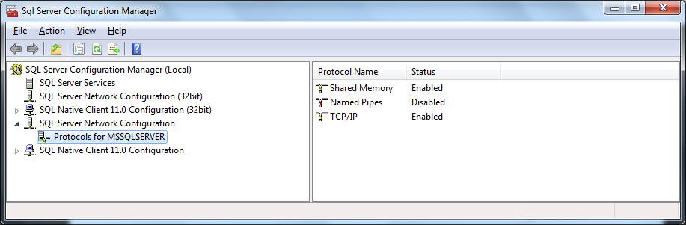

1. Choose SQL Server Network Configuration /Protocols for MSSQLSERVER In SQL Server Configuration Manager window.
2. Ensure TCP/IP is enabled.
3. Ensure TCP/IP Port is set to 1433.

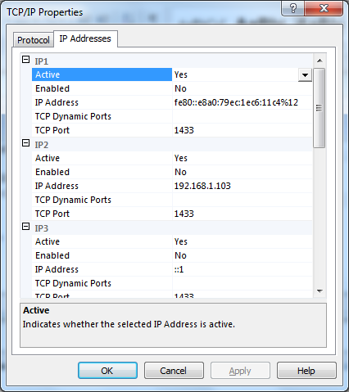

1. Restart MSSQLSERVER in SQL Server Services.

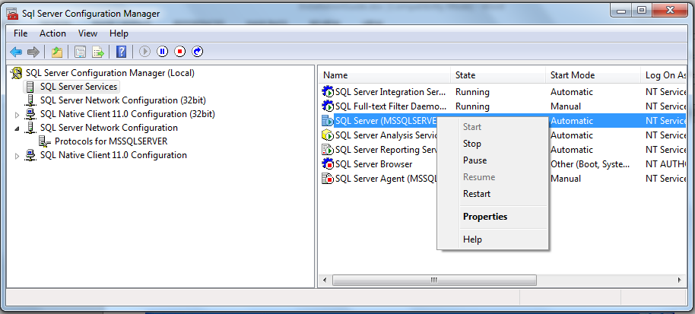

# C. Setup

**❖ Solution 1 :**

1.Copy folder **CIS** to C:\

2.Open Netbeans IDE and Open Project **CIS**.

3.Run file GUI\**Login.java**

**❖ Solution 2 :**

1.Copy folder **CIS** to C:\

2.Run file C:\CIS\dist\**CIS.jar**

☞The login window **with configure-panel** will open at the **first time**.

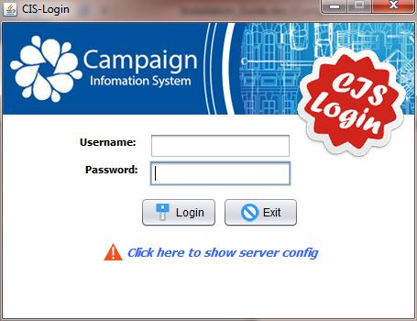☞Click on **the blue line** to show the configure panel and then **input the information**

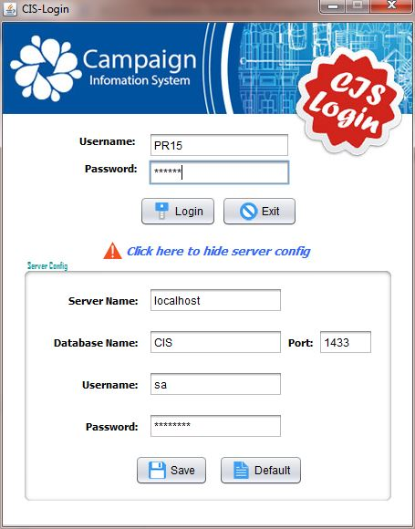

* Server Name : localhost
* Port : 1433
* Database Name: **Your** designed database name.
* User: **Your account** to connect Microsoft SQL Server Management Studio
* Password : **Your password** to connect Microsoft SQL Server Management Studio
* Press OK

# D. Installation successful:

- The login window is displayed.

- Login information:

* Username : PR15
* Password : 123456

-Homepage will display if login-info is corrected



---🙞Congratulation🙜---