Supplementary Information
Investigating the Relationship Between AI-Based Structure Prediction Confidence and Experimentally Determined Protein Stability
Paper BJ-1129 · Revised 5 November 2026

Scope and data definitions
This supplement records the 20 canonical WT proteins, all 200 experimental mutation labels, additional model summaries and the analyses added during revision. The experimental endpoint is folding ΔΔG from Pak et al., Supplementary Table S1, derived from ThermoMutDB. Positive values denote destabilisation and negative values stabilisation. Exact-zero values are retained. Historical experimental constructs were not independently reconstructed.
Each protein contributes ten substitutions sharing a matched WT baseline. Local ΔpLDDT is MT minus WT at the mutated residue; global ΔpLDDT is the difference between equal-residue sequence means. Explicit native confidence arrays on a 0–1 scale were multiplied by 100. Three signed seed-label differences are averaged equally for each mutation and model. Seed labels 42, 43 and 44 are computational repeats, not extra experimental observations.
The main manuscript retains the central local scatter plot and numerical model/baseline comparison. The files accompanying this supplement retain full-precision tables and executable calculations. The record-level CSV is authoritative for machine-readable reuse; rounded display tables are for reading.

Analysis added during revision
The signed Kyte–Doolittle hydrophobicity change is H(mutant residue) − H(WT residue). The BLOSUM62 baseline is the untransformed matrix entry for that substitution, in conventional half-bit units. Neither baseline is trained, sign-selected to maximise agreement, or calibrated as a folding energy. Both use only mutation identities. Kyte–Doolittle values are represented as integer tenths before subtraction; exact-tenth differences are used before ranking so binary floating-point noise cannot split genuine ties.
Pooled 95% intervals use 10,000 protein-cluster percentile bootstrap draws. Twenty accessions are drawn with replacement in each replicate, preserving all ten mutations for every selected cluster. Baseline calculations use NumPy default_rng(20260916), lexicographically sorted accessions and saved shared draws. Pairwise comparisons require both features on those same rows and draws. Baseline calculations independently recovered every experimental label from the submitted Appendix A2 and reproduced the reported count, range, moments and quartiles.
Per-protein Pearson Fisher-z intervals, where reported, are approximate pointwise intervals with n = 10. They assume independent bivariate-normal mutation pairs conditional on the shared predicted WT. They omit uncertainty in that shared WT baseline and experimental measurement error, and are not multiplicity adjusted. Their purpose is to display heterogeneity, not to establish model superiority for an individual protein.

Figure S1 Workflow
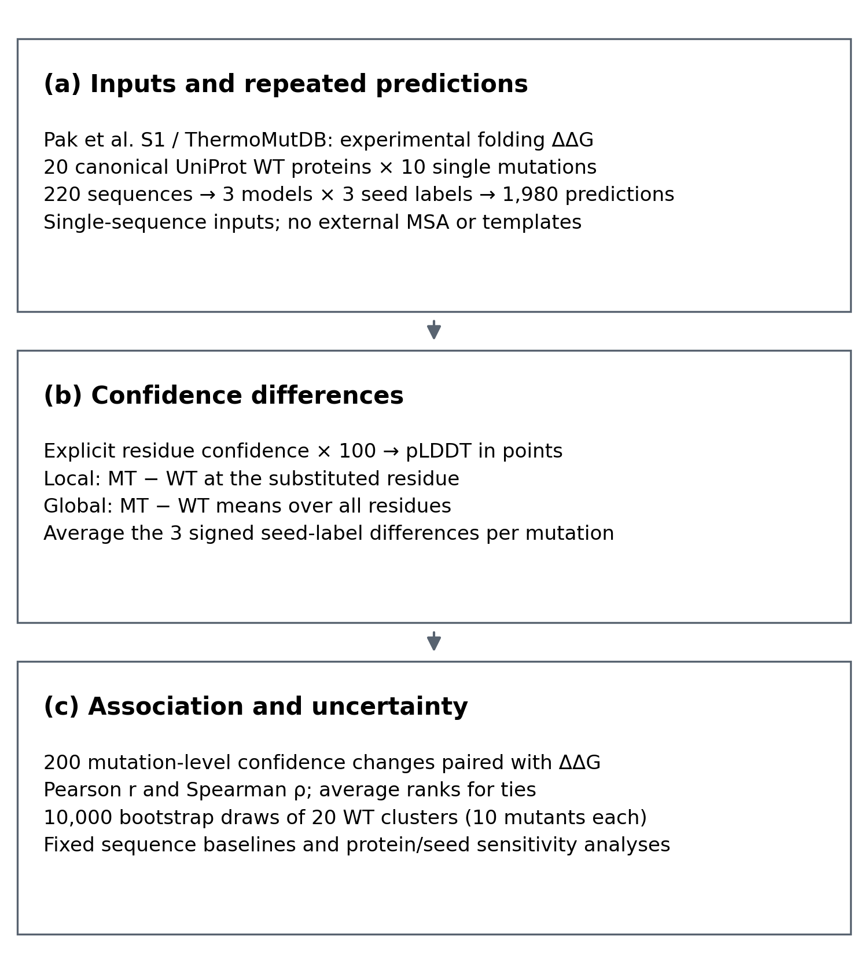
Figure S1. (a) Experimental labels and canonical sequences define the shared prediction panel. (b) Signed local and global confidence differences are averaged across three seed labels. (c) Association, cluster uncertainty and sensitivity analyses are evaluated at the mutation level. Shared seed labels do not guarantee identical WT–MT random-number trajectories.

Table S1 Canonical WT protein inventory
Sequences were retrieved from reviewed UniProtKB/Swiss-Prot entries on 15 September 2026. Every accession contributed ten single substitutions. Length refers to the complete canonical input sequence, not necessarily the construct used in a historical assay.
UniProt accession | Protein | Length (residues)
P00044 | Cytochrome c isoform 1 | 109
P00149 | Cytochrome c′ | 146
P00651 | Guanyl-specific ribonuclease T1 | 130
P00711 | Alpha-lactalbumin | 142
P00720 | Endolysin | 164
P00974 | Pancreatic trypsin inhibitor | 100
P01053 | Subtilisin-chymotrypsin inhibitor-2A | 84
P02185 | Myoglobin | 154
P02417 | 50S ribosomal protein L9 | 149
P02633 | Protein S100-G | 79
P03050 | Transcriptional repressor arc | 53
P05230 | Fibroblast growth factor 1 | 155
P05798 | Guanyl-specific ribonuclease Sa | 96
P0A3E0 | Flavodoxin | 170
P0A7Y4 | Ribonuclease HI | 155
P23370 | 30S ribosomal protein S6 | 101
P29160 | 50S ribosomal protein L30e | 101
P41016 | Cold shock protein CspB | 66
P62942 | Peptidyl-prolyl cis-trans isomerase FKBP1A | 108
P69543 | DNA-binding protein G5P | 87

Table S2 Local and global correlation summaries
Pointwise 95% protein-cluster intervals below preserve the manuscript results. All six rows use the same 200 observations; intervals for different features are not themselves tests of differences.
Model and endpoint | Spearman ρ [95% CI] | Pearson r [95% CI]
Boltz-2 local | −0.106 [−0.278, 0.076] | 0.038 [−0.168, 0.198]
Boltz-2 global | −0.078 [−0.245, 0.117] | 0.063 [−0.144, 0.193]
Chai-1 local | −0.271 [−0.408, −0.122] | −0.235 [−0.394, −0.095]
Chai-1 global | −0.287 [−0.416, −0.132] | −0.227 [−0.372, −0.111]
ESMFold2 local | −0.255 [−0.414, −0.109] | −0.218 [−0.388, −0.060]
ESMFold2 global | −0.281 [−0.422, −0.139] | −0.134 [−0.413, 0.077]

Table S3 Local confidence changes by stability direction
Values are median [first quartile, third quartile] in pLDDT points. The groups contain 43 stabilising and 153 destabilising substitutions. The four zero-valued observations remain in every pooled correlation and are excluded only from this two-group display.
Model | Stabilizing ΔΔG < 0  n = 43 | Destabilizing ΔΔG > 0  n = 153
Boltz-2 | −1.215 [−5.827, 1.943] | −2.321 [−8.734, 1.307]
Chai-1 | 0.384 [−1.412, 3.819] | −0.364 [−3.459, 0.939]
ESMFold2 | 0.362 [−1.443, 4.013] | −0.144 [−1.840, 0.519]

Table S4 Fixed baseline correlations
The baselines were evaluated on exactly the same experimental labels and do not use model outputs. Point estimates and intervals are shown to three decimal places; the accompanying CSV retains full precision.
Feature | Spearman ρ [95% CI] | Pearson r [95% CI]
Signed hydrophobicity change | −0.230 [−0.387, −0.078] | −0.193 [−0.375, −0.022]
BLOSUM62 substitution score | 0.006 [−0.190, 0.178] | −0.061 [−0.224, 0.086]
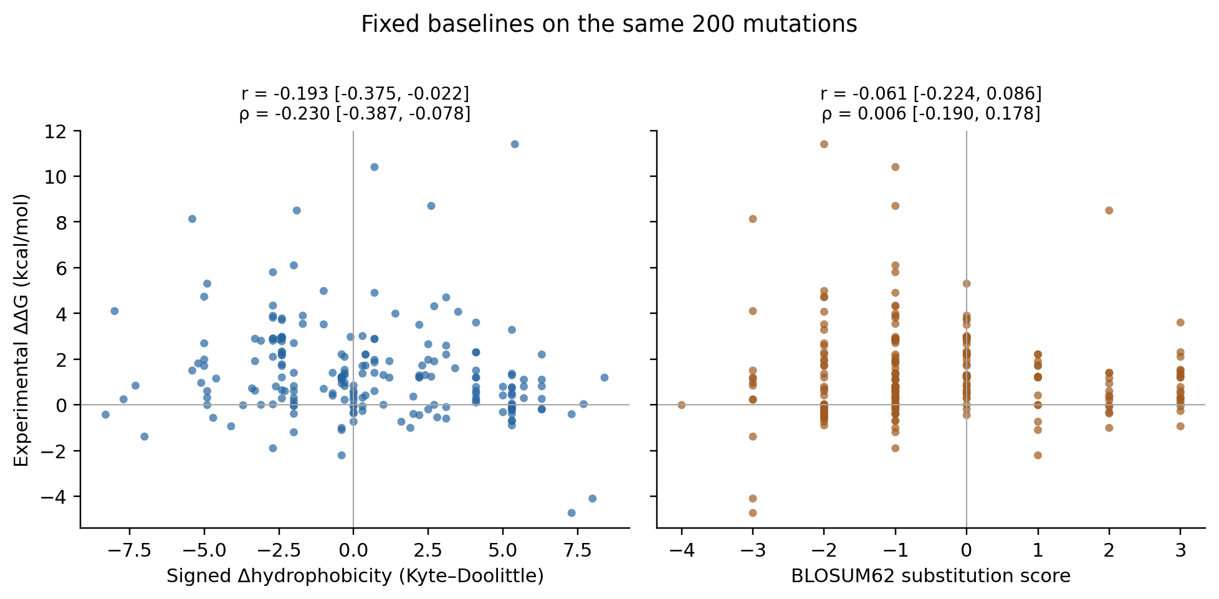
Figure S2. Fixed sequence baselines versus experimental folding ΔΔG. Hydrophobicity is mutant minus WT; BLOSUM62 is the raw substitution score. Each panel retains all 200 observations. The displayed features are not fitted energy predictions.

Table S5 Complete experimental mutation records
Mutation IDs encode accession, WT residue, one-based canonical position and mutant residue. ThermoMutDB and S1 row identifiers retain the original source links. Values retain Pak et al.’s sign convention, including exact zeros; no sign reversal was applied.
Mutation ID | ΔΔG (kcal/mol) | ThermoMutDB ID | Pak S1 row | WT accession
P00044_G12A | 3.5 | 2016 | 432 | P00044
P00044_K28H | 10.4 | 6640 | 914 | P00044
P00044_K33H | 4.9 | 6639 | 913 | P00044
P00044_K33Q | 1.72 | 6634 | 912 | P00044
P00044_N58H | 1.7 | 2009 | 431 | P00044
P00044_N58I | -4.1 | 1982 | 427 | P00044
P00044_N58L | -4.73 | 1981 | 426 | P00044
P00044_N58Q | 0.84 | 2006 | 430 | P00044
P00044_K78I | 1.19 | 2248 | 448 | P00044
P00044_K78L | 0.03 | 2244 | 447 | P00044
P00149_D24H | 1.37 | 9511 | 1103 | P00149
P00149_K34H | 0.6 | 9510 | 1102 | P00149
P00149_K41H | 2.88 | 9509 | 1101 | P00149
P00149_K60H | 1.86 | 9507 | 1100 | P00149
P00149_A87H | 1.98 | 9504 | 1099 | P00149
P00149_E94H | 3.01 | 9503 | 1098 | P00149
P00149_K105H | 2.88 | 9502 | 1097 | P00149
P00149_A112H | 1.7 | 9501 | 1096 | P00149
P00149_K118H | 1.97 | 9500 | 1095 | P00149
P00149_A125H | 2.69 | 9499 | 1094 | P00149
P00651_N35A | -0.9 | 665 | 162 | P00651
P00651_S38A | 1.23 | 662 | 159 | P00651
P00651_V42A | 2.19 | 5741 | 778 | P00651
P00651_G49A | 1.2 | 4899 | 720 | P00651
P00651_N70S | 1.9 | 4157 | 661 | P00651
P00651_Y82F | 0.78 | 659 | 157 | P00651
P00651_Y83F | 0.5 | 660 | 158 | P00651
P00651_W85Y | 0.93 | 2414 | 457 | P00651
P00651_V104S | 4.73 | 5750 | 782 | P00651
P00651_V115C | 3.54 | 5744 | 779 | P00651
P00711_V61G | 1.15 | 4542 | 698 | P00711
P00711_V61N | 0.24 | 4540 | 697 | P00711
P00711_Q73A | 0.41 | 4543 | 699 | P00711
P00711_Y122P | 0.22 | 4545 | 701 | P00711
P00711_H126A | 0.79 | 4535 | 692 | P00711
P00711_H126W | 1.72 | 4536 | 693 | P00711
P00711_L129H | -1.39 | 4527 | 685 | P00711
P00711_L129R | -0.43 | 4528 | 686 | P00711
P00711_W137H | 0.6 | 4532 | 690 | P00711
P00711_W137Y | 1.17 | 4531 | 689 | P00711
P00720_I50A | 2.9 | 8691 | 1078 | P00720
P00720_G77A | 1.2 | 874 | 179 | P00720
P00720_A82P | 0.72 | 875 | 180 | P00720
P00720_P86G | 1.91 | 876 | 181 | P00720
P00720_L91P | 8.13 | 877 | 182 | P00720
P00720_R119E | 0.0 | 5355 | 749 | P00720
P00720_A146I | 4.31 | 884 | 185 | P00720
P00720_A146T | 2.87 | 885 | 186 | P00720
P00720_I150V | 2.1 | 8696 | 1082 | P00720
P00720_T157F | 4.07 | 891 | 191 | P00720
P00974_T46A | -0.2 | 3317 | 585 | P00974
P00974_T46M | 8.7 | 6191 | 859 | P00974
P00974_P48A | 1.6 | 1881 | 408 | P00974
P00974_A51V | 1.3 | 1884 | 410 | P00974
P00974_L64M | 8.5 | 6190 | 858 | P00974
P00974_F68L | 1.3 | 1886 | 411 | P00974
P00974_Y70A | 4.7 | 1887 | 412 | P00974
P00974_G71D | 2.8 | 1893 | 416 | P00974
P00974_R74A | -0.2 | 3318 | 586 | P00974
P00974_E84M | 11.4 | 6193 | 861 | P00974
P01053_K22A | 0.8 | 1528 | 292 | P01053
P01053_E27Q | 0.6 | 1533 | 295 | P01053
P01053_E34N | 0.49 | 1539 | 300 | P01053
P01053_E34Q | 0.34 | 1537 | 298 | P01053
P01053_V39A | 0.28 | 1548 | 308 | P01053
P01053_I49A | 3.89 | 2508 | 464 | P01053
P01053_V54A | 0.64 | 1937 | 421 | P01053
P01053_F70A | 3.52 | 1573 | 326 | P01053
P01053_D72A | 3.28 | 1574 | 327 | P01053
P01053_I77A | 4.34 | 2514 | 465 | P01053
P02185_E5A | -0.7 | 4519 | 682 | P02185
P02185_L12A | 0.6 | 4338 | 667 | P02185
P02185_E19A | -0.7 | 4518 | 681 | P02185
P02185_L30A | -0.39 | 6867 | 925 | P02185
P02185_I31A | -1.9 | 6866 | 924 | P02185
P02185_D45A | -0.2 | 4521 | 683 | P02185
P02185_D61A | -0.15 | 4522 | 684 | P02185
P02185_F107A | 0.7 | 4339 | 668 | P02185
P02185_L116A | 1.4 | 4343 | 669 | P02185
P02185_A145L | -0.4 | 4327 | 666 | P02185
P02417_V3I | 0.31 | 7840 | 1024 | P02417
P02417_V3L | 2.21 | 7846 | 1028 | P02417
P02417_F5V | 3.99 | 8248 | 1072 | P02417
P02417_L6V | 0.41 | 7842 | 1026 | P02417
P02417_E17Q | 0.21 | 7833 | 1021 | P02417
P02417_V21A | 2.33 | 7848 | 1030 | P02417
P02417_V21L | 1.23 | 7844 | 1027 | P02417
P02417_E54Q | -0.33 | 7829 | 1018 | P02417
P02417_H134Q | 0.97 | 7453 | 990 | P02417
P02417_H144Q | 0.82 | 7452 | 989 | P02417
P02633_L10V | 2.2 | 3974 | 656 | P02633
P02633_Y17F | 1.19 | 1416 | 282 | P02633
P02633_E21Q | -0.38 | 1007 | 206 | P02633
P02633_D23N | -0.74 | 1008 | 207 | P02633
P02633_P24G | 1.19 | 1415 | 281 | P02633
P02633_E30Q | -0.09 | 1009 | 208 | P02633
P02633_V65A | 3.78 | 3979 | 657 | P02633
P02633_F70A | 4.98 | 3982 | 658 | P02633
P02633_V74L | 1.2 | 3983 | 659 | P02633
P02633_I77V | 1.53 | 3984 | 660 | P02633
P03050_E17A | 0.5 | 13289 | 1140 | P03050
P03050_L19A | 0.82 | 6538 | 875 | P03050
P03050_R23A | 1.1 | 13299 | 1147 | P03050
P03050_E27A | -0.4 | 13282 | 1137 | P03050
P03050_G30A | 1.29 | 6539 | 876 | P03050
P03050_V33A | 1.77 | 6542 | 879 | P03050
P03050_N34A | 0.0 | 13295 | 1144 | P03050
P03050_V41A | 3.71 | 6547 | 884 | P03050
P03050_M42A | 2.97 | 6544 | 881 | P03050
P03050_E48G | 2.59 | 5277 | 739 | P03050
P05230_C31S | 2.89 | 5239 | 730 | P05230
P05230_H36Y | -1.01 | 7225 | 972 | P05230
P05230_V46W | 0.96 | 9580 | 1106 | P05230
P05230_L59W | -0.57 | 9573 | 1104 | P05230
P05230_C98S | 1.91 | 5233 | 727 | P05230
P05230_H108G | -0.55 | 5236 | 729 | P05230
P05230_F123Y | -0.94 | 7228 | 973 | P05230
P05230_V124I | -0.06 | 7229 | 974 | P05230
P05230_C132I | 0.36 | 9578 | 1105 | P05230
P05230_C132S | 0.62 | 5234 | 728 | P05230
P05798_D17K | 1.1 | 5359 | 753 | P05798
P05798_E41K | 1.2 | 5357 | 751 | P05798
P05798_Y49F | 0.2 | 5765 | 788 | P05798
P05798_Y51F | 2.3 | 5766 | 789 | P05798
P05798_Y52F | 3.6 | 5767 | 790 | P05798
P05798_Y55F | 0.6 | 5768 | 791 | P05798
P05798_E74K | -1.1 | 5358 | 752 | P05798
P05798_Y80F | 1.5 | 5762 | 785 | P05798
P05798_Y81F | 1.2 | 5763 | 786 | P05798
P05798_Y86F | 0.3 | 5764 | 787 | P05798
P0A3E0_V19I | -0.27 | 7949 | 1059 | P0A3E0
P0A3E0_I22A | 0.02 | 7932 | 1052 | P0A3E0
P0A3E0_I22G | -0.01 | 7934 | 1053 | P0A3E0
P0A3E0_E41K | -2.21 | 7313 | 975 | P0A3E0
P0A3E0_L51A | -0.05 | 7936 | 1054 | P0A3E0
P0A3E0_I53V | 1.38 | 7340 | 982 | P0A3E0
P0A3E0_G69A | -0.45 | 7960 | 1060 | P0A3E0
P0A3E0_Q112G | -0.1 | 7939 | 1056 | P0A3E0
P0A3E0_D127K | -1.01 | 7316 | 977 | P0A3E0
P0A3E0_L144A | 0.14 | 7350 | 987 | P0A3E0
P0A7Y4_R27A | 2.2 | 4586 | 708 | P0A7Y4
P0A7Y4_I53A | 2.1 | 4584 | 706 | P0A7Y4
P0A7Y4_I53D | 4.1 | 6994 | 944 | P0A7Y4
P0A7Y4_I53F | 3.9 | 6993 | 943 | P0A7Y4
P0A7Y4_I53L | 1.4 | 6992 | 942 | P0A7Y4
P0A7Y4_H62P | -0.74 | 44 | 5 | P0A7Y4
P0A7Y4_S68G | 2.2 | 28 | 2 | P0A7Y4
P0A7Y4_Q105G | 2.2 | 4585 | 707 | P0A7Y4
P0A7Y4_H124A | -0.32 | 604 | 150 | P0A7Y4
P0A7Y4_H127A | 0.41 | 605 | 151 | P0A7Y4
P23370_V6A | 1.7 | 7702 | 999 | P23370
P23370_I8A | 2.9 | 7703 | 1000 | P23370
P23370_L21A | -1.2 | 7704 | 1001 | P23370
P23370_I26A | 2.8 | 7706 | 1002 | P23370
P23370_Y33A | -0.6 | 7707 | 1003 | P23370
P23370_L48A | 0.3 | 7710 | 1005 | P23370
P23370_V65A | 2.3 | 7713 | 1008 | P23370
P23370_L79A | 2.7 | 7715 | 1009 | P23370
P23370_V85A | 2.9 | 7716 | 1010 | P23370
P23370_V88A | 1.2 | 7717 | 1011 | P23370
P29160_E7A | 0.77 | 7907 | 1036 | P29160
P29160_K10A | 0.29 | 7909 | 1038 | P29160
P29160_D13A | -0.24 | 7910 | 1039 | P29160
P29160_K47A | 1.1 | 7919 | 1043 | P29160
P29160_E48A | 0.05 | 7920 | 1044 | P29160
P29160_R55A | 0.26 | 7923 | 1045 | P29160
P29160_E63A | 1.29 | 7924 | 1046 | P29160
P29160_E70A | 0.74 | 7926 | 1048 | P29160
P29160_R77A | -0.19 | 7927 | 1049 | P29160
P29160_D88A | 1.36 | 7929 | 1050 | P29160
P41016_Q2L | -0.41 | 6126 | 839 | P41016
P41016_N11S | 0.0 | 6127 | 840 | P41016
P41016_Y15F | 0.1 | 6115 | 836 | P41016
P41016_G23Q | 0.0 | 6131 | 843 | P41016
P41016_F38W | -0.02 | 7009 | 945 | P41016
P41016_E46A | -0.1 | 6134 | 845 | P41016
P41016_Q53E | -0.02 | 6125 | 838 | P41016
P41016_V64T | 0.31 | 6117 | 837 | P41016
P41016_L66A | -0.02 | 6128 | 841 | P41016
P41016_L66E | 0.84 | 6129 | 842 | P41016
P62942_V5A | 2.78 | 3772 | 608 | P62942
P62942_V24A | 2.97 | 4554 | 703 | P62942
P62942_T28A | 1.97 | 3802 | 624 | P62942
P62942_I57T | 1.81 | 3780 | 612 | P62942
P62942_R58A | 0.81 | 3790 | 618 | P62942
P62942_R58G | 2.29 | 3791 | 619 | P62942
P62942_V64A | 2.97 | 3781 | 613 | P62942
P62942_T76A | 2.65 | 3804 | 626 | P62942
P62942_I77A | 3.81 | 3783 | 614 | P62942
P62942_V99A | 2.16 | 3787 | 615 | P62942
P69543_V19T | 0.6 | 1698 | 352 | P69543
P69543_C33A | 0.5 | 1666 | 331 | P69543
P69543_V35T | 5.3 | 1671 | 333 | P69543
P69543_L37I | 1.4 | 1674 | 336 | P69543
P69543_I47A | 5.8 | 930 | 195 | P69543
P69543_I47L | 0.4 | 933 | 198 | P69543
P69543_L49A | 6.1 | 1681 | 340 | P69543
P69543_L65P | 1.5 | 2709 | 485 | P69543
P69543_M77T | 0.8 | 1726 | 364 | P69543
P69543_I78V | 1.3 | 1693 | 349 | P69543

Software and inference provenance
The successful Boltz freeze verifies boltz 2.2.1, PyTorch 2.7.1, pytorch-lightning 2.5.0 and NumPy 1.26.4. Initial Chai and ESM version-capture files contain “No module named pip”, not valid package manifests. An exact Chai version and immutable ESM source revision are therefore not established by those captures. Boltz-2 used three recycles and 200 sampling steps; Chai-1 used three trunk recycles and 200 diffusion timesteps; Biohub ESMFold2 used 20 loops and 200 sampling steps. These model-specific operations are not equivalent compute budgets. Each sequence used labels 42, 43 and 44 with one sample per label. Chai-1 and ESMFold2 reset seeds per sequence, whereas Boltz-2 seeded each batch.
Boltz-2 official implementation and output documentation: https://github.com/jwohlwend/boltz and https://github.com/jwohlwend/boltz/blob/main/docs/prediction.md. Chai-1 implementation: https://github.com/chaidiscovery/chai-lab. Biohub ESMFold2 model card: https://huggingface.co/biohub/ESMFold2. Package versions do not uniquely establish checkpoint revisions. The ESMFold2 implementation is distinct from the 2023 ESMFold model.
Biohub ESMFold2 used the full local checkpoint, local ESMC-6B embeddings and recorded language-model dropout of 0.3; its successful environment used PyTorch 2.11.0+cu128. Boltz-2 had an empty MSA and optional optimised kernels disabled. Chai-1 used ESM embeddings with MSA and template services disabled. No partners, restraints, affinity outputs or computational folding-energy estimates entered the confidence analysis.

S6 Recorded execution costs and environment
Archived host wall-clock timers are available for all 660 Chai-1 and 660 successful ESMFold2 predictions. They begin before per-item input preparation and include the model call, structure/output writing, confidence conversion and sequence validation. They end before writing the completion JSON. ESM model/ESMC loading occurs before the loop and is excluded. The Chai mean retains first-call overhead; its first item is also its maximum. These are host timers, not CUDA-event kernel measurements.
Table S6. Recorded execution time by model and seed. Per-item results show mean ± sample SD and range in seconds; Boltz has no comparable per-item timer.
Model | Seed | Items | Mean ± SD (s) | Range (s)
Chai-1 | all | 660 | 32.398 ± 3.784 | 29.533–77.073
Chai-1 | 42 | 220 | 32.304 ± 4.358 | 29.533–77.073
Chai-1 | 43 | 220 | 32.632 ± 3.790 | 29.755–46.390
Chai-1 | 44 | 220 | 32.258 ± 3.106 | 29.670–40.674
ESMFold2 | all | 660 | 5.110 ± 1.549 | 3.047–8.608
ESMFold2 | 42 | 220 | 5.116 ± 1.552 | 3.056–8.220
ESMFold2 | 43 | 220 | 5.107 ± 1.550 | 3.051–8.167
ESMFold2 | 44 | 220 | 5.107 ± 1.552 | 3.047–8.608
Boltz-2 final batch prediction-progress displays were 29:08, 29:03 and 29:06 for seeds 42, 43 and 44, respectively: 1,748, 1,743 and 1,746 seconds for 220 items each. The displays have seconds-level precision and do not measure individual items or full process runtime. Each batch reports zero failures. The Chai/ESM completion JSON records match the corresponding inference-log records exactly.
Boltz and Chai were launched concurrently on the selected CUDA device. ESM was attempted after both finished, failed during model loading and subsequently completed a separate retry after its PyTorch CUDA environment was repaired. The successful retry used PyTorch 2.11.0+cu128. The observed device name is NVIDIA vGPU-32GB; the underlying physical GPU, exclusive allocation and per-model FLOPs are not established. Thus, the recorded times are descriptive protocol costs, not a fair speed ranking.
The complete recorded launcher-to-final-retry envelope was 26,502 seconds (7 h 21 min 42 s), including concurrency, failed loading and unpartitioned waiting/repair. It is not a sum of GPU-hours or billed time. Device-wide ten-second monitoring recorded sampled maxima of 10,670 MiB during overlapping Boltz/Chai and 15,141 MiB during the ESM retry. Those samples cannot attribute memory to individual concurrent models, establish isolated peaks, or exclude shorter unsampled peaks. No energy or monetary cost is inferred.

S7 Paired baseline comparisons
Differences below are signed model coefficients minus baseline coefficients, recalculated in the same 10,000 cluster draws. They are not absolute-correlation differences, predictive-error measures, or evidence of independent predictive information. All local Spearman intervals against signed hydrophobicity include zero, without proving equivalence. Only the Chai-1 versus BLOSUM62 Spearman pointwise interval excludes zero; no multiplicity correction was applied.
Table S7. Paired model-minus-baseline local coefficient differences.
Model | Baseline | Metric | Difference [95% CI]
Boltz-2 | Hydrophobicity | Pearson r | 0.231 [-0.026, 0.483]
Boltz-2 | BLOSUM62 | Pearson r | 0.099 [-0.066, 0.240]
Boltz-2 | Hydrophobicity | Spearman ρ | 0.123 [-0.104, 0.377]
Boltz-2 | BLOSUM62 | Spearman ρ | -0.112 [-0.290, 0.102]
Chai-1 | Hydrophobicity | Pearson r | -0.042 [-0.237, 0.166]
Chai-1 | BLOSUM62 | Pearson r | -0.174 [-0.333, 0.001]
Chai-1 | Hydrophobicity | Spearman ρ | -0.041 [-0.204, 0.126]
Chai-1 | BLOSUM62 | Spearman ρ | -0.277 [-0.463, -0.061]
ESMFold2 | Hydrophobicity | Pearson r | -0.025 [-0.140, 0.122]
ESMFold2 | BLOSUM62 | Pearson r | -0.157 [-0.389, 0.061]
ESMFold2 | Hydrophobicity | Spearman ρ | -0.025 [-0.198, 0.153]
ESMFold2 | BLOSUM62 | Spearman ρ | -0.261 [-0.510, 0.001]

S8 Per-protein heterogeneity
Each coefficient uses all ten mutations within its protein and the mean of three signed MT–WT confidence differences. Local Pearson ranges are −0.834 to 0.641 (Boltz-2), −0.959 to 0.557 (Chai-1) and −0.891 to 0.629 (ESMFold2). Local Spearman ranges are −0.830 to 0.648, −0.891 to 0.673 and −0.924 to 0.127, respectively. Negative local Spearman coefficients occur in 14/20, 17/20 and 14/20 proteins. These signs do not constitute individual-protein significance tests.
For the descriptive Pearson intervals, z = arctanh(r), SE(z) = 1/√(10−3), and bounds are tanh[z ± 1.95996398454 × SE(z)]. The conditional independence and bivariate-normal assumptions are approximations. Shared prediction uncertainty, assay error, construct mismatch and mutation-selection uncertainty are not propagated. The intervals are pointwise, not simultaneous or multiplicity adjusted. Full-precision local and global coefficients and Pearson bounds are retained in per_protein_correlations.csv.

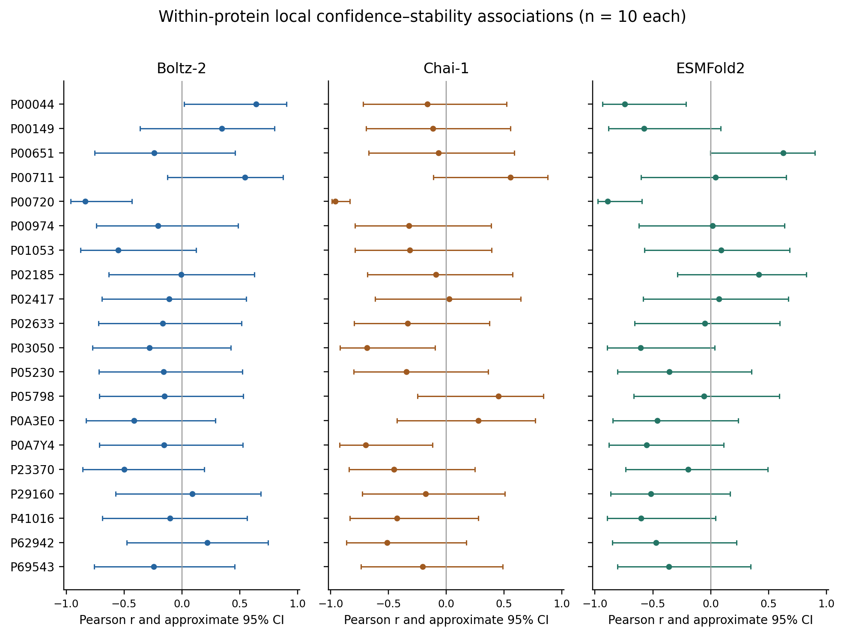
Figure S3. Local within-protein Pearson r and approximate Fisher-z 95% intervals for all 20 proteins. Every estimate uses ten mutations. All panels share the −1 to +1 correlation scale. Intervals are descriptive under the assumptions in Section S8, not model-superiority tests.

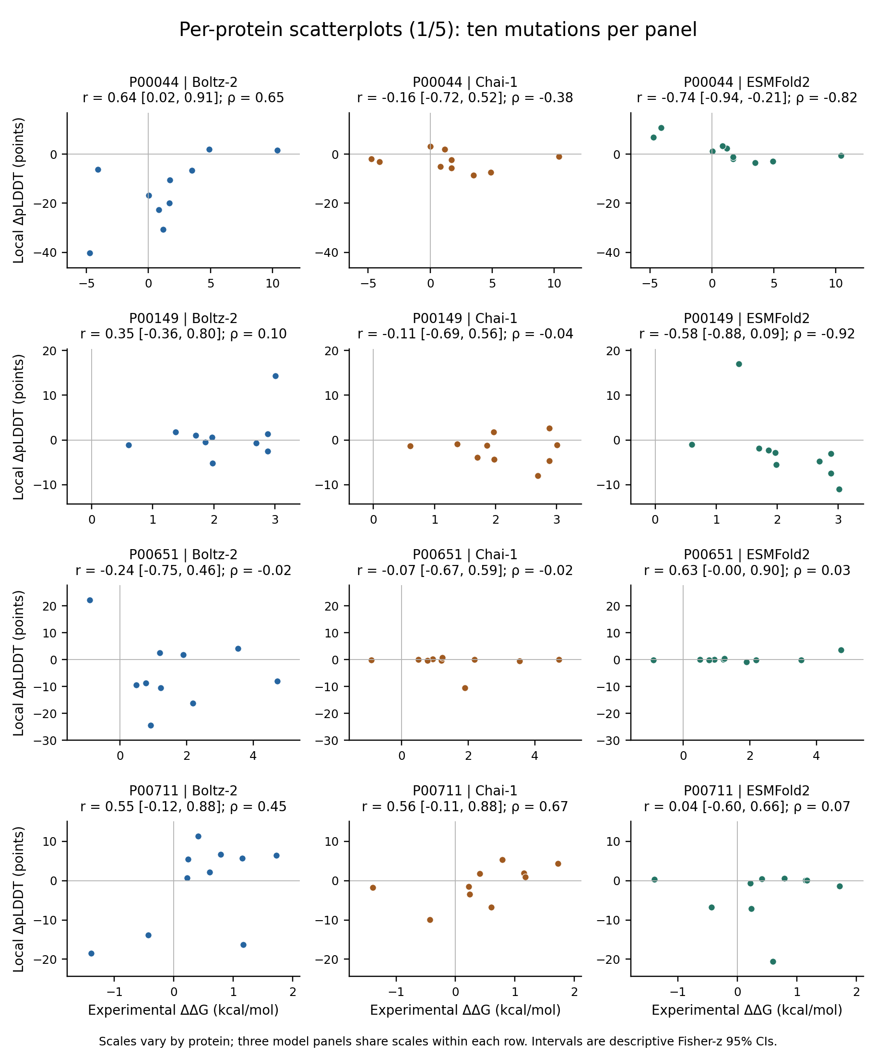
Figure S4a. Local confidence–stability scatter plots, proteins 1–4 of 20. Each panel contains all ten mutations and reports Pearson r with its approximate 95% interval and Spearman ρ. Axis ranges differ between protein rows but match across models within each row. No jitter, filtering or fitted line is applied. See Section S8 for interval assumptions.

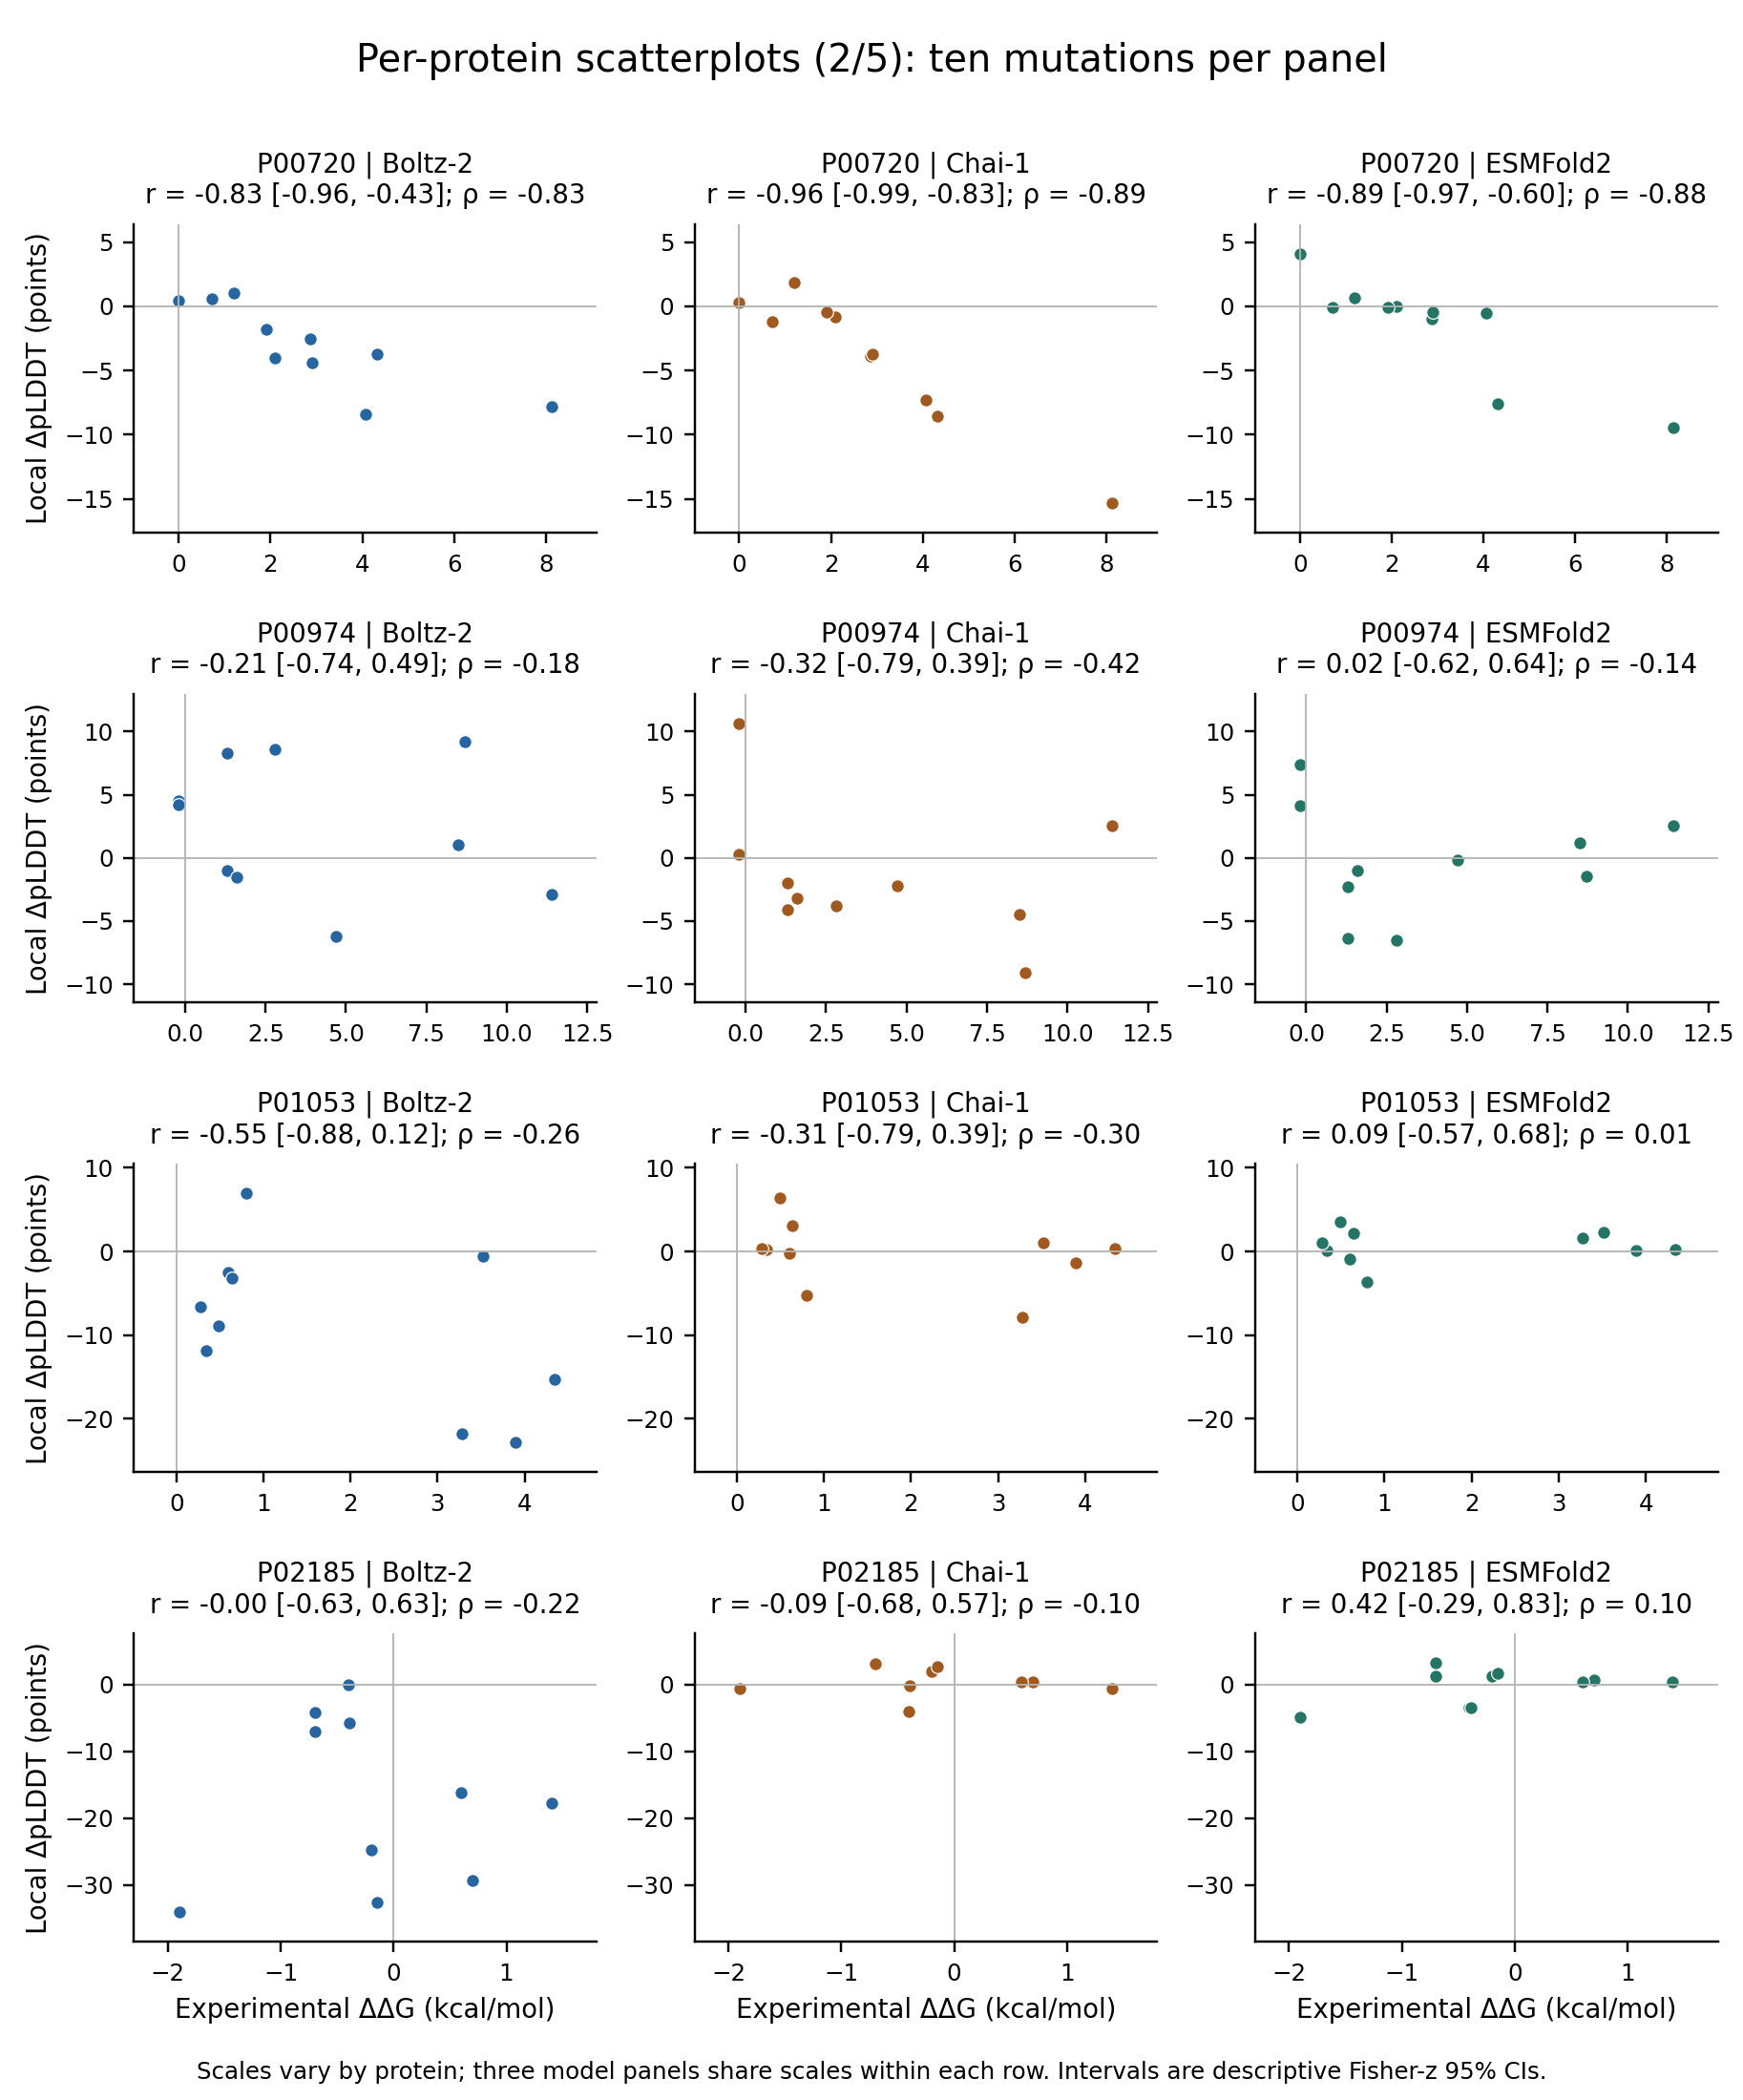
Figure S4b. Local confidence–stability scatter plots, proteins 5–8 of 20. Each panel contains all ten mutations and reports Pearson r with its approximate 95% interval and Spearman ρ. Axis ranges differ between protein rows but match across models within each row. No jitter, filtering or fitted line is applied. See Section S8 for interval assumptions.

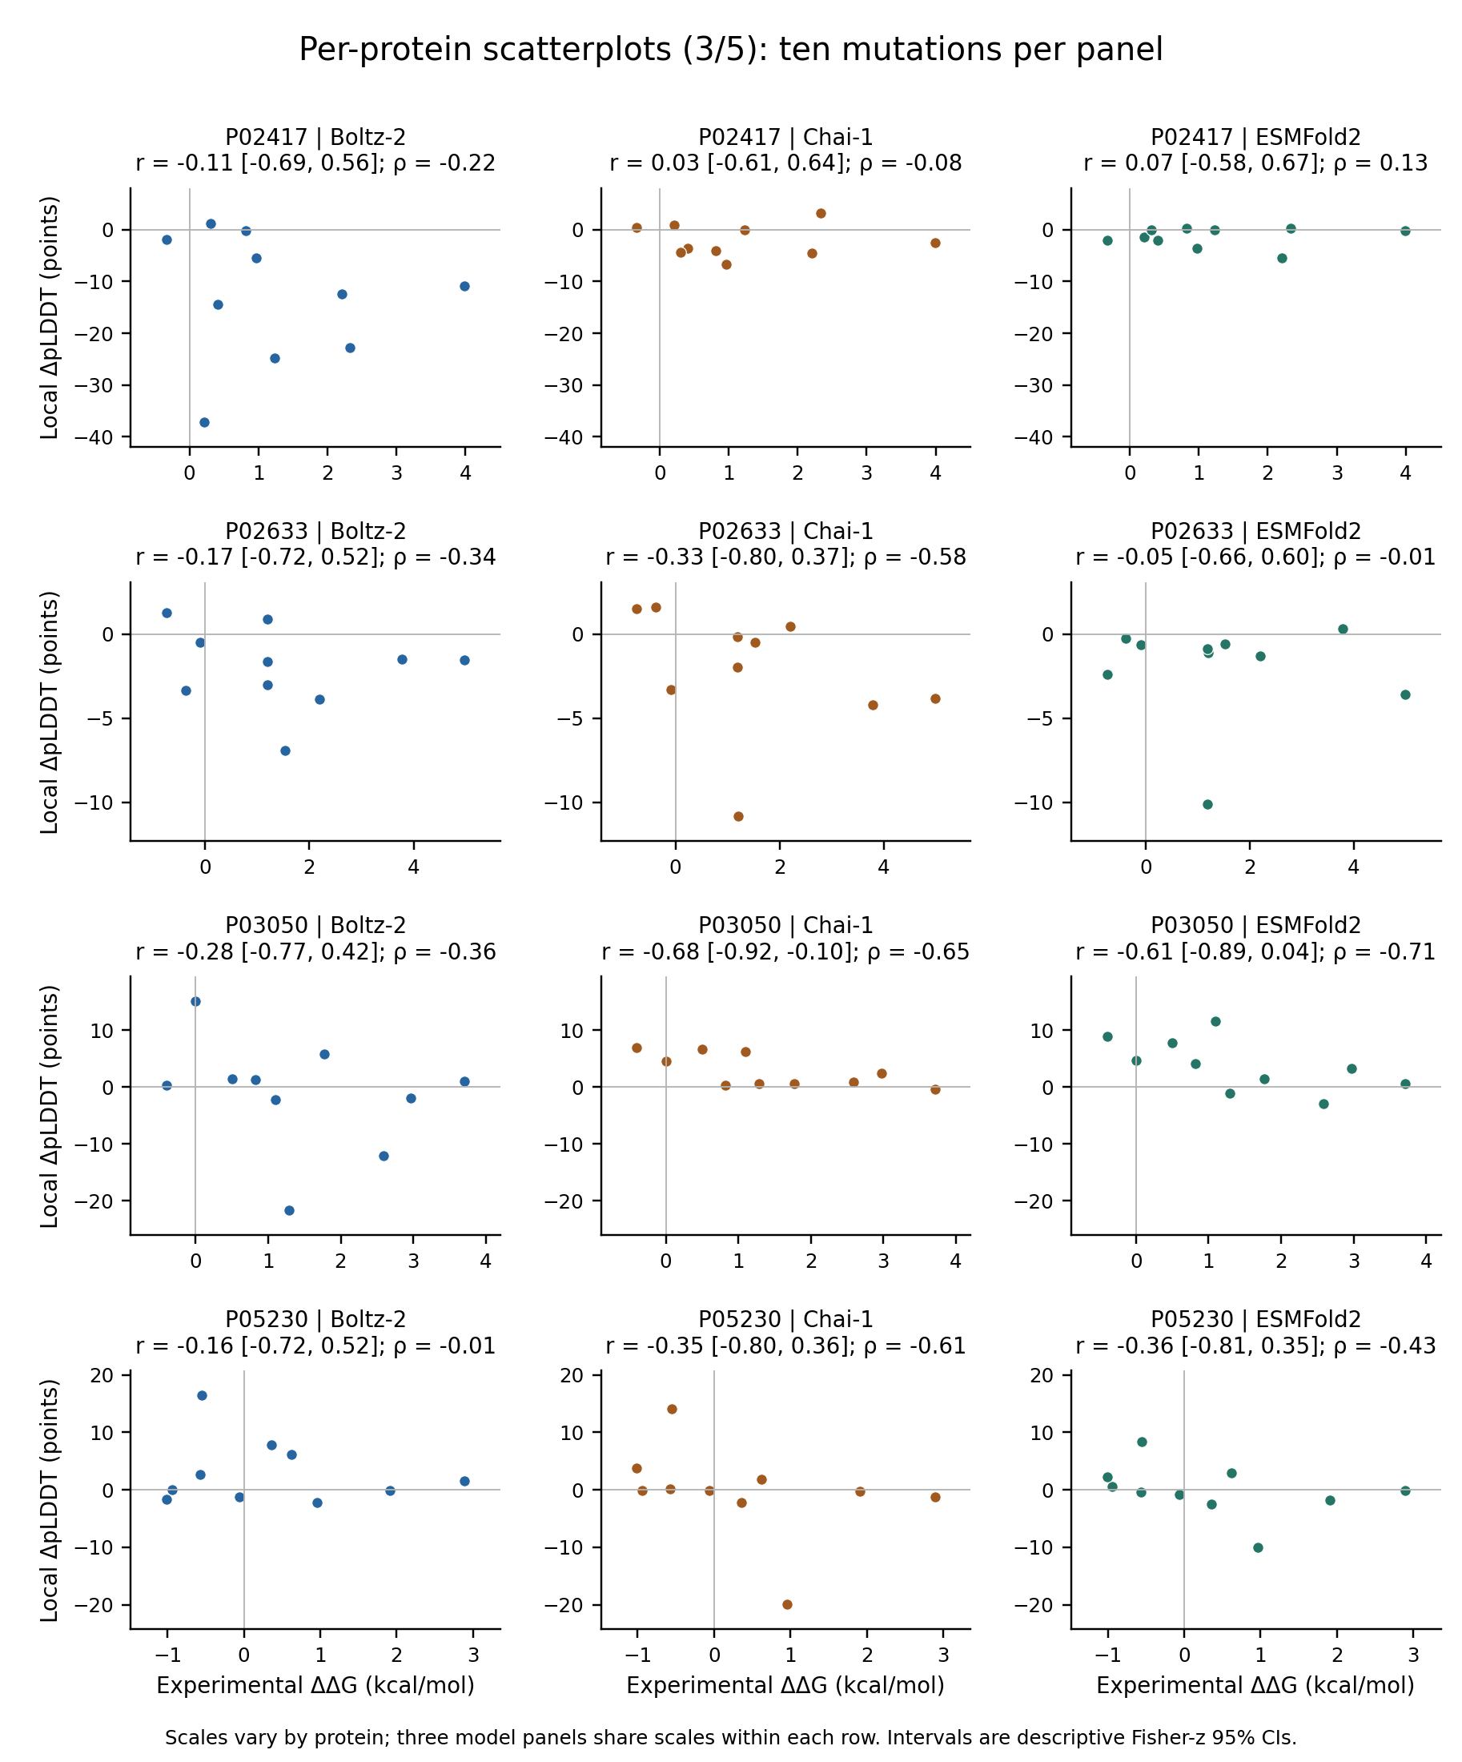
Figure S4c. Local confidence–stability scatter plots, proteins 9–12 of 20. Each panel contains all ten mutations and reports Pearson r with its approximate 95% interval and Spearman ρ. Axis ranges differ between protein rows but match across models within each row. No jitter, filtering or fitted line is applied. See Section S8 for interval assumptions.

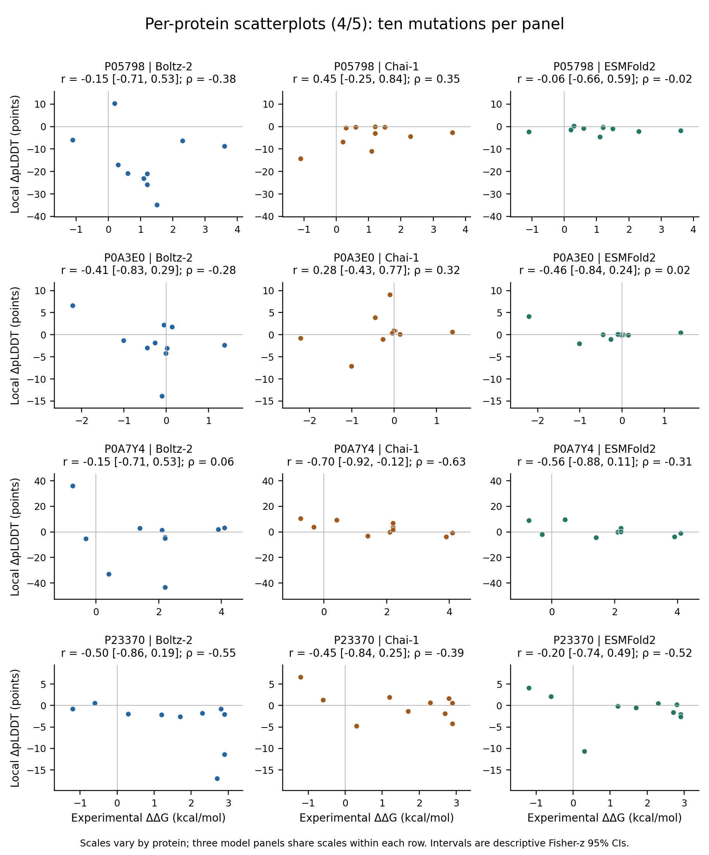
Figure S4d. Local confidence–stability scatter plots, proteins 13–16 of 20. Each panel contains all ten mutations and reports Pearson r with its approximate 95% interval and Spearman ρ. Axis ranges differ between protein rows but match across models within each row. No jitter, filtering or fitted line is applied. See Section S8 for interval assumptions.

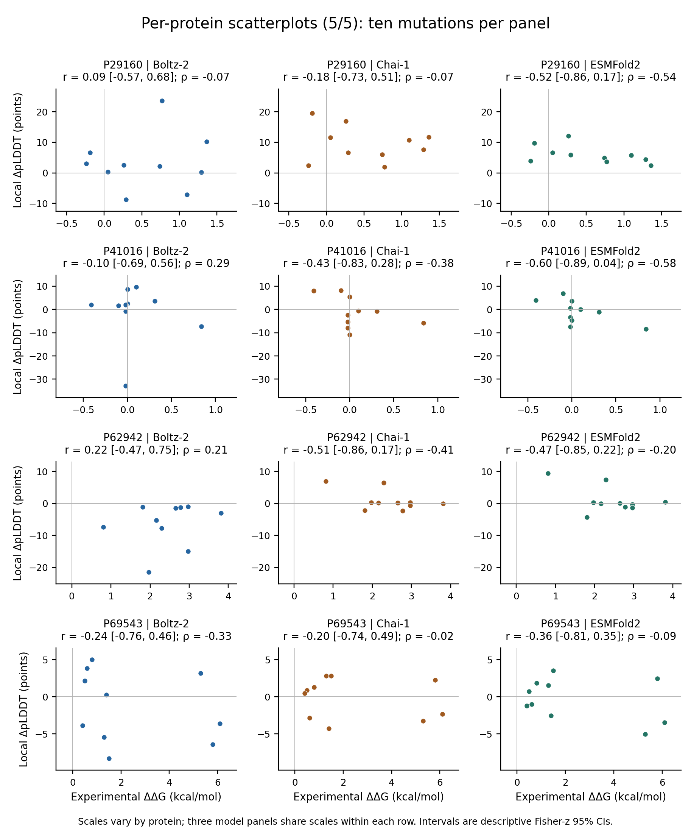
Figure S4e. Local confidence–stability scatter plots, proteins 17–20 of 20. Each panel contains all ten mutations and reports Pearson r with its approximate 95% interval and Spearman ρ. Axis ranges differ between protein rows but match across models within each row. No jitter, filtering or fitted line is applied. See Section S8 for interval assumptions.

S9 Data integrity and reproduction
The recovered model table contains 600 unique model–mutation rows: three models on the same 200 experimental substitutions. Experimental values, ThermoMutDB identifiers and Pak S1 row numbers agree with all independently recovered Appendix A2 records. Native-confidence verification covered 1,980 arrays and 232,551 residue values against the original completed-run snapshot. All 1,800 seed-level MT–WT comparisons and their mutation means and sample SDs were checked. No new model inference was performed during revision.
All 12 pooled coefficient estimates and protein-cluster intervals reproduce the submitted manuscript at displayed precision. All 120 per-protein model–endpoint rows, including both Pearson and Spearman coefficients, match the archived table within 5 × 10⁻¹³. Unrounded data are retained for reuse; rounded values in plots are display values only.
To reproduce the new baseline and comparison outputs, run calculate_baselines.py followed by analyze_model_comparisons.py in the supplied analysis directory. The second script reuses the saved bootstrap draws. Dependencies for the revision analysis were Python 3.12.14, NumPy 2.3.5, SciPy 1.17.0, pandas 2.2.3 and Matplotlib 3.10.8. These analysis-software versions are distinct from the inference environments. Source scripts that launch or install prediction models were inspected but not executed during this revision.

References
Pak MA, Markhieva KA, Novikova MS, et al. Using AlphaFold to predict the impact of single mutations on protein stability and function. PLoS One. 2023;18:e0282689. doi:10.1371/journal.pone.0282689.
Xavier JS, Nguyen TB, Karmarkar M, et al. ThermoMutDB: a thermodynamic database for missense mutations. Nucleic Acids Res. 2021;49:D475–D479. doi:10.1093/nar/gkaa925.
The UniProt Consortium. UniProt: the Universal Protein Knowledgebase in 2025. Nucleic Acids Res. 2025;53:D609–D617. doi:10.1093/nar/gkae1010.
Kyte J, Doolittle RF. A simple method for displaying the hydropathic character of a protein. J Mol Biol. 1982;157:105–132. doi:10.1016/0022-2836(82)90515-0.
Henikoff S, Henikoff JG. Amino acid substitution matrices from protein blocks. Proc Natl Acad Sci U S A. 1992;89:10915–10919. doi:10.1073/pnas.89.22.10915.

