

# Condor GUI

Condor GUI is a tool for managing and working with one or more HTCondor pools. It was developed at the Otto von Guericke University Magdeburg, Germany, to support the daily work using HTCondor.

## Requirements

To use the whole functionality of Condor GUI some packages and additional software are required.

### Python Packages

Condor GUI is developed in Python 3.4. The program uses the LGPL-licensed PySide bindings for Qt 4.8 and the package QDarkStyleSheet (optional). The Python packages must be installed to run the source code directly. We recommend using *pip* for installing the required packages.

The binary distribution contains all packages.

### HTCondor

To use Condor GUI HTCondor is required. Version 8.4.4 was used for developing. Other Versions should work, too.

<https://research.cs.wisc.edu/htcondor/>

## Running Condor GUI

It is possible to run Condor GUI in different ways:

### Running the Executable on Windows

The simplest way to run the program double click on the *Condor\_GUI.exe* file. The current director is set where the exe file or a submitted job or DAG description file is located.

To set the current working directory use the *–cwd* option:

Condor\_GUI.exe -cwd <directory>

### Running from the Source Code

To run Condor GUI directly from the source code execute *condor\_gui.py.* This method works on both Windows and Linux platforms.

Note that Python 3.4, PySide are required. QDarkStyleSheet is an optional package to set the style of the GUI.

## User Interface

The user interface contains two domains: the resource domain and the job domain. Both domains are refreshed every 5 seconds.

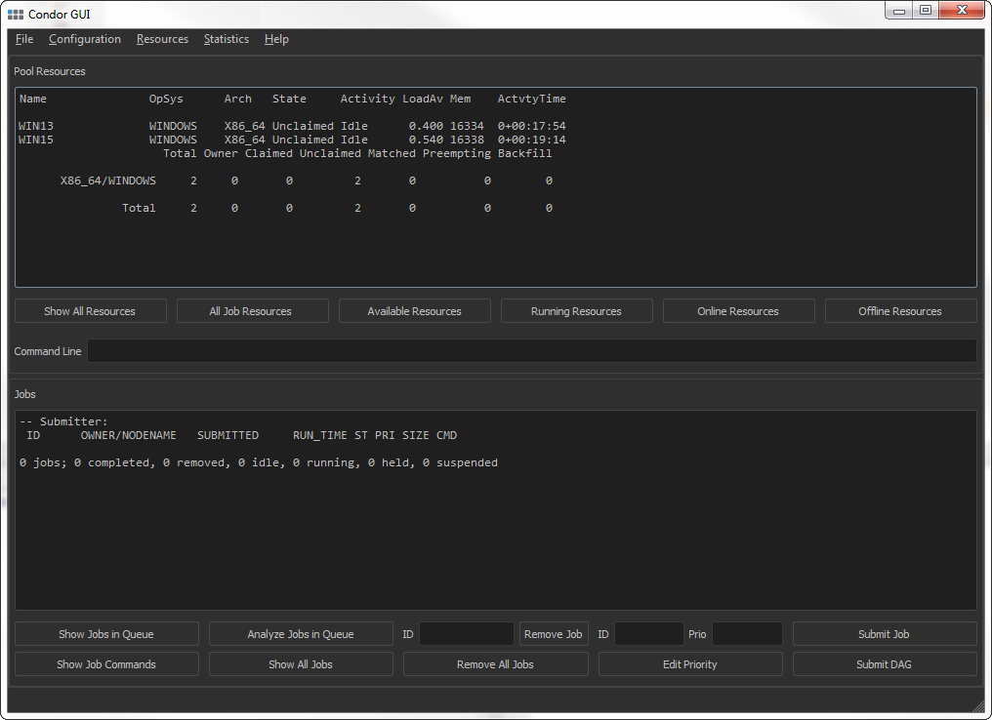

### Submit Jobs

To submit a job or a DAG select *Submit Job* or *Submit DAG* and select a job description file or a DAG description file.

D:\_Austausch\_work\Condor_GUI_dev\Condor_GUI\screenshots\submit.png

### Create Job File

To create a new job description file select *File → New Job (Ctrl+J)*. In the appearing dialog select the appropriate files and settings. An executable and a job file name are required to create a job file. Selecting *Create Job File* will create a temporary job description. The job file must be saved before closing the dialog.

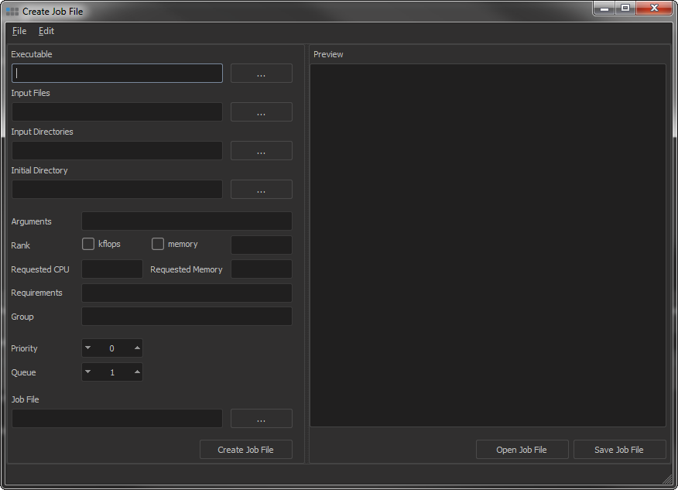

### Create DAG File

To create a new DAG description file select *File → New DAG (Ctrl+D)*. In the appearing dialog select the appropriate job files, priorities and dependencies. Two job files and a DAG file name are required to create a DAG file. Selecting *Create DAG File* will create a temporary job description. The DAG file must be saved before closing the dialog.

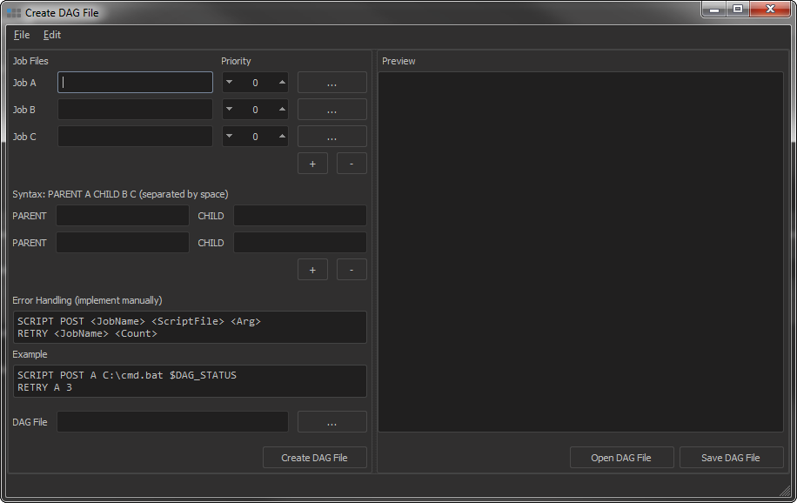

### Show Statistics

Selecting *Statistics* *→ Show in Browser* will open *C:/condor\_extra/viewdir/index.html* in a web browser. The CondorView Client is required for that.

## License

Condor GUI is distributed with the BSD license.

Copyright © 2016, Condor GUI Developers

Bartosz Dziubaczyk ([info@dziubaczyk.de](mailto:info@dziubaczyk.de))

Andreas Wünsch ([andreas.wuensch@ovgu.de](mailto:andreas.wuensch@ovgu.de))

Otto von Guericke University Magdeburg

All rights reserved.

Condor GUI includes parts of the following software and modules:

|  |  |  |
| --- | --- | --- |
| Software / Module | Copyright / Contact | License |
| PySide  (Ver. 1.2.2) | <http://www.pyside.org> | LGPL |
| QDarkStyleSheet  (Ver. 2.1) | Copyright © 2013-2014, Colin Duquesnoy  <https://github.com/ColinDuquesnoy/QDarkStyleSheet> | MIT |

### BSD License

Redistribution and use in source and binary forms, with or without modification, are permitted provided that the following conditions are met:

* Redistributions of source code must retain the above copyright notice, this list of conditions and the following disclaimer.
* Redistributions in binary form must reproduce the above copyright notice, this list of conditions and the following disclaimer in the documentation and/or other materials provided with the distribution.
* Neither the name of the copyright holder nor the names of its contributors may be used to endorse or promote products derived from this software without specific prior written permission.

THIS SOFTWARE IS PROVIDED BY THE REGENTS AND CONTRIBUTORS “AS IS” AND ANY EXPRESS OR IMPLIED WARRANTIES, INCLUDING, BUT NOT LIMITED TO, THE IMPLIED WARRANTIES OF MERCHANTABILITY AND FITNESS FOR A PARTICULAR PURPOSE ARE DISCLAIMED. IN NO EVENT SHALL THE REGENTS OR CONTRIBUTORS BE LIABLE FOR ANY DIRECT, INDIRECT, INCIDENTAL, SPECIAL, EXEMPLARY, OR CONSEQUENTIAL DAMAGES (INCLUDING, BUT NOT LIMITED TO, PROCUREMENT OF SUBSTITUTE GOODS OR SERVICES; LOSS OF USE, DATA, OR PROFITS; OR BUSINESS INTERRUPTION) HOWEVER CAUSED AND ON ANY THEORY OF LIABILITY, WHETHER IN CONTRACT, STRICT LIABILITY, OR TORT (INCLUDING NEGLIGENCE OR OTHERWISE) ARISING IN ANY WAY OUT OF THE USE OF THIS SOFTWARE, EVEN IF ADVISED OF THE POSSIBILITY OF SUCH DAMAGE.

### MIT License

Permission is hereby granted, free of charge, to any person obtaining a copy of this software and associated documentation files (the "Software"), to deal in the Software without restriction, including without limitation the rights to use, copy, modify, merge, publish, distribute, sublicense, and/or sell copies of the Software, and to permit persons to whom the Software is furnished to do so, subject to the following conditions:

The above copyright notice and this permission notice shall be included in all copies or substantial portions of the Software.

THE SOFTWARE IS PROVIDED "AS IS", WITHOUT WARRANTY OF ANY KIND, EXPRESS OR IMPLIED, INCLUDING BUT NOT LIMITED TO THE WARRANTIES OF MERCHANTABILITY, FITNESS FOR A PARTICULAR PURPOSE AND NONINFRINGEMENT. IN NO EVENT SHALL THE AUTHORS OR COPYRIGHT HOLDERS BE LIABLE FOR ANY CLAIM, DAMAGES OR OTHER LIABILITY, WHETHER IN AN ACTION OF CONTRACT, TORT OR OTHERWISE, ARISING FROM, OUT OF OR IN CONNECTION WITH THE SOFTWARE OR THE USE OR OTHER DEALINGS IN THE SOFTWARE.

## Information for Developers

### Building on Windows

1. Compiling resource files

Since we are using QtResource for icons and help file, the resource files must be recompiled after applying changes using *resource\_icon.bat* and *resource\_doc.bat* or the following commands:

pyside-rcc.exe resource\_icon.qrc -o condor\_gui\_resource\_icon.py

pyside-rcc.exe resource\_doc.qrc -o condor\_gui\_resource\_doc.py

In the Python files make the following changes:

|  |  |  |
| --- | --- | --- |
| qt\_resource\_data = "\x00 | -> | qt\_resource\_data = b"\x00 |
| qt\_resource\_name = "\x00 | -> | qt\_resource\_name = b"\x00 |
| qt\_resource\_struct = "\x00 | -> | qt\_resource\_struct = b"\x00 |

1. Compiling source code

For compiling the sources we use PyInstaller (Ver. 3.2) ([www.pyinstaller.org](http://www.pyinstaller.org)) and the file *setup\_pyinstaller\_build.bat* including the following command:

pyinstaller.exe --onefile ^

--windowed ^

--icon=icon\_condor\_gui.ico ^

--distpath=./bin ^

condor\_gui.py

### Building on Linux

1. Compiling source code

For compiling the sources we use PyInstaller (Ver. 3.2) ([www.pyinstaller.org](http://www.pyinstaller.org)) and the file *setup\_pyinstaller\_build.sh* including the following command:

pyinstaller --onefile \

--windowed \

condor\_gui.py

## Release Notes

### Version 0.9.3

* QDarkStyleSheet is an optional package now

### Version 0.9.2

* New layout of job file editor
* Keyword arguments in job file editor
* Linux compatibility