Learning a computer to play a tabletop game

The Idea
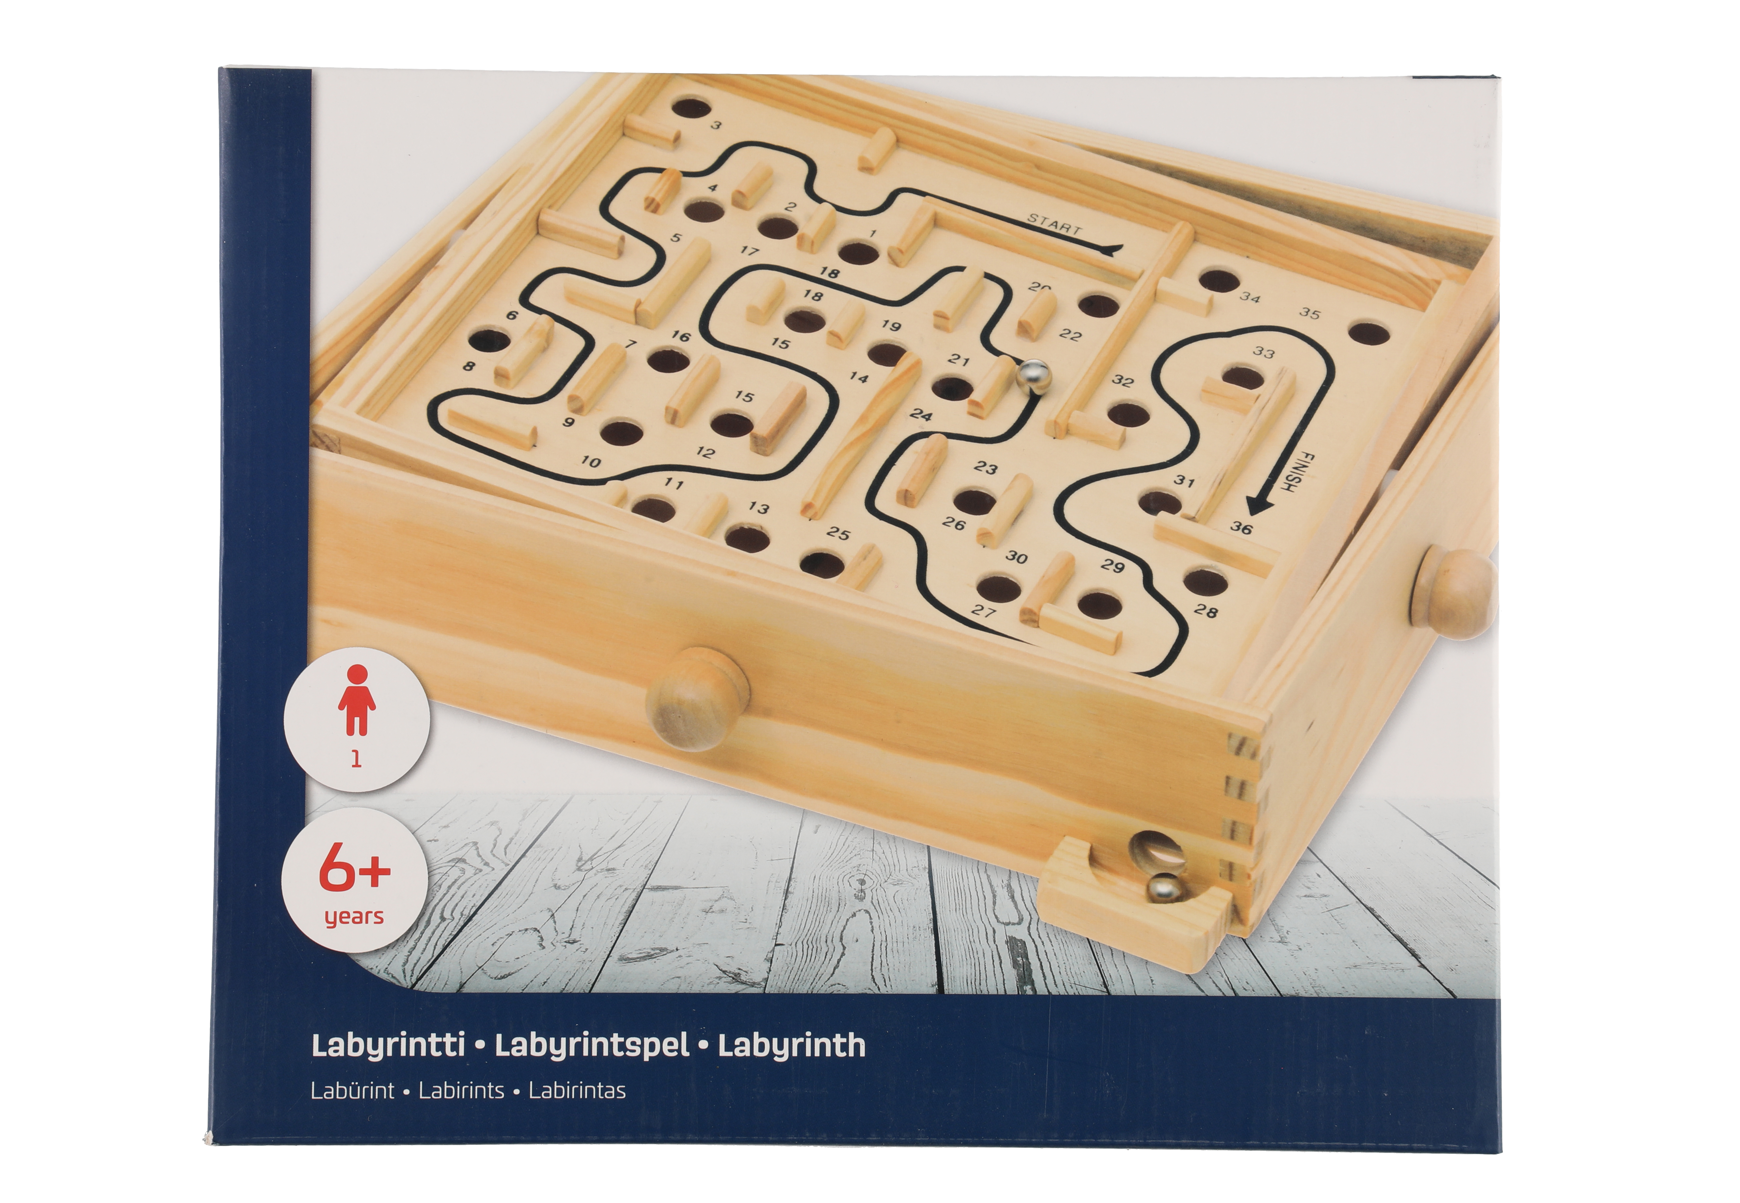
The idea with this project is to learn a computer to play the famous labyrenth game using computer vision and reinforcement learning. On this game two servos will be mounted to control the inclination of the board, this will make the marble to roll. Additionally a couple of servos will be mounted to lift the ball and reset the game to make it easier for the game to play by itself.
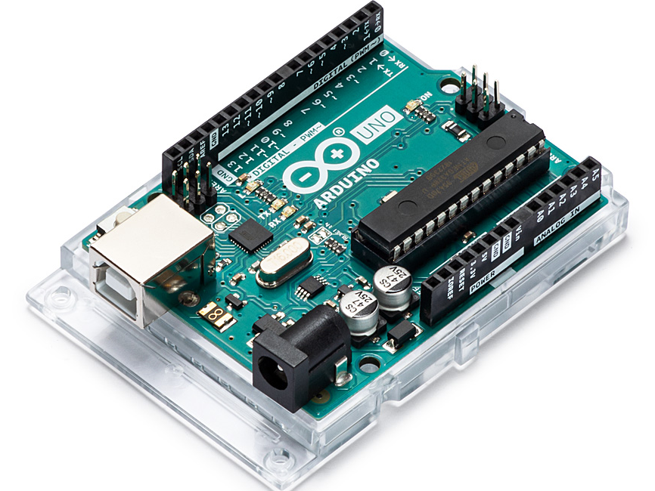
The servos will be controlled by an Arduino Uno that uses PWM (pulse width modulation) to control the position of the servos. The computer running the Machine Learning script will communicate with the Arduino using serial communication. A Raspberry Pi with a High Wuality Camera is mounted to observe the game and give input to the ML script. The camera communicate over USB with the computer to give a high enough frame rate.
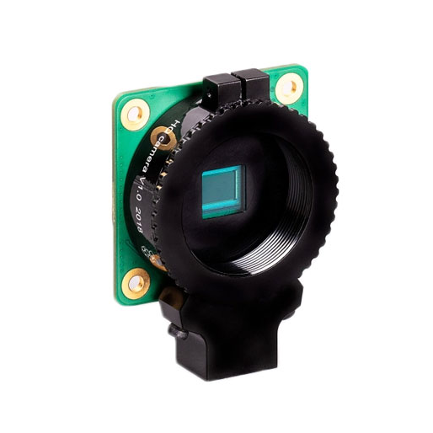

Challenges
I think I somewhat need to flatten the image from the camera. This means removing excessive information. First i crop the image so it just contains the board. Then i try to isolate the marble. I have tried using red color, but it turns out to be rather hard to isolate and will most likely try a different color on the marble.

