What is crosslisting and why do I want to do it?
→ Crosslisting is simply a way to consolidate your alike courses into one canvas course in order to reduce the need to create assignments for multiple courses. Your periods (sections) will still be able to be graded separately, assign different material if needed, etc. Crosslisted courses will also still sync grades back to Infinite Campus to your individual periods. It really is a time saver and a highly suggested process to implement. Keep in mind that, crosslisting needs to be done PRIOR to any student-submitted assignments.

- Select one of your existing rostered courses to be your “parent” course. Rename it with your name, semester, school year, subject(if you teach more than one). Parent course is the course you plan to teach from-you will move content into this course later.
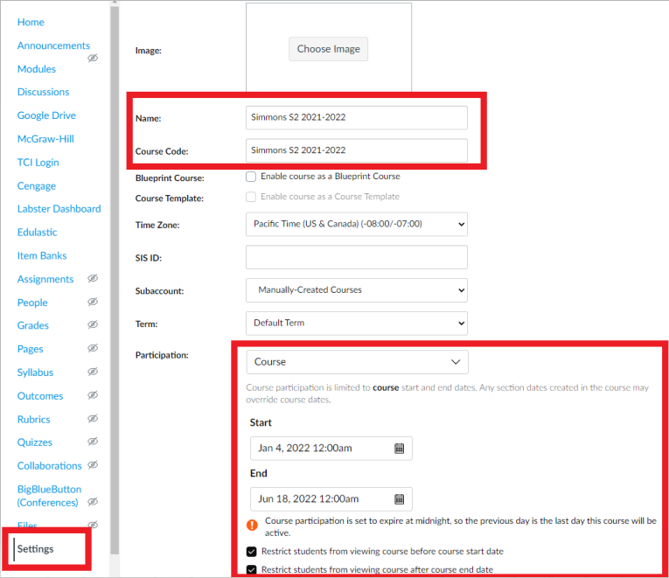
  - Some teachers prefer to manually create a new course (a “sandbox course”) where there are no students attached to the course (but content may be created and housed) - This is helpful as you simply copy the content from your Sandbox course to your parent course.
  - If you are wanting to reuse a previous Canvas course, simply copy the desired course in course settings and use the copy version as your parent course. See image to ensure proper settings- Select Import Existing Content from the homepage→ Select Copy Course Content → Find your parent course→ Adjust Dates and Events→ Remove all dates.
    - I HIGHLY recommend that once you have a complete Shell Course with assignments throughout the year that you wish to reuse each year--SHARE TO THE COMMONS. Then you just can dump all of that content into your Parent Course.
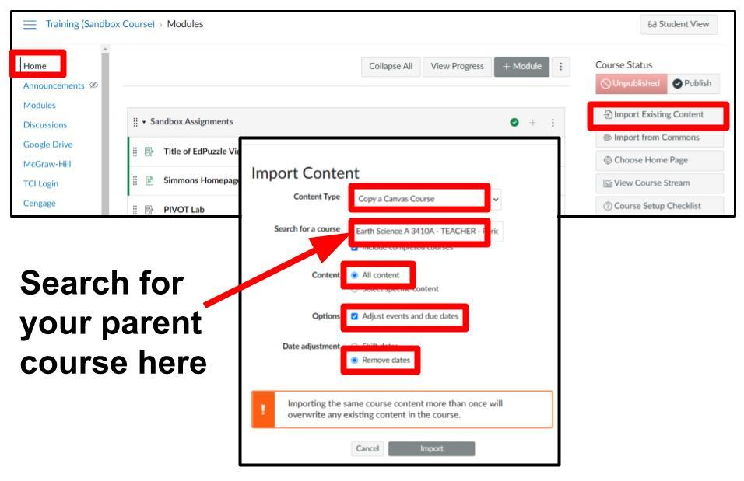

- Now that you have your parent course identified and named, go to a class period that you want to be part of that course. These will be under your Unpublished courses in your dashboard or in your course list (all courses). Find the remaining courses that have been pushed over from Infinite Campus. First semester has the letter ‘A’ in the course name, and the second semester has the letter ‘B’ in the course name.
  - Go to that course’s settings
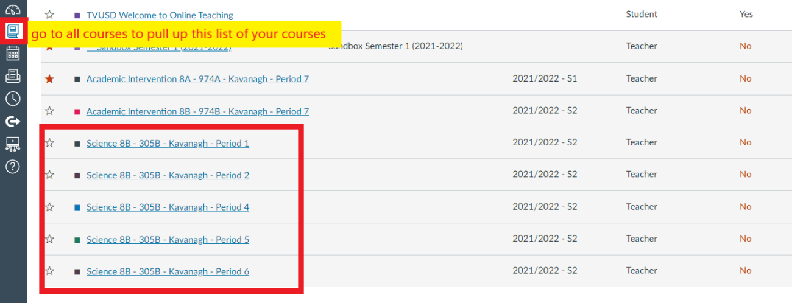
- Under the Sections tab in the course settings, click on the blue link for that course section. This will open a list of the enrolled students for this section (period).
  - To the far right, click on “Cross-List this Section”
  - Type in the name of the parent course you named in step 1. Once it pops up, click on the blue button that says, “Cross-List this Section.”
  - Your students have now been moved to the parent course (the one in which you will teach from).
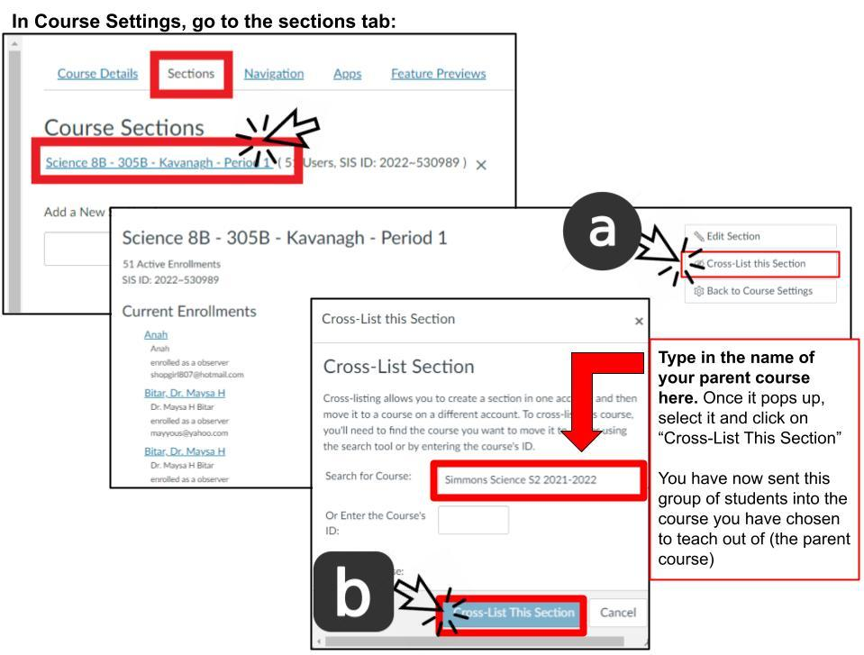

- Repeat steps 2 & 3 for all your alike sections. You will notice that when you cross-list, that section will no longer show up on your course list or on your dashboard as it has been “merged” (more or less) into your parent course. Don’t worry, it still exists, it’s just no longer a separate course
- That’s it! Be aware that if you don’t specify a date and restrict students from access, then that course will be visible to enrolled students once you publish. You can modify these under the course settings: