Video Tutorial
- In your Canvas course go to Settings and Navigation.
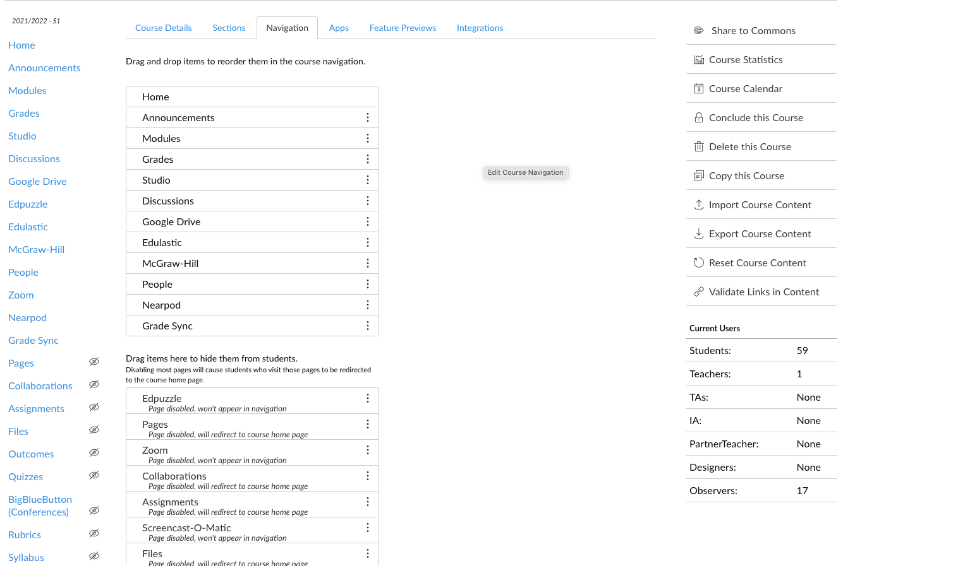

- Any items you want students to see you will drag to the top portion of the navigation. They will appear in the order you see. Things you absolutely want to include: Modules, Announcements, McGraw-Hill (or TCI), People (when using groups), Edulastic and Grade Sync (Students will not see Grade Sync, but you will want access to it. The goal is to only have navigation for the items students will use on a regular basis...less is more!

- Anything below “Drag items here to hide them from students” will not appear in the student navigation. You should plan on hiding Assignments and Quizzes as students will access these through the Modules, leaving them in the navigation will cause confusion for the students.

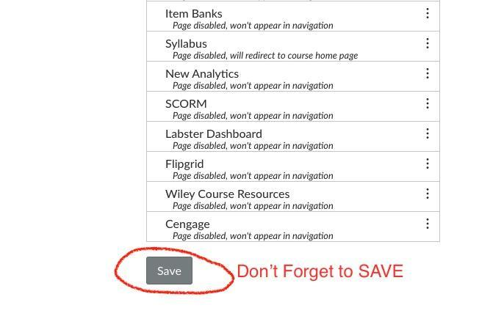
- When you have organized the Navigation don’t forget to scroll to the bottom of the page and click on the Save button.

