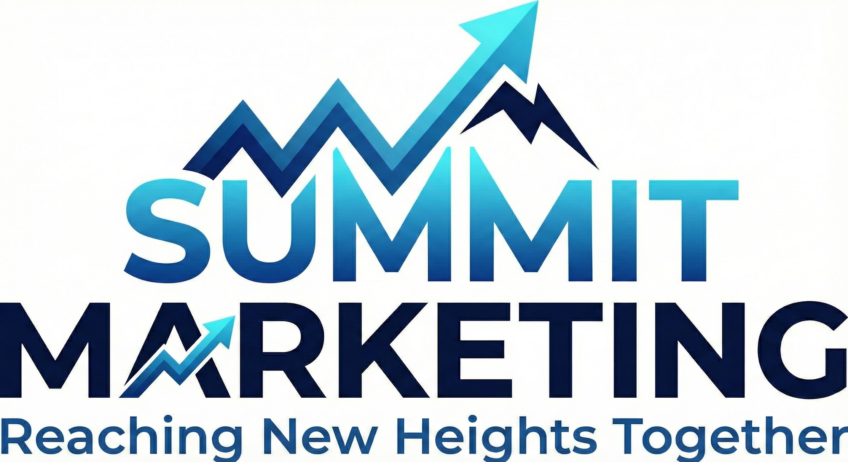

Summit Marketing Packages
Make the Climb. Own the Summit. Reach the Peak.

Strategic Growth Infrastructure for Home Service Companies
CRM Automation | Organic Visibility | AI Follow-Up | Brand Authority

Who We Are
Summit Marketing is a performance-driven growth partner for home service companies. We install revenue automation, increase organic visibility, and implement AI-powered follow-up systems that turn more leads into booked jobs. Every system is built inside GoHighLevel for full ownership and scalability.

Onboarding & Implementation
Each package includes:
• Full CRM system build- What does this CRM do?
• Automation configuration- What exactly are we automating?
• SEO structural setup- Details
• Reporting dashboard creation
• Team onboarding & training

Standard Onboarding Investment
Basecamp System: $1,500
Ascent System: $2,000
Elevation System: $3,000
Peak System: Custom Scope

BASECAMP
Lay the foundation. Stop missing leads.
Investment: $697/month (First 90 Days) | Standard Rate: $897/month
• CRM & pipeline buildout
• Missed call text-back automation
• Instant SMS lead response
• 7-day nurture sequence- Unsold estimates, Unbooked leads
• Automated review requests
• Google Business Profile optimization checklist
• Local SEO structural setup
• Monthly reporting dashboard

ELEVATE
Climb higher. Increase visibility and booking rate.
Investment: $1,297/month (First 90 Days) | Standard Rate: $1,697/month
• Everything in Basecamp
• On-page SEO optimization
• Schema markup implementation
• Keyword tracking integration
• Google Business Profile posting automation
• 30-day multi-channel nurture sequence
• AI booking assistant
• Enhanced performance reporting

ASCENT
Build authority. Dominate follow-up. Outperform competitors.
Investment: $2,297/month (First 90 Days) | Standard Rate: $2,997/month
• Everything in previous packages
• Advanced AI multi-channel conversations
• Estimate follow-up automation
• Lost lead revival campaigns
• Full lifecycle automation sequences
• Competitor visibility tracking
• GEO & AEO content structuring
• Advanced pipeline automation
• Branded CRM mobile app included
• Automated review response

PEAK
Market authority. Full automation. Maximum control.
Investment: Custom Strategy Build
• Everything in Elevation
• Custom AI strategy implementation
• Multi-location SEO structuring
• Content authority planning (pillar strategy)
• Advanced call routing & IVR system
• Full marketing dashboard buildout
• Custom reporting integrations
• Strategic content + automation roadmap
• Premium backlinks + listings

Add-Ons
• AI Booking Assistant – $297/month
• Advanced AI Conversation (Chatbot + Inbound + Outbound) – $997/month
• Branded CRM Mobile App – $797/month
• SEO Blog Automation – $297/month
• Database Reactivation Campaign – $497 per campaign
• Smart Call Routing (IVR) – $147/month
• Premium backlinks + listings - $300/month

Social Media Management (Optional)
• Light Social – $497/month (8 posts, 1 platform)
• Active Social – $897/month (12–16 posts, 3 platforms, 2 short-form videos)
• Authority Social – $1,697/month (20+ posts, 4 short-form videos, 1 long-form edit, all platforms)

Our Approach
We install systems that increase lead flow, improve close rates, build long-term authority, and eliminate operational leaks. Everything compounds over time.
Performance Guarantee: If visibility and operational efficiency do not improve within 90 days, you are not locked into a long-term agreement.

