Nic Mowll

CPSC 2310 Lab 10

1. When the driver.c file was now in a different directory than the functions.h file, I needed to change the #include “functions.h” to #include “src/functions.h” so that the driver could access the function definitions from the functions.h file.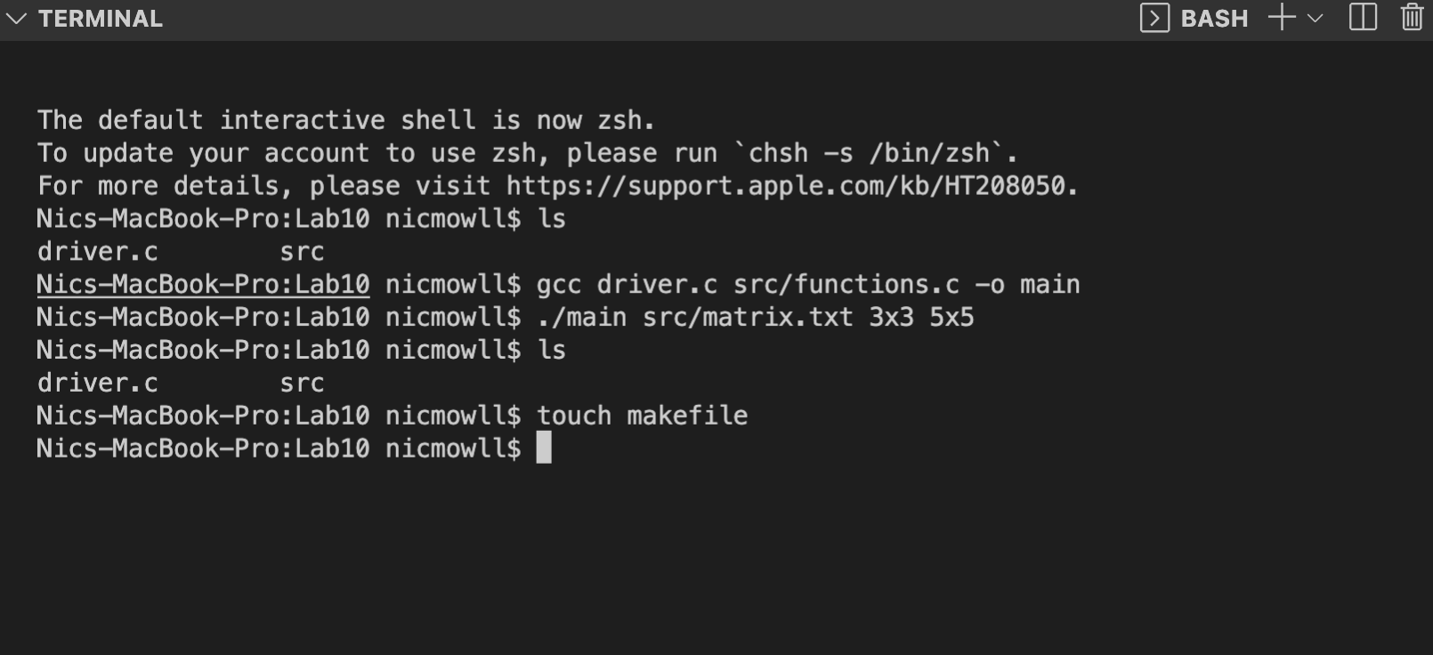

2.

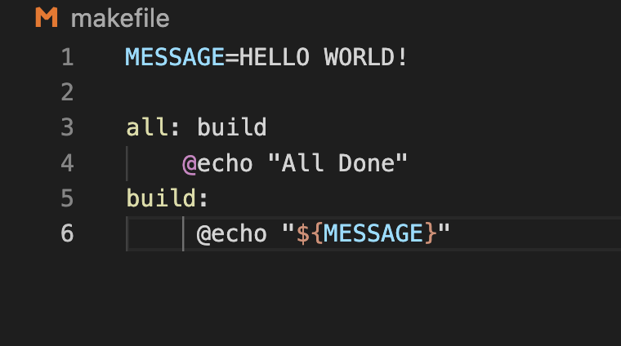

3.

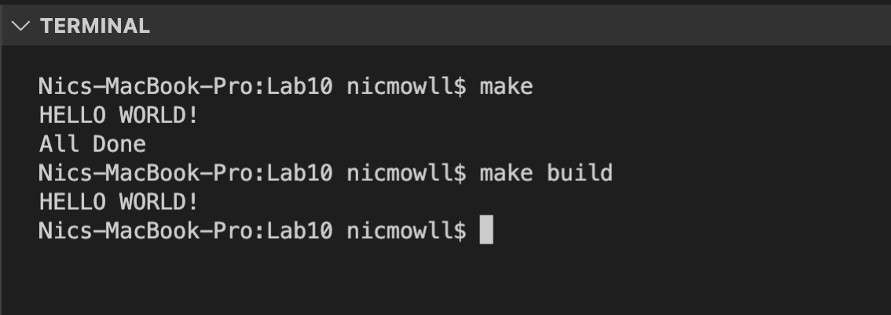

4.

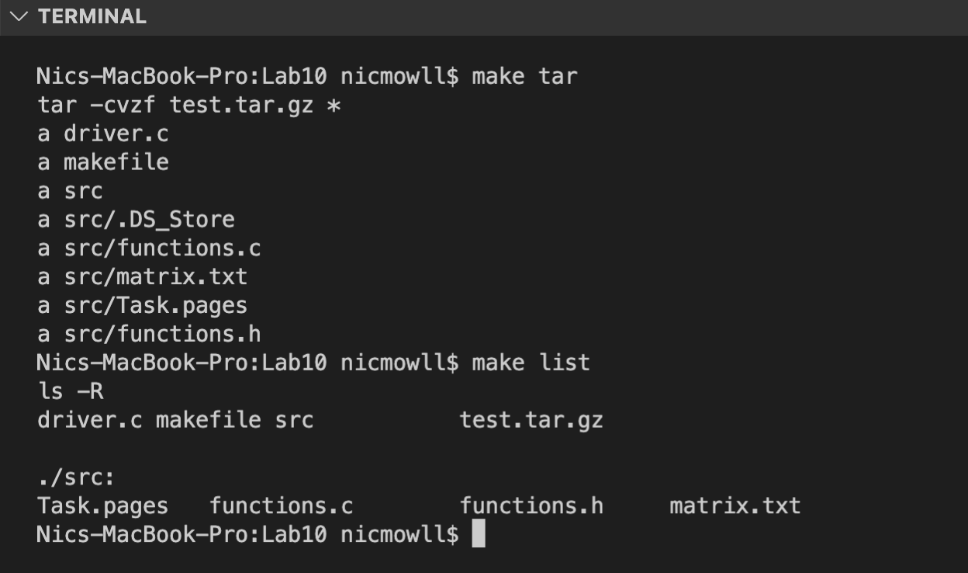

5.

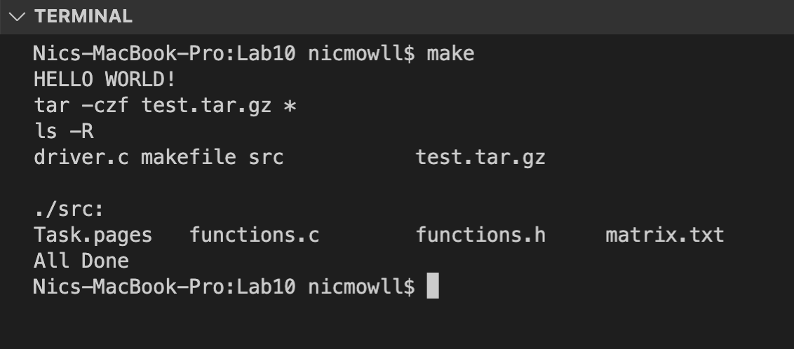

6.

7.