Brains and Machines
Lecture 1
Cognitive offloading
- Understand that people are cognitive misers and be able to distinguish between and give examples of thinking fast and thinking slow.
- Be able to define and explain cognitive offloading and distinguish and generate examples of it in action.
- Apply an understanding of divided attention and multitasking to domains such as personal safety, study, and risk assessment.

In this lecture series I want to talk about how humans interact with machines and have come to rely on them to such an extent that we have forgotten where we end and machines begin. In this first lecture I will talk about how humans are cognitive misers – lazy thinkers, and how we cognitively offload tasks to computers, yet often take credit for the outputs. In the second lecture I will talk about how our lives are becoming gamified and we are easily manipulated by all manner of virtual currencies. In the final lecture in this series, I will talk about virtual worlds we can disappear into.
Consider what it is like to drive a modern car. The gearbox is automatic, that’s nothing new, and you have cruise control – and that’s not new - but even in regular models now you can set a speed limit and then the car will look ahead and see what’s in front of you: it will choose a safe following distance based on your speed, and match the speed of the car in front of you. All you have to do is hold the steering wheel, and even then, it is checking to make sure you’re staying in the lane and it will take over and make adjustments when needed. I learned to drive a manual car many years ago. I learned how to control the clutch and manage the interaction between the engine and the wheels – I could choose a low gear in wet weather and use the engine to slow the car down without relying on brakes. That level of control is all gone. Those skills are no longer taught, and they are no longer needed – so long as the technology works. The world we are building for ourselves is catering to people who cannot or do not want to acquire the skills and understanding to be in control. The world we are building for ourselves does not trust humans and is designing them out. This car example is going to age like milk because very soon we won’t need to hold the steering wheel at all.
Daniel Kahneman, along with his equally brilliant collaborator Amos Tversky, were psychologists who ended up winning Nobel prizes, not for psychology, but for economics. Their early work focused on how humans relied on ‘heuristics’ or mental shortcuts, instead of reason and logic, when faced with questions and problems.
Consider this question: What is the likelihood you will be killed by a shark in Sydney Harbour? How are you meant to answer this question? If you’d asked me this question just a year or so ago I would have told you that the likelihood is extremely low, almost 0, because the last fatal shark attack in Sydney harbour was in 1963 and was famous because it was the last time someone died. However, in January 2026 twelve year old Nico Antic jumped off a rock in Rose Bay and was bitten badly by a shark on both legs and tragically did not survive. Around this time, in fact within a few days, there were other shark attacks around Sydney – the cluster was blamed on bull sharks attracted by the murky water caused by heavy rain, and the bait fish attracted by the food sources in that murky water. In a sense your probability of interacting with a shark probably was increased by all those factors, and it’s always good advice around Sydney to not swim at all until a few days after heavy rain because of how filthy the water is, sharks aside. However, since those tragic events, when you ask someone ‘What is the likelihood you will be killed by a shark in Sydney Harbour?’ – they’re going to bring to mind that tragic January, and they’re going to somehow use that memory to answer the question.
Kahneman and Tversky called this mode of thinking a use of the ‘availability heuristic’. We don’t use probabilities or logic or reason, we just try to think of examples – and if it is very easy to think of examples, the probability must be high, but if it is very hard to think of examples, the probability must be low. Consider this question: “Are there more words that start with the letter ‘K’ or more words that have the letter ‘K’ as the third letter?” Most people might answer more words start with K because they answer it using the availability heuristic by simply trying to think up as many words as possible, and it is easier to ‘search’ for words using the first letter. There are actually many more words with ‘k’ as the third letter.
Decades later Daniel Kahneman published a book called ‘Thinking fast and thinking slow’ where he distinguished between what he called “System 1” (fast) and “System 2” (slow) forms of thinking, and claimed that humans tend to use System 1 because it is fast, works most of the time, and we’re lazy ‘cognitive misers’.
System 1 | System 2
Fast, automatic, unconscious | Slow, deliberate, conscious
Effortless, involuntary | Effortful, requires attention
Intuitive, emotional and associative | Logical, sceptical and controlled

Consider when you’re choosing a product to buy. Do you spend a long time looking through and comparing lists of ingredients or features or looking through reviews? Or do you just choose a brand that has worked for you before? When you’re choosing a movie, do you spend any time looking through reviews and plot synopses, or just choose a movie with an actor you like? When choosing how to vote, do you consider how the party you are voting for agrees or disagrees with your many views, or do you cast your vote for the most attractive politician in the smartest suit? You might claim that in all these cases you do put as much effort into the decision as time allows, but Kahneman would argue that even when you’re trying to use System 2, System 1 processes still intervene and affect your decision in some way.
If we have a natural tendency to be lazy thinkers and take heuristic mental shortcuts, chances are technology is going to make us even lazier. Thirty years ago, every healthy sociable teenager would have memorised a dozen phone numbers or more: their parents, friends, partners etc. But then with the advent of phones with memories, and no need to remember… people stopped remembering. Nowadays most of our information is stored in the cloud, but there were several years in between when people would lose or break their mobile phones and have to send out desperate requests for everyone to let them know their numbers all over again!
The phenomenon of not encoding information with our neurons, because a machine is remembering for us, is referred to as “cognitive offloading”. It makes perfect sense why we do it: why bother remembering information that is always easily accessible nearby?
Sparrow, Liu and Wegner (2011, Experiment 2) had participants type in the answers to 40 memorable trivia statements. Half of them were led to believe their answers would be saved, the other half were told their answers would be erased. Everyone was asked to write down what they remembered and those who believed their answers would be erased remembered more. Sparrow et al. (2011, Experiment 4) also found that when participants believed their answers were saved and were given a save location (a simple folder name), they remember the location better than the information itself. Why do humans do the bare minimum and not remember information that is saved elsewhere? Possibly because memory and memorisation consume cognitive resources that could be spent elsewhere.
Storm and Stone (2015) had participants study word lists and were instructed to ‘save’ the words to be viewed again later. Unlike Sparrow et al. (2011) these participants were shown those words again. Another group of participants were not permitted to save the words (Experiment 1) and yet another group were told the saving process was unreliable (and they were shown evidence of this, Experiment 2). Storm and Stone were not focused on how well participants recalled these words (they obviously remembered the words they were able to see again better). However all participants had to learn a second word list after saving or not saving or unreliably saving the first list. Storm and Stone found that participants who believed the first word list had been reliably saved remembered the words in the second list better than those in the ‘not saved’ or ‘unreliably saved’ conditions. They called this ‘saving-enhanced memory’. The cognitive offloading of participants not bothering to remember words they thought were saved, freed up their memory resources to remember new information.
So cognitive offloading can be a good thing – why bother remembering phone numbers when they are in your phone when you can use your mind for something else? Isaacson (2007, cited by Storm and Stone, 2015) tells a story of how Einstein did not remember something as fundamental to physics as the speed of sound, and responded that he did not “carry such information in my mind since it is readily available in books”.
Problems arise though when the objective is to actually remember the information. Imagine you’re a student, at a university, and the final assessment is a closed book ‘secure’ exam. All the learning literature in psychology shows that the more effort you put into learning, the better you will retain the information, so cognitively offloading to recordings, slide-packs and transcripts will hurt your memory and learning.
Worse, sometimes when you cognitive offload memories and tasks, you come to believe that you can still remember those things and do those things. Your understanding and judgement of your own abilities and memories is referred to as ‘metacognition’. Someone with poor metacognition will inaccurately believe they can do things and remember things themselves, when they can’t.
The best example of this is the Dunning-Kruger effect (Kruger & Dunning, 1999), where people with very low skill in a domain actually overestimate their ability – their metacognition is inaccurate because they have very little understanding of what they are doing, so they are not capable of evaluating their true performance. Poor metacognition when cognitively offloading is a little different. When relying on machines, perhaps we don’t fully grasp just how much the machine is doing for us?
Consider e-bikes. There are a lot of illegal ones in Sydney right now, but to be legal an e-bike requires you to pedal, so it feels as if you are riding a regular bike, just with a bit of help. Your muscles are offloading their effort onto the engine. The direct cost of that offloading is your muscles are doing less work and may become significantly weaker (if you have just shifted from a regular pushbike), but the metacognitive cost might be that you come to believe you are a stronger, faster cyclist – not realising the engine is doing most of the work.
Apply that analogy to modern tools like Google and AI. If you use this technology regularly to help you find and read material, not only might you be learning less, and losing skills you should be practicing (like reading and research) you might also start deluding yourself metacognitively into thinking you are more capable than you really are.
Gerlich (2025) asked 666 participants to self-report their AI use and rate their own critical thinking skills (refer to the table below).
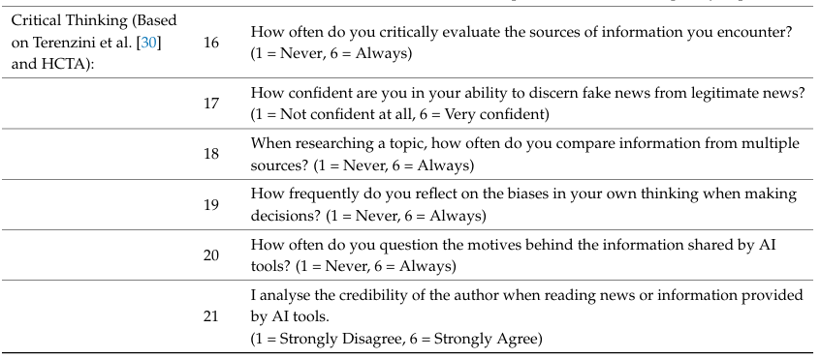
Surprisingly those who used AI a lot rated their critical thinkings skills lower than those who did not use AI much. Look carefully at the ‘critical thinking’ questions though: many relate directly to AI use and tap into the willingness of participants to avoid looking into sources, questioning them and comparing them – it is not a convincing measure of critical thinking. A better study would directly assess critical thinking with a test, not a self-report. Importantly also, unlike the older controlled studies of Sparrow et al. (2011) and Storm and Stone (2015), the participants Gerlich (2025) questioned were not forced to offload but were simply asked if they do it. It may be that people with lower confidence in their abilities, or just lower abilities in the first place, are more likely to seek help from AI. If that is true AI is not causing a lack of critical thinking, it is something relied on by people who have no skill in it. Perhaps we should train people in critical thinking before we let them use AI? Because the way AI works is mysterious – a ‘black box’ that somehow answers our questions – simply using it does not teach you how to think.
Risko and Dunn (2015) allowed their participants to choose whether or not to write down to be remembered items. Surprisingly even when they were asked to remember only two items, many still chose to write them down. Risko and Dunn asked participants why they were doing this, and the ones that did reported lower confidence in ‘internal’ (brain) memory than ‘external’ (writing down) memory. People might cognitively offload, not because of efficiency, or even a lack of skill, but simply a lack of confidence.
All these studies seem to show that by helping us, technology is also confusing us in terms of our own abilities. Metacognition, our own awareness of our own thought processes, will always be limited. Our ego and our need to think the best of ourselves might be behind a lot of overconfidence, but the way our mind works is probably the main reason why the extent to which we cognitively offload goes unnoticed. When psychology was first studied at the end of the 1800’s one method widely used was “introspection” – where researchers were trained to think about their own thoughts. Introspection is not an objective method at all. It failed to give insights into how our minds actually work mainly because we are simply not conscious or able to be conscious of everything that happens in our minds. This is why modern experimental psychology prioritises objective measures over self-report.
Logan and Crump’s (2009) research on typing illustrates the issue of metacognitive limits well. Logan and Crump found that skilled typists’ performance was disrupted when they were asked to pay attention to what their hands were doing. They suggested this is because the control system of the mind is constructed with an ‘inner loop’ which directly controls the hands, but is not available to consciousness, and an ‘outer loop’ which plans sentences and words which we are consciously aware of. While the inner loop can interpret the information coming from the outer loop in terms of which letters need to be typed, the outer loop is never consciously aware of how the hands and fingers turn this into button presses. You can work it out slowly of course, but the process of working it out is very disruptive. Next time you’re performing any complex skill try shifting your attention to exactly what your hands and feet are doing… and it won’t help your performance.
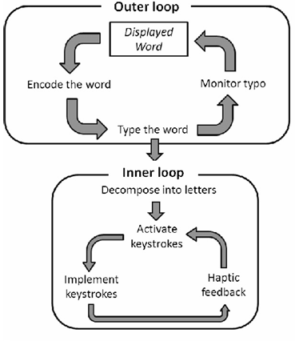
If we are unaware of the full extent of our skills, and we are also using machines and computers as part of our tasks, then we are not the best judges of just how dependent we are. Students will be graduating soon having used AI throughout their entire degrees without reading a single primary source, or ever learning how to integrate or critically evaluate information. They could be the air traffic controller in charge of your flight, or the anaesthetist measuring out the precise doses to put you to sleep – they obviously think they know exactly what they are doing, but do they really?
Every day drivers are choosing to use phones while driving, because they believe they can pay full attention. They are on the same roads as you. It is not hard to see some pedestrians think the same way – they walk along busy footpaths staring down at their phones, occasionally looking up, and while a minority might simply be rude, many have convinced themselves that they are fully aware of everything around them and they are not causing any problems. They cannot of course see all the annoyed people around them because, whatever they tell themselves, they are not paying full attention.
Ophir, Nass and Wagner (2009) studied ‘media-multitaskers’, people who self-reported that they frequently used more than one device at the same time, e.g. using their phones while watching television or a tablet, or gaming as well. While they didn’t ask these participants for a rating of their own sense of control, you can imagine the kind of person who frequently combines the use of many technologies feels confident and capable of doing so – they have stronger control of their actions to do so many things at once. Ophir et al. (2009) ran their participants through a battery of cognitive tests related to control (e.g. task switching, response inhibition) and found that heavy ‘media-multitaskers’ were significantly worse at filtering out irrelevant stimuli, less capable of ignoring irrelevant representations in memory and far worse at suppressing irrelevant task sets. Whatever people surrounded by phones and screens tell themselves, they are using all those devices because they cannot help themselves, because they have a distinct lack of control over their attention.
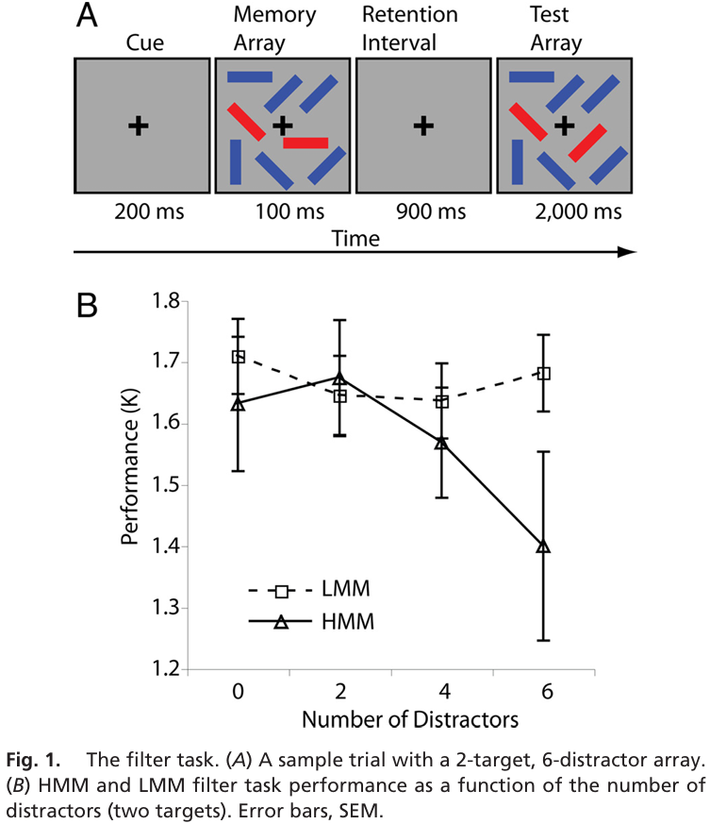
In the figure above HMM = Heavy media multitaskers.
The problem for the rest of us – trying to live in a world of rude zombie pedestrians and dangerous distracted drivers – is that these people have little awareness of just how little they are aware of.
Kirschner and De Bruycke (2017) considered homo zappiens – young people who are ‘digital natives’, who have never known a world without computers, and because of this are extraordinarily technically proficient and remarkable multitaskers. Reviewing years of research, they concluded this species does not exist. There is no need for teachers to alter their practices or to even be mildly intimidated by younger computer savvy people. No one has any special skills. That more of us are surrounded by technology just causes more distractions. While modern apps are incredibly sophisticated, most users do not go beyond the basic functionality. At university (from a teacher’s perspective) it is just as difficult to teach students how to use databases and software as it was decades ago - humans have not changed at all in what they can do, only perhaps in what they think they can do.
My advice to conclude this first lecture is : use technology to help you but always be aware of what it is doing. Use an e-Bike occasionally to get somewhere quickly without sweating. Use a regular bicycle most of the time to get fit and stay fit. Use AI occasionally to help you understand a particularly difficult paper or reword a tricky paragraph. Most of the time read papers yourself and write paragraphs yourself, to acquire and maintain academic skills.

References
Kruger, J., & Dunning, D. (1999). Unskilled and Unaware of It: How Difficulties in Recognizing One’s Own Incompetence Lead to Inflated Self-Assessments. Journal of Personality and Social Psychology, 77(6), 1121–1134. https://doi.org/10.1037/0022-3514.77.6.1121
Gerlich, M. (2025). AI Tools in Society: Impacts on Cognitive Offloading and the Future of Critical Thinking. Societies (Basel, Switzerland), 15(1), 6. https://doi.org/10.3390/soc15010006
Logan, G. D., & Crump, M. J. C. (2009). The Left Hand Doesn’t Know What the Right Hand Is Doing: The Disruptive Effects of Attention to the Hands in Skilled Typewriting. Psychological Science, 20(10), 1296–1300. https://doi.org/10.1111/j.1467-9280.2009.02442.x
Risko, E. F., & Dunn, T. L. (2015). Storing information in-the-world: Metacognition and cognitive offloading in a short-term memory task. Consciousness and Cognition, 36, 61–74. https://doi.org/10.1016/j.concog.2015.05.014
Sparrow, B., Liu, J., & Wegner, D. M. (2011). Google Effects on Memory: Cognitive Consequences of Having Information at Our Fingertips. Science (American Association for the Advancement of Science), 333(6043), 776–778. https://doi.org/10.1126/science.1207745
Storm, B. C., & Stone, S. M. (2015). Saving-Enhanced Memory: The Benefits of Saving on the Learning and Remembering of New Information. Psychological Science, 26(2), 182–188. https://doi.org/10.1177/0956797614559285

Amos Tversky died before his prize could be awarded.

