Brains and Machines
Lecture 3
False worlds
Learning outcomes:
- Understand the ways in which VR and digital immersive worlds can assist people overcome phobias and distract them from painful procedures.
- Know about the diverse ways avatars are used in digital worlds and what the ‘proteus effect’ is.
- Be able to describe the difference between immersion, escapism and escape/avoidance using the concepts of compensation and dissociation.
In this final lecture in the series on brains and machines, I want to talk about the relationships we can have with alternate realities created by computers. We have come a long way since Space Invaders such that computers can now simulate convincing alternate worlds. With high-definition displays and VR headsets there can be a sense of being present somewhere else. The question is: is this helpful, or harmful?
If someone is afraid of spiders, or heights, or social situations, having an entirely safe simulated virtual world could become integral to psychotherapy.
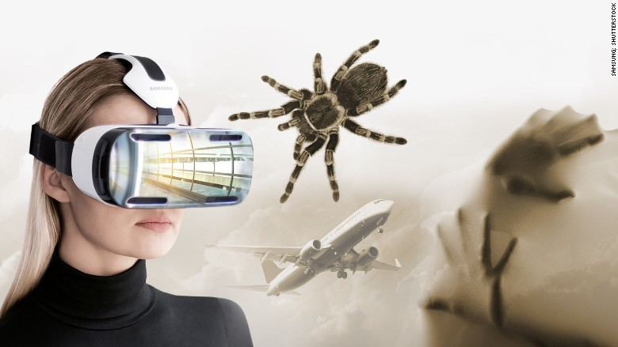


Ferreira et al. (2025) reviewed many studies where augmented reality (AR), extended reality (XR) or virtual reality (VR) was used during treatment for a wide range of phobias. They describe eight studies which looked at treatments for arachnophobia (fear of spiders). In each study participants were exposed to compelling depictions of spiders close to them and even on them, often using exposure to real spiders as the control and finding equivalent improvements. Across all studies reviewed (all the phobias), 58% of the participants experienced significant reductions in phobia symptoms, 37% no great change, 4% no change at all and 0.3% got worse. None of the studies looked at long term efficacy of the treatments and there is a technological burden on the therapist to set up the equipment and software.
Immersing a person in an alternate world need not have such specific aims though. Hoffman et al. (2011) used a virtual ‘SnowWorld’ as a distraction. SnowWorld was full of snowmen, igloos, penguins and woolly mammoths and you could throw snowballs around at everything which would react. With a VR headset people were completely immersed, but why was all this developed? It was made as a distraction for patients undergoing painful treatments for burns.
Hoffman et al. (2011) explain:
“The logic for how VR works is as follows. Pain requires attention. Humans have limited attentional capacity. Interacting with virtual reality uses a substantial amount of the patient’s limited controlled attentional resources. For example, VR has been found to reduce performance on a divided attention task. Consequently, when in VR, the patient has less attention available to process incoming signals from pain receptors. As a result, patients report less pain while in VR, they spend less time thinking about their pain during VR, and often report having more fun during wound care while in VR compared with wound care with no VR.”

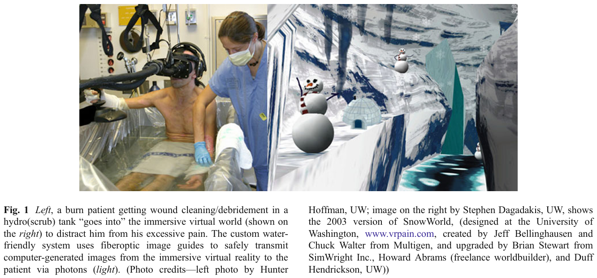
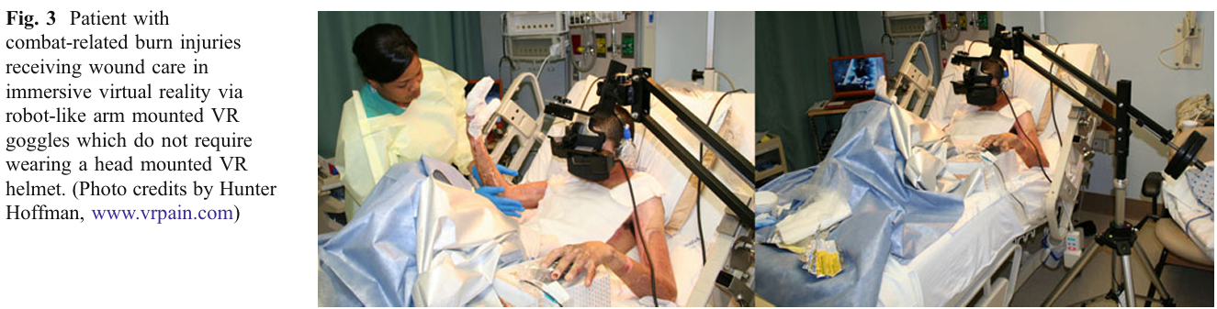
They found patients reported less pain while distracted, but they were also able to measure brain correlates of pain to confirm just how effective it was. Interestingly:
“The more-immersive VR group who interacted with the virtual world via a trackball showed significantly more pain reduction than the less-immersive VR group who received non-interactive VR with no track ball.” (pp.186) It could be that interactivity leads to more immersion, or simply that the snowball throwing took more attentional capacity?
Kosa and Johnson-Glenberg (2023) examined the use of VR for stress reduction and mood management and made an interesting distinction in the nature of the game being experienced.
Hedonic game experiences lead to moment to moment pleasure, comfort, satisfaction and enjoyment.
Eudaimonic games experiences arise from connectedness, authenticity, self-realisation, growth and meaning.
While they did construct a controlled study, they only had a single game for each condition. ‘Tetris Effect’ was their hedonic game, and ‘Luna’ was their eudaimonic game. They also contrasted flat screen gaming on a desk, VR and just watching a video of the game (non-interactive). You can see their results for stress relief in the table below: immersion (VR) helped, with an additional benefit of eudaimonic over hedonic.
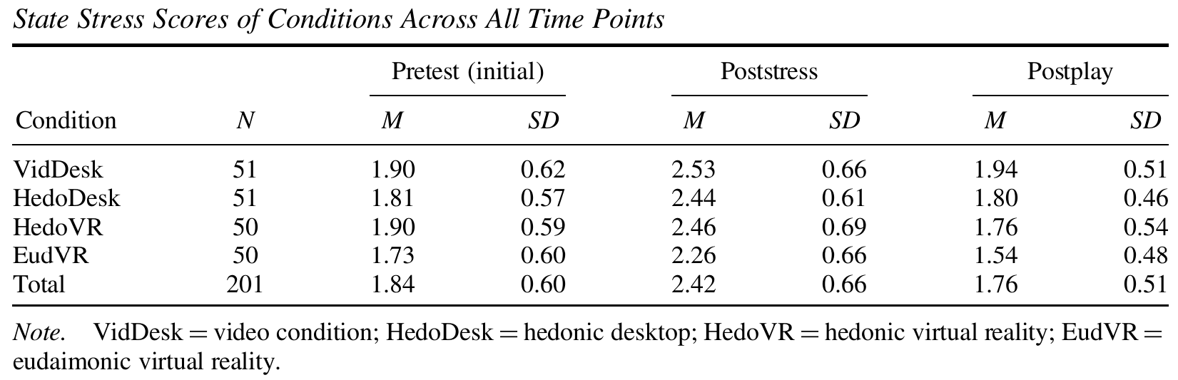
The choice of just a single game was problematic. Tetris effect in VR is a very pretty game but you use a controller and are essentially looking at a flat tetris field within the VR space. Luna however involves hand gestures in a 3D world. Also Tetris Effect – despite the calming music and environmental flourishes, is a frantic puzzle game, not one you would expect to relieve stress, so it’s hard to make the case that the ‘eudaimonia’ was the key factor here. It is still a good idea that connectedness and growth and meaning might be more valuable in an immersive experience, but perhaps not tested clearly in this case.
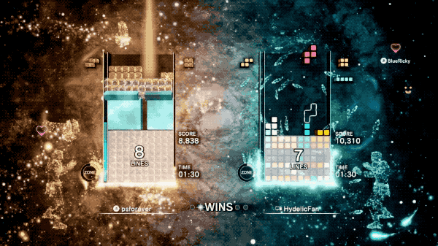

Maksatbekova and Argan (2025) recruited participants from a “Pokémon VR Station game center” (possibly in Turkiye as that’s where the authors were) for their study. I’m leading with that detail because while they tried to control for the VR experience of their participants by making them all play one game (Beat Sabre), the interview responses relate to almost everything except that game!
While Beat Sabre is the greatest VR game of all time, it is a solitary game requiring you slash boxes in time to music.

So even though they only asked them to play beat sabre, the responses of participants covered a wide variety of benefits.
“It distracts me from pain and encourages me to move more” (Participant 8, 29 years old, male).
“Using VR, I’ve become more open and sociable in real life. It is like the confidence I build in VR carries over” (Participant 29, 22 years old, male)
“Because of VR, I am better at managing social interactions. I used to overthink every conversation, but now I am more relaxed and natural” (Participant 5, 27 years old, male).
“Playing VR games where I had to cooperate with others made me more confident in group projects and presentations” (Participant 22, 25 years old, female).
“In VR, I can be anyone I want to be, and it helps me understand myself better,” noted Participant 1 (23 years old, female).
With the exception of the first response, the participants seem to be saying things relevant to social anxiety. It all sounds very helpful, although it’s not clear which experiences led to these outcomes.
A critical feature of many games which try to be immersive is the ability to create ‘avatars’ to represent who a person is. Depending on the game, you can name your avatar, choose its gender, appearance, clothing and skills. Avatar creators have become so sophisticated gamers can take a long time deciding on who ‘they’ want to be in the game. This is even more important in multiplayer games as the avatar will be how ‘you’ are seen by others in the game.
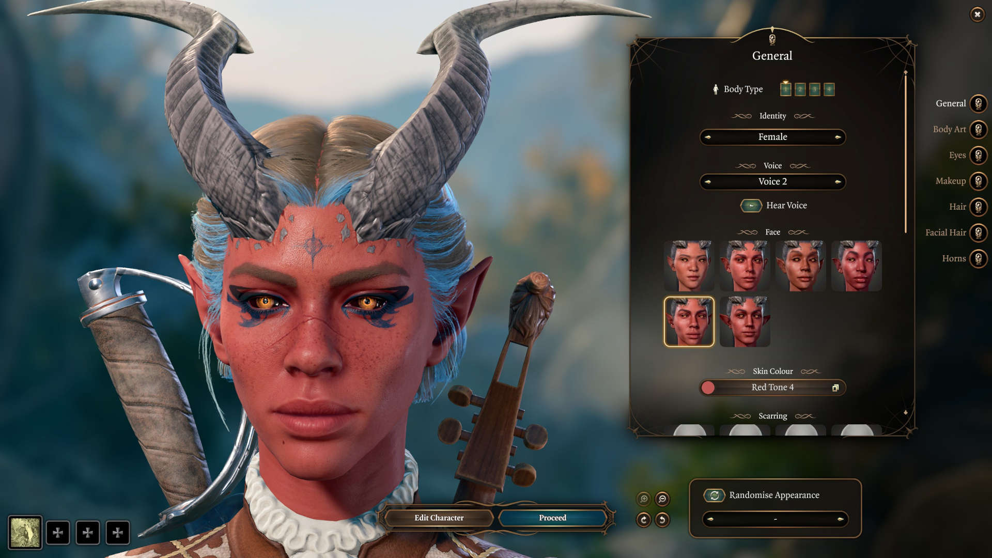
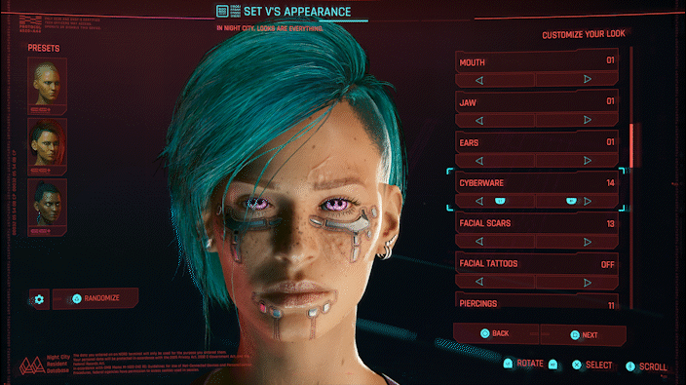

You might assume that this creation process is just a question of decoration and variety – usually I just randomize features or choose a pre-made one – but for many gamers the process is critical to ‘integrating’ themselves into the game. The “proteus effect” has been widely studied (see Ratan et al., 2020, for a review), and it is a phenomenon where people begin to think, feel and behave in ways to match the characteristics of their digital avatar, and not just in the game itself, but beyond the game! The kinds of dimension that it applies is staggering: negotiation aggressiveness, dating partner choices, antisocial behaviour, food choice, physical exercise, racial bias, body dissatisfaction, financial risk-taking, consumer choices, mathematics performance, student engagement, and creative thinking.
Here’s a quote from the mathematics study’s abstract:
Female and male participants (N=120) were randomly assigned either a female avatar or a male avatar through a process masked as a random drawing. They were then placed in a numerical minority status with respect to virtual gender—as the only virtual female (male) in a computer-mediated triad with two opposite-gendered avatars—and performed a mental arithmetic task either competitively or cooperatively. The data revealed that participants who were arbitrarily represented by a male avatar and competed against two ostensible female avatars showed strongest performance compared to others on the arithmetic task. This pattern occurred regardless of participants' actual gender, pointing to a virtual stereotype lift effect.
(Li, Nass & Bailenson, 2013; “Does the mask govern the mind?”)

Given how easy it is to select a gender and build your own body within many games now, the effect this might have on gender diverse and transgender adolescents has also been studied. McKenna et al. (2024) interviewed many gamers in various categories and found an equally diverse way in avatars were being used.
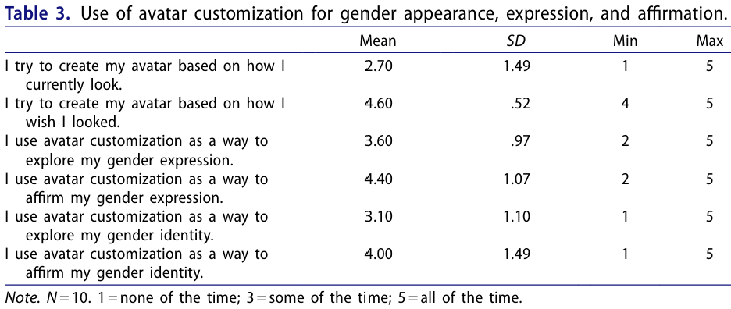
Here are some of the interviewee’s responses:
“Creating avatars definitely helped with socially transitioning in that it helped me understand who I am and how I want to be referred to. Creating avatars essentially helped me test the waters of coming out to people online and see how they respond before doing it IRL [in real life]. (18-year-old, nonbinary individual)”
“[A]vatars were a tool in which I was able to explore my identity, without having to consciously think about it. It’s less of a “Oh well let’s customize an avatar to fit my gender” and more so it’s a way to kind of nonchalantly put myself into a different world and see how that would feel. (17-year-old, transmasculine individual)”
“I just like playing video games with like guy avatars and that’s what made me like realize I was trans. And I picked my name the first time when I played Persona 5. I named that character [affirmed name] and that’s how I found out that that’s the name I wanted. (15-year-old, binary transman)”
“Sometimes I worry if I’m really trans even though I know I am. And then, when I create a male avatar, it’s just an instant reminder and it’s like “No, that’s how I really feel”. So, I’d say avatars help me be more sure of myself and who I am. (15-year-old, binary transman)”
“[T]he ability to pick a name for a character in a game is the best thing in the world. You can’t be deadnamed in a video game. Other characters will always get your name right. And that really carries a lot of weight. (18-year-old, nonbinary)”
“I think [avatars] were more so helpful in terms of like my parents and family’s journey then [sic] for mine. […] Like for my parents it was sorta like “oh, yeah, well he’s always used boy avatars” so it was easier for them to mentally trail it backwards and be like “oh, this makes sense”. It was probably helpful for them to feel more comfortable with me starting testosterone. (18-year-old, transgender male).”
Clearly the alternate worlds are providing support in many different ways. Everything I have mentioned so far has ranged from positive to overwhelmingly positive: the ability to transport yourself into an alternate world can have remarkable effects on your health and mental health. I do have to swing around though and consider the potential negatives.
It’s a rainy day and way too windy so I cannot go kayaking. So I pull out my VR headset and ‘go kayaking’ in my house. Is there anything wrong with that? I’m going to hopefully show that it is not the alternate world or the technology that is bad, but how it is approached and used. When I’m sitting in a real kayak on the water, it is most definitely an ‘escape’ from the usual day to day existence. I’m in a different place. Different rules apply: I need to be wary of the wind and waves, other boats, my level of tiredness and distance to my port. These concerns distance me from the usual worries of the world. Yet at the same time I am connected. I can literally see the shore and the ‘real’ world in the distance. That is very different to the VR headset. If I spent enough time ‘kayaking’ in VR with the headset on, the sun might set and I wouldn’t even know. Every sense is covered, so not only is time perception affected but I am completely disconnected.
Marques et al. (2023) reviewed the link between virtual gaming and mental health and in contrast to everything I have discussed so far, the links were overwhelmingly negative. Many of the studies they reviewed measured a construct called “Escapist motivation” (EM). This construct, adapted for gaming by Przybylski et al. (2009), is defined as a motivation to avoid negative affect or an undesirable self-state through self-engagement in media.
Marques et al. (2023) found: “(i) Escapist motivation (EM) is one of the main motives for playing virtual games; (ii) EM is related to negative clinical traits; (iii) EM predicts negative psychological/ emotional/mental health outcomes; (iv) EM is associated with impaired/negative perception of the real-world life; (v) EM predicts non-adaptive real social life; and (vi) EM is associated with dysfunctional gaming practices in some cases.” (from Abstract)
It sounds awful doesn’t it, as if gaming in virtual worlds is causing lots of problems? These are just associations though. It seems likely that people with severe emotional issues seek out gaming for relief.
Marques et al. write: “Individuals who feel the need to escape often turn to gaming as an option, and while this is evident, it is equally important to delve into the impact that escapism has on gaming practice characteristics. In place of regular gaming, individuals with a strong inclination for escapism are at a higher risk of developing addictive gaming habits.” (p.13)
The disorder most closely linked to escapist motivation is Internet Gaming Disorder (IGD). You can imagine a person in distress seeks out gaming for temporary relief, only to find themselves drawn into worlds (and possibly gambling loops as discussed in the last lecture) which further disconnect them from reality, exacerbating their problems. Internet Gaming Disorder was added to the Diagnostic and Statistical Manual of Mental Disorders, 5th Edition in 2013 with these criteria:
- Preoccupation
- Withdrawal
- Tolerance
- Loss of control
- Loss of interest in other activities
- Continued use despite problems
- Deception
- Escape (gaming to relieve negative mood)
- Functional impairment
Diagnosis threshold: ≥ 5 of 9 criteria for 12 months.
While DSM considers it a ‘condition for further study’, the World Health Organisation in 2018 formally noted “Gaming Disorder” with these features:
- Impaired control over gaming
- Priority given to gaming over other activities
- Continuation despite negative consequences
Duration: ≥ 12 months Severity: Must cause significant functional impairment

It is a lot of shuffling around of terminology and symptoms, and there remains controversy over where the line is between healthy gaming and pathological gaming.
While I wouldn’t recommend Giardina et al.’s (2024) paper for casual reading (full reference below if you want to have a go), it comprehensively examines constructs like escapism and proposes a helpful solution. They differentiate between four ways in which a person might approach a virtual world.

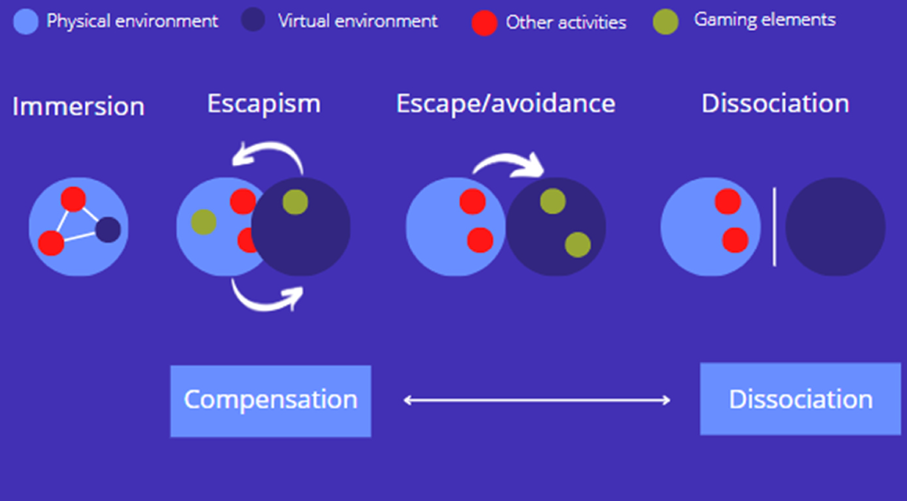
(Figure 1 from Giardina et al., 2024, p.7)
Immersion is a concept Giardina et al. argue is too often equated with harmful escapism. In the diagram above you can that the virtual environment is part of the physical environment and is completely linked to other activities. Imagine playing on your mobile for a few minutes each morning as you commute on the train. You will definitely be immersed in the game if its good enough, but it is just a part of the world you inhabit and you are still aware of.
Escapism is when the overlap between the virtual and real environments increases, and gaming elements intrude into the ‘real’ world. This happens through what Giardina et al. refer to as compensation. Elements of the game are used to make up for shortcomings in reality. We saw this with the proteus effect: you build the avatar of the person you actually want to be, and elements of that creation bleed back into your real world behaviour, compensating for what you need. Escapism when it is compensatory like this is not necessarily harmful and may be quite helpful. Consider any hobby, for example recreational sport for kids, where there is no practical way in which kicking a ball around assists with school work, but the confidence and self-efficacy the child builds up from the completely different activity does transfer back and makes it all worthwhile.
Escape/avoidance is where things do become harmful. According to Giardina et al. this is about moving completely into a separate virtual environment and leaving behind the challenges of the real world. No longer is the game compensating and supporting the real world person, it is replacing it. This might be understandable for short amounts of time when faced with extreme stress or grief, but the immersion and avoidance could be catastrophic in the medium to long term – look back at some of the clinical diagnosis boxes this would tick: Loss of control, Loss of interest in other activities, Continued use despite problems, Escape (gaming to relieve negative mood), Priority given to gaming over other activities.
Dissociation is more extreme that escapism where you become so cutoff from the real world that you begin to stop looking after yourself.
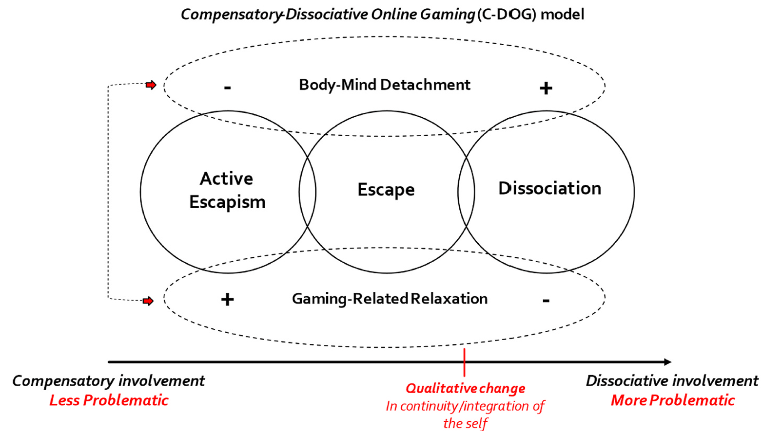
(Figure 2 from Giardina et al., 2024, p.7)
“Hikikomori” comes from the Japanese words “hiku”, to pull back, and “komoru”, to shut oneself in. It is a term which comes up a lot in discussion of gaming disorders even though it is not a formal diagnosis. People associated with this description stay at home permanently, avoid social situations so they cannot attend school of go to work, and otherwise do not participate in normal daily life.
Artan et al. (2026, citing Eckardt, 2023) write: “the prevalence of hikikomori has been reported to range from 0.87% to 1.2% in Japan; 6.6% in China; 1.9% in Hong Kong; 2.3% in South Korea; 20.9% in Singapore; 9.5% in Nigeria; 2.7% in the United States; and 9% in Taiwan”. These estimates seem quite high, and I wonder how reliable data on people who are essentially hiding could be.
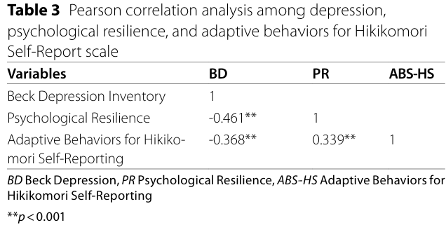
Artan et al. (2026) found significant negative correlations between adaptive behaviours (e.g. valuing social connections) and psychological resilience and depression. People who are depressed are most vulnerable to falling into dissociative lives, gaming and virtual worlds are just one of the options.
You might think it doesn’t get darker than this, but I’ll have a go. If you’re not a gamer, or are uninterested in fully immersive games with avatars and complex worlds, you might snort at all this and think it is silly of people to have such hobbies. Yet consider what social media has done to the world: technology panders to the egos and preferences of the consumer. You get the news delivered to you with your own biases built in, you only see what appeals to you, and algorithms draw you in to never ending doom scrolling sessions. While it might not be so obvious – there are no dragons or magical swords – you very much are living in an alternate false world, and because there is no connection with the real world as you walk around scrolling through only things you agree with, it is a kind of dissociation which is even more harmful because you believe you are in the real world and fully connected, when you simply aren’t.
I did begin this lecture as positively as I could knowing the dark conclusion, but examining this continuum of healthy to unhealthy behaviours allows me to succinctly sum up the lecture series. To have a healthy relationship with machines, you need to always know where the machine ends, and you begin. When you’re on an e-Bike or in a car, or using AI to write an assignment, remind yourself constantly what you are doing, and what the machine is doing so that cognitive offloading does not lead to a distortion of your understanding. When you’re spending virtual currencies or time, playing or gambling, set limits and constantly remind yourself how much money and time you are spending. Finally, when you are exploring virtual worlds, know what time it is, how much time you have spent, and don’t forget who you really are.

References
Artan, T., Çakin, E., Dinçer, R., & Özkan, A. O. (2026). Hikikomori among young adults: examining the protective function of psychological resilience. BMC Psychology, 14(1), Article 381. https://doi.org/10.1186/s40359-026-04165-6
Coelho, F., & Abreu, A. M. (2026). Mental healing through immersive play: An umbrella review. Virtual Reality : The Journal of the Virtual Reality Society, 30(2), 114. https://doi.org/10.1007/s10055-026-01352-z
Ferreira, T., Batista, T., Lopes, T., Malheiro, P., Vitorino, J., Vaz, R., & de Sousa, J. (2025). Extended Reality and Phobia Treatments: A Systematic Literature Review. Procedia Computer Science, 256, 1064–1072. https://doi.org/10.1016/j.procs.2025.02.213
García-Ortiz, C., Lorenzo-González, M., Fernández-Sánchez, J., Solano-Lizcano, V., Del Coso, J., & Collado-Mateo, D. (2025). Recommendations for Physical Exercise as a Strategy to Reduce Problematic Use of the Internet and Digital Devices: A Perspective. International Journal of Environmental Research and Public Health, 22(5), 753. https://doi.org/10.3390/ijerph22050753
Giardina, A., Schimmenti, A., Starcevic, V., King, D. L., Di Blasi, M., & Billieux, J. (2024). Problematic gaming, social withdrawal, and Escapism: The Compensatory-Dissociative Online Gaming (C-DOG) model. Computers in Human Behavior, 155, Article 108187. https://doi.org/10.1016/j.chb.2024.108187
Gao, W., Li, Z., & Li, M. (2026). Joint physical activity and screen time patterns in relation to mental health and sleep among university students: A systematic review with exploratory quantitative synthesis. Journal of Affective Disorders, 408, Article 121890. https://doi.org/10.1016/j.jad.2026.121890
Hoffman, H. G., Chambers, G. T., Meyer, W. J., Arceneaux, L. L., Russell, W. J., Seibel, E. J., Richards, T. L., Sharar, S. R., & Patterson, D. R. (2011). Virtual Reality as an Adjunctive Non-pharmacologic Analgesic for Acute Burn Pain During Medical Procedures. Annals of Behavioral Medicine, 41(2), 183–191. https://doi.org/10.1007/s12160-010-9248-7
Kosa, M., & Johnson-Glenberg, M. C. (2024). The Additive Effects of Interactivity, Immersion, and Eudaimonia for Stress Reduction and Mood Management: A Randomized Controlled Study on Games and Virtual Reality. Psychology of Popular Media, 13(4), 696–708. https://doi.org/10.1037/ppm0000512
Marques, L. M., Uchida, P. M., Aguiar, F. O., Kadri, G., Santos, R. I. M., & Barbosa, S. P. (2023). Escaping through virtual gaming—what is the association with emotional, social, and mental health? A systematic review. Frontiers in Psychiatry, 14, 1257685. https://doi.org/10.3389/fpsyt.2023.1257685
Maksatbekova, A., & Argan, M. (2025). Virtual reality’s dual edge: navigating mental health benefits and addiction risks across timeframes. Current Psychology (New Brunswick, N.J.), 44(7), 6469–6480. https://doi.org/10.1007/s12144-025-07623-3
McKenna, J. L., Wang, Y.-C., Williams, C. R., McGregor, K., & Boskey, E. R. (2024). “You can’t be deadnamed in a video game”: Transgender and gender diverse adolescents’ use of video game avatar creation for gender-affirmation and exploration. Journal of LGBT Youth, 21(1), 29–49. https://doi.org/10.1080/19361653.2022.2144583
Ratan, R., Beyea, D., Li, B. J., & Graciano, L. (2020). Avatar characteristics induce users’ behavioral conformity with small-to-medium effect sizes: a meta-analysis of the proteus effect. Media Psychology, 23(5), 651–675. https://doi.org/10.1080/15213269.2019.1623698
Stašek, A., Löchner, D., Boniel-Nissim, M., Canale, N., van den Eijnden, R., Furstova, J., Galeotti, T., Hulbert, S., Jeriček Klanšček, H., Marino, C., & Blinka, L. (2026). Problematic gaming, problematic social media use, and psychological well-being in adolescents: exploring networks of symptoms in 10 European countries. Child and Adolescent Psychiatry and Mental Health. https://doi.org/10.1186/s13034-026-01123-3

