Brains and Machines
Lecture 2
Confusing currencies
- Understand what secondary reinforcers are and how they motivate behaviour.
- Be able to explain the certainty effect in the context of prospect theory and the differential ‘value’ of gains and losses.
- Know of at least three predatory consumer practices related to shopping and gaming.
- Appreciate the difficulty in estimating probabilities when comparing physical poker machines, digital poker machines in regulated spaces, and online poker machines.

Most recently I have travelled to Japan and the UK and there is a lucky association with the Yen (JPY) and Pound (GBP) which makes transactions easy to understand. The British pound is currently hovering around $2 Australian dollars (AUD), so when I was buying things in the UK, I just had to double every price I saw, very easy to do. The Japanese Yen is a little more unstable, but the last few years has moved between 80-110 for each Australia dollar, so all you need to do to ‘translate’ the price is move the decimal place on any price tag two to the left (i.e. 100 yen is about $1). It is not always so simple, but even when the mathematics you need to do is a little more complicated, you are still dealing with proportions. In this lecture I want to show you how humans are quite bad at understanding currencies, and are easily misled. Consider the score school leavers received currently when they finish high school, an ATAR. It is a rank which determines which university courses a student might be eligible for. It is not a currency, but without any prompting, people will naturally treat it like one. For no reason, people will think of it like money, realise there is only a single transaction possible, and so aim to ‘spend’ as much of it as possible by choosing the hardest to get into course they can, thus minimising any ‘change’ they ‘waste’. None of that makes any sense. Imagine choosing a university course simply based on not wanting to ‘waste’ your ATAR ‘currency’, instead of choosing something you actually want to do! Humans need to learn how to understand numbers better.
Without any training, learning or experience, humans seek out warmth and food and sex because such things give us immediate direct rewards. These rewards are often referred to a ‘reinforcers’, because any behaviour that was involved in getting them (e.g. picking an apple from a tree) is ‘reinforced’ by the reward and thus more likely to be repeated. Behavioural psychologists like BF Skinner in the 1950s gave pigeons seeds to reinforce their behaviour and were able to train them to do remarkable things.
The problem with using direct reinforcers like food though, is satiety: you reach a point where you have had enough. Also, to keep motivating behaviour, you would have to follow the animal around in order to give them food. Secondary reinforcers do not result in satiety and can be ‘given’ at a distance. They are symbolic but inherently linked to the primary reinforcer.
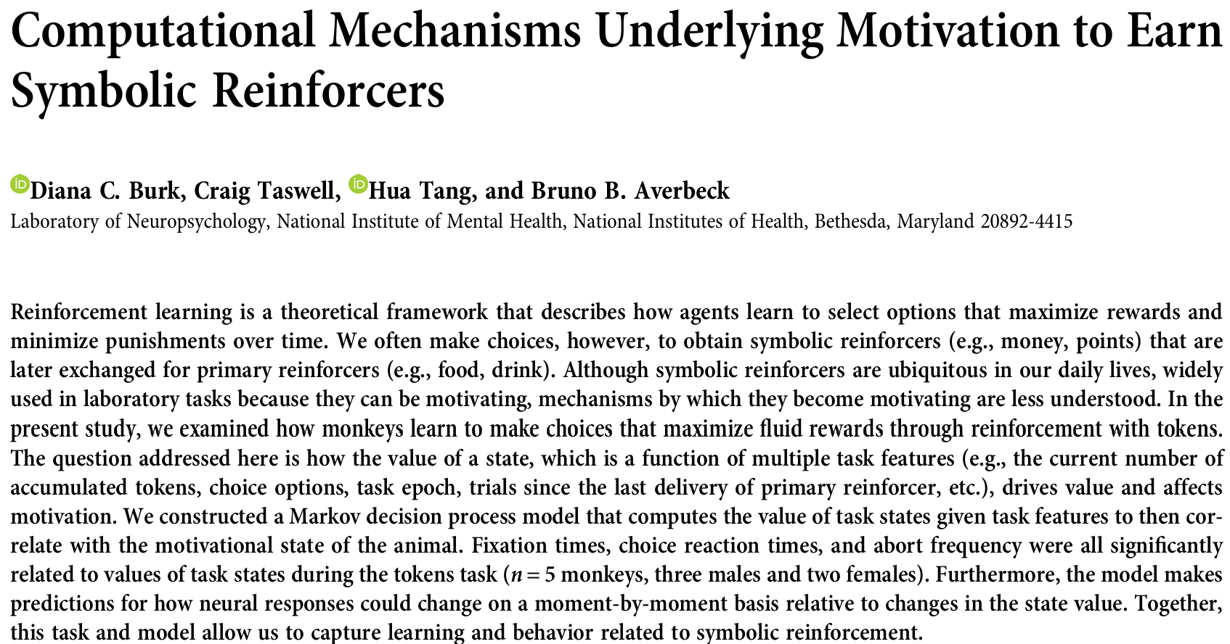
Diana Burk et al. (2024) found that monkeys would alter their behaviour to earn ‘tokens’ which were associated with the delivery of juice. It’s quite amazing that they managed to make monkeys sit and participate in a visual task presented on a screen (they had to look in particular places and hold their gaze for a certain amount of time) just to earn abstract tokens. The tokens were ‘exchanged’ relatively frequently for the juice, but it shows how symbolic reinforcement can alter behaviour.
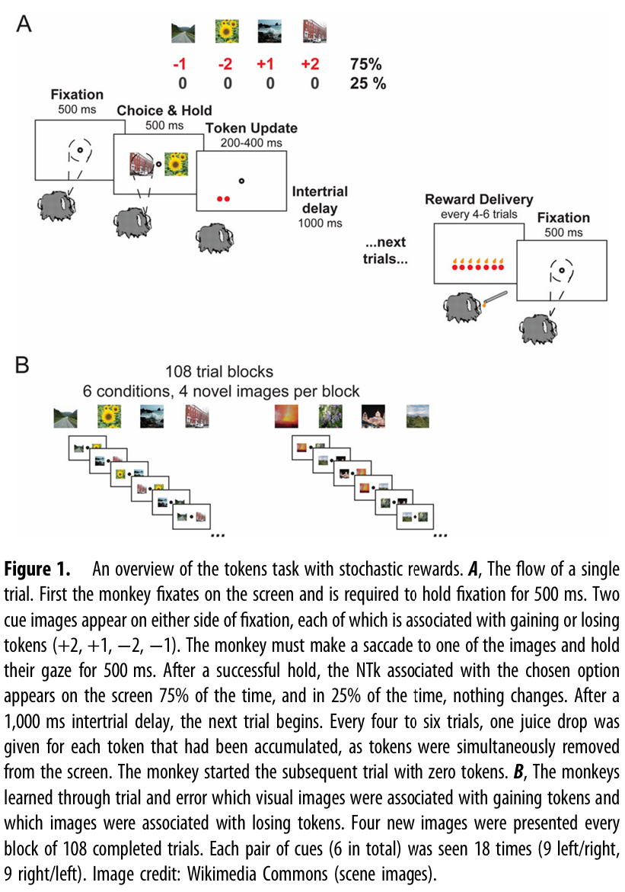
When I was going to school in the 1980s corporal punishment was being phased out. Previously students breaking rules could be caused physical pain as a punishment. In primary schools (and perhaps some high schools) today, there are often symbolic reinforcement structures to encourage good behaviour. “Classdojo” is a system whereby kids earn points for good behaviour, and receive awards for milestones (e.g. reaching 200 points). Central to such systems is transparency and clarity: every participant needs to know how the system works and what they need to do. (Compare this later with some of the problematic systems I describe towards the end of the lecture)
Most civilisations use money as the main secondary reinforcer. You cannot eat money, but you can use it to buy food. As you work, money is delivered as your salary or wage at a distance, no one needs to follow you around giving you coins as you work. And you always want more money, meaning satiety is not a problem.
Because they are abstract though, secondary reinforcers can be presented in ways which are confusing. Consider these two options:
A. A certain gain of 25 points.
B. A 25% chance of getting 100 points and a 75% chance of gaining nothing.
Even though over time the options would give equivalent gains, most people would choose A, because people overweight certain gains. On the other hand, consider these two options:
A. A certain loss of 25 points.
B. A 25% chance of losing 100 points and a 75% chance of losing nothing.
Here, even though the options are still equivalent in the long run, most people would avoid the certain loss and gamble. While people are risk averse when faced with certain gams, they are risk seeking when faced with certain losses.
All four of these options are the same in terms of long-term payoffs, so because of the systematic ways people are influenced by their presentation, they are called ‘framing effects’.
Also, even though we are dealing with abstract numbers, they don’t behave like numbers for us psychologically. It is as if we treat them as limited real resources. The difference between $30 and $20 is $10. The difference between $1800 and $1790 is also $10. However we might drive across the city to buy a $30 T-shirt for $20, but we wouldn’t even go to the shop next door if the $1800 laptop was only $1790. It’s as if the same difference in price is ‘worth more’ when it is closer to zero. Also, the ‘value’ of a gain is psychologically weaker than the ‘value’ of a loss. Consider how much happier you would be if you found a $10 note! Great, but then compare that extra happiness to how less happy you would be if you lost a $10 note; you would be much more miserable.
If we combine these observations, we get something Kahneman and Tversky (1979) called ‘prospect theory’ . Their paper contains an image of what they call a ‘hypothetical value function’.
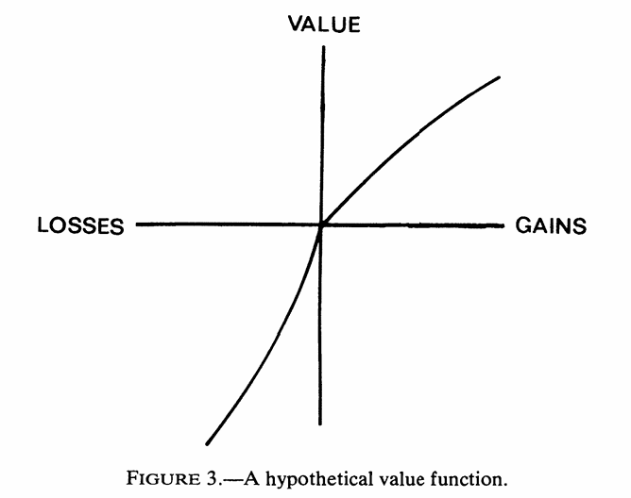
Before this paper was published, the idea of drawing a graph of the value of something against the amount of something would be nonsensical – surely abstract tokens, points, money, they are numbers and their value is their value – this should be a straight line? However Kahneman and Tversky’s graph is a graph of the psychological weight and value against the abstract value. You can see how the slope for gains is shallower, because it’s nice to get more, but the slope for losses is steep, because it is terrible to lose things. The way both lines curve, that’s an illustration of how the same amount is somehow worth less at great magnitudes.
Kahneman and Tversky’s work paved the way for behavioural economics and the following decades have seen it deployed to coerce many a shopper to hand over more money than they originally planned. Consider the offer to “buy one get one free”. Why does it work? Look a few paragraphs up, this is the certainty effect being used against you. Here, the options are:
A. 50% discount
B. Buy one. Then get one free.
The “get one free” is the certain gain. And people love certain gains and psychologically overweight them. Your risk/survival/resource management system is being used to manipulate you into buying something you probably never wanted, let alone two of them!
Nowadays things are even more complicated. Chain stores implement symbolic reinforcement through rewards and points, and just as primary school kid’s behaviour is manipulated so is yours. A good friend of mine had nearly finished shopping at a major supermarket, his trolley was full, but then his elderly mother rang and scolded him for buying the weekly groceries at the ‘wrong store’, so he put everything back just so his mum could earn her rewards points somewhere else. This friend of mine is a well-paid project manager at a multinational company, and the amount of time of his that doing this wasted would be an order of magnitude more valuable than the minor discount any points might have earned. It’s also worth pointing out that the symbolic reward systems always require a card or login, so even the discount is illusory, you are selling them your private shopping records.
Lee and Kim (2024) tested prospect theory framing for something positive: promoting policies to combat obesity. They found it was more impactful than what they called health communication ‘persuasion framing’. Compare these options:
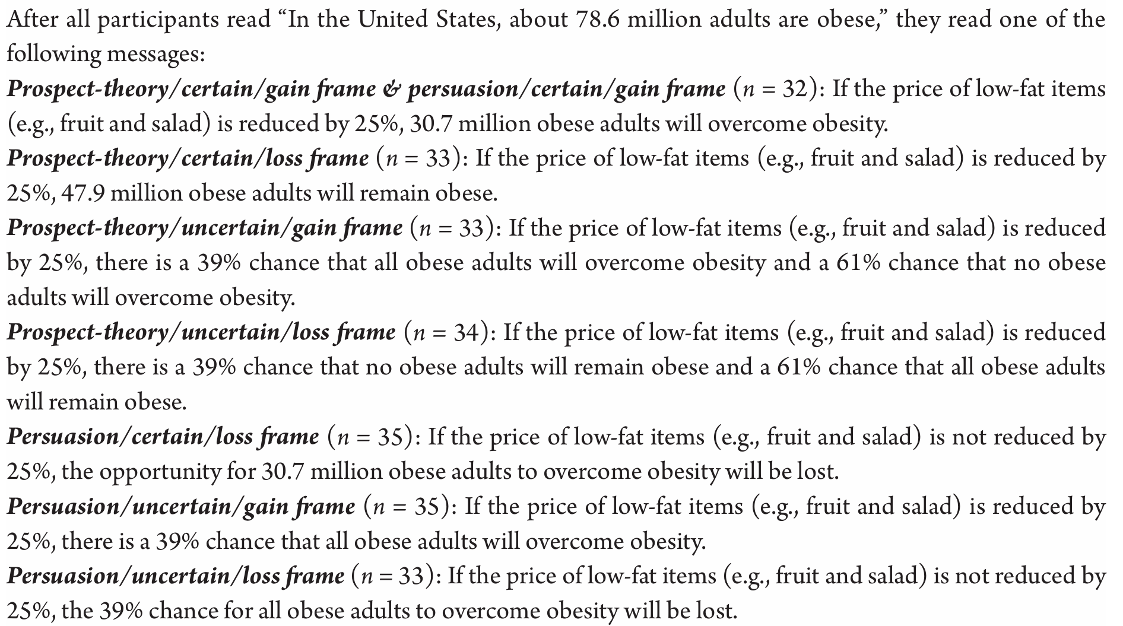
(from Lee and Kim, 2024, pp.193)

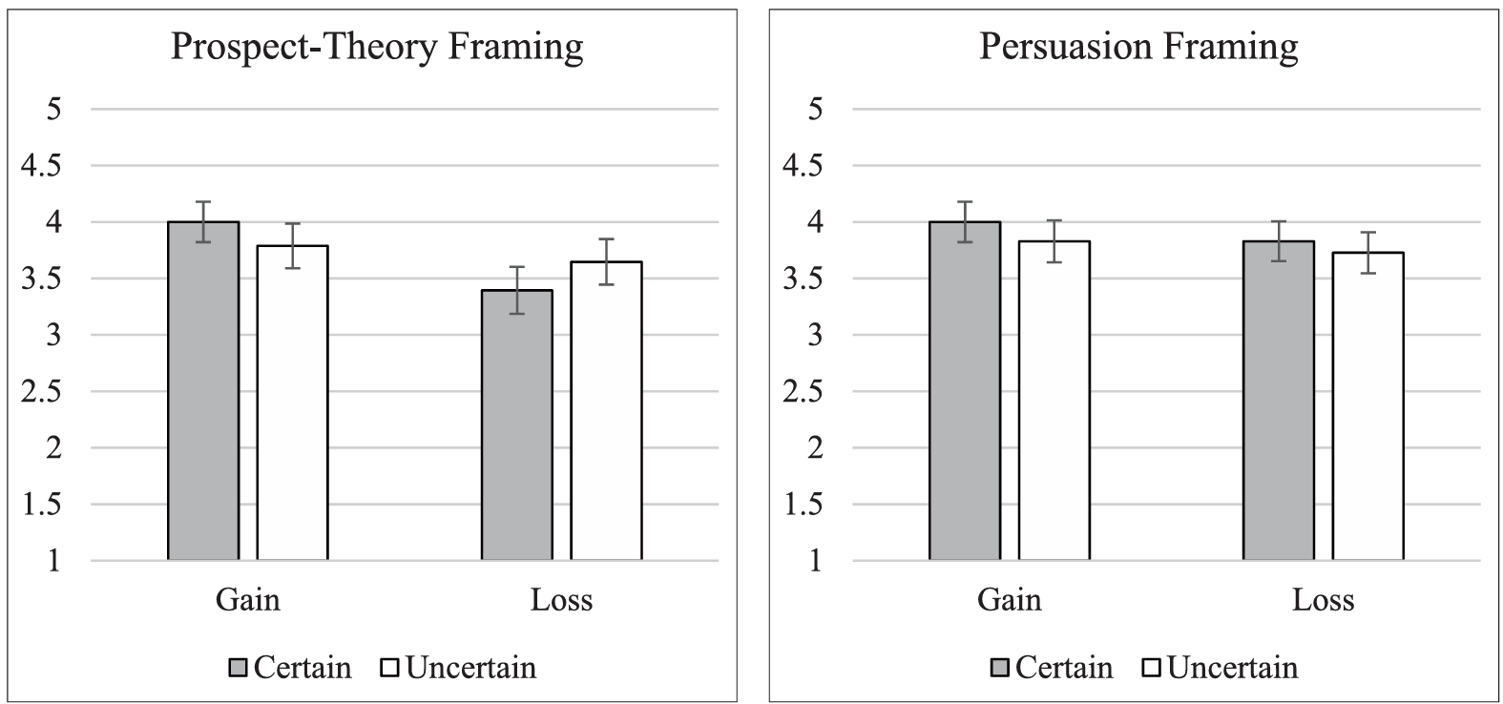
(Figure 1 from Lee and Kim, 2024, pp.183)
The y-axis here is support for the policy, and you can see that when choices are framed as certain gains (30million obese adults will overcome obesity) and when choices are framed as certain losses (47.9million obese adults will remain obese) people will support the other option. Persuasion framing (see above for the examples) was not as effective – it seems more confusing to be talking about probabilities than certainties.
There are so many ways to frame and manipulate and distort and misunderstand simple gains and losses with single, simple currencies, so imagine how confusing things can get if there are multiple currencies.
Worldwide, the videogame industry made approximately $180 billion USD in 2025-26.
(Global Gaming Revenue Is Expected to Reach $188.8 Billion in 2025, With Growth Set to Continue)
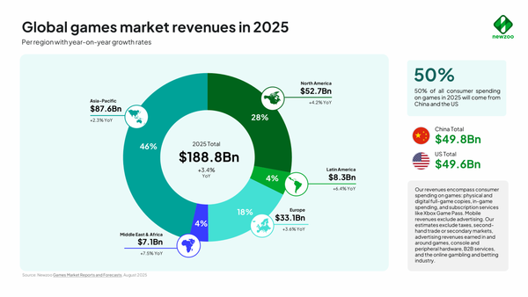
This amount is considerably more than the movie industry, projected to earn around $35 billion USD over the same period.
Gower Street Revises 2026 Global Box Office Estimate Ahead Of Cinemacon - Gower Street Analytics
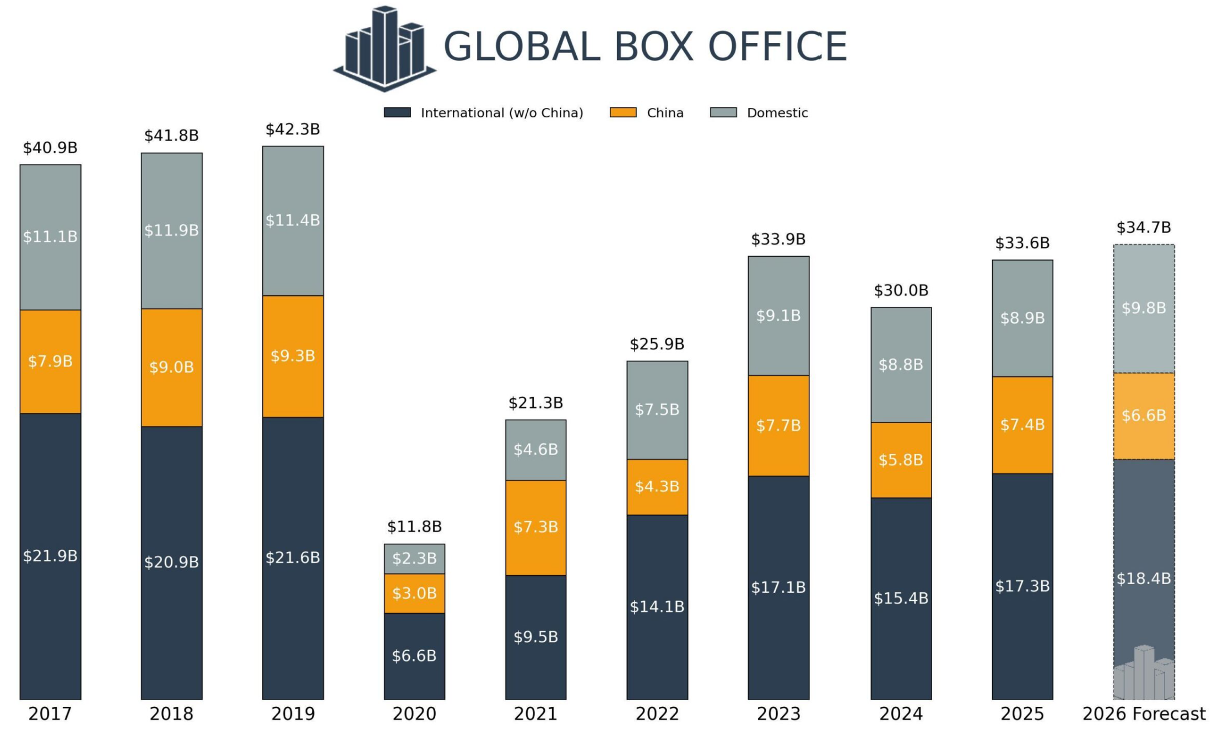
This surprises many, as we all know lots of film stars, but are much less aware of which particular videogames are raking in so much money.
What is also less well known, is that the revenue earned from videogames is much less straightforward than companies selling copies of games. In 2024, companies made only 36% of their cash from selling videogames. They made the rest from selling subscriptions (8%), downloaded content (9%) and the rest from ‘microtransactions’ (45%). (source: WN Hub communication platform. Feed. Analytics - hot | WN Hub)
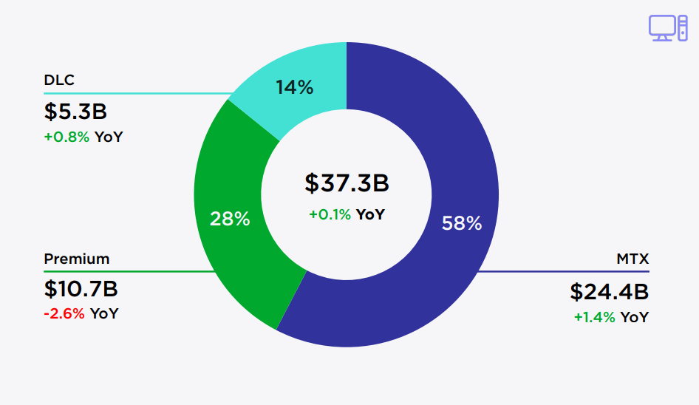
(in the graph above “premium” refers to sale of the games themselves, DLC = downloaded content and MTX = microtransactions)
Some AI’s have even told me that microtransactions make up 80%+ of all videogame revenue, it’s hard to nail down, but it is a massive amount of money.
So, what on earth are microtransactions and why are they making more money than the movie industry!?
In the 1970’s one of the first videogames called “Pong” enticed people to engage with it by running a simple competition: who can score the highest. It was certainly popular, however the first really popular games were ‘Space Invaders’ and ‘Pacman’. You might think they are much the same as Pong given they involve a game and a score, but for these games you weren’t just competing with another person, you were competing with the ‘high score’.
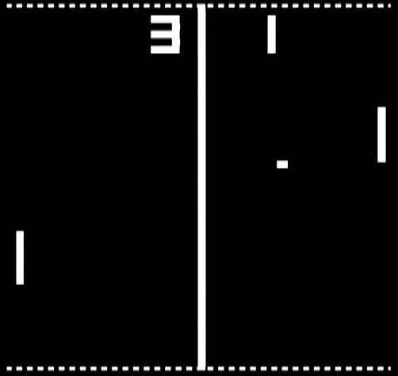
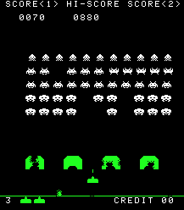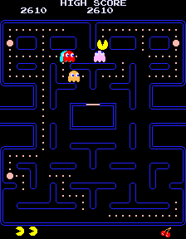
High scores seem to be a form of symbolic reinforcement, although what primary reinforcer are they associated with? Perhaps a personal satisfaction with beating a challenge become associated with the score, or, as these arcade games were outside the home in social spaces, perhaps scores became associated with social status. Whatever it was, the simple introduction of scores and high scores seemed to make all the difference. There was a shortage of quarters (coins) in America and a shortage of 100 yen coins in Japan when Space Invaders was released. It made $600 million in its first year… a staggering 2.4 billion quarters. To an extent people were paing for the experience and the fun (and I’ll talk more about the escapism of videogames in the next lecture), but there was something about the score and the high score and the sense of competition and skill that must have fired everyone up.
Fifty years later videogames remain a combination of something fun and interesting along with the accumulation of ‘points’… although it’s no longer as simple as a single score. Now players accumulate all manner of currencies. Each currency they are collecting is its own reward symbolic reinforcement structure.


(Above) A wall of currencies in Destiny 2. In the lecture video you will see a similar screen from the same game – but many are different, because even for one game they keep changing to be even more confusing.
Game designers want players to interact with all aspects of their game, so having a single currency to spend on everything would give players the freedom to simply enjoy playing the game as they want. By having different currencies, gamers can be pushed and nudged into behaviours they might not have chosen.
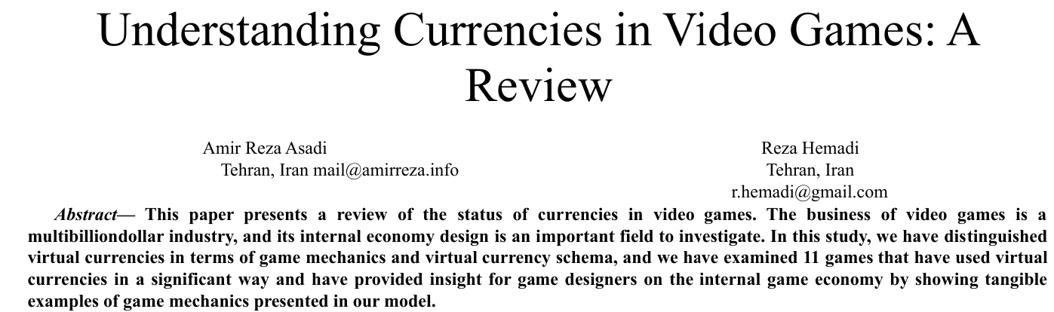
Asadi and Hemadi (2024) review the various forms of these currencies and what they are used for. They aren’t just for collecting per se, you are further motivated by the prosect of ‘spending’ your ‘wealth’, all entirely within the game. Space invaders gave you an extra life when you gained 1500 points, but a game called ‘Rogue (1980)’ was the first to introduce an in game ‘shop’. Asadi and Hemadi (2024) distinguish between three kinds of virtual currency: 1. Earned in the game and spent in the game. 2. Purchased using real money, but cannot be converted back, and 3. Purchased with real money and can be converted back. #3 is quite rare (they cite the game ‘Second life’ as the only example), and #1 is common in single player games where you are collecting/growing/crafting things.

(Above) Story of Seasons Grand Bazaar (2025) is a single player game with a virtual economy + crafting and growing and processing. None of the items can be bought with real money (except extra costumes).
#2 though, ‘Purchased using real money, but cannot be converted back’ – this is where microtransactions come in. While many games have downloaded content (DLC) which you can buy for money directly, or spend more when you first buy the software (the ‘deluxe edition’), many modern videogames have in game economies.

The first thing you notice about these is, money is largely hidden. Most in game shops have a virtual currency. There is a separate page somewhere where you have to buy the virtual currency with real money, but once you have that and move to the shop for in game items, you can lose track of how much everything actually costs.
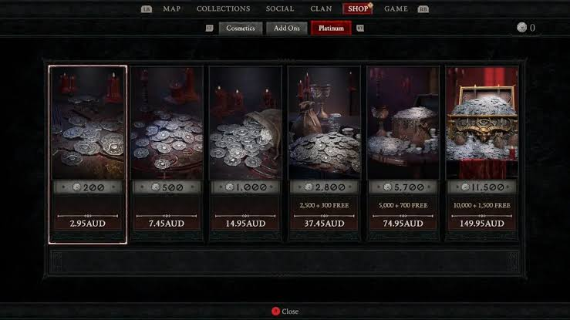
What is particularly mean/manipulative is that the virtual currencies are sold in packets which won’t quite match what you want to buy. For example, the cosmetic you might want costs 2400 “silver” but the shop only sells silver in 2800 bundles, so as well as spending more than you want to (and being motivated to somehow spend the 400 in ‘change’ you have by buying more), you aren’t quite sure exactly how much you spent ($35?) on the cosmetic.
The images above and below are real and are from a game called Diablo 4: To purchase a single costume, just for use in the game, is a third as expensive as the game itself.

Gutiérrez-Manjón et al. (2026) call monetisation practices like this “dark design patterns”. In amongst the many confusing currencies, there is usually one which is the one you cannot earn in the game no matter what, you must buy it with real money.
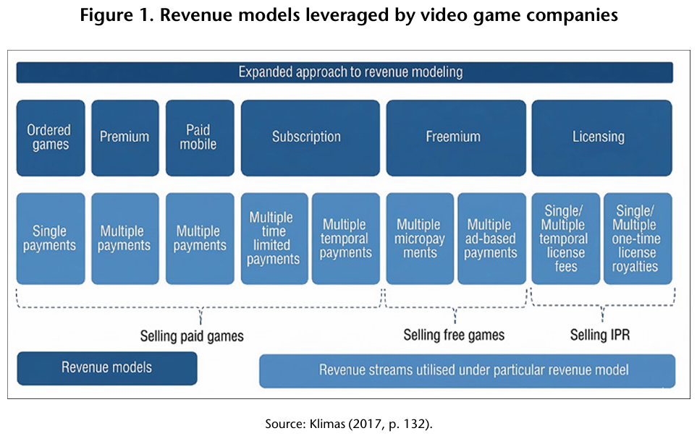
This kind of monetisation is prominent in so called ‘freemium’ or ‘free to play’ games, where there is no cost at all to download the game and start playing it, but there are constant enticements to spend.
Gutiérrez-Manjón et al. (2026) distinguish between three kinds of “Dark Game Design Patterns”:
1. Temporal patterns, to keep players engaged. 2. Monetary patterns, to keep players spending, and 3. Social patterns, to control the way players interact with others.
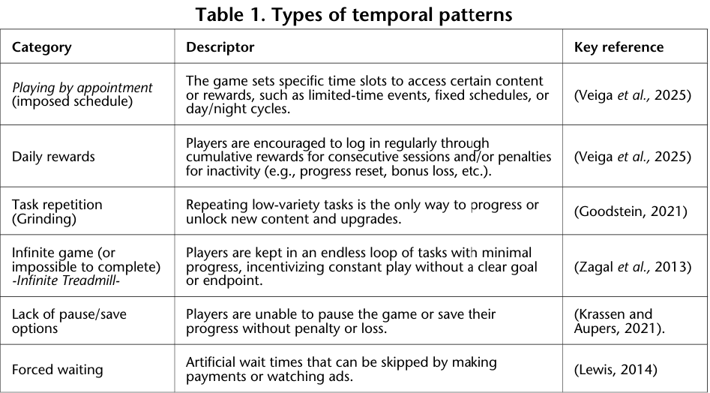
Images above and below are from Gutiérrez-Manjón et al. (2026).
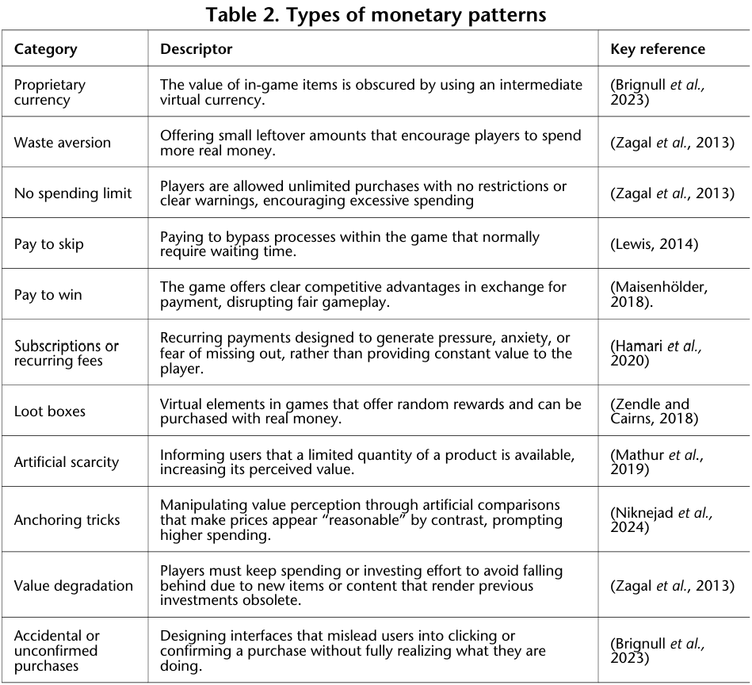
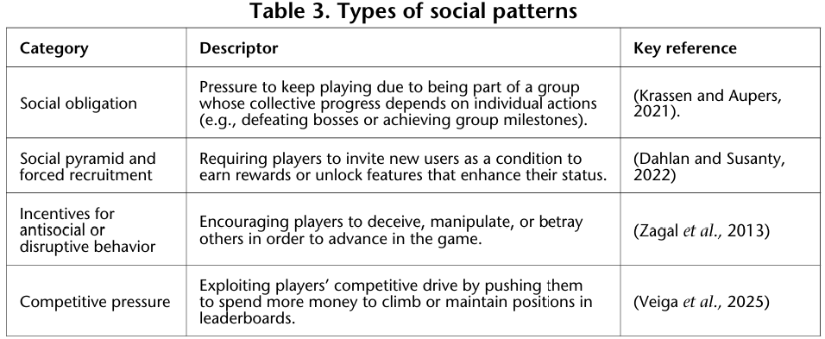

Gutiérrez-Manjón et al. (2026) use their lists of dark practices to analyse a handful of recent games. I won’t paste in more tables (the link to their full article is at the end), so here is what they found for just one game, called Fortnite.
Temporal dark patterns: Fortnite has a ‘battle pass’ which expires, so you need to engage. There are daily rewards, grindings, it is an infinite treadmill, you cannot pause or save, you have to wait to play.
Monetary dark patterns: Fortnite has a virtual currency called ‘V-bucks’, it does not have leftover money (the packets cost the same as the skins), you can pay to skip levels, there is artificial scarcity (the costumes switch in and out of the shop), and it has anchoring tricks: you can buy v-bucks packs to ‘save’ money.
Social dark patterns: Fortnite allows team play but has no clans so has only a medium social obligation but apparently has a social pyramid scheme to have players recruit others, antisocial behaviour is somewhat encouraged, and it is highly competitive.
If this kind of analysis seems a bit silly – it’s just a game – consider that Fortnite alone generally makes between $4-6 billion per year. That money is being earned through all these practices to keep people playing and to keep them spending.
Gutiérrez-Manjón et al. (2026) conclude:
“Players may lose control over their time and decision-making within systems where reward and spending mechanisms are often obscured. This reality underscores the urgent need for an ethical discourse on the boundaries of persuasive design, as well as a shared responsibility among developers, regulators, and scholars to promote more transparent, equitable, and user-respecting digital environments.”

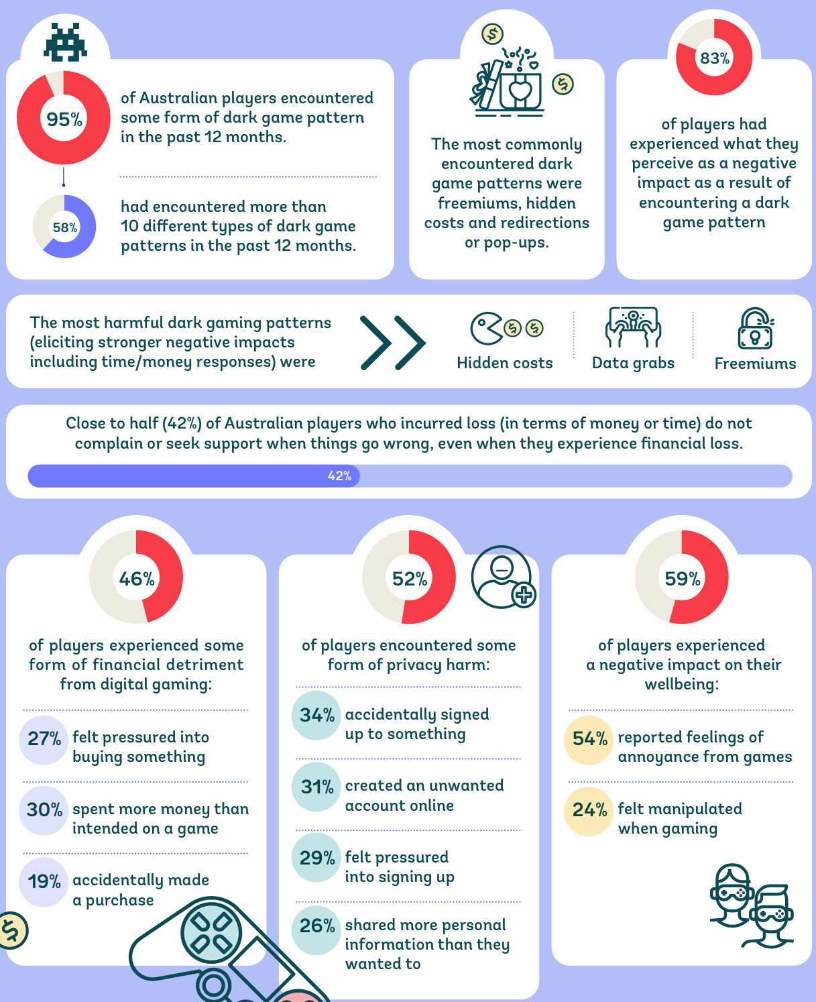
The Consumer Policy Research Centre, and Monash University published an extensive report in 2025 called “Playing the player: Unfair digital gaming practices and their impact on Australians.” – you can find the link in the references at the end.
It makes sense that serious attention is given to this industry given how much money is being spent under these conditions. However shocking it is that people might be encouraged to spend real money on in games cosmetics (the Fortnite and Diablo examples from above), imagine being asked to spend money on an opportunity to win an in game prize. These are called ‘loot boxes’. See below for definitions of loot boxes from the Monash report.
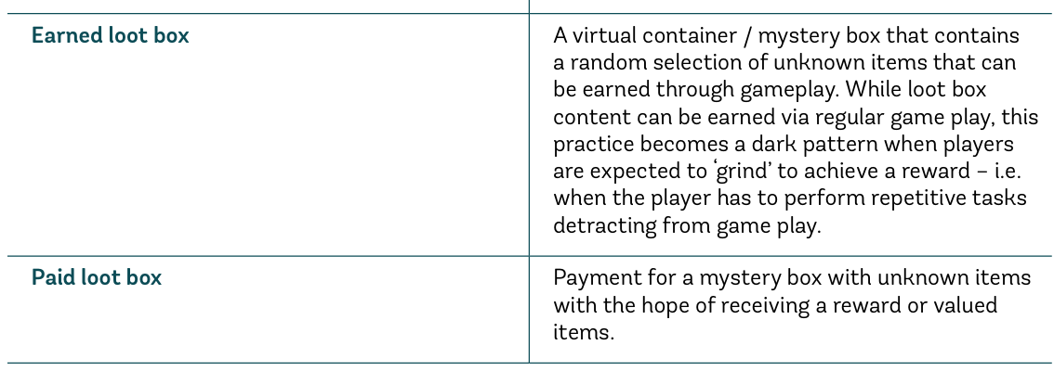
So many factors stack onto the potential harm for such loot boxes. Humans do not understand randomness. We all overinterpret coincidences and there are entire belief systems and industries based on humans inferring causation and control over random outcomes (e.g. astrology and alternative medicine). Also, we know from learning research in psychology that the variable-ratio reinforcement schedule is the most effective for maintaining behaviour. What this means is that is you are getting rewards of random magnitudes at random intervals; you are likely to keep playing. Added to this though, is that the randomness present in videogames is hidden, and because it is not disclosed or transparent, it might not even be true. So not only is the videogame loot box at least equivalent to gambling, but it may also be even worse if players are misled into thinking something is random when it is not. Consider that AI might be deployed to monitor a player’s engagement levels, such that a big win might be made to occur just as their interest is flagging.
Both the Monash University report and Gutiérrez-Manjón et al. (2026) describe the traditional loot box experience as represented boxes or treasure chests. They are mysteries to open. However, any kind of reward presented randomly can have much the same effect. Players invest time in completing a task, and then open a chest at the end which has a random chance of giving rare rewards. There are no currencies involved, but you have paid with your time. The most extreme example of this I can think of involves ‘raids’ from a game called ‘Destiny’ (the game I am seen playing in the lecture video). A raid can take anywhere up to 4 hours to complete, and while they can be extremely satisfying to play and complete (as they involve six players working together to solve complex problems), at the very end players get to open a final chest and they get one chance to win the rare exotic weapon. After 12 years of this system, the game developer Bungie has never communicated the actual probability of this occurring, but it is extremely low (1-5%). You might imagine such low probabilities, particularly after 4 hours of ‘work’, would be discouraging, but it has the opposite effect for many. The soccer world cup is being broadcast as I write this lecture, and the rareness of a goal may drive some people away (“soccer is boring, 90min for one goal!), but others become more transfixed. It is a variable ratio scale of reinforcement, and just like a Destiny 2 exotic, the reward is rare, unpredictable, high-value, socially salient, and emotionally intense. Importantly, rareness alone is not the key factor – we only get one birthday per year, but we know when it is quite precisely so don’t always appreciate it – it is the unpredictability which drives the behaviour to engage.
Over the years I completed nearly 300 raids in Destiny 2 and ‘won’ every single raid exotic, some on my first attempt, twelfth attempt, my fortieth attempt! Raid teams are very chatty, you get to know everyone well after an hour or so – so once near the end of a raid I let slip “We’re on our way to the loot box!” and I received an interesting reaction. “What do you mean, it’s not a loot box, we didn’t pay for it? Loot boxes are for mobile games and <names other games>”. I was able to explain that we were all investing time (lots of time), but most of the other players tended to emphasise distinctions between what they were doing and what ‘other games’ involved. This is a pattern common amongst gamblers: “Of course that <other way/game/context> is a waste of time, but the way I do it is valuable, enjoyable, and results in me winning.” Ellen Langer (1975) found that gamblers often attributed winning to skill and confidence, even in games of chance. The ‘illusion of control’ as she called it, was present whenever players had any choice at all, even if it did not affect the outcome (e.g. being allowed to choose your lottery numbers). Gamers who play games requiring a high degree of skill are perhaps more easily misled into thinking they also have control over what is inside the loot box.
Given the overlap between paid loot boxes and poker machines, they are worth mentioning. However poker machines and gambling issues could fill a whole other lecture series, so I’ll stick to just a single aspect: the way randomness is presented. I’ll back up just a little first though: humans do not understand randomness intuitively anyway. If anything, humans are wired to find patterns in the world, so even completely random events are often given more significance than they should. Ask a human to simply generate random numbers between one and ten, and they’ll say: 2,8,1,9,3,10,4,7 and so on – which is not random, they are ‘balancing’ out each number, and will rarely repeat numbers. When that person misses both their bus and train on the same day suddenly karma/god/luck is against them, when such things are quite common with all the randomness in the world. This idea things ‘balance out’ over short periods is behind ‘gambler’s fallacy’: the expectation that outcomes will balance such that if a coin lands heads four times in a row, ‘tails is due’, when in fact on the fifth toss, tails and heads are equally likely.
All gambling results in losses in the long run. You don’t need to be mathematically minded in order to understand that huge profits are being made because people who gamble lose vast amounts of money. Informing gamblers about the probability of winning is often required by law, but businesses can use framing effects (explored earlier) to manipulate people. Which poker machine would you play?
A. ‘this game has an average percentage payout of 90%’
B. ‘this game keeps 10% of all money bet on average’
(Examples from: Newall, 2024)
It is the same machine and the same probability, just framed in different ways.
If humans do not understand randomness or probabilities very well, imagine how thoroughly they can be manipulated by gambling games which utilise computers.
Decades ago, poker machines were physical, mechanical contraptions, full of springs and cogs, and set going with a pull of a lever. At the centre was a series of ‘wheels’ containing the symbols which needed to be lined up. Line up the right symbols and win money.
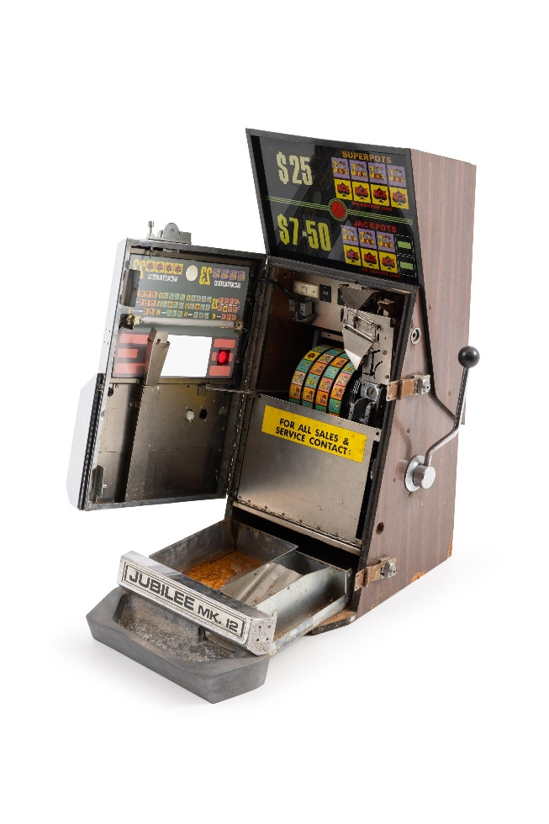
Now that poker machines are electronic and the reels are displayed on a screen and no longer physical, you need to trust the designer and owner of the machine to treat the reels as if they were physical. However, in at least two ways the reels can differ: while they might look similar on the screen, they can each be different sizes, and some of them can be huge (with a hundred symbols or more); also, the digital spin can be altered such that even when you lose it can be made to appear that you were close to winning (i.e. the row above or below might contain the rarest symbol). These are called ‘near misses’, and gambling research shows how important they are for motivating people to keep gambling. But if near misses are being artificially generated more than they could by chance, that is pretty deceptive and nasty. I don’t know the laws for NSW, but this practice has been tested in legal settings and sometimes outlawed, although Harrigan (2008) argues that what exactly is outlawed is not what people assume: near misses on the registered line might be outlawed, but near misses displayed above or below the line might still be legal, even though they are clearly still harmful.
Rocha Dores et al. (2020) looked at brain behaviour comparing wins, losses and two types of near misses. It was the near miss after the payline (see diagram below) which the brain considered most similar to a win.
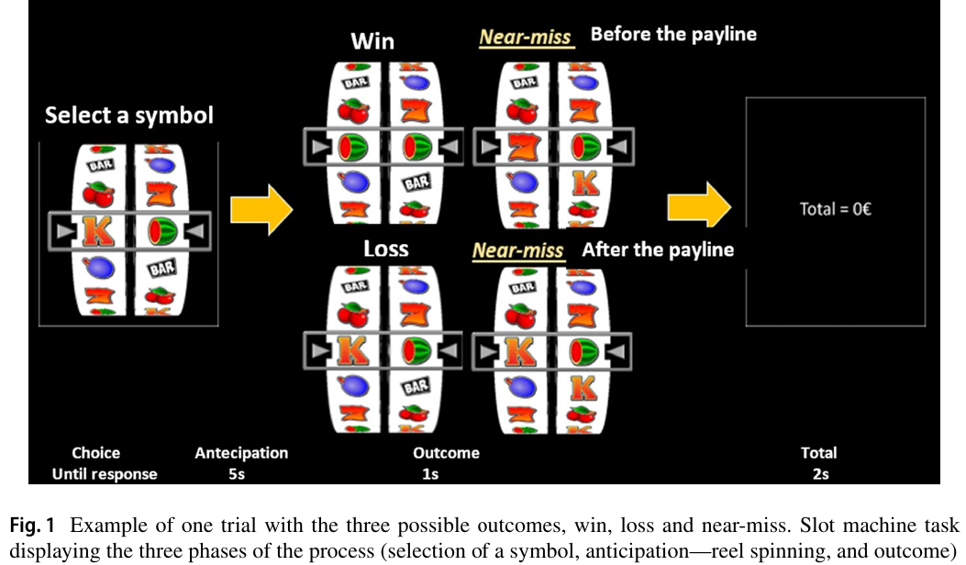
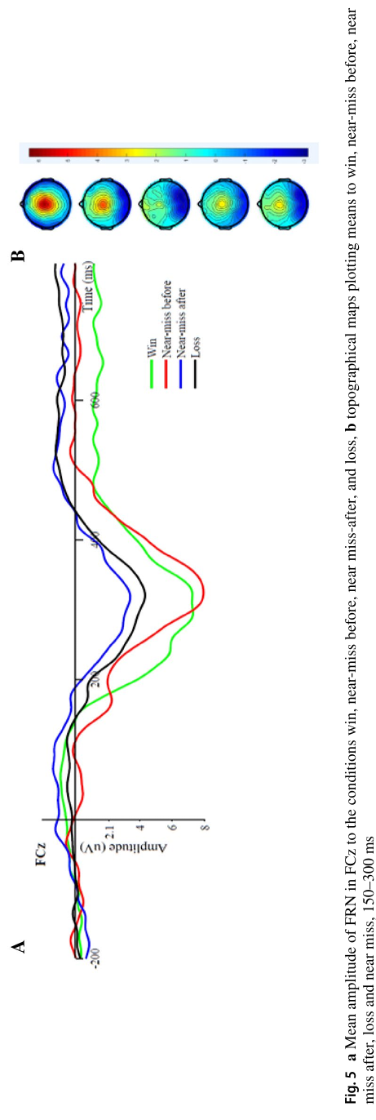
I don’t want to get into the neuropsychology, all I want to say is: if these were physical games of chance then rare near misses might give factual information about probability, however because the reels are digital and the output can be manipulated, then giving a player lots of near misses is treacherous. You can understand why this kind of practice should be outlawed if it isn’t already.
It seems reasonable to assume that poker machines in physical locations, even if they are digital, are carefully regulated and monitored, but a lot of gambling these days takes place online. Phillip Newall’s 2024 paper on online gambling is called “Sludge, dark patterns and dark nudges” – and you can read it if you want to find out the difference between sludge and a dark nudge.
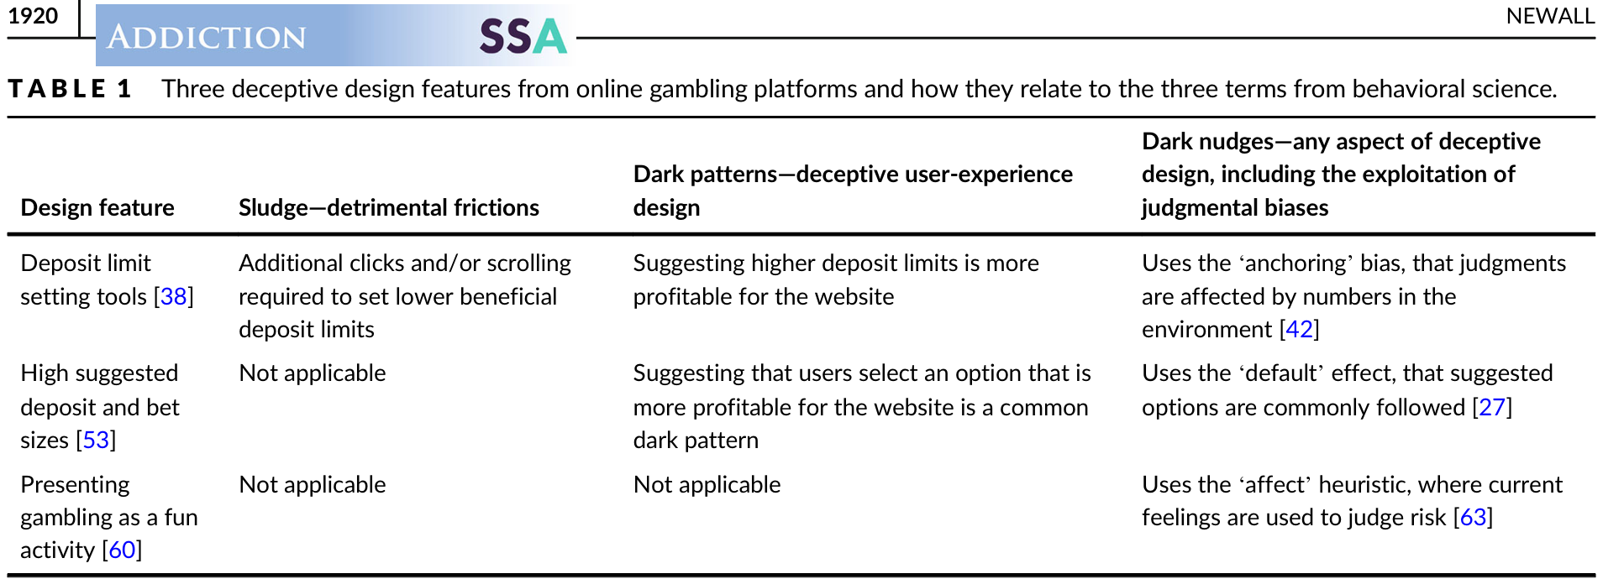
While his paper is focused on online gambling, most of the techniques described are applied to many other aspects of commercial exploitation. For example, he discusses the asymmetry in the number of clicks needed to perform certain behaviours. If it takes just five clicks to create an account but nine clicks to delete it, that’s a sludge to manipulate you. In other contexts: it is very easy to sign up for Facebook, or Netflix, or Microsoft Office, but very hard to delete those accounts. The companies might defend these practices by saying they want to prevent accidental account deletion, but they never appear to have any safeguards for accidental subscriptions.

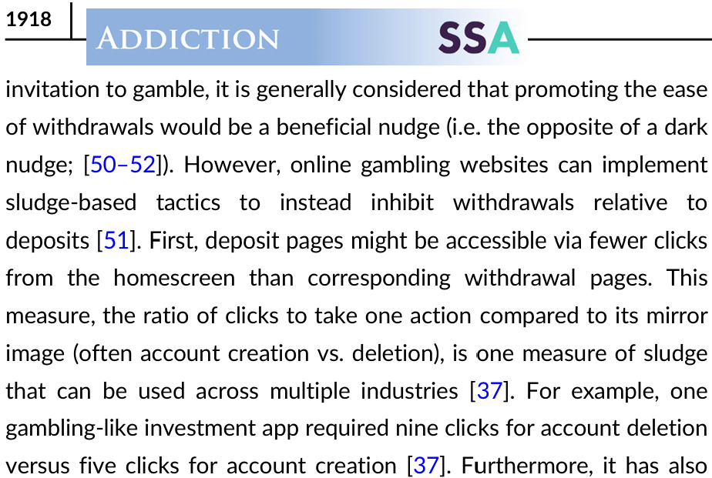
While I have focused purely on the technological side of gambling – specifically how technology makes a harmful practice even more deceptive – since I have mentioned gambling a lot:
If you ever feel gambling is affecting you or someone close to you, there are confidential services in NSW that can help you talk it through. GambleAware NSW (24/7) 1800 858 858, National Gambling Helpline (1800 858 858), Lifeline (13 11 14).
To sum up: humans have inherent cognitive biases which affect the way we understand value, even on a single linear monetary scale. Videogames can overwhelm us with multiple confusing currencies and rewards and penalties for engagement collectively known as ‘dark patterns’. Electronic gaming shares many of these practices to overwhelm our understanding of the risks we are actually taking.
In the recorded lecture I do plan on somehow being slightly positive at the end. Certainly understanding helps. Now you know some of the techniques to look out for, hopefully the next time you are gaming you are a little less likely to be manipulated. Just be very careful of the “not me, but other people fall for that” type thinking, for example “that videogame/gambling habit is terrible but my videogame/gambling habit is just fine”. It can often be difficult to be critical of your own behaviour, often it takes someone else to point out what is wrong – make sure you listen to them! It is also just a sad part of growing up in a capitalist society to gradually realise that you are constantly surrounded by businesses and people and structures designed to confuse you to take your money. There is nothing unique about gaming in that respect.
I’ll always be a little bitter about how crafty university marketing using ATARs stopped me being a psychologist – but I’ll save the details of that for the recording.

References
Asadi, A. R., & Hemadi, R. (2024). Understanding Currencies in Video Games: A Review. arXiv.Org. https://doi.org/10.48550/arxiv.2203.14253
Billieux, J., Van der Linden, M., Khazaal, Y., Zullino, D., & Clark, L. (2012). Trait gambling cognitions predict near-miss experiences and persistence in laboratory slot machine gambling. The British Journal of Psychology, 103(3), 412–427. https://doi.org/10.1111/j.2044-8295.2011.02083.x
Burk, D. C., Taswell, C., Tang, H., & Averbeck, B. B. (2024). Computational Mechanisms Underlying Motivation to Earn Symbolic Reinforcers. The Journal of Neuroscience, 44(24), e1873232024. https://doi.org/10.1523/JNEUROSCI.1873-23.2024
Consumer Policy Research Centre, & Monash University. (2025). Playing the player: Unfair digital gaming practices and their impact on Australians. Consumer Policy Research Centre. CPRC_Gaming_PTP-Report_FINAL.pdf
Dores, A. R., Rocha, A., Paiva, T., Carvalho, I. P., Geraldo, A., Griffiths, M. D., & Barbosa, F. (2020). Neurophysiological Correlates of the Near-Miss Effect in Gambling. Journal of Gambling Studies, 36(2), 653–668. https://doi.org/10.1007/s10899-020-09937-2
Gutiérrez-Manjón, S., Gómez-García, S., & Bonales-Daimiel, G. (2026). Designing for monetization: A taxonomy of dark patterns in top-grossing GaaS video games. Trípodos (Barcelona), (59), 5. https://doi.org/10.51698/tripodos.2026.59.05
Harrigan, K. A. (2008). Slot Machine Structural Characteristics: Creating Near Misses Using High Award Symbol Ratios. International Journal of Mental Health and Addiction, 6(3), 353–368. https://doi.org/10.1007/s11469-007-9066-8
Kahneman, D., & Tversky, A. (1979). Prospect theory: An analysis of decision under risk. Econometrica, 47(2), 263–292. https://doi.org/10.2307/1914185
Langer, E. J. (1975). The illusion of control. Journal of Personality and Social Psychology, 32(2), 311–328. https://doi.org/10.1037/0022-3514.32.2.311
Lee, T. K., & Kim, H. K. (2024). Reconsidering Prospect Theory in Health Communication: Interplay of Certainty with Different Types of Framing. Asian Communication Research, 21(2), 175–194.
Newall, P. (2025). Sludge, dark patterns and dark nudges: A taxonomy of on-line gambling platforms’ deceptive design features. Addiction (Abingdon, England). https://doi.org/10.1111/add.70085

