Truth and lies
Lecture 1
Curiosity and certainty
- Understand the need for cognition scale and how this construct has been shown to relate to conservatism.
- Be able to define the behavioural immune system and explain how it can conflict with vaccine uptake.
- Be able to explain and apply probabilistic decision making using the coin toss analogy and relate this to the attitude of science in adopting the ‘best right now’ approach to explanations.
- Understand and define tolerance and how it relates to uncertainty using the international flight or sandstone building example.

Every civilisation has foundations which ought to be understood by the people relying on them. I’m sure Ancient Egyptians understood the importance of the flooding of the Nile and the fertility it brought, and every Mayan would understand and pray for the maize crops. Yet while our modern civilisation owes so much to the scientific method, not only do many people not understand basic science, but an increasing proportion deny it and attack it.
Two thousand years ago romans built many buildings with what we now call ‘roman concrete’. This technology created structures which were incredibly strong and durable and could be built underwater. When the roman empire collapsed, the technology was lost. During the Middle Ages people built villages in the shadow of roman ruins, which were stronger.
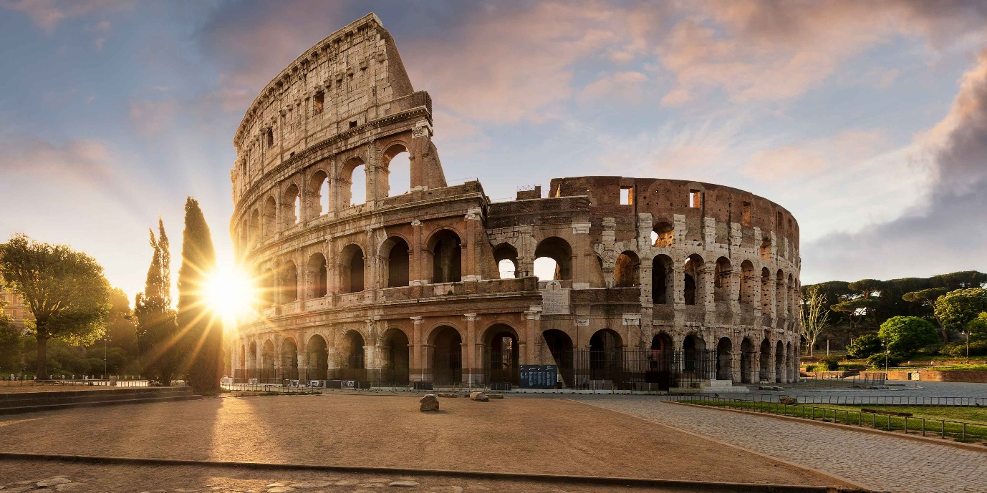

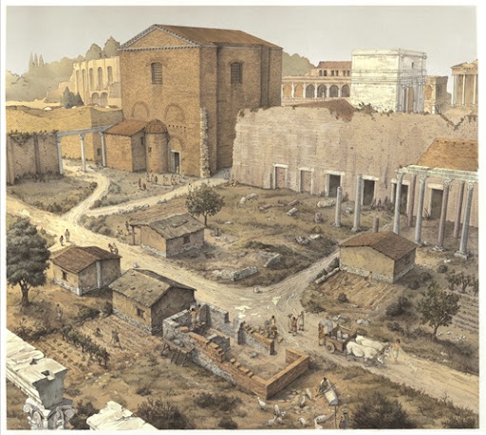

A roman architect called Vitruvius wrote down a method for making roman concrete around 25 BCE which seemed quite specific, but did not give away all the secrets. Scientists have long searched for ways to create roman concrete, and there are occasional breakthroughs. In 2023 MIT researchers proposed that the Romans used hot mixing with quicklime and not the slaked method described by Vitruvius. How do you test a hypothesis about a technology lost for centuries? Incredibly in 2025 a preserved construction site in Pompeii was analysed, frozen in time since 79 CE, and they found dry premixed volcanic ash and quicklime awaiting hydration. (https://www.scientificamerican.com/article/pompeii-house-frozen-mid-renovation-reveals-secrets-of-roman-cement).
As technologies beyond the understanding of all but the most dedicated specialists take over, are we doomed at some point in the future to build fragile shacks in the shadow of overwhelming structures? Even if the technology is not lost to everyone in our civilisation, how are ordinary citizens of a civilisation based on technology meant to navigate it?


There will always be an issue with cognitive overload. No single individual can fully understand everything we have created. The basis of any civilisation is specialisation. However what happens if most people don’t even understand the basics, like the scientific method? Worse, what if many or most people are not even curious enough to want to find out?

Cacioppo and others (Cacioppo and Petty, 1982; Cacioppo, Petty and Kao, 1984) argued for the existence of a personality trait called “need for cognition”, defined as an individual’s tendency to engage in and enjoy effortful analytical thinking. As a cognitive psychologist, it makes me uncomfortable to explain behaviour as being caused by innate ‘features’ of people (i.e. personality traits) but this is a useful construct as you’ll see. Look below at the short version of the need for cognition scale Cacioppo et al. (1984) developed.
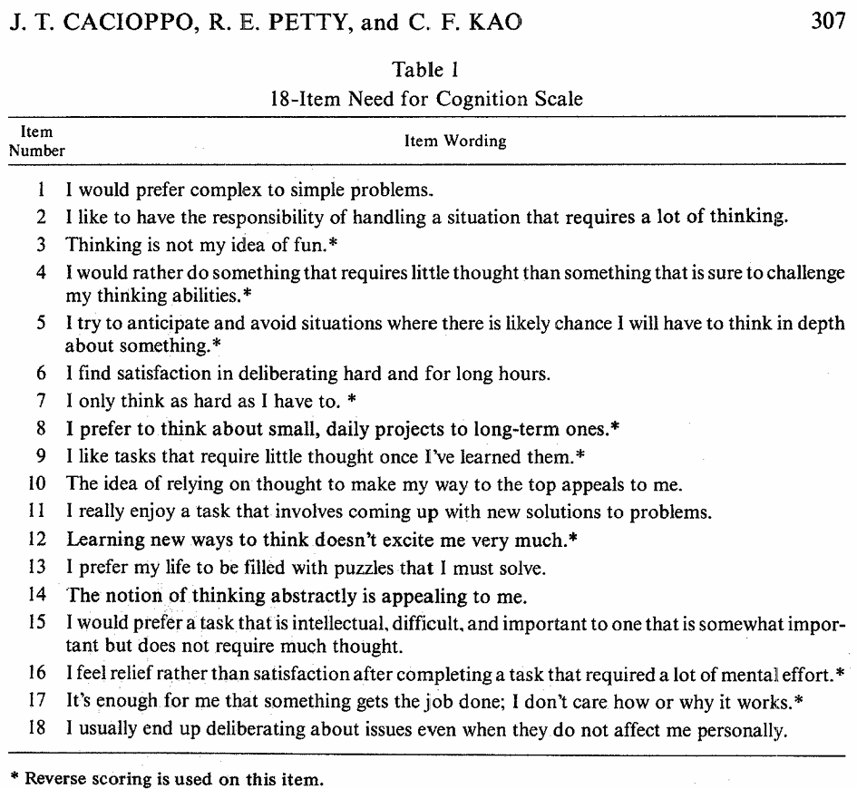
Decades later Hussak and Cimpian (2016) attempted to link need for cognition to conservative political views. They hypothesised that people who take cognitive shortcuts by using heuristics, create for themselves a simplified world of simple explanations. The availability heuristic (our tendency to only use the most easily available information) makes people focus on the ‘inherent’ features of something, ignoring context. For example if you ask someone why engagement rings usually have diamonds, if they are just focused on the inherent characteristics of diamonds, they will simply respond ‘because diamonds are pretty’, and they will ignore a long history of marketing campaigns by diamond companies (Tworek & Cimpian, 2016, cited by Hussak and Cimpian, 2016). Think how this translates to people. If a person of a particular skin colour or social group does something, a heuristic approach based on inherent ideas will explain the behaviour as being caused by who they are, ignoring the context entirely.
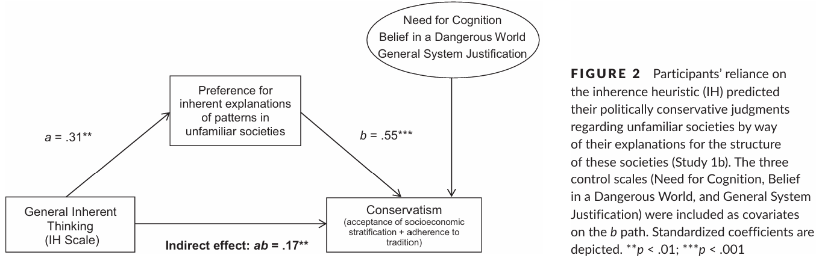
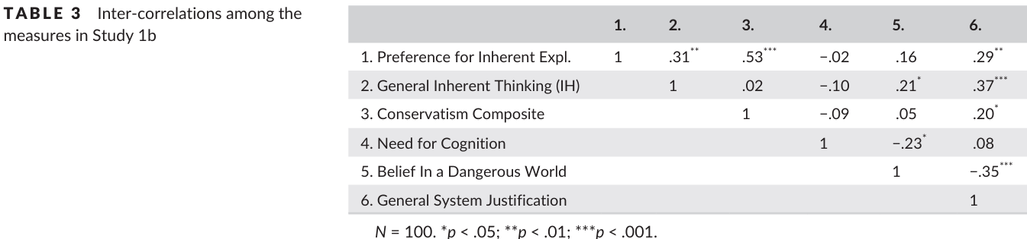
Hussak and Cimpian (2016, Study 1B) gave 100 adult participants scenarios about alien planets where wealth disparities existed in an attempt to evaluate conservatism in an abstract sense. Look above to see their findings, conservatism was positively associated with a preference for inherent explanations and negatively associated with need for cognition. It does seem as if people who seek out simple explanations and avoid effortful thought are more likely to be conservative in their views, at least in terms of blaming the inherent characteristics of people for their circumstances.
Isn’t saying that ‘need for cognition’ is an inherent part of people problematic then? Jost and others (Jost, 2006; Jost & Amodio, 2012) have a different view that it is people’s motivations and political viewpoints which lead to a lack of cognition. According to Jost, political ideology arises from motivated social cognition, which in turn is associated with avoidance of cognitive effort, higher need for closure, and greater reliance on heuristic processing.
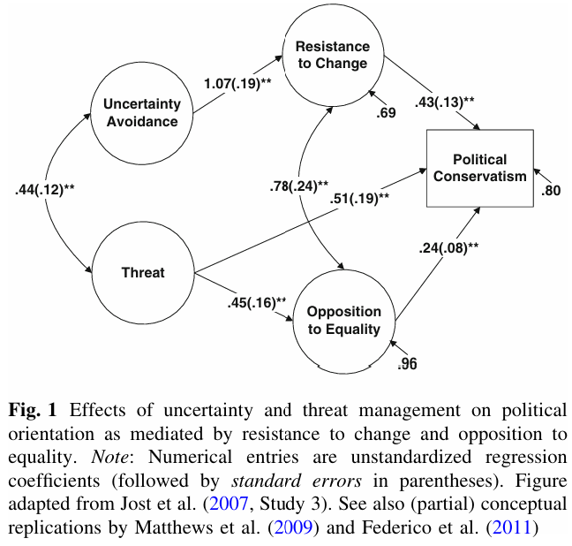
As you can see from the diagram above, fear, resistance to change and opposition to equality are all strongly related to political conservatism, but the aspect of interest here is ‘uncertainty avoidance’. Any kind of deep, detailed analysis of any topic inevitably reveals imperfections or exceptions, leading to qualifications which spoil a simple conclusion. It may be that Hussak and Cimpian (2016) and Jost and Amodio (2012) are both correct, and that politically conservative groups of people are a mix of simple people seeking simple answers, and people who begin with simple answers (e.g. from parents, religion), so are motivated to avoid looking further. Modern conservative parties founded on maintaining substantial disparities in wealth, often seek out low-income voters by appealing to cultural identity, nationalism, or threat sensitivity (Norris & Inglehart, 2019) – immigration covers all those.
One reason why I avoid ‘explanations’ based on personality characteristics or innate ideologies is because it is somewhat depressing and there is no obvious way to change people who apparently have such attribute. So, for now, I will set aside that line of thought and consider something that could help: education. Motivations aside, if a person lacks knowledge entirely, or worse, clings to false information, then their vulnerability to further misinformation or manipulation is enhanced. For example, if a person does not understand ‘plate tectonic theory’, the idea that the earth’s crust consists of moving pieces, then earthquakes and volcanoes could be caused by any number of things (punishing gods, stepping on a crack) which must cause great anxiety. If a person does not understand the germ theory of disease (most illnesses are caused by bacteria and viruses) then they will be vulnerable to false health claims and ideologies, lose a lot of money and potentially their life.
If you were born several thousand years ago there was a lot to be afraid of as very little was well understood. As human bodies contain extremely well evolved immune systems, many illnesses would be overcome with white blood cells, food and rest. However during those times of recovery if your tribe, parent or witchdoctor happened to be chanting/praying/slapping you with a fish, then your recovery could be attributed to the fish! While some genuinely effective remedies were discovered, imagine what thousands of years of superstitions builds in terms of elaborate health beliefs.
Hippocrates (460-370 BCE) the ‘father’ of medicine, modelled a new health remedy on menstruation, hypothesising that the process appeared to cleanse women of bad humours. The remedy, which probably had many other origins, was called ‘bloodletting’ and over the centuries it evolved into all kinds of elaborate techniques: leeches, cupping, or simply opening patient’s veins and draining their blood. While there is some sense in which blood carries pathogens, as a remedy bloodletting is profoundly misguided. Similarly remedies based on invisible force fields (chi, qi, prana) simply do not work yet have persisted over centuries.
The miasma theory of disease, again traceable to Hippocrates but with more origins, was part of European medical belief for some time. A ‘miasma’ is a form of bad or noxious air, and if you breathed it in then you got sick. Cholera, one of the deadliest diseases historically (and even today), was thought to be caused by bad smells or miasma. In London hundreds of years ago if you lived in a house near the Thames, you lived surrounded by toxic gases from the raw sewage in the river, and you often got cholera and could die. The “great stink” of July and August 1858 and associated cholera outbreaks led to determination to finally build a vast London sewerage system. When it was finished sewage smells were greatly reduced and far fewer people contracted cholera, but scientists had begun to work out that the miasma was not the cause of the disease, it was the sewage itself and what was in it.
Imagine travelling back in time a thousand years and trying to explain to people that most of their sicknesses were caused by viruses and bacteria, entities so small that they cannot be seen yet are everywhere. Don’t think of ancient peoples as stupid or misguided, they were doing the best they could trying to work out what was going wrong and treat their loved ones. The microbiologist Louis Pasteur debunked the idea of ‘spontaneous generation’ and showed that disease could be prevented or cured by focusing on germs. Pasteur is rightfully credited with saving millions of people’s lives, and today the germ theory of disease is the foundation of all modern medicine. Life expectancy rocketed up in countries which, like London, built sewerage systems and promoted hygiene to minimise our contact with pathogens.
And yet… today, your mother might tell you to wear a warm jumper in Winter, ‘so you don’t catch a cold’ – that’s spontaneous generation… it gets cold or you get cold and so a cold virus pops into existence? Even the name ‘cold’ for flu viruses contains that mistake. The reality is, flu viruses spread more easily when it’s cold because we close doors and windows ruining our ventilation, the temperature is a distal cause. And today, you might see someone with cupping scars at the local swimming pool – they paid someone to enact the European bloodletting method from the Middle Ages… in 2026? And today, when a worldwide pandemic hits, thousands, millions of people will deny the germ theory of disease, not wear a mask, object to a lockdown, and either die or kill others with their ignorance?
Crosby et al. (2024) attempted to evaluate the impact of an education campaign to stop so many children dying of infectious diseases in India. Too often children contract cholera and die from diarrhoea. The UK book “A Germ’s Journey” was adapted to make a Gujarati version and placed in 200 schools. Crosby et al. (2024) used a more modest sample of 100 children to test the direct effects in a controlled situation. You might be wondering what exactly was the technical focus of this book on the germ theory of disease? Hand washing, and basic hygiene. It was not obvious to surgeons in the 1800’s that they should actually wash their hands between operating on patients, so why should it be obvious to children that washing hands is important? - the invisibility of viruses and bacteria is the cognitive challenge humans are faced with – the most dangerous things to us, but we cannot see them.
Interestingly, researchers in public health don’t just talk about the biological immune system – what our bodies do to pathogens once inside – but the behavioural immune system: psychological adaptations which limit our exposure to pathogens. Some of these are ancient and basic: don’t eat food that smells bad, avoid people with sores or who are coughing. The behavioural immune system is fuelled by disgust, anxiety and germ aversion. There is a risk these sensitivities can be over tuned – leading to extreme withdrawal behaviours or excessive hand washing. Also, our best defence against viruses is often vaccines, yet vaccines involve putting foreign particles into our bodies – many but not all vaccines consist of deactivated germs to prepare our bodies for a real infection. You see the problem – people with generally adaptive germ aversions might also avoid vaccines.
Solek et al. (2022, p.2) review the evidence (BIS = behavioural immune system):
“people with high disgust sensitivity were more skeptical about the efficacy and safety of vaccines (Clifford & Wendell, 2016). Similarly, contamination aversion was positively correlated with nega tive attitudes towards vaccines (Clay, 2017; Luz et al., 2019), and vaccine-hesitant individuals had higher disgust sensitivity (Reuben et al., 2020). This surprising negative relationship between BIS and vaccination attitudes has been explained by the possibility that BIS treats vaccines as contamination cues.”
Both ‘germ aversion’ and ‘perceived infectibility’ contribute to the behavioural immune system, but relate differently to vaccines.
Solek et al. (2022) surveyed 525 people during the covid pandemic and confirmed that people with a high ‘germ aversion’ were more likely to be vaccine hesitant, but ‘perceived infectibility’ was related instead to vaccine intention. Karlsson et al. (2022) conducted three much larger studies (n=3401, n=1139, n=1022) before and during the covid pandemic. Like Solak et al. (2022), Karlsson et al. (2022) found that ‘perceived infectibility’ consistently predicted vaccine intention overall, but their germ aversion findings were more variable. Before the pandemic they found results similar to Solek et al. (2022), germ aversion was unrelated to vaccine intention, however during the covid pandemic those with high germ aversion had higher intentions to vaccinate and perceived vaccines as safer, a reversal of many previous findings. What happened? Was the scale of death and sickness that covid caused sufficient to alter people’s beliefs?
“We conjecture that high disease threat reverses the relationship between the behavioral immune system response and vaccination.” Karlsson et al. (2022)
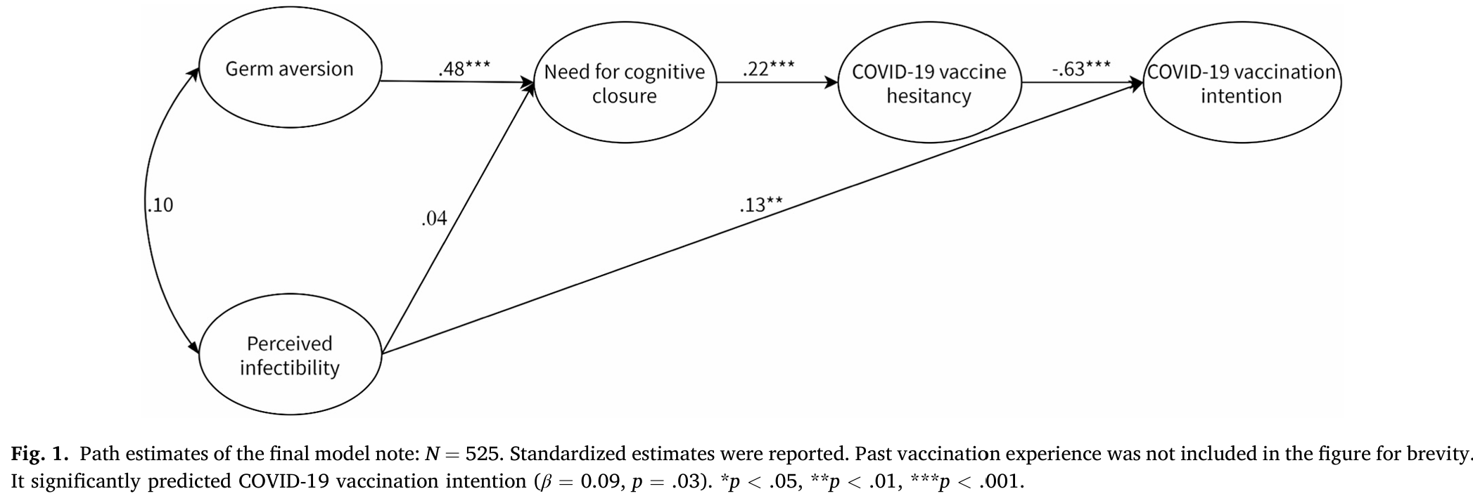
This is Solek et al.’s (2022) data above, and something else they measured which links to the first part of this lecture: “need for cognitive closure” is right there in the middle, very strongly related to both germ aversion and vaccine hesitancy. Need for cognitive closure is measured with a scale which taps preference for order and predictability and discomfort with ambiguity and uncertainty. Just because it is measured on a scale does not mean it is an enduring personality characteristic, but its role suggests that educating people about how to deal with uncertainty might be even more useful than explaining the germ theory of disease.
What is the ultimate role of educational institutions if not to impart knowledge and facts and current understandings? If we know many people attending such institutions are simply going to ignore the content they are taught thanks to motivated ignorance, there is not much point simply presenting knowledge and facts. Teachers need to convince and compel. Also, the best knowledge that can be conveyed should not be the list of facts, knowledge, learning outcomes, but an understanding of how knowledge is acquired. Much of the content being taught now is not true now or will be superseded very soon. But what if we teach students about the methods of knowledge acquisition and maintenance – scientific methods, approaches and attitudes.
I don’t know if it will solve the insurmountable challenges of some people simply not being curious and not wanting to know, but teaching a person how knowledge is acquired brings them into the experience and makes them part of the endeavour. Imposing scientific facts from high above simply won’t work. During the covid pandemic Dr Norman Swan had no official government role, but as a journalist he would regularly appear on television and radio calmly explaining what was happening with covid and vaccines and answering questions.

Knowledge was changing quickly, advice was changing just as fast. Evolution deniers were somewhat silent as the virus rapidly adapted to our attempts to stop it. Cutting through it all was Dr Norman Swan’s calm voice assuring us everything was being done.
The lack of certainty though from authorities drove many to simple explanations and simple solutions. Got covid? Drink bleach some said after Trump speculated about using disinfectants inside the body.
How to deal with uncertainty is at the heart of the scientific method and the attitude of science. Science necessarily begins from a position of uncertainty. People who know everything don’t make good scientists. If science knew everything, it would stop. The objective of science is to reduce that uncertainty, but there is a realisation that it never gets reduced entirely. You can see how people who insist on certainty might want to avoid it or deny it: absolute certainty has no place at the beginning or middle or end.
Wherever you start, the current understanding of the world must be seen as flawed/imperfect. The aim of science is to replace that flawed current understanding with something better – not something perfect, just something better.
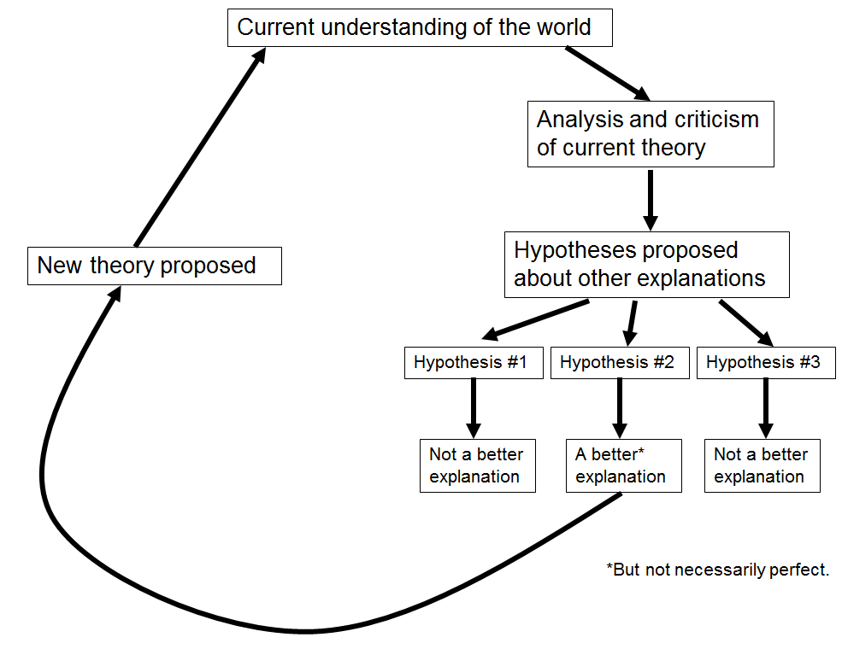
You build up your theory, design a way to test it and compare it with other explanations, and then choose the best explanation. Then, the current explanation improves a little, and science continues to criticise and attack it. You get famous in science by successfully attacking and disproving things. There is no room for respect or silence or sacred knowledge. Even when there is rampant corruption – and there often is, with scientists fabricating data or selectively reporting it – the system self-corrects because the next team of scientists won’t be able to find those results (failure to replicate). This cycle goes around and around forever, and the explanations gradually improve.
Importantly, the way we test evidence and frame decisions in science is based on probability. Imagine I’m curious to see if a coin is ‘fair’ and is likely to turn up heads or tails equally. I test the coin by tossing it a hundred times and note down how many heads and tails. I need to make a binary decision, either it is fair or it isn’t.
Outcome (number of heads) | Probability the coin is fair | Interpretation
52 | ≈ 0.93 | Very strong evidence for fairness
58 | ≈ 0.73 | Still more likely fair than unfair
64 | ≈ 0.28 | Now more likely unfair than fair
70 | ≈ 0.03 | Very strong evidence against fairness
80 | ≈ 0.00002 | Essentially impossible to be fair
90 | ≈ 10⁻⁹ | Fairness is effectively ruled out
100 | ≈ 10⁻²⁹ | Mathematically possible, practically zero

If you get 52 heads, that’s more than you would expect (50), but at the same time, shit happens, randomness is real, we just took a sample of 100 tosses, so meh, 2 heads doesn’t matter, it is still probably a fair coin. I’m being intentionally flippant because people who do not understand randomness, will attach value and meaning to those two extra heads. For those people every squeaky floorboard is a ghost, and their oversensitivity is going to drive their chance-based decisions erratically. Science cannot work with being too liberal like that. The media is not science though, and will often report highly improbable findings as if they are certain facts: dark chocolate and red wine are often reported as healthy, then dangerous, then healthy again!
What about 80 heads then? That would be very strong evidence it is not a fair coin. If it’s a theory you are testing, time to reject it and replace it with another one. And yet, in crowded lecture halls over twenty years I asked people these exact questions, and by 80 heads, there would still be a few dozen with their hands up saying it was a fair coin, by 90, still a handful, even at 100 normally one or two – and almost always male…? I thought I worked out what their problem was a few years in, I would emphasise that the question is “With this number of heads, is it probably a fair coin, not possibly, but probably?” – but that had little impact. A person seeing ghosts in shadows is too liberal, but a person refusing to change their mind in the face of overwhelming evidence is too conservative. If someone is claiming that a coin tossed 100 times coming up 80 heads is probably a fair coin, they do not understand probability, or science, or statistical decision making.
Tony Abbott, a previous conservative prime minister of Australia said of climate change in (2019):
“The so-called settled science is not quite as settled as people say and that's my position.”
Science is never settled of course, and it remains possible, if not probable, that you can toss a fair coin 100 times and it could land heads 80 times, but when the evidence is overwhelming, if you refuse to change your mind, then you’re being too conservative. (NB: While the terminology does line up to some extent, ‘liberal’ and ‘conservative’ decisions in inferential statistics have more specific meanings than political alignments)
So, what does science do? It tries to find a way in between the errors of being too liberal and being too conservative. In psychology we normally pick a 5% cutoff, we will reject a hypothesis for which evidence that has a less than 5% chance of being obtained by chance. For coin tosses, that comes at 64 heads. Science does not make a big deal for anything between 50 and 63 heads, that’s written off as sampling error and noise, but 64 heads or more… something systematic must be happening. Is that too conservative? It depends on the context. But when you realise that is how most probabilistic scientific decision-making works, you realise that science is neither ‘close minded’ or ‘open minded’ as some might claim, it is just a system of making decisions in line with evidence.
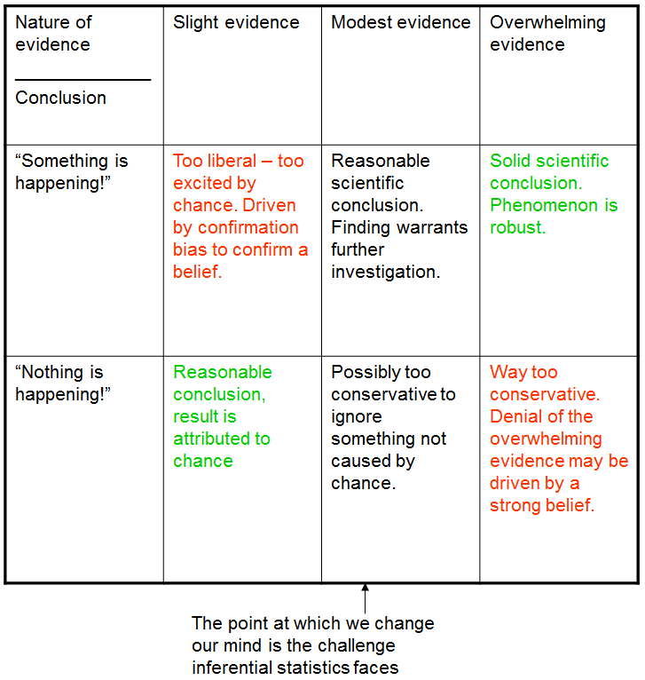

The other side of probabilistic decision making is that conclusions are never ‘settled’ or certain. Those many men over the years who kept their hands up when I called out 80 heads, 90 heads, 100 heads – maybe they had stubbornness built into their minds, but sometimes sampling error does lead to errant results, just not very often. If you publish results affected by sampling error, science will still self-correct because that result cannot be replicated. The worse error is simply ignoring the overwhelming evidence.
[As an aside if you are studying statistics in any context, yes this was an explanation of inferential statistics. The cutoff is the decision rule, the probabilities p-values, the idea of a fair coin is the null hypothesis and we’re deciding whether or retain or reject it, the distance from 50 heads can be expressed as a z or t value. You can even watch an old lecture of mine about all this here: https://youtu.be/dQVIpTvo580 . BUT for the purposes of PSYC1003 – relax, the connections are not needed, just know science makes probabilistic decisions and understand where I go with this.]
Understanding that science makes probabilistic decisions and never deals with certainty even at that basic level can help you see how successful it is but also might help you see why so many humans struggle to accept it. Humans prefer certainty over all else. (My Brains and Machines lecture series has a segment on monetary decisions and the certainty effect) A holy person, usually a man, walks up a mountain then comes back down and tells people that a god has told him the truth of all things. A person selling magic crystals tells the desperate person living with cancer that it will cure them. The email from Nigeria promises that Joseph, who looks very handsome in the photo, will definitely marry your lonely grandmother if only she sends him $10k. In contrast, a scientist presenting a covid vaccine mutters about a relative risk probability of 50%. Yes there is a probability you will still get covid even if you have the vaccine, and even a possibility you could get a nasty side effect, but you will be 50% less likely to get covid than if you didn’t have the vaccine…. It takes too long to explain uncertainty. People will focus on simplicity and certainty and simple statements. For them, scientific decision making is a world away, but a person wearing a nice suit selling a product like a remedy or a religion will get their attention and their money.
Certainty builds walls as well. When you desire certainty, you seek to affirm the truth of it. Evidence that confirms your beliefs gets focused on and celebrated. Evidence that disconfirms your beliefs gets ignored or heavily criticised and diminished.
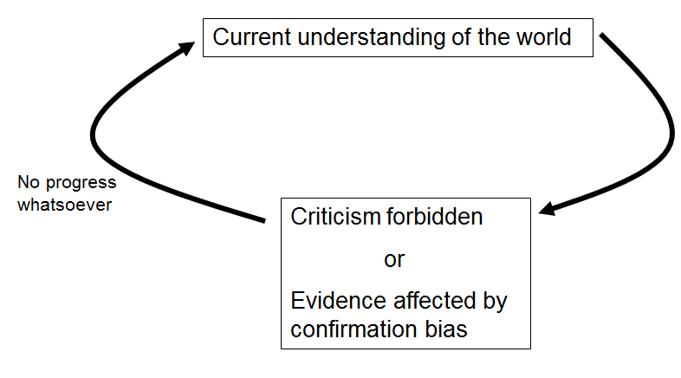

This psychological bias is often referred to as confirmation bias. As you can see in the image above, when understandings are not able to be criticised, they don’t change. It is not a flex for a belief of yours that it has not changed in thousands of years, it probably means anyone who criticised it was killed and/or the people clinging onto it have spent a lot of time completely ignoring evidence against their idea and feverishly collecting evidence in favour of it.
For scientists though, they must remain humble. After a surprisingly short amount of time with probabilistic decision making, progress has been astonishing. The germ theory of disease alone has meant we all live lives that are twice as long as those of our great grandparents, and yet our great grandmother might have believed in X, and all X has managed is to maybe make our lower back pain ever so slightly less painful from time to time. In terms of achievements science next to pseudoscience is like a rock the size of a house next to dandelion seed – it is very easy for scientists to be arrogant and come across as authoritarian.
If you feel uncomfortable accepting a system that is based on only ‘the best answer right now’ and managing uncertainty, consider that you behave like this every day of your life. Imagine you have an international flight from the airport. You have to calculate a good time to leave to allow time to get to the airport and check in and board. There is nothing certain about the process: traffic, queues, delays etc. You do not throw your hands up in frustration and pay a charlatan to fly you to your destination on a flying carpet, instead, you embrace the uncertain and possible variations, accept it, and account for it. The concept of tolerance describes this situation well. You know that if you allow 10min to travel to the airport and check in, you will probably miss your flight, but if you allow 4 hours you will probably catch it. Four hours might seem too much, so how much can you push your luck and leave later – what is your tolerance? This decision making process is embedded in science and technology.
The stone used to make a building has no certain strength, every stone is different, especially sedimentary stones which are naturally formed by sand compressed over millions of years: every one of them is different. You do not build a building at all if you fear any uncertainty. You build a building by understanding the nature of the uncertainty, and accounting for it. The walls are thicker than they need to be. Every step in science is cautious, accepting of uncertainty and trying to reduce it, but what it has made in such a short period of time is magnificent.
So, what is the most important thing you should learn at university? Which fact, which kind of knowledge? Only uncertainty. There is an emotional side to it, you learn humility, you learn how to cope with the realisation that every foundation you thought you had is unstable, but also you learn there is so much that needs to be done to improve our understanding of the world. Importantly, and at some point there is no getting away from mathematics, you learn the need to master and express uncertainty. You use it decide which explanations are the best. Deciding between options is the topic of the next lecture.

References
Crosby, S., Younie, S., Ujenia, H. V., & Laird, K. (2024). The longitudinal effect of disseminating handwashing public health education to children in India via co-created, culturally relevant resources: This article is part of the Pedagogy collection. Access Microbiology, 6(1). https://doi.org/10.1099/acmi.0.000677.v3
Karlsson, L. C., Soveri, A., Lewandowsky, S., Karlsson, L., Karlsson, H., Nolvi, S., Karukivi, M., Lindfelt, M., & Antfolk, J. (2022). The behavioral immune system and vaccination intentions during the coronavirus pandemic. Personality and Individual Differences, 185, Article 111295. https://doi.org/10.1016/j.paid.2021.111295
Norris, P., & Inglehart, R. (2019). Cultural backlash : Trump, Brexit, and authoritarian populism. Cambridge University Press. https://doi.org/10.1017/9781108595841
Solak, Ç., Peker-Dural, H., Karlıdağ, S., & Peker, M. (2022). Linking the behavioral immune system to COVID-19 vaccination intention: The mediating role of the need for cognitive closure and vaccine hesitancy. Personality and Individual Differences, 185, Article 111245. https://doi.org/10.1016/j.paid.2021.111245

